CAPPS Custom Hire

Summary:

CAPPS provides a method to hire an employee utilizing a custom process and page(s) to bring them into CAPPS.
This document is intended as a brief reminder of the steps, navigation, and screens used to complete the CAPPS Custom Hire process. It is not intended to replace training.

Prerequisite:
Information you will need to complete the hire process:
· Hire Date (Start Date)
· Social Security Number
· Name
· Birth Date
· Gender
· Education Level
· Ethnic Group
· Military Status (Veterans Status and Preference)
· Position Number
· Salary
Note: Much of this data is visible to the employee on ‘My Profile’ section. For example, if the Education Level is entered the employee will see the Education Level in Employee Self Service.

Steps Required:

- Navigate to Workforce Administration / Job Information / CAPPS Custom Hire
- Follow the navigation listed above
  - Enter the Social Security number for the new hire
  - Enter the Agency Number
  - Enter the Hire Date
  - Select “Continue”
- After selecting the “Continue” link on the previous screen, Web Services will run behind the scenes to check the Social Security number against all other State agencies. It may take a moment to display the screen once the process runs.
  - Select “Add Name”
  - Complete the First and Last Name fields select any prefixes or suffixes if needed.
  - Select “Refresh Name”
  - Select “OK”
- Add the Date of Birth (DOB). Be careful to indicate the appropriate date. CAPPS will calculate some benefits based on the DOB.
- Use the check boxes to select the Information Release indicators. Some employees will default protected depending on the agency and/or the employee.
- Indicate the Gender (Required), Highest Education Level (Optional)
- Select the Contact Information tab
  - Select “Add Address Detail”
  - The effective date (Hire Date) and country (USA) will auto-populate
  - Select “Add Address”
  - Enter all Address information
  - Select the county of residence using the drop-down menu
  - Select “OK”
  - Enter the Phone Type, Phone Number, and check the “Preferred” box. If more phone numbers are needed, use the + button to add an additional row. The preferred box must be checked on one number only
  - Enter the Email Type, Email Address, and check the “Preferred” box. If more email addresses are needed, use the + button to add an additional row. The preferred box must be checked on one address only. Do NOT enter a business email address as a part of the CAPPS Custom Hire. This information will be updated via the Business Email Interface or can be entered online after the employee is hired.
- Select the Regional tab
  - Enter Regulatory Region: USA
  - Select the look up icon next to the Ethnic Group field (Required). Select the appropriate Ethnic Group from the menu
  - Enter Military Status and the date of hire as the Effective Date (Required)
  - Chose the appropriate indicators in the Texas Application Data section.
- Select the Organization Relationships tab
  - Defaults to the Org Relationship of “Employee”
  - Select Add Relationship
- On the Work Location tab, Enter the Hire Reason Code (use the look up icon to the right of the field to search applicable codes)
  - Enter the Position number and then hit the Tab key. Many of the remaining fields will be populated after you enter the position number:
- Regulatory Region
- Company
- Business Unit
- Department & Department Entry Date
- Location
Notes: Validate that the correct position data is defaulted. If the information is not accurate you may need to update the position. It is recommended that you check the position before hiring the employee through the CAPPS Custom Hire Process to make sure any updates have already been made to position. The Establishment ID is not used in CAPPS.

- Additional fields on the following tabs:
  - Payroll
    - Validate payroll information
Note: The process will default W-4 information of single and zero into Employee Tax Data. The information can be updated by the employee through Employee Self Service after the hire is complete.
  - Salary Plan
    - Validate salary plan, grade and step (if applicable)
  - Compensation
    - Enter Compensation rate
    - Select “Calculate Comp” button and validate amount is correct
- Save the record
- Update any Prior State Service or Hazardous Duty (if applicable)

Navigation: Main Menu / Workforce Administration / Job Information / CAPPS Custom Hire
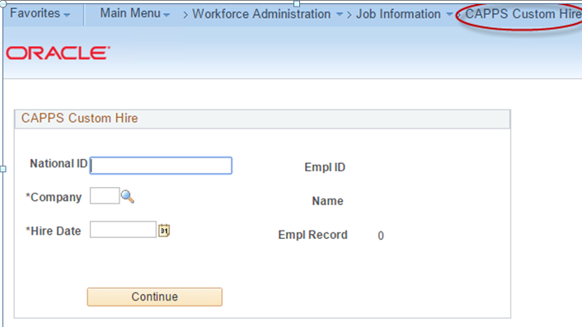
Biographical Details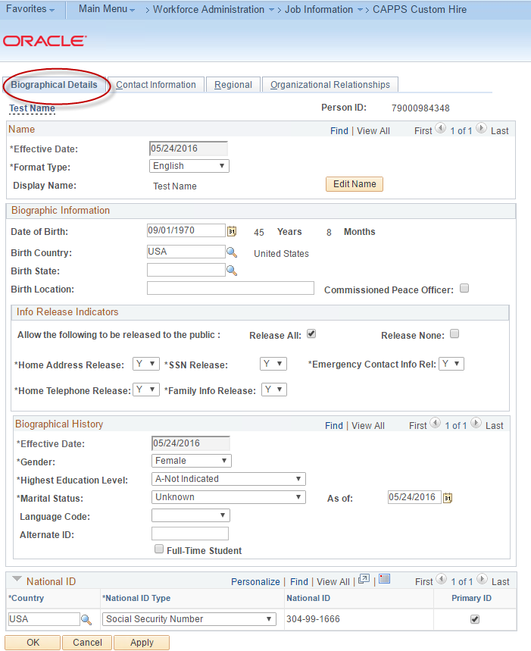

Contact Information
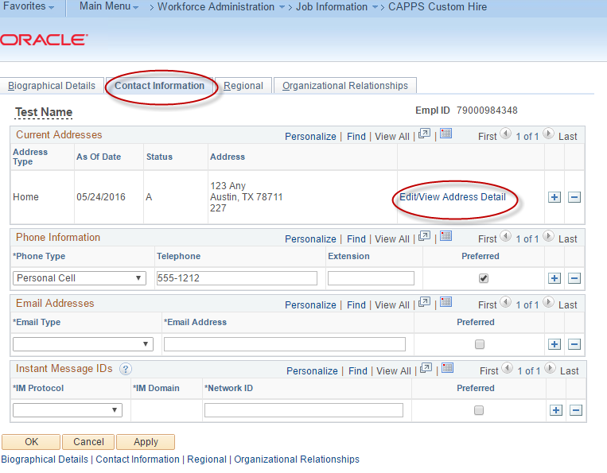

Regional Information
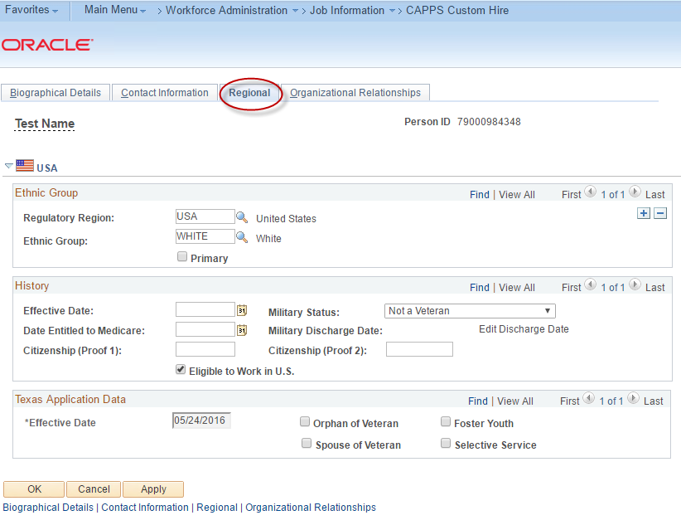

Organizational Relationships 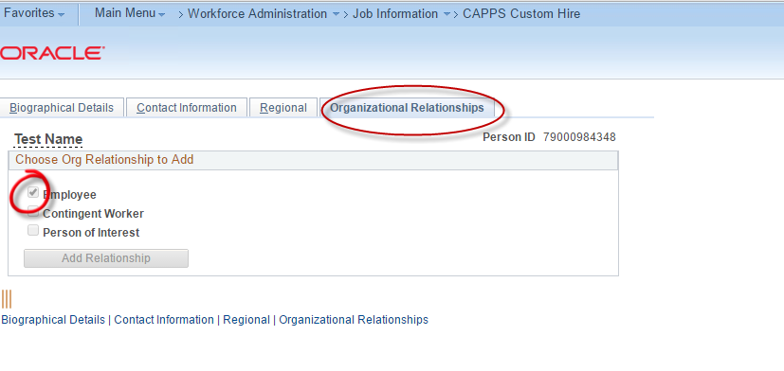

Work Location
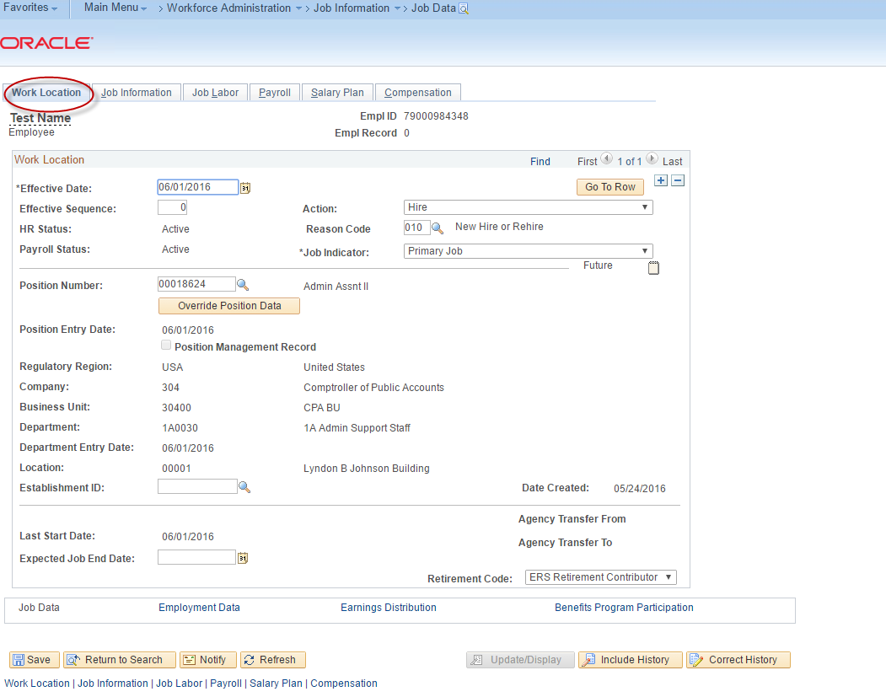

Job Information
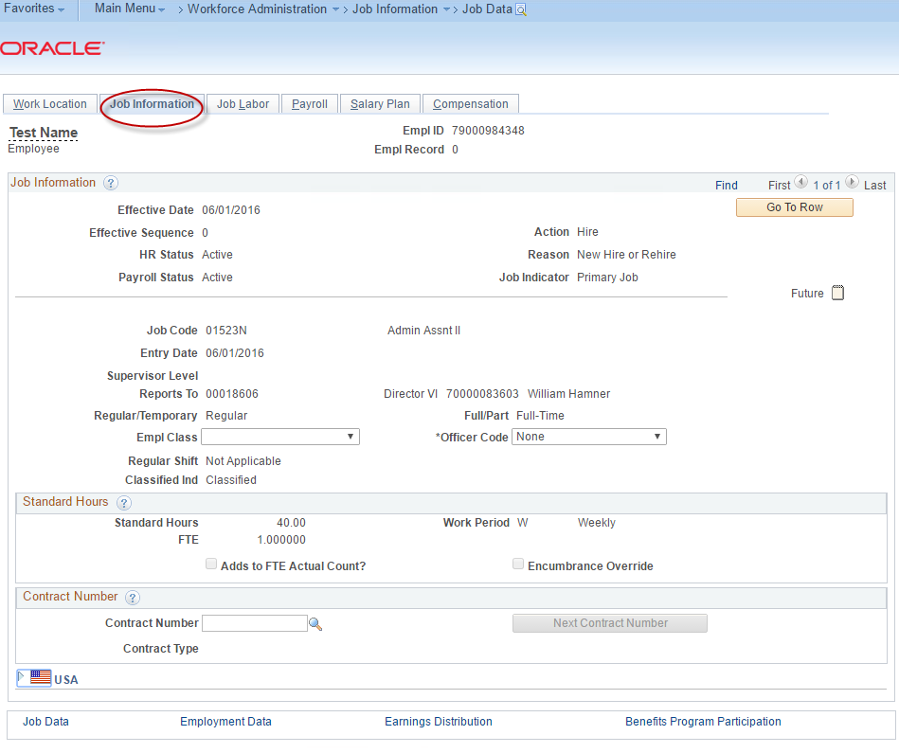
Payroll
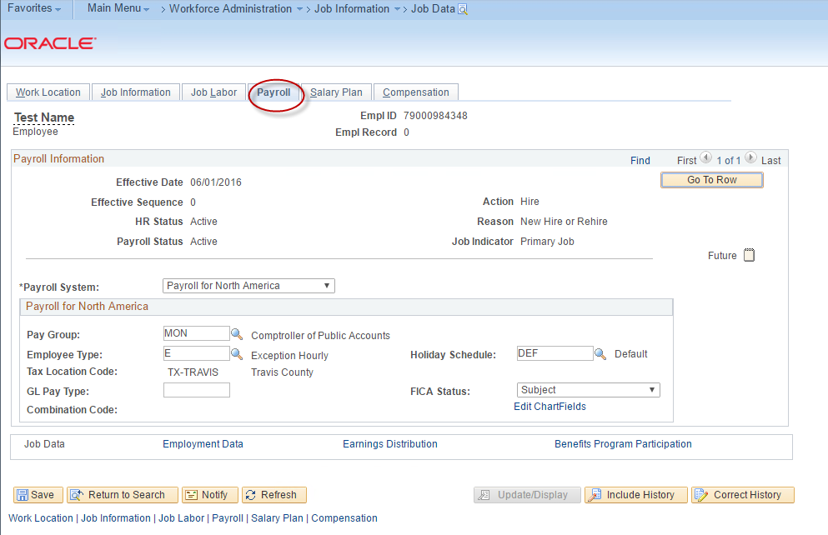
Salary Plan
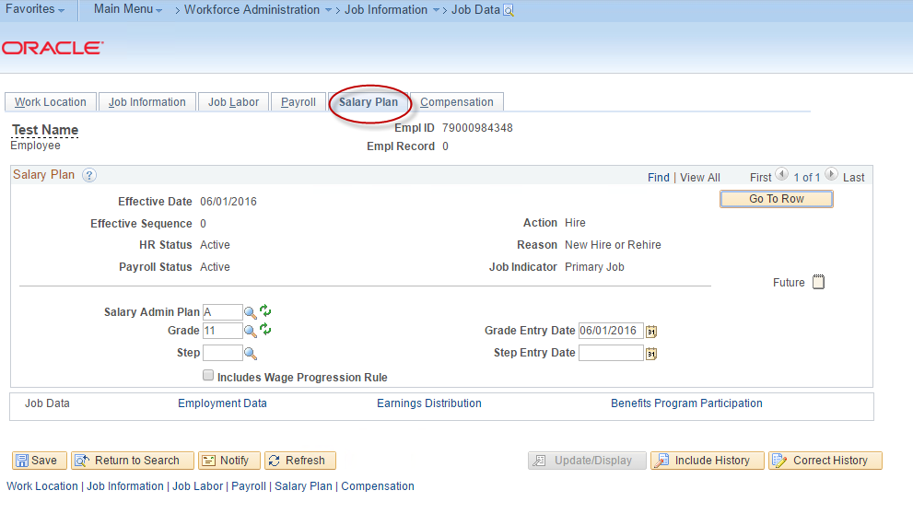
Compensation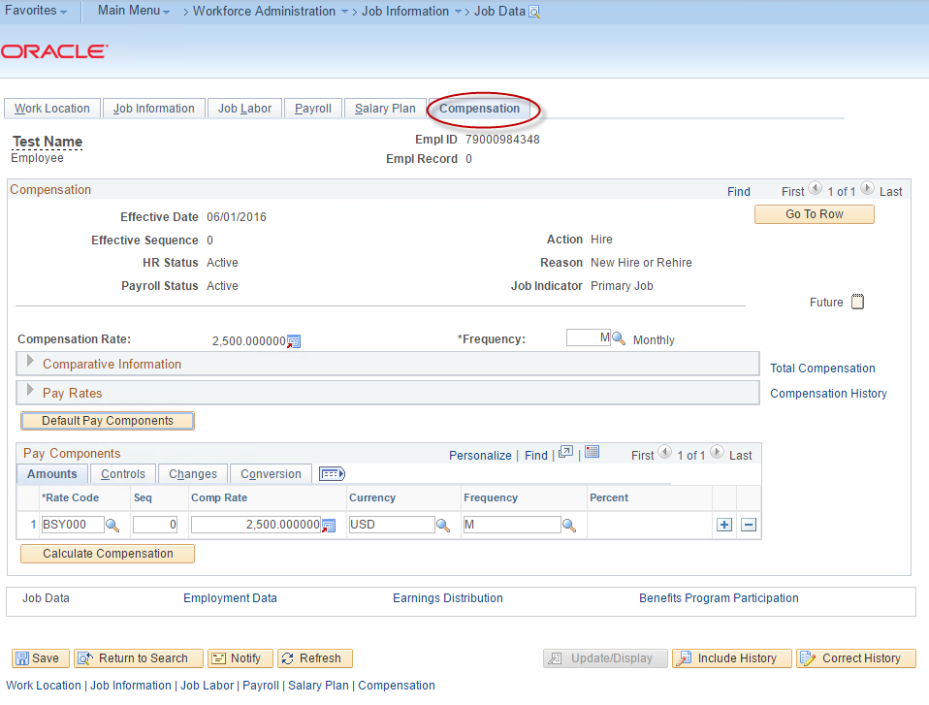

Employment Information
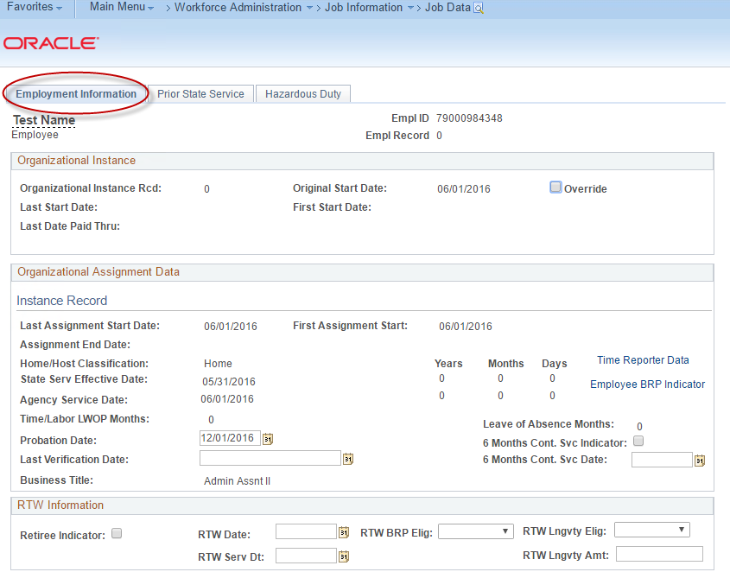

Prior State Service if applicable
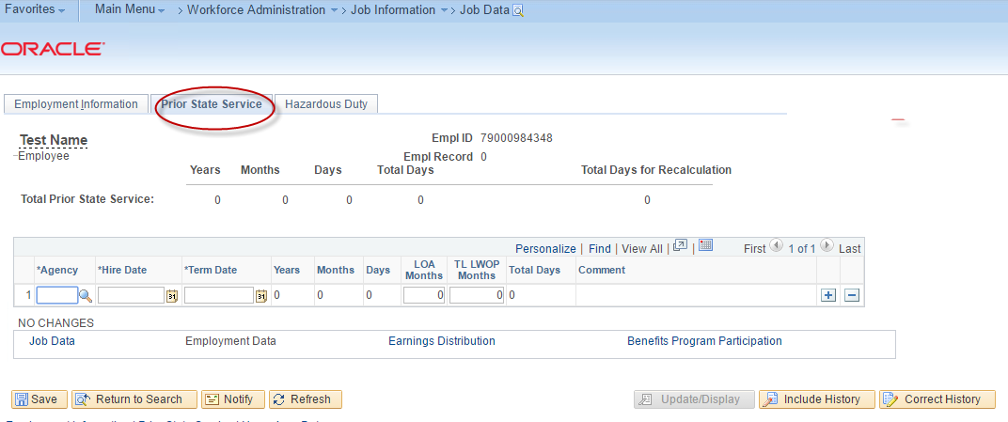

Hazardous Duty if applicable

