Choose to Quit (CTQ) Process
After the ERS daily files are loaded each morning, the benefit coordinator will check the online results by navigating to the following page:
Main Menu>CAPPS Interfaces>Benefits>Inquire>ERS Inbound Results
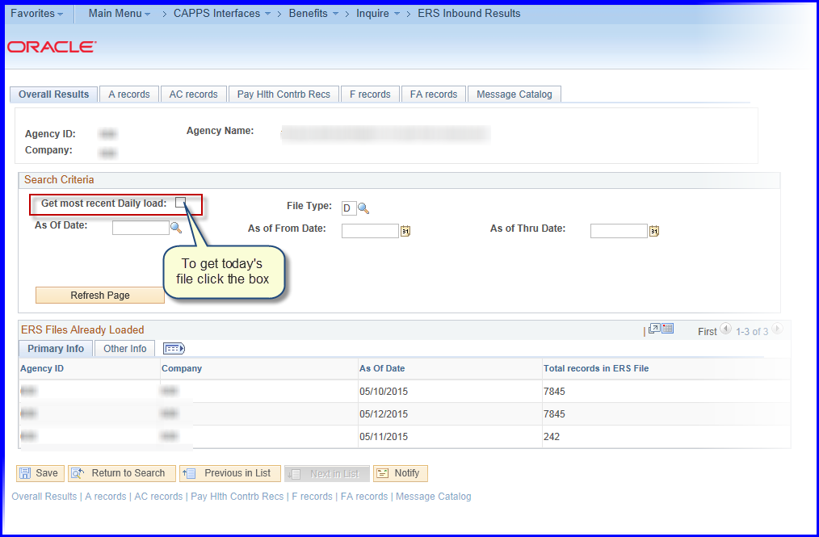
If retrieving today’s file, checks the box (noted above) otherwise, select a date in the “As of Date” box.
Note: This is the same inquiry page(s) the benefit coordinators should check for errors from the ERS Daily Inbound file.
The Choose to Quit (CTQ) refunds will appear on the FA Records tab: 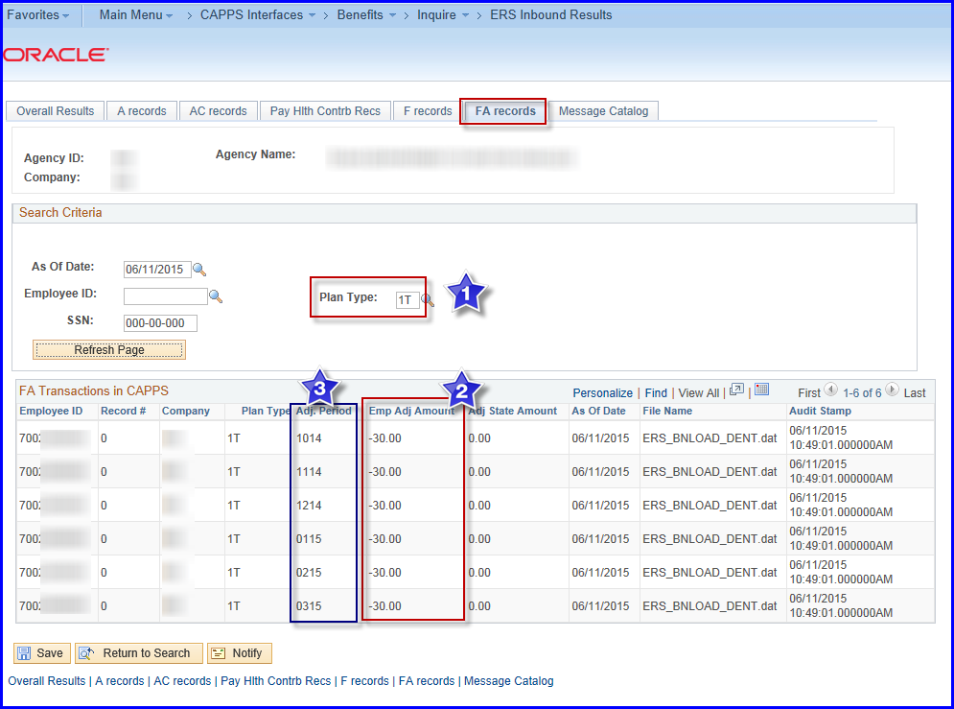
- Select Plan_Type ‘1T’ Medical Tobacco Premium
- Emp Adj Amount: Amount to be refunded (6X-30.00= $180.00)
- Adj. Period: MM/YY for the period of the refund

Navigate to enrollments: Main Menu>Benefits>Enroll in Benefits>Health Benefits
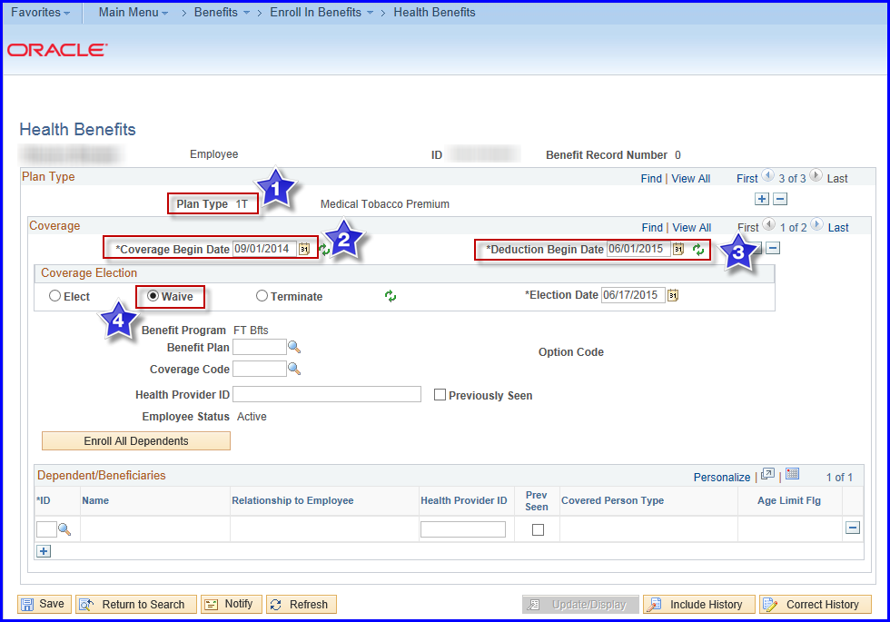
Verify Tobacco Premium is now updated so future deductions will be correctly withheld from the employee’s paycheck. In some situations, the employee may quit but their spouse or child may still be a smoker so the coverage code would change. Please check ERS Online to confirm the coverage code.
Note: At this time, we are not sure how ERS will send the waived rows for the CTQ refunds so this picture may change in the future.

Next: Notify payroll coordinator (with access to TX CPE page) to create refund for next pay period.
Navigate: Main Menu>Payroll for North America>Payroll Processing USA>TX CPE Main
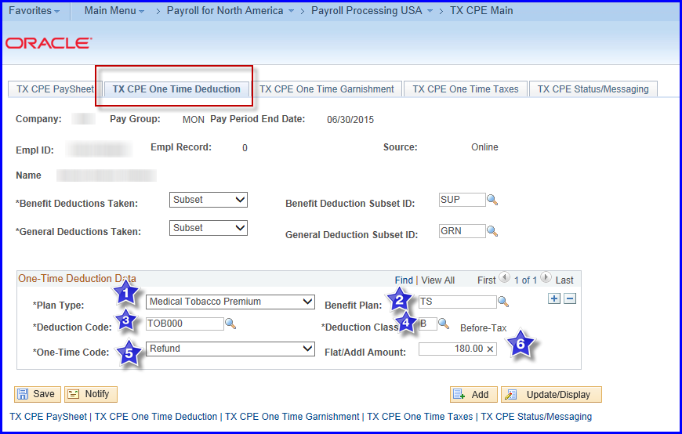
- Click on TX CPE One Time Deduction tab
- Select Tobacco Premium Plan Type
- Select the Benefit Plan
- Select Deduction Code
- Select Deduction Class
- Choose “Refund”
- Enter amount of refund
- Save

