Record a Disciplinary Action in CAPPS

Summary:

CAPPS provides a method to record and track disciplinary actions as needed.

Prerequisite: N/A

Steps Required:

- Navigate to Workforce Administration / Labor Administration / Record Disciplinary Action page
- Insert the 7 number that is assigned to the Employee; or you may use the search parameters
- The Company should default in based off your agency that you have access to. Verify the company (agency code) and continue
- Select the “Continue” button which will take you to the Disciplinary Actions tab
  - Enter the effective date which is the reported date of the disciplinary incident
  - Enter in the required fields (type, date, description)
  - Note: purge date is defaulted to 6 months automatically; does not require any change to date; currently, purging of the disciplinary records is not in place
  - Additional fields such as supervisor id, letter code and date letter printed are not required and functionality is not being utilized at this time
- Select the Action Steps tab to enter action steps taken for the particular disciplinary action
  - Enter in the required fields (type, date)
  - Note: Please enter the number of days an EE is placed on probation and/or time off without pay in the description field. See the example below.
  - PRB – probation, use the description field to indicate number of days; for example:
    - “Days on Probation: 180”
  - TOF – time off without pay, use the description field to indicate number of days; for example:
    - “Days without Pay: 01”

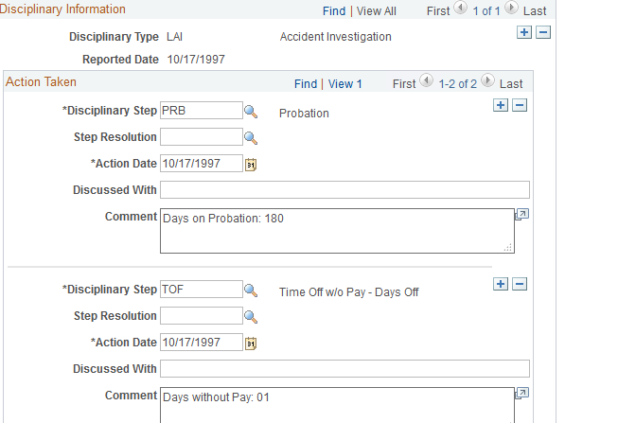

  - Insert any other applicable information you wish to maintain in the description field
  - If additional action steps are required, use the “+” sign and enter accordingly
  - A resolution for each action step may be entered as needed
  - Save the record at this time unless a “final resolution” for the entire disciplinary action needs to be entered
- Select the Disciplinary Resolution tab
  - Select the appropriate “final resolution”
  - Add any comments as needed in the description field (optional)
- Save the record and verify the disciplinary action and steps successfully exist in “Record Disciplinary Actions” pages

