941 Filing Instructions

Summary:

Federal law requires employers to withhold federal income tax, social security tax, and Medicare tax from employees’ paychecks each time wages are paid. Agencies must deposit federal income tax withheld and both the employer and employee social security and Medicare taxes no later than the date prescribed by the applicable IRS deposit schedule.
Following the end of each quarter, agencies must file IRS Form 941 and (941) Schedule B to report the following information:
- Federal income tax withheld (Form 941)
- Both the employer’s and the employee’s share of social security and Medicare taxes (Form 941)
- Current quarter’s adjustments to social security and Medicare taxes for fractions of cents (Form 941)
- Tax liability, by day (Schedule B)
In order for agencies to perform the daily tax liability and deposit reconciliation necessary to ensure timely deposit of all tax liability payments and comply with Form 941, Schedule B daily liability reporting requirement they must have access to a detailed accounting of tax liabilities, by actual payment issue date and document number, for a specified period of interest.
Reconciliation of daily tax liabilities and deposits is especially difficult when payments and tax deposits are generated from an external reporting system. This difficult process is further complicated by a large volume of payment and cancellation document traffic between CAPPS and external legacy systems. Inaccurate reconciliation, deposit, and reporting of daily tax liabilities can lead to substantial penalties, interest, and levies therefore reconciliation tools/reports are critical.
In order for agencies to properly reconcile daily tax liabilities and deposits and complete accurate Form 941, Schedule B daily liability reporting they must have access to a detailed accounting of tax liabilities, by actual payment issue date and document number, for a specified period of interest.
As delivered, PeopleSoft quarterly tax reporting does not provide the ability to report daily liabilities by SPRS processing date, actual payment issue date, and document number.
Using the TX_PY_941_HISTORY QUERY: You must run the TX TAX 941 History Refresh process in order to pull accurate data.
The H_TAX941_HIST table is used to store daily tax liability information, by agency & document number, for each SPRS processing date. By utilizing data stored in H_TAX941_HIST, agencies have access to employee and employer taxable gross wages and withholdings, and total liability for payments, cancellations, and replacements, by payment date, SPRS processing date, tax liability date, and document number. The H_TAX941_HIST table is only updated upon manual execution of the H941HIST SQR Report process.
When executed, the H941HIST SQR process updates H_TAX941_HIST with document level reporting detail for all document batch types (PAY, CAN, REP, SYS) where the H_DOC_NUMBERS.H_STATUS = U (USAS Accepted) and H_DOC_NUMBERS.H_SPRS_DT >= the SPRS Process Date found on the H_RUN_H941HIST run control (H_RUN_H941HIST.H_SPRS_DT).

Some important notes for this quarter’s filings:
- 941 Filing
  - Since the conversion to CAPPS was performed mid-quarter, the reconciliation process for wages and taxes related to the Federal 941 form must include information from both USPS and CAPPS.
  - Since we converted year and quarter to date balances into CAPPS, the 941 report information on the CAPPS report includes all wages and taxes for the entire quarter.
  - Since this is the first quarterly filing from CAPPS, it is very important that a complete and accurate reconciliation is performed as quickly as possible to provide a second validation of the balances conversion. An accurate filing for the 3rd quarter will avoid year end reconciliation issues during a critical processing window for W-2’s.

Steps required:

After Each Payroll Cycle:
Balance taxes on payroll summary to SPRS & to taxes paid on the DAFR (USAS Federal Tax deposits), with CAPPS Balance adjustments

- Run Payroll Summary - PAY018
Navigation: Main Menu > Payroll for North America > Payroll Processing USA > Pay Period Reports > Payroll Summary

  - Enter appropriate On or Off Cycle Parameters. Select Run and review PDF report.
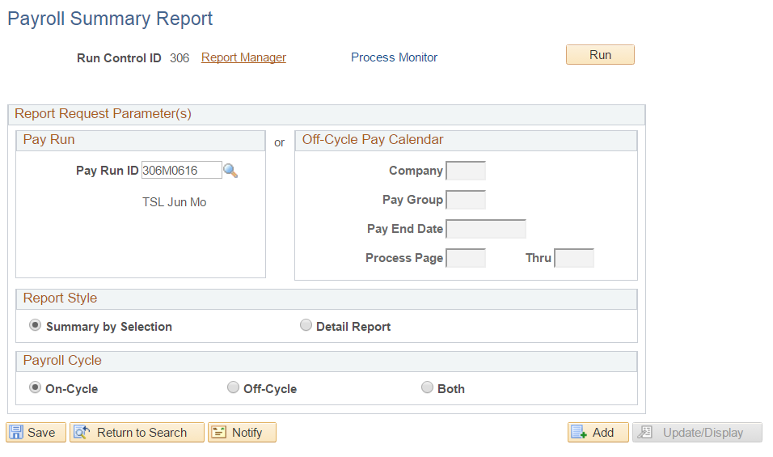

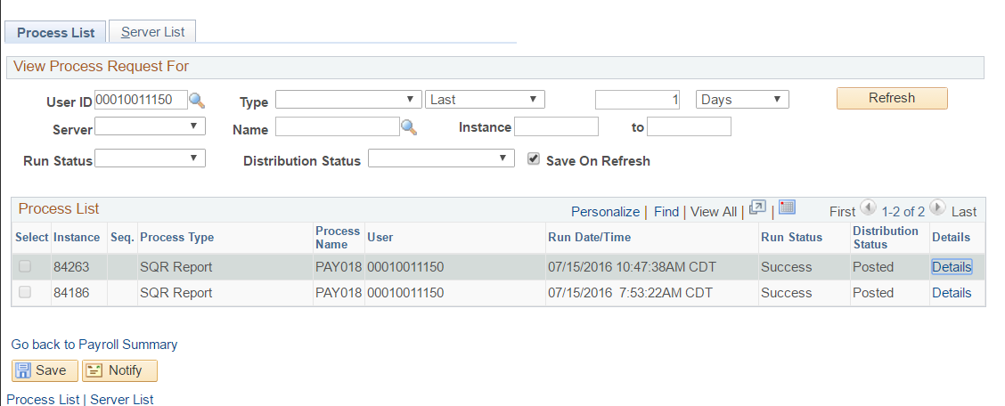

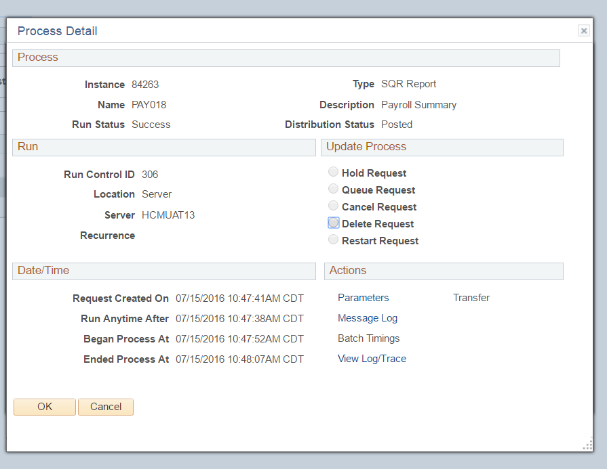

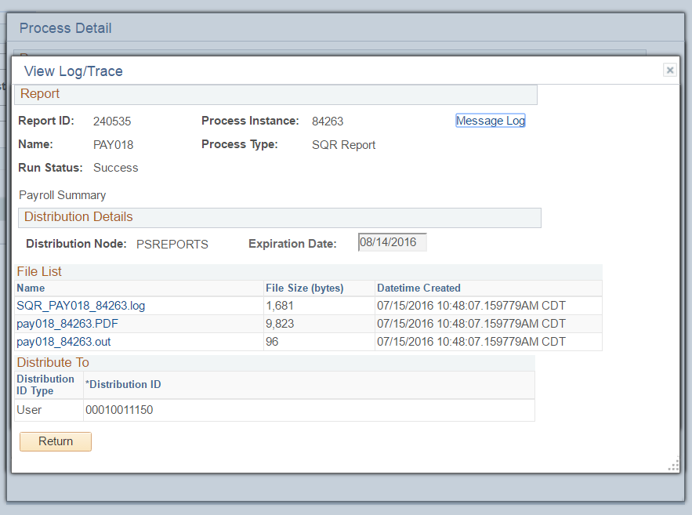

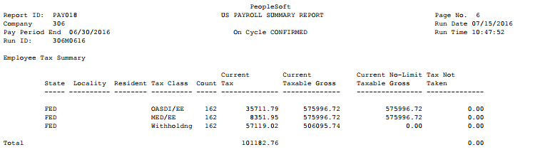

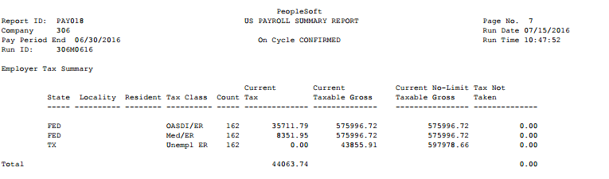

- Run TX Tax 941 History Refresh Process
This process populates custom history tables that the query TX_PY_TAX941_HISTORY uses to extract the data that will be used in your reconciliation process.

Navigation: Payroll for North America > U.S. Quarterly Processing > Quarterly Reports > TX Tax 941 History Refresh

  - Enter three digit Company number, and SPRS Processing Date (This date represents the SPRS Date appearing on the TX Document History page. Below example would be 5/12/16).

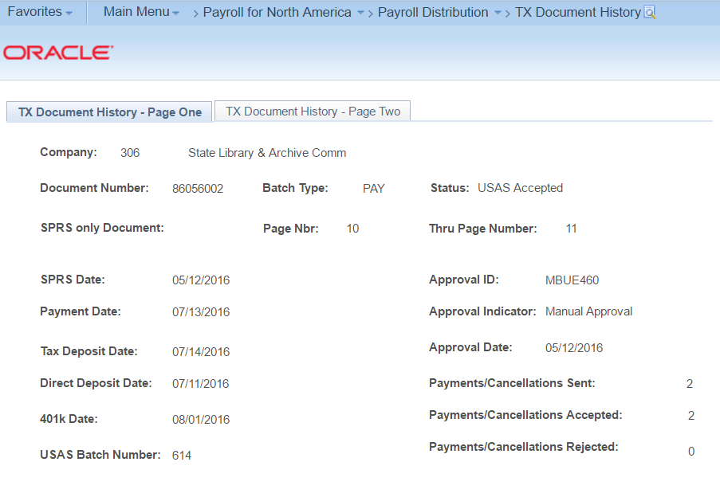
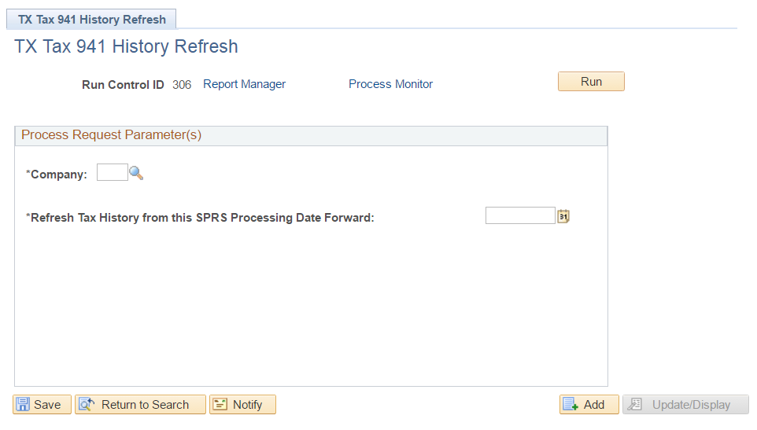

  - Select Run

- Run TX_PY_TAX941_History Query
Use this query to reconcile the DAFR.

Navigation: Main Menu > Reporting Tools Query > Query Viewer

  - Enter three digit Company number, and SPRS Processing Date (This date represents the SPRS Date appearing on the TX Document History page. This example, date would be 5/12/16).

- Run Balance Adjustment Report – PAY025
This report pulls any balance adjustments made in CAPPS. Will need to add this to the Refresh History results to ensure it balances to TXTX10FD. Use date range to review and adjust balances Monthly.

Navigation: Main Menu > Payroll for North America > Periodic Payroll Events USA > Balance Adjustments > Balance Adjustment Report.

- Enter Date Range: (Begin and End Dates)
- Enter Date Type: Balance Date (Dates of balance recs)
Adj Date (Date adjustment made).
Recommend using ‘Balance Date’)
- Enter Company: Agency Number

- Select Run and review PDF report.
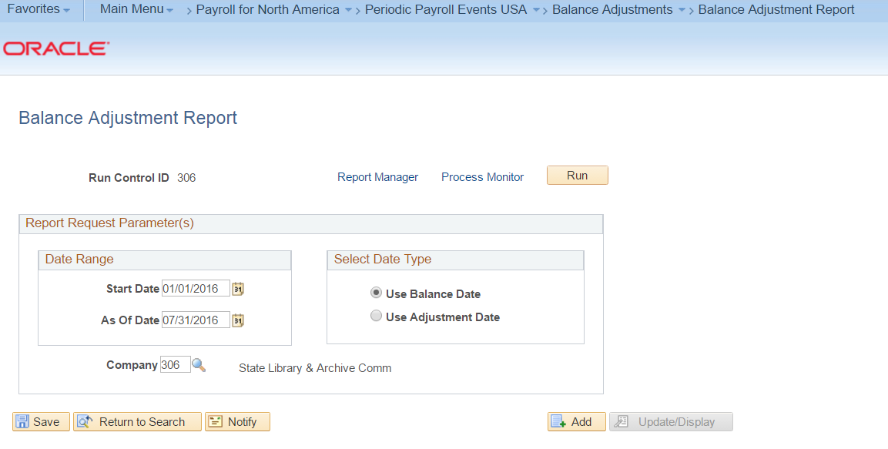

- Reconcile Payroll Summary, SPRS Tax Deposits and USAS DAFR

Recommend doing above steps after each pay period.

Quarter End Process:

- Set up TX Quarterly Tax Parameters
Set up processing Year and Quarter to define date for the 941 reporting. Search for your Agency. If Agency does not exist, setup your agency using the processing values.

Navigation: Payroll for North America > U.S. Quarterly Processing > Define Quarterly Tax Reporting > TX Tax Reporting Parameters.
Only enter the following fields:

  - Balances for Year: Enter the calendar year being processed.
  - Balances for Quarter: Enter the calendar quarter being processed.
  - Transmitter ID: Enter your Agency number.
  - Click Save.

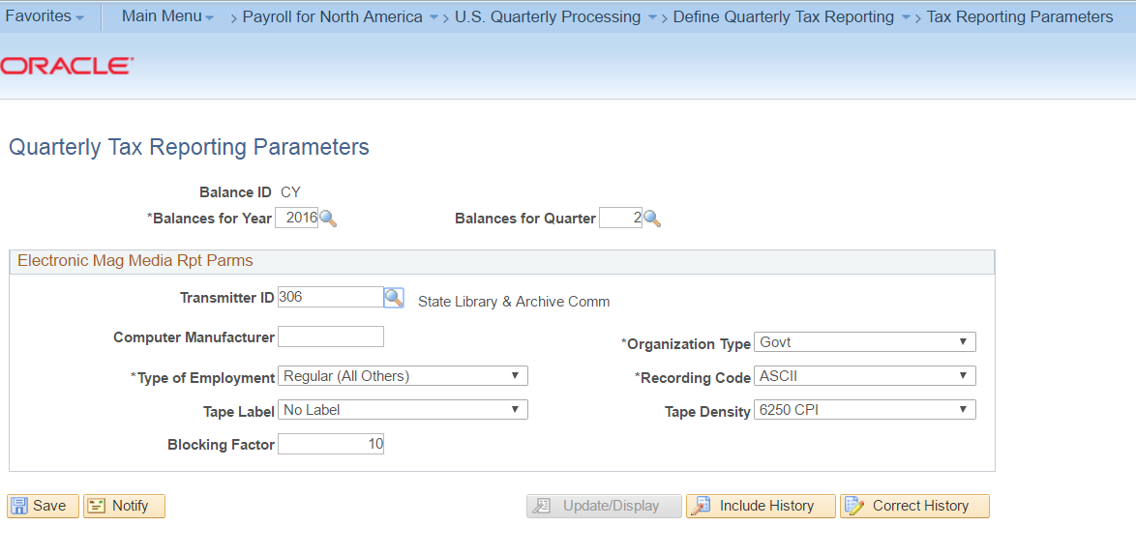
- Complete Steps 1 – 5 above under “After Each Payroll Cycle” instructions.

- Run Federal Tax Summary (TXTX10FD) Report
This report is used to balance to the 941 query results over the full quarter.

Navigation: Main Menu > Payroll for North America > Pay Period Tax Reports USA > TX Federal Tax Summary.

- Company: Enter Agency Number
- Balances for Year: Enter Calendar Tax Reporting year
- Quarter: Enter Calendar Tax Reporting quarter
- Period: (This report can be ran by Period (monthly) or Quarter. If both are populated,
Quarter overrides period).
**If you need to change from quarter to period or vice versa, blank out populated value
And click Save. Select “OK” and both fields will be open for entry.

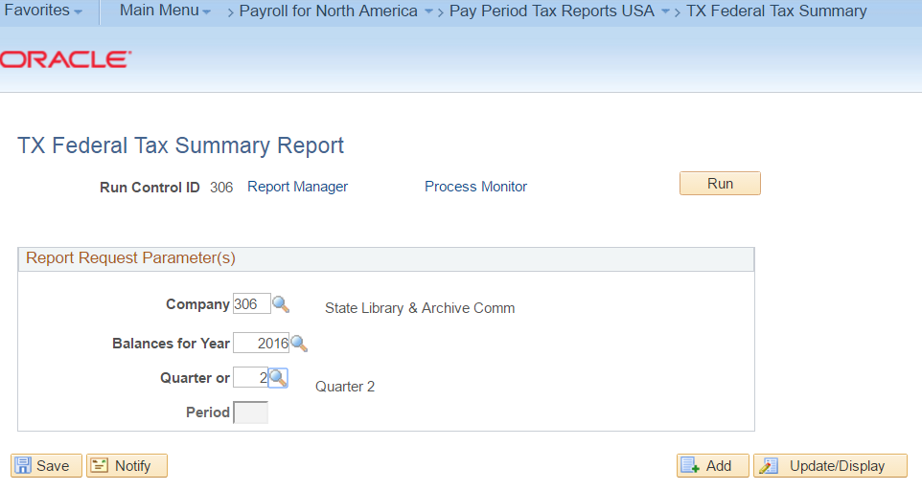

- Run TX Fed Tax Summary – Detail (TXTAX007) – Employee level.
Only run this report if needing to reconcile down to the employee level.

Navigation: Main Menu > Payroll for North America > U.S. Quarterly Processing > Quarterly Reports > TX Fed Tax Summary – Detail

- Company: Enter Agency number
- Run and review PDF report

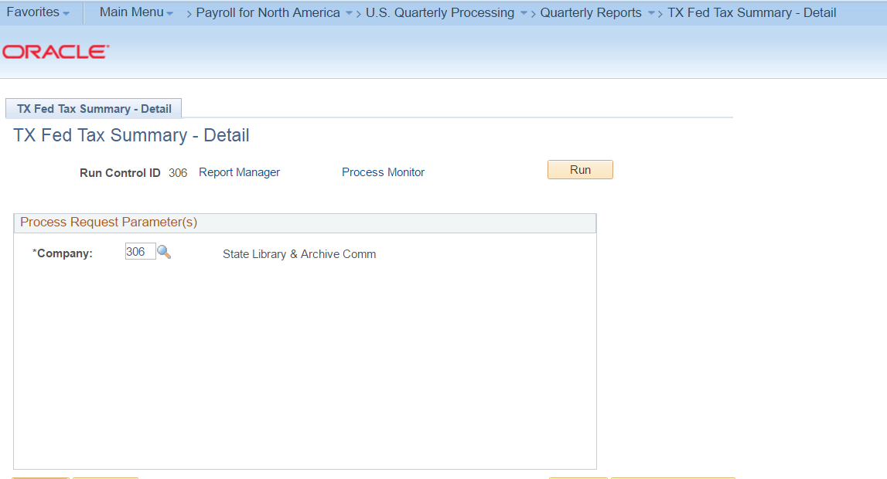

- Run TX IRS 941 Quarterly Tax Report – TXTAX941
This report displays all quarterly 941 reportable data including OASDI/HI adjustments formatted to match 941. Use this data to complete the 941 Form

Navigation: Payroll for North America > U.S. Quarterly Processing > Quarterly Reports > TX 941 Quarterly Fed Tax

- Company: Enter Agency Number
- Balances for Year: Enter Calendar Tax Reporting Year
- Balances for Quarter: Enter Calendar Tax Reporting Quarter

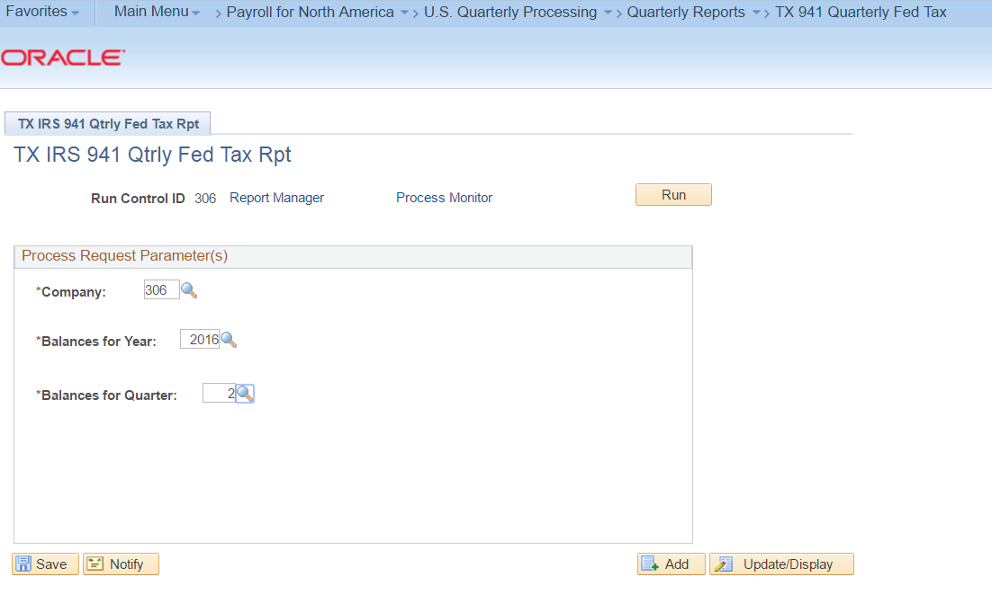

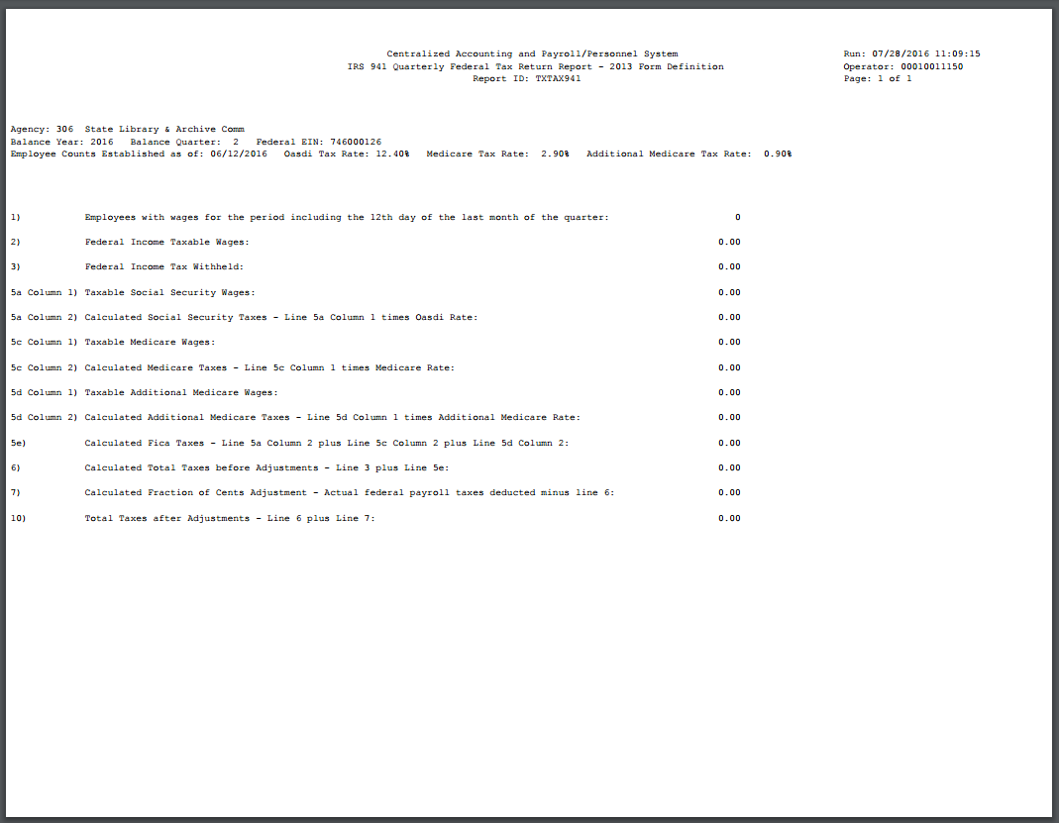

- Run TX_PY_TAX941_HISTORY query to complete Schedule B.
If your agency converted to CAPPS mid quarter, you will need to use the daily liabilities from this CAPPS query and from USPS for the first Quarterly filing processed from CAPPS.

Navigation: Main Menu > Reporting Tools Query > Query Viewer

- Company: Enter Agency Number
- SPRS Processing Date: This will populate all data from this date forward.

