Receiving – Assets – Multi-funded
- Navigate to Add a Receipt.
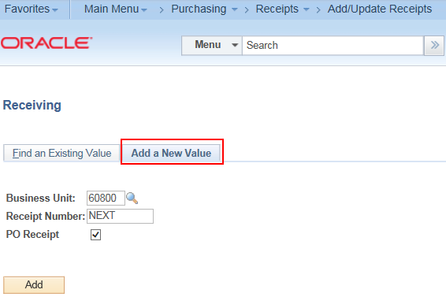
- Fetch in the PO Line(s).
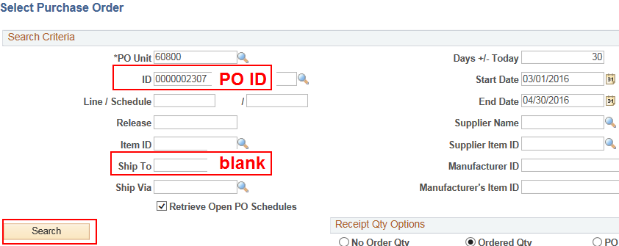
- Select the Asset PO line or lines you want to receive and click OK.
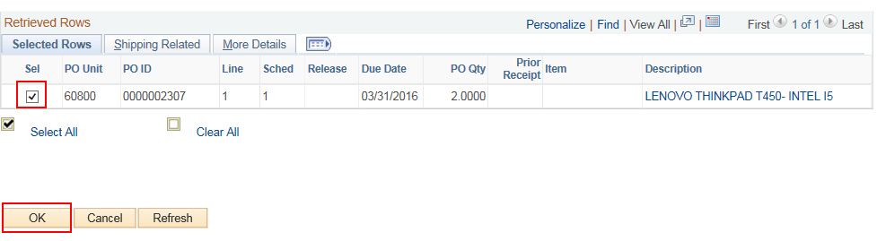
- Click the 'AM Status'link.
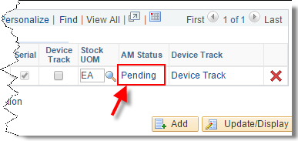
- In the 'Apply to Details' section, enter Tag Number, Serial ID, and Asset ID.
- Asset ID and Tag Number must be the same‼!
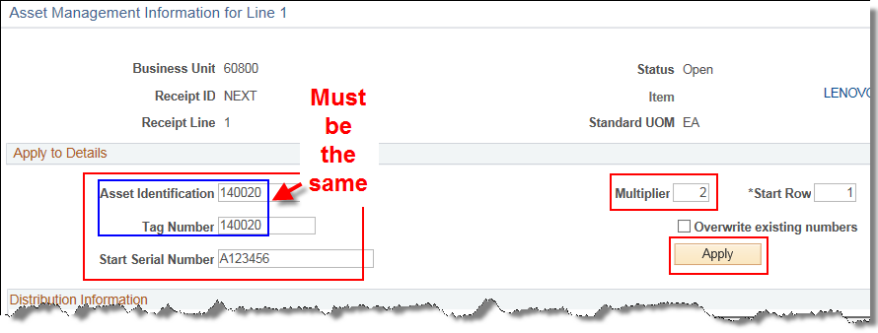
- The Multiplier defaults to “1”. If you want to sequence your Asset ID/Tag #s (AST1, AST2, AST3…) when receiving multiple assets by another number you can change the multiplier (Ex. if set to “2”, Asset ID/Tag#s will sequence by 2, or AST1, AST3, AST5…). Click Apply.
This populates the Tag Number, Serial ID and Asset ID for each distribution line. 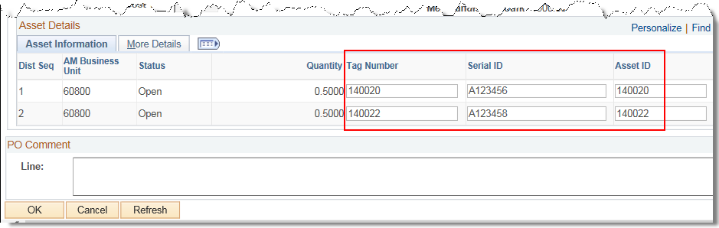
- Go to the 'More Details' tab and enter a Custodian (if you know the custodian – otherwise the Asset Manager can add custodian information later). Click OK.
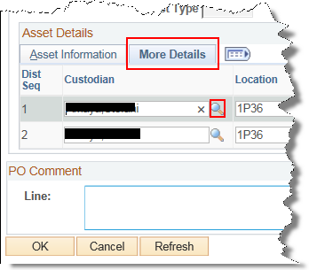
- Click OK.
- Save the Receipt.
- Click OK to acknowledge the confirmation message.
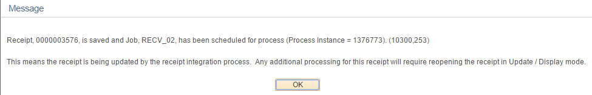
- The Receipt ID is created.
