Receiving – Basics
- Navigation to enter a new Receipt.
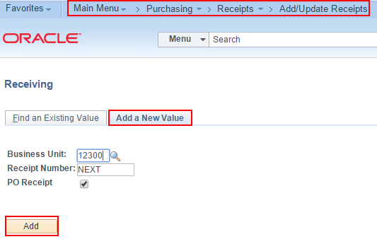
- Fetch the PO you want to receive.
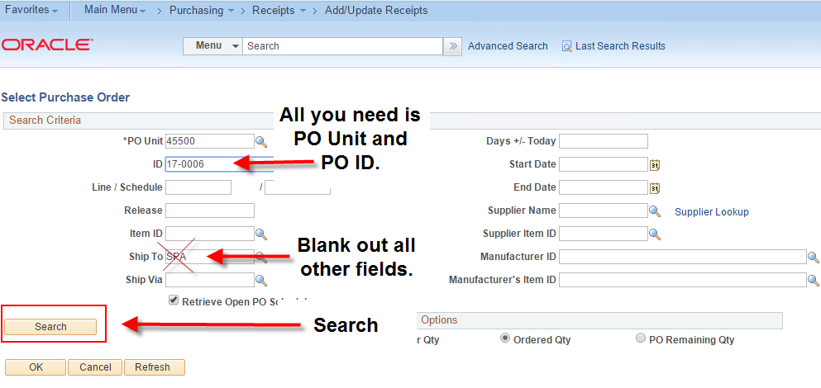
- Find the PO Lines you want to receive.
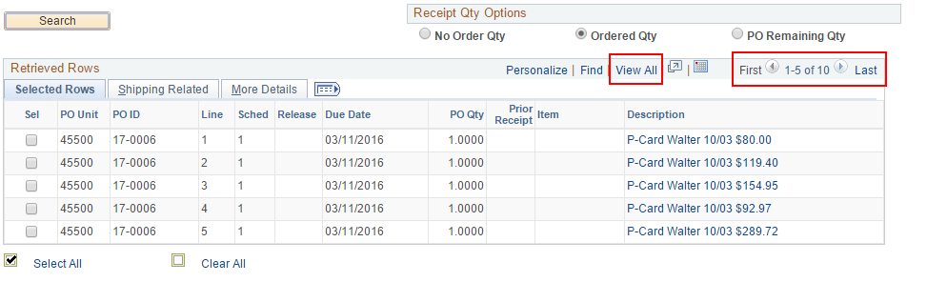
- Selelct individual lines or Select All.
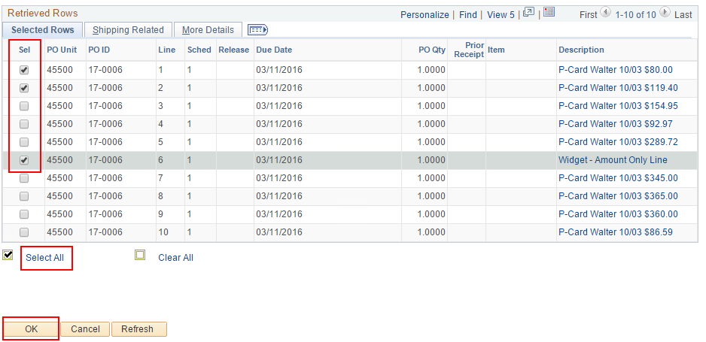
- Let's say you only need to receive $80 against this $200 line, and you want to allocate all $80 to a specific budget.
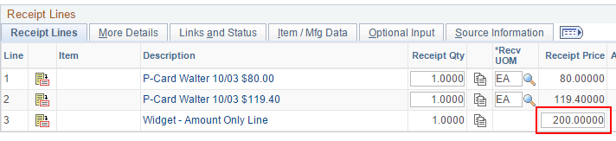
- Change the Amount to $80.00 and go to the 'Links and Status' tab.
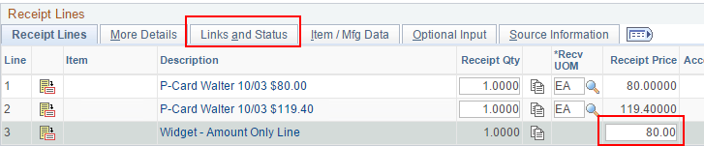
- Click the 'Distrib' button for the line you need to allocate to a specific budget.
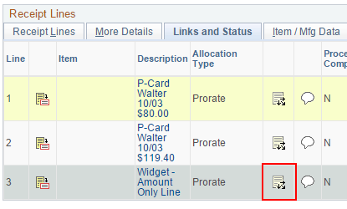
- Choose 'Specify' in the Allocation Type dropdown list. This will ungray the amount fields.
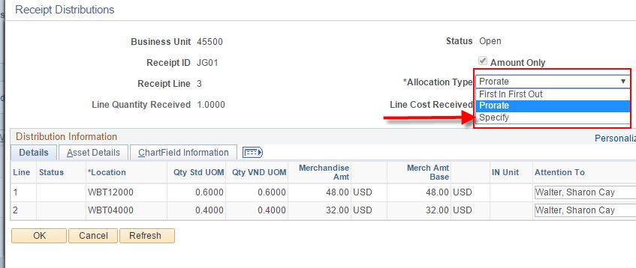
- In this example, we're receiving $0 against Distrib Line 1 and $80 for Distrib Line 2. Click OK.
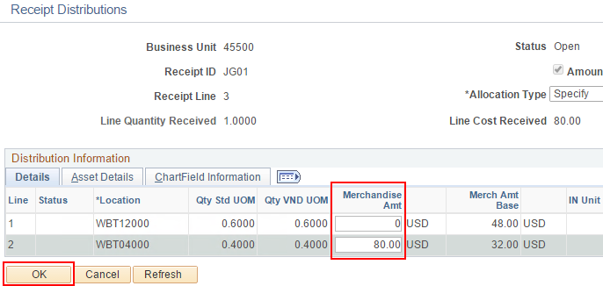
- Click 'Save'. Not necessary to go back to the Receipt Lines tab. Just showing you that the $80 is grayed out (unchangeable) after specifying which budget to receive against.
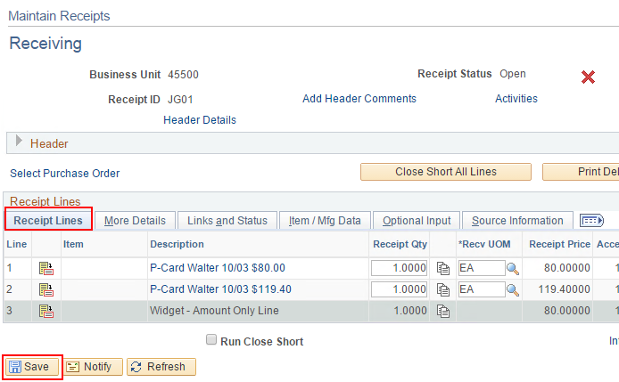
- A confirmation message will appear. Click OK.
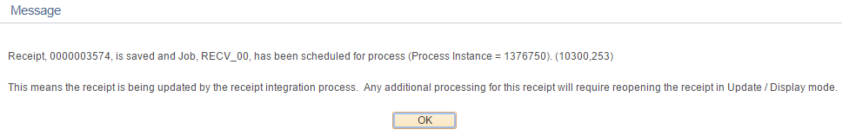
- Receipt ID is created. The Receipt Status will show 'Fully Received' even if you only partially received the full quantity or amount on the PO. It simply means you fully received the quantity or amount you wanted to receive in this one Receipt.