Requisition – SpeedCharts
- Navigate to Main Menu > eProcurement > Requisition.
- Click on Special Requests.
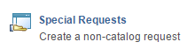
- Enter the Item Description, Price, Quantity, Unit of Measure, NIGP Class, NIGP Item and Due Date.
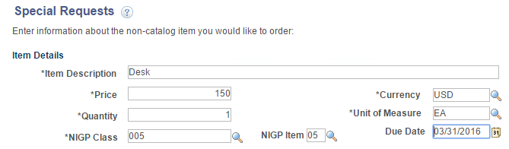
- Click Add to Cart.
- Click Checkout.
- Enter a Requisition Name.
- Show Ship To and Accounting.
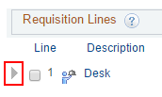
- Expand Accounting Lines.
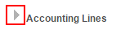
- Click the SpeedChart search button. The field can be blank or you can enter a few characters to narrow the search.
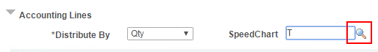
- Select a SpeedChart from the list.
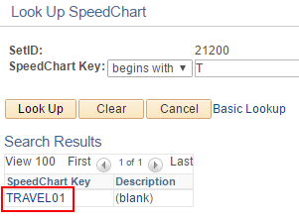
- Manually enter the chartfield elements not populated by the SpeedChart, making sure to complete all the accounting lines created by the speedchart.
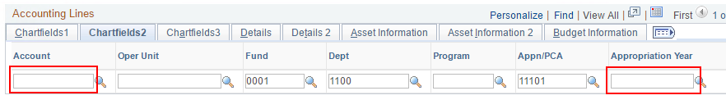
- Click Save & submit.
- If the chartfield is missing any required fields or contains any conflicting values, a warning message will appear. If so, click OK. The req will save, but will not be able to budget check until the problem is corrected.
Message reads: "Warning – Invalid ChartFields Combination on Line Number: 1 Schedule Number: 1 Distribution Number: 1 for Chartfields…."
