Requisition – Multiple Lines and Distribs
- Navigate to: Main Menu > eProcurment > Requisition
- Select: Special Requests
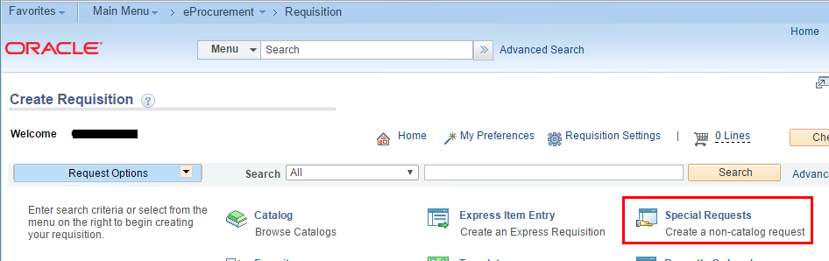
- Enter: Item Description, Price, Quantity, NIGP Class, Unit of Measure, Due Date.
Click ‘Add to Cart’.
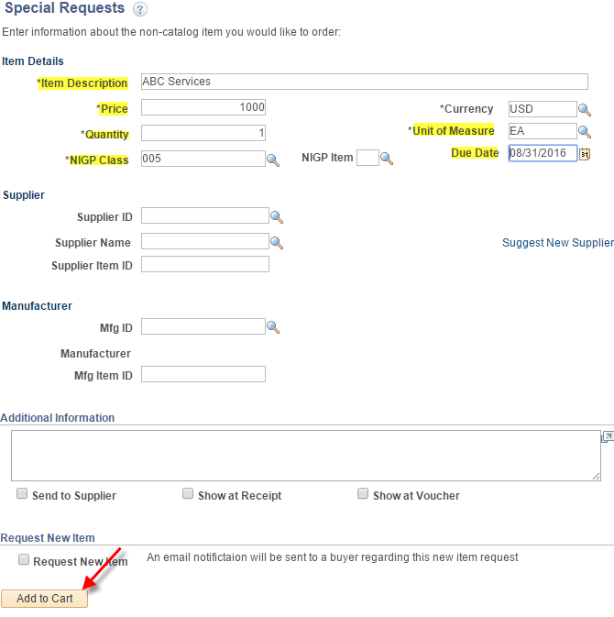
- Click: Checkout
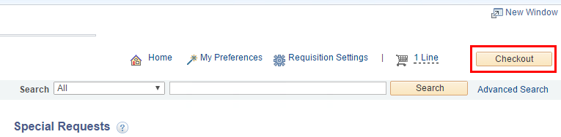
- Enter: Requisition Name
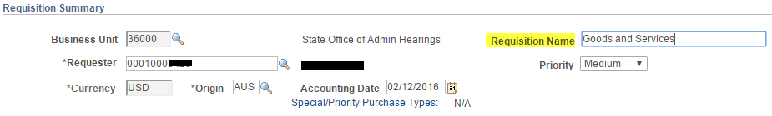
- Click the Line arrow and Accounting Lines arrow to reveal the chartfields.
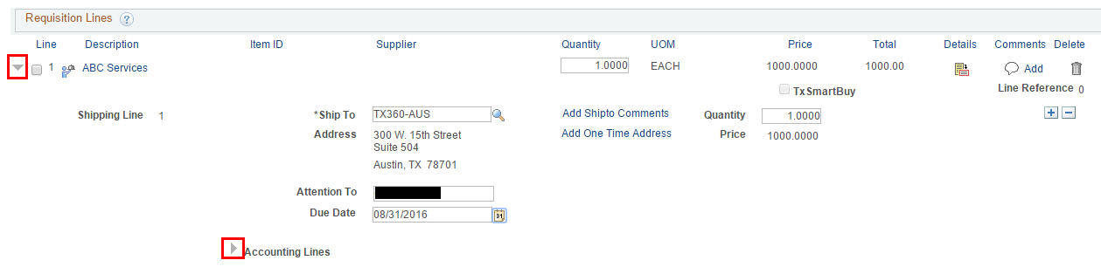

- Click the SpeedChart search button and choose a Speedchart Key. If you don’t use SpeedCharts, go on to Step 8.
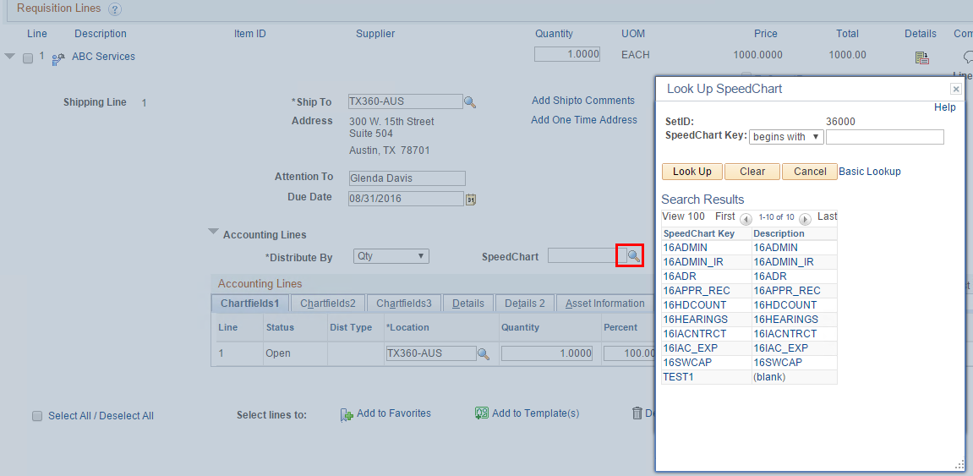
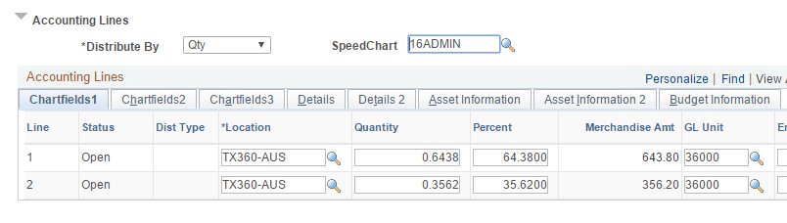
- Change the ‘Distrib By’ field to ‘Amt’ because this line is buying services and will be need to be vouchered multiple times without regard to quantity.
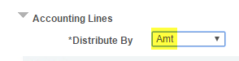

- Select the ‘Chartfields2’ tab and enter the necessary chartfield values not already populated by the SpeedChart.
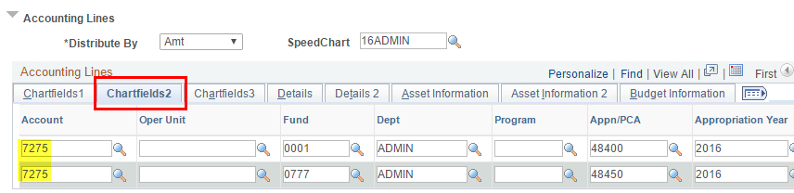
- Scroll down and click ‘Save and submit’ before adding another line to the requisition.
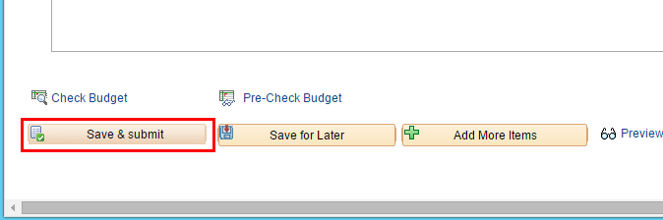
- Click ‘Edit This Requisition’.
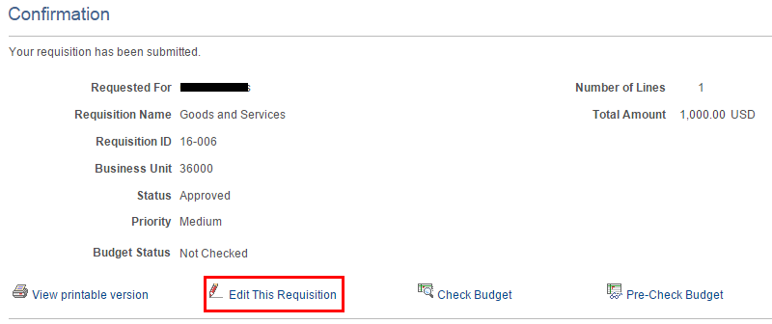
- Click ‘Add More Items’.
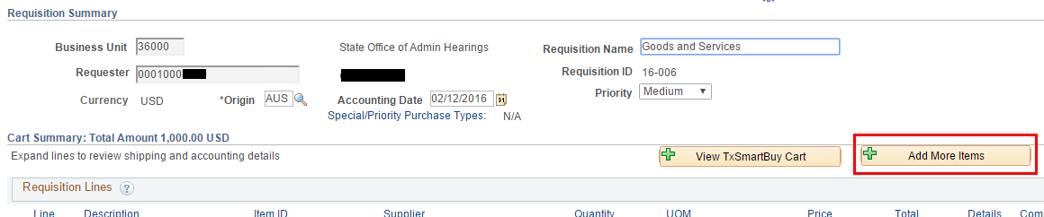
- Notice you already have 1 Line. Click ‘Special Requests’ to add a second line.
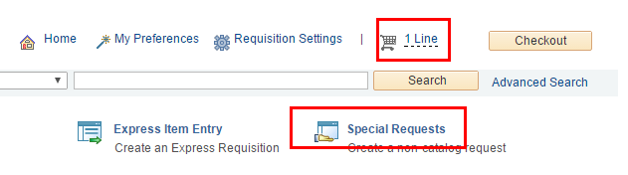
- Enter the Item Description, Price, Quantity, NIGP Class, Unit of Measure, Due Date.
Click ‘Add to Cart’.
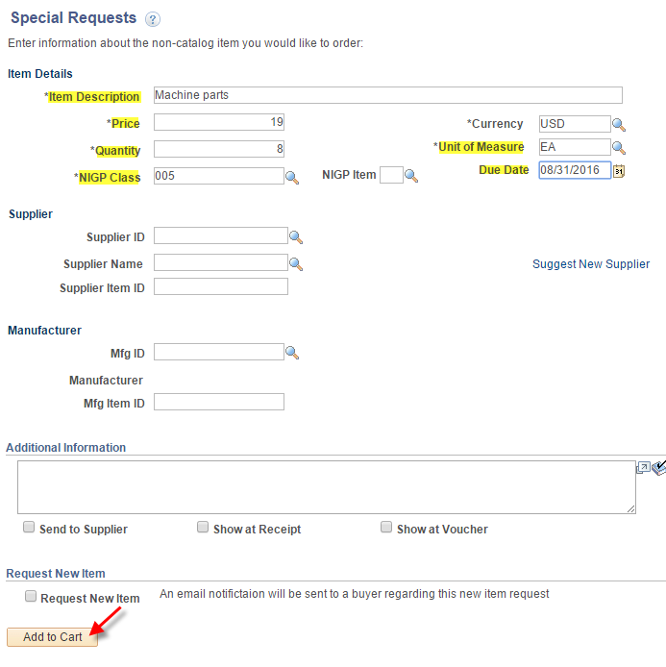

- Notice you now have 2 Lines. Click Checkout.
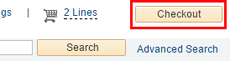
- Use the arrow buttons to expand Line 2 and the Accounting Lines.
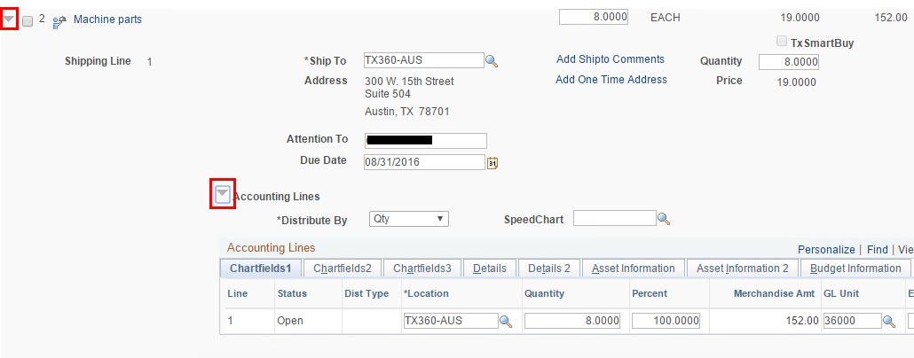
- Leave ‘Distrib By’ on ‘Qty’.
Click the SpeedChart search button and choose a SpeedChart.
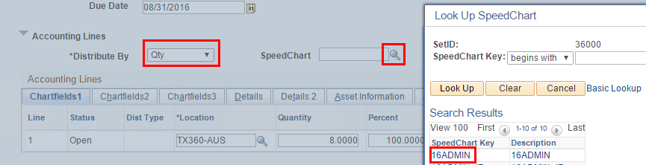

- Select the ‘Chartfields2’ tab and enter any required chartfield values that did not populate with the SpeedChart.
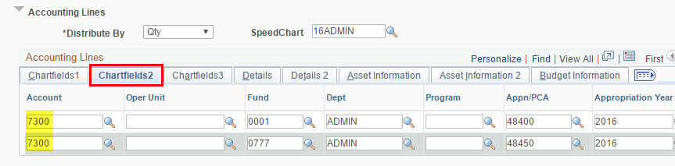
- Scroll down and click ‘Save and submit’.
- If Status = Pending, go to Step 21.
If you’re in a testing or training environment with workflow turned OFF, the Requisition will save in an ‘Approved’ status with Budget Status = ‘Not Checked’. If so, click ‘Check Budget’.
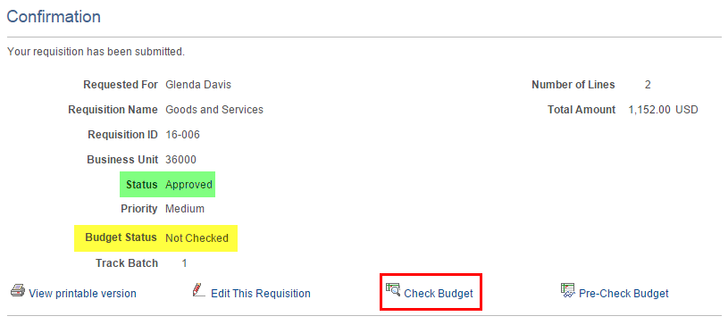

- If Workflow is turned on you can budget check the requisition after it is Approved by pulling it up in Main Menu > eProcurement > Manage Requisitions.
(Note: In a Production environment the requisition may be budget checked by a “batch” budget checking process that runs several times per day looking for eligible requisitions.)
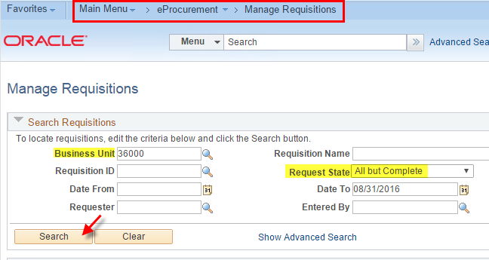
- Select ‘Check Budget’ from the dropdown list and click the ‘Go’ button.
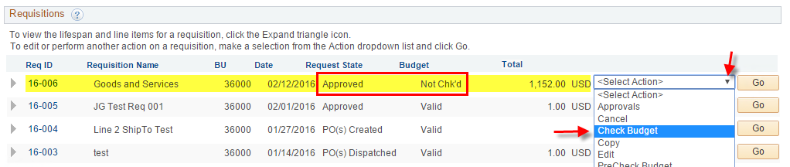
- “Approved” and “Valid” means the requisition is available to purchasing.
