Finalizing and Unfinalizing Remaining Encumbrance on a PO
Purchase Order 17-0040 has a remaining encumbrance balance of $1,007.66. No additional vouchers will be created against this PO and you want to put this money back into the available budget.
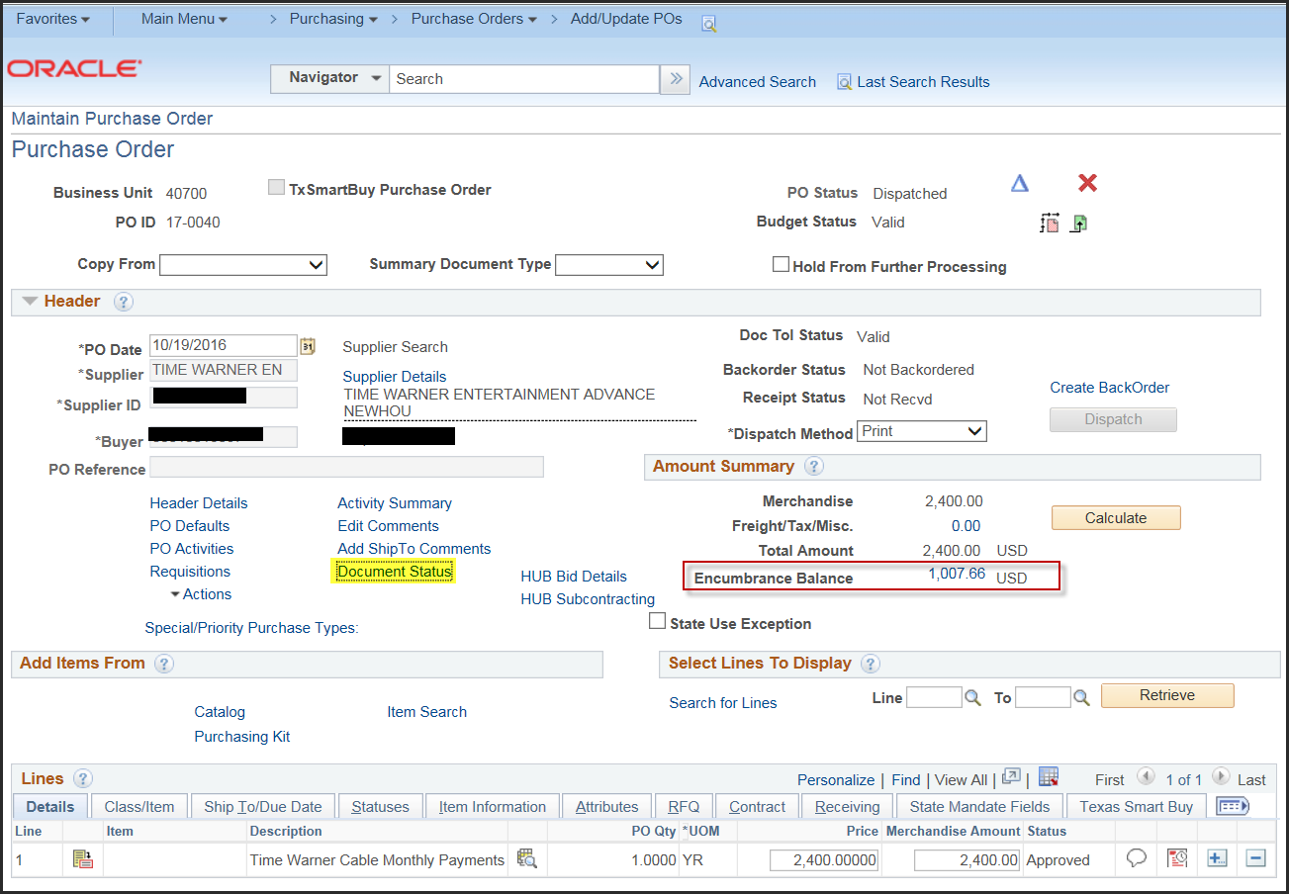
Click the “Document Status” hyperlink on the PO to view all associated vouchers. You can Finalize/liquidate the remaining PO encumbrance from any of the vouchers associated with the PO. I selected 00000620, the last voucher created against this PO.
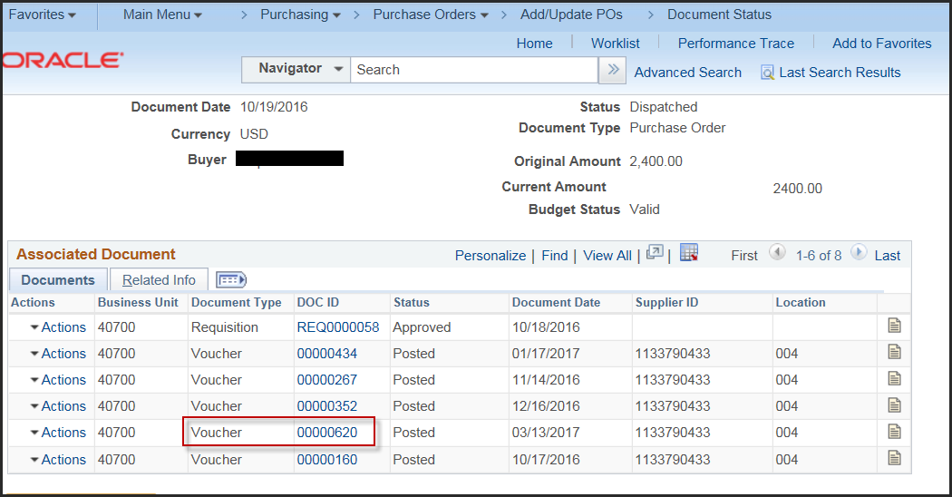
Navigate to the voucher and click on the “Invoice Information” tab. The "Finalize" button appears on both the voucher header and the voucher line. Since we want to liquidate the encumbrance for the entire PO, we will click the Finalize button on the voucher header. If you want to liquidate the encumbrance on just one line of the PO, you would click the Finalize button on the voucher line that corresponds to the PO line. Note: if finalizing at the line level, you would need to select the voucher containing the PO line to be finalized.

Finalize all remaining encumbrance on the PO by clicking the “Finalize” button on the voucher header
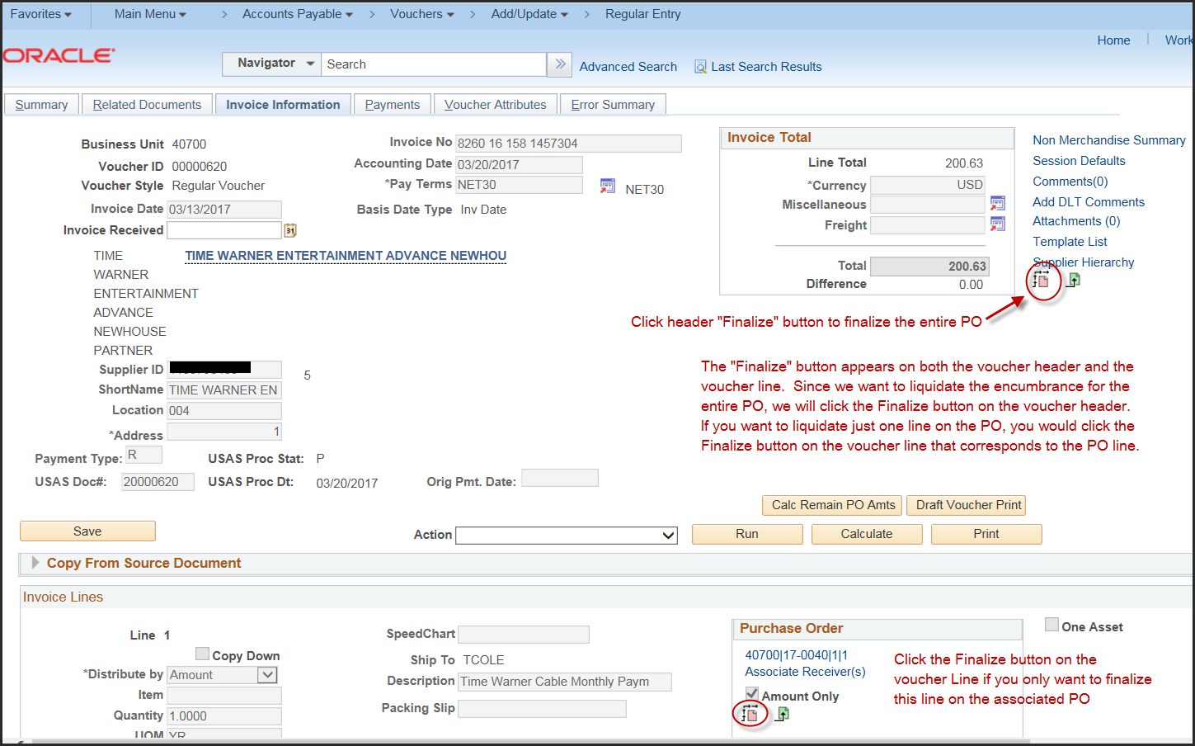

Click “Yes” on the finalize message:
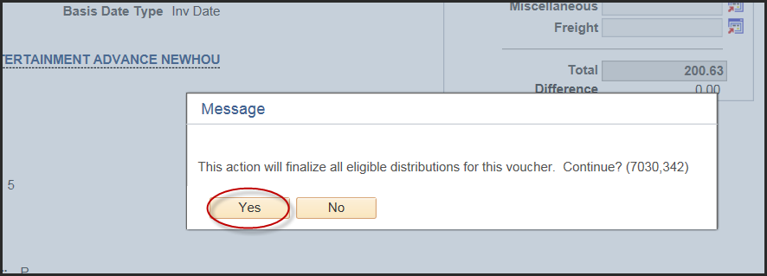

“Save” the voucher
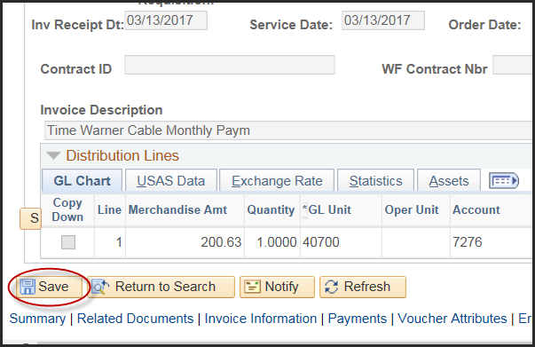

Budget Check the voucher
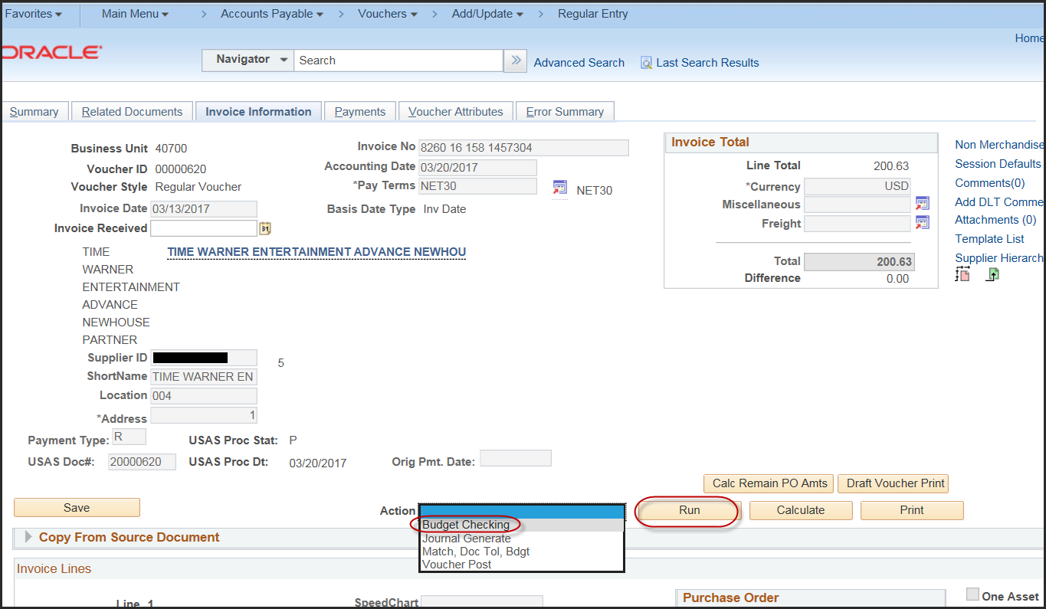
Click “Yes” to wait for the budget checking process to complete.
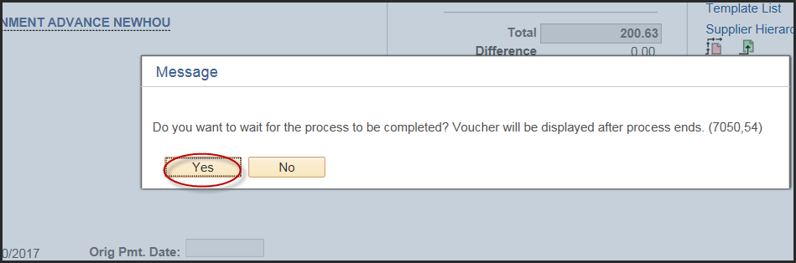
Confirm voucher Budget Check is complete. Should be “Valid”
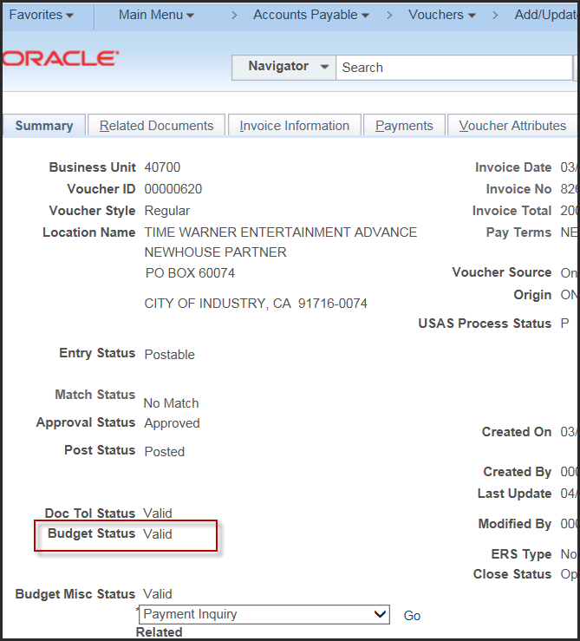
Navigate back to PO 17-0040. You may need to refresh the PO page by re-searching and pulling the PO up again. Confirm that the PO encumbrance balance is now $0.00
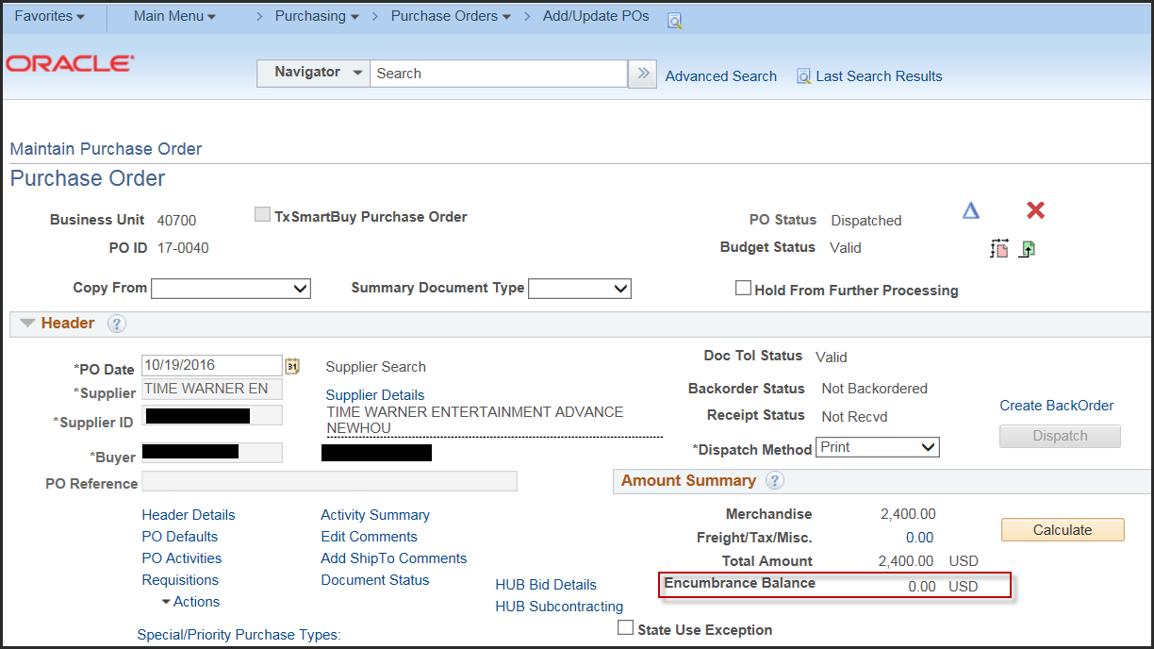

If you later learn that you need the $1.007.66 encumbrance back on the PO you can use the “Undo Finalize” button on the voucher.
Navigate to voucher 00000620. Click the “Undo Finalize” button
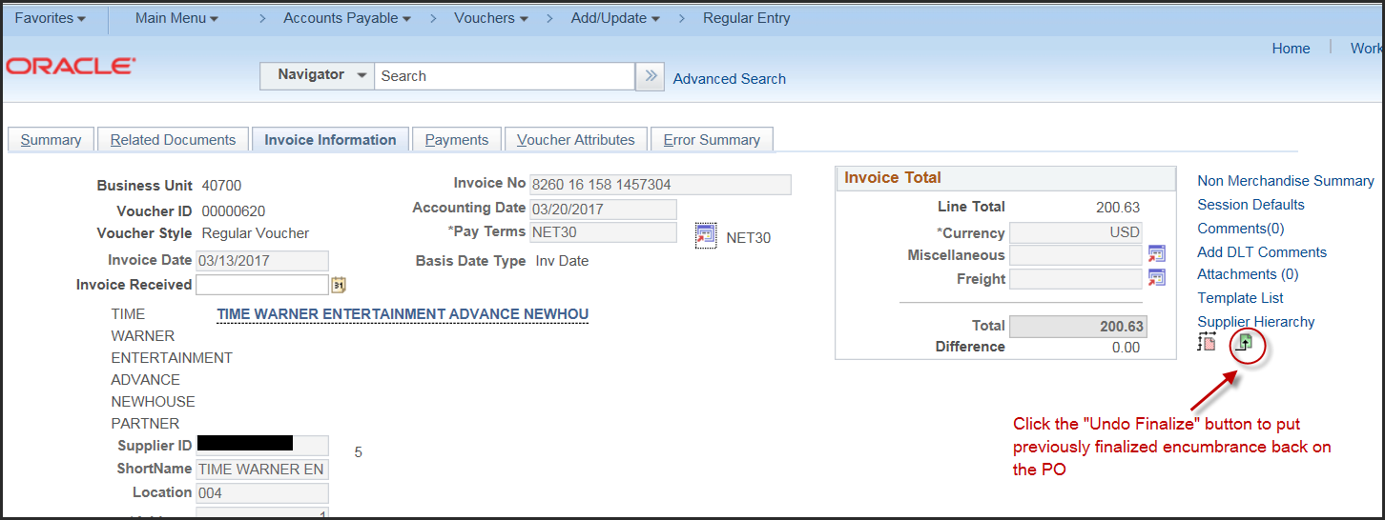
Click “Yes” on the message
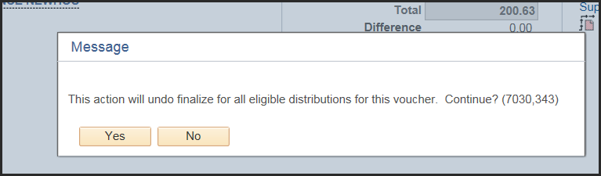
Save the voucher

Budget Check the voucher
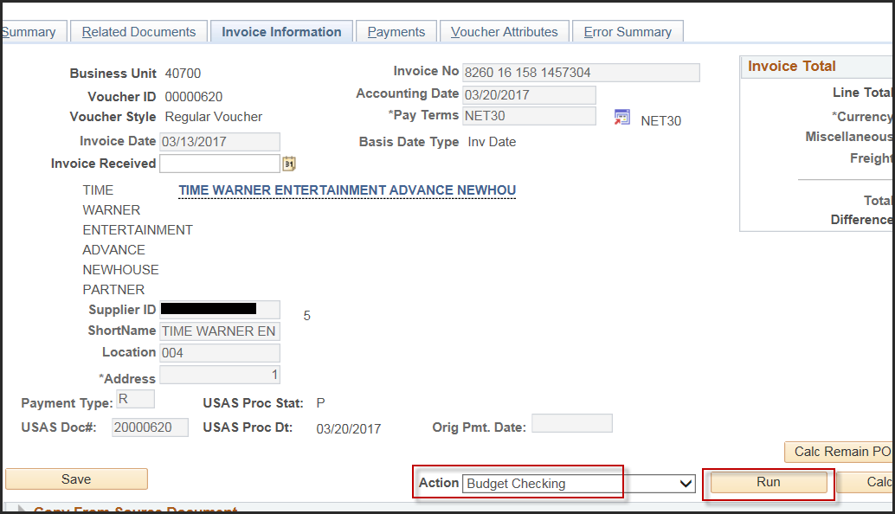
Click “Yes” to wait for the Budget Check process to complete
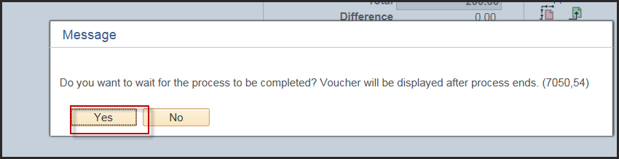
Confirm the Budget Check process is complete and “Valid”
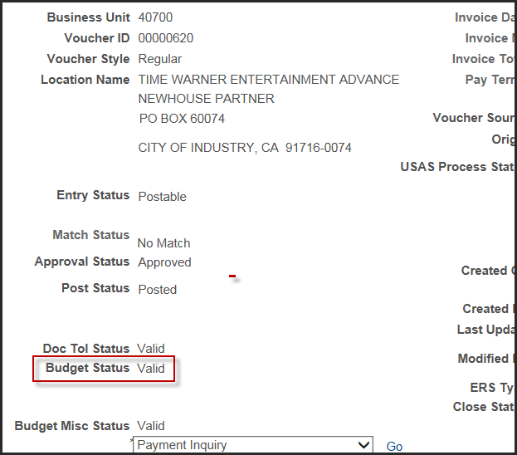
Navigate back to PO 17-0040. You may need to refresh the PO page by re-searching and pulling the PO up again. Confirm that the PO encumbrance balance of $1,007.66 has been added back to the PO.
