Requisition – Comments and Attachments
- Comments can be added to an individual line, called Line Comments.
- Add a Line Comment by clicking the Line Comments button at the right side of each line.
- Multiple comments can be added by using the plus (+) button.
The ‘Send to Supplier’ button allows the comment to carry through to the Purchase Order. 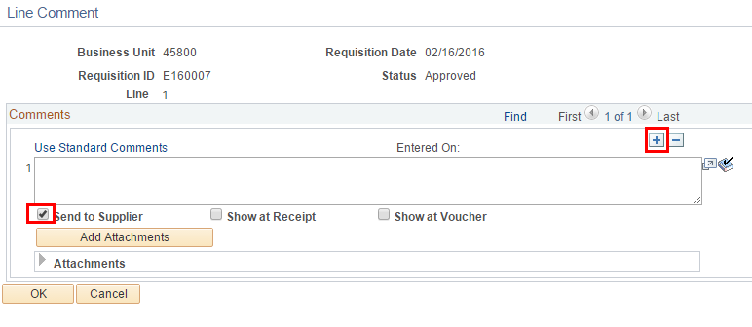
- To attach a document to a line comment, click the ‘Add Attachments’ button.
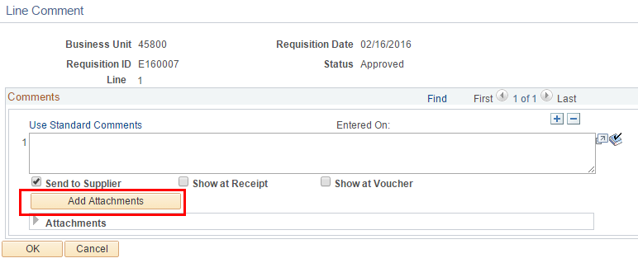
- After you enter a comment, the Line Comment button changes
from this to this.
- Requisition Comments and attachments that are not specific to a particular line are entered near the bottom of the req entry page.
