Requisition – Asset
- Navigate to: Main Menu > eProcurment > Requisition
- Select: Special Requests
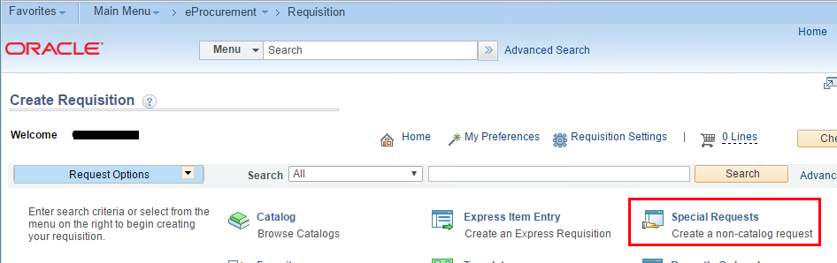
- Enter: Item Description, Price, Quantity, NIGP Class, Unit of Measure, Due Date.
Click ‘Add to Cart’.
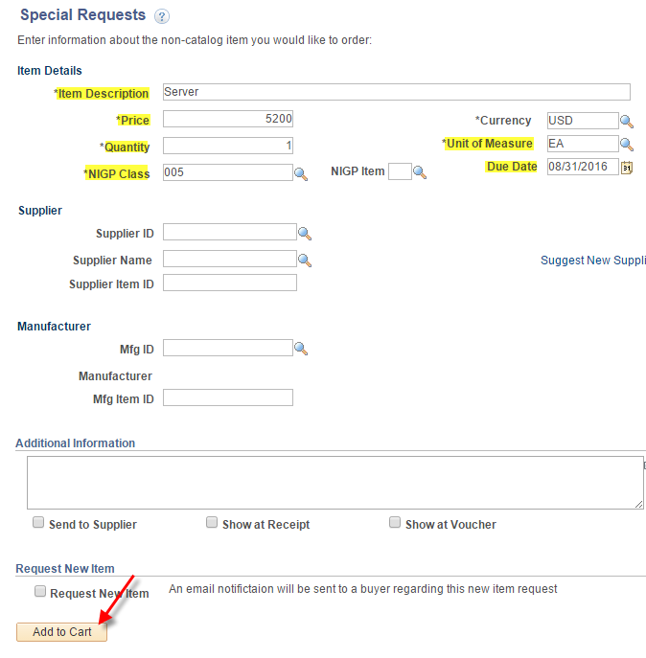
- Click: Checkout
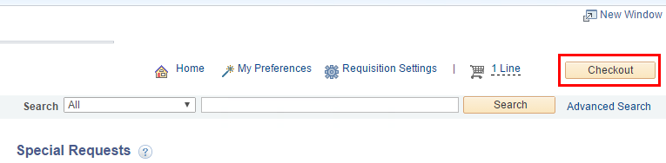
- Enter: Requisition Name
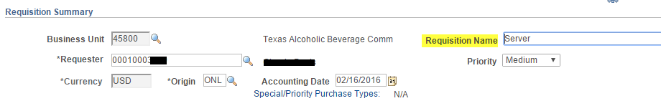
- Click the Line arrow and Accounting Lines arrow to reveal the chartfields.
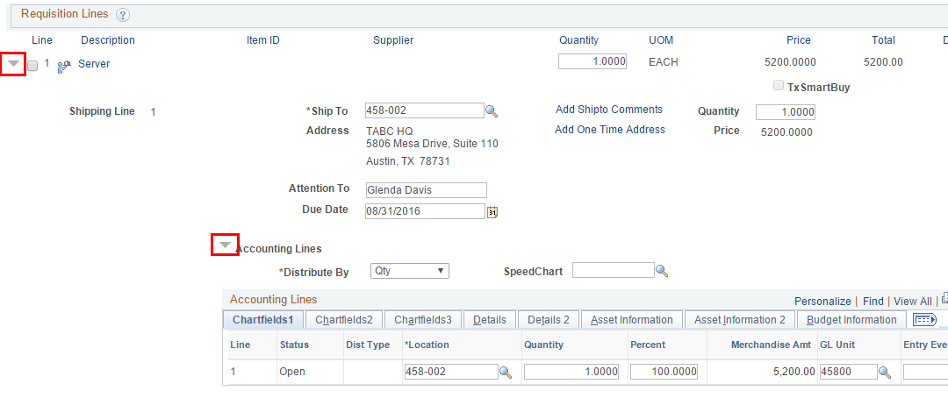
- Click the Chartfields2 tab and populate the chartfield.
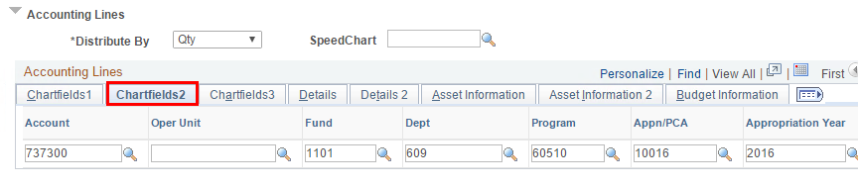

- Click the Asset Information tab and enter the AM Business Unit and Profile ID for the asset.
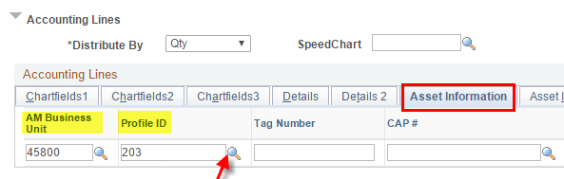
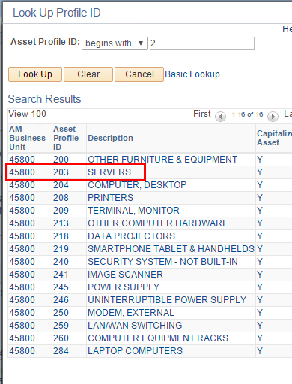
- Scroll down and click ‘Save and submit’.
