PO– Stand Alone – No Requisition
- Go to Main Menu > Purchasing > Purchase Orders > Add/Update POs and
either
(a) click ‘Add’ if your agency uses auto numbering for POs
or
(b) replace the word NEXT with whatever PO ID you want to create if your agency does not use auto numbering for POs.
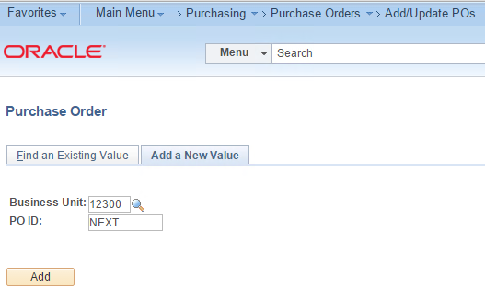
- Enter a Supplier. Search by Supplier ID or Name.
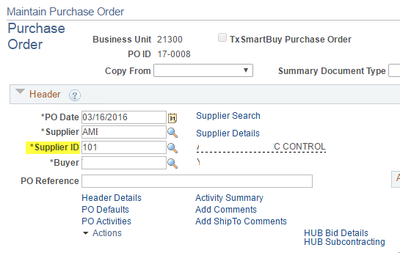
- Go to ‘HUB Bid Details’.
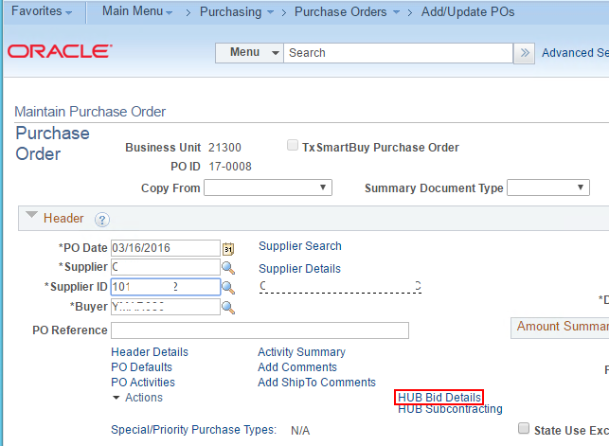

- Set 'Competitive' to 'No' and click 'OK' or
Set 'Competitive' to 'Yes' and enter specific counts for Bids Sent and Received.
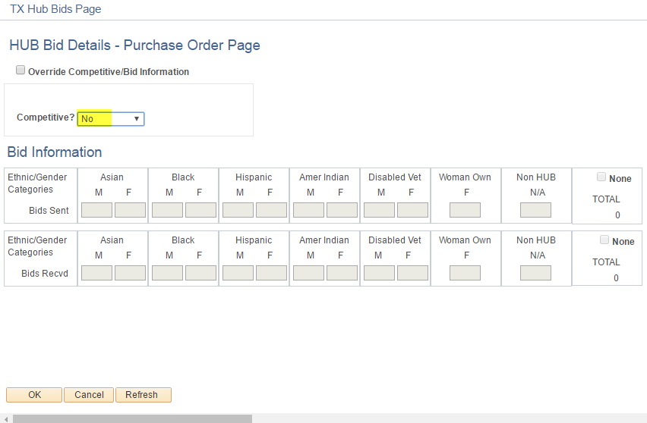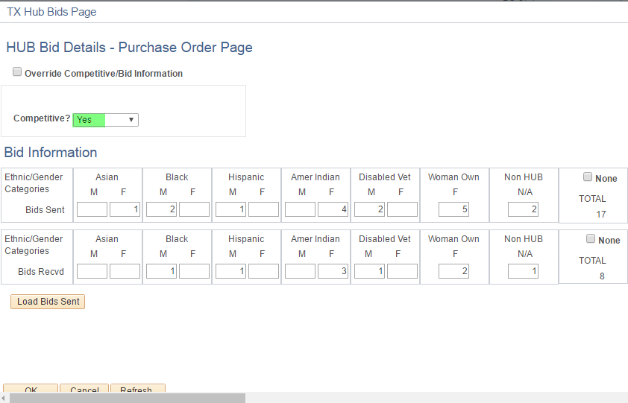
- Enter Description, QTY, Unit of Measure, and Price.
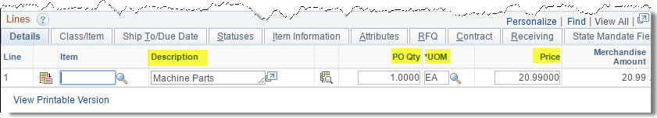
- Go to the 'Class/Item' tab and enter the NIGP Class, NIGP Item, PM and PCC.
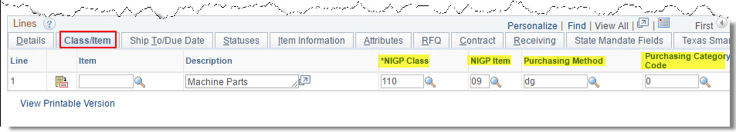
- Under the ‘Receiving’ tab is a dropdown list that controls how the voucher can be entered. If receiving is required, the voucher cannot be entered without a receiver. You may find that you’re happy with the default and therefore won’t need to check this every time you enter a new PO.
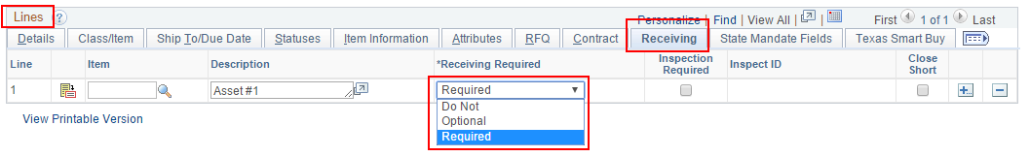
- If the order has a Quantify of 1 and will be received or vouchered multiple times, go to the Attributes tab and check the 'Amount Only' checkbox. This will allow Total Received Qty and Total Vouchered Qty to exceed the PO Qty.
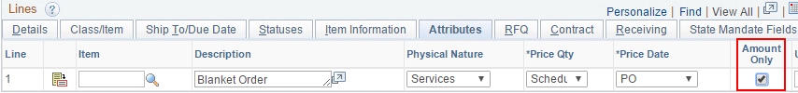
- Go back to the Details tab to click the 'Schedule' button.
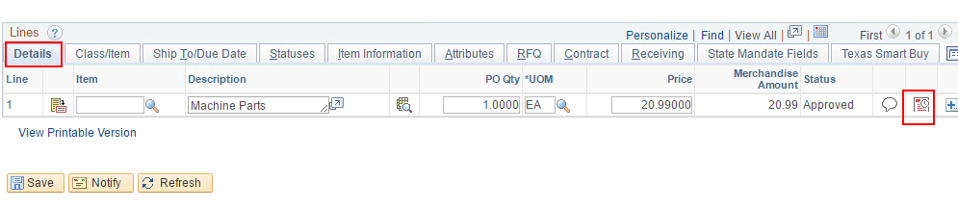
- Click the Distributions/Chartfields button.
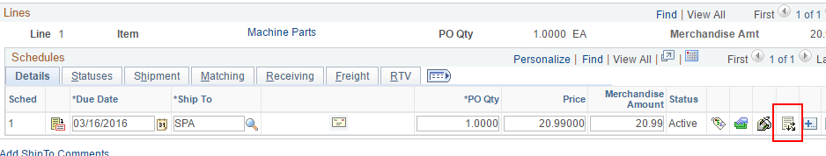
- The 'Distribute By' field can be set to 'Quantity' if the receiving and vouchering will be based on quantity or set to 'Amount' if receiving and vouchering will be based on amount. If you're ordering goods, use Quantity. If you're ordering services, it's common to use Amount, unless you're purchasing a certain number of contractor hours, for example, in which case you may still want to Distribute by Quantity.
Since you did not pull a requisition into the Purchase Order you will need to populate the chartfield data manually or via SpeedChart.
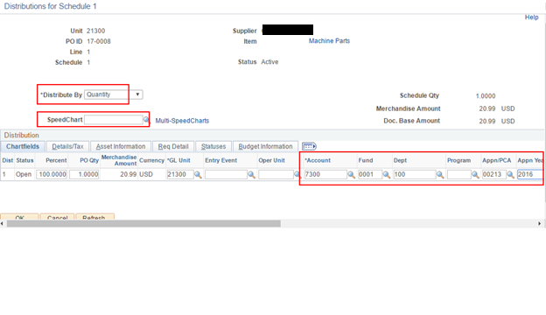
- Click OK to leave the Distributions page.
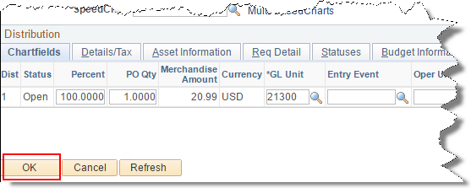
- Click 'Return to Main Page'.
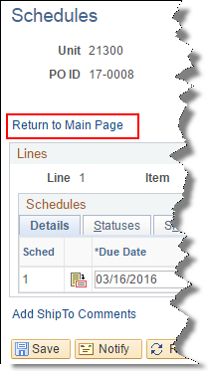
- Save the PO.
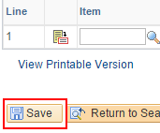
- A ‘Saved’ note will briefly appear in the upper right hand corner when the PO saves successfully.
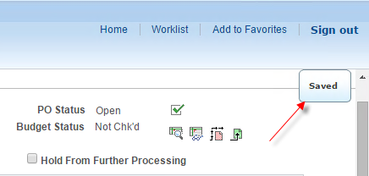
- If you’re using auto numbering, the PO ID will display.
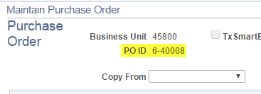
- If the PO goes into workflow for approval, it will save with a status of ‘Pending Approval’. You must wait for Approval before the PO can be budget checked, and the PO must be budget checked before it can be Dispatched.
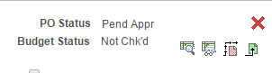
- When the PO has a status of ‘Approved’, it can be budget checked.
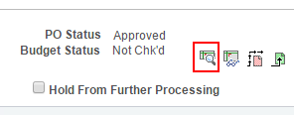
- When the PO is Approved and Valid, it can be Dispatched.
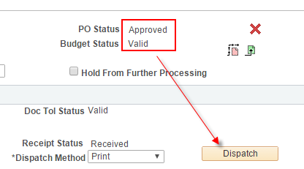
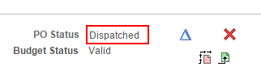
- The PDFs of your dispatched POs are stored in the Administration page of the Report Manager.
