PO – Buyer's Workbench - Close and Reopen POs
- Your first time to use Buyer's Workbench, set up your own WorkBench ID here. Use any name you like. No spaces allowed, but you can use underscore(_).
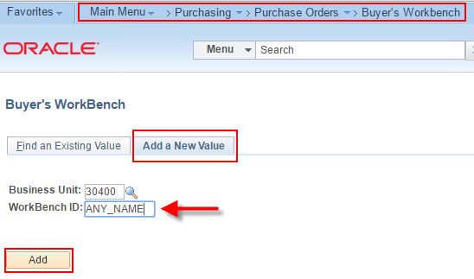
- Your second and following times to use Buyer's Workbench, search for your own Workbench ID. Entering a character or two helps to narrow your search.
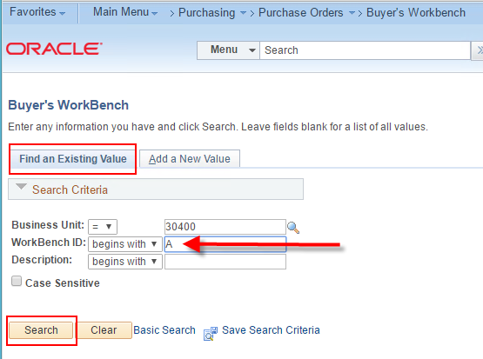
- Click anywhere on your WorkBench ID to load the page.
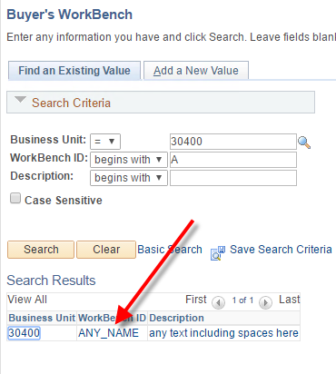
- The first page is a search page. The most common search is for a single purchase order for which you already know the PO ID.
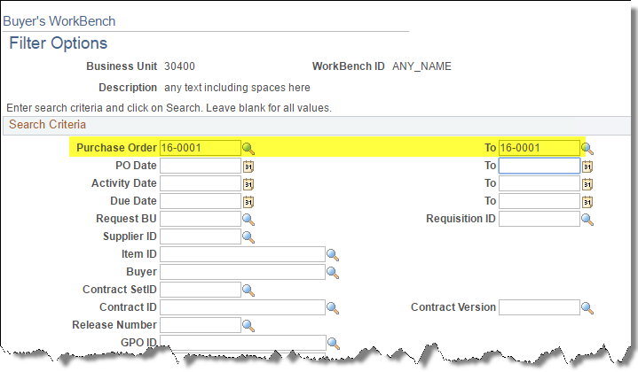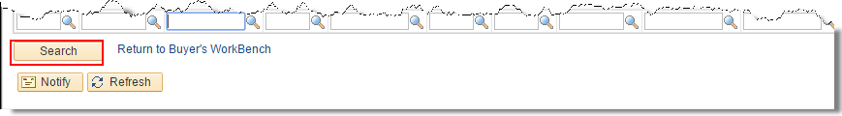

- Your first time on this page you'll need to enter a Description. You can use spaces.
Select the checkbox to the left of the PO ID.
Click the action button. In this example, we are attempting to close the PO.
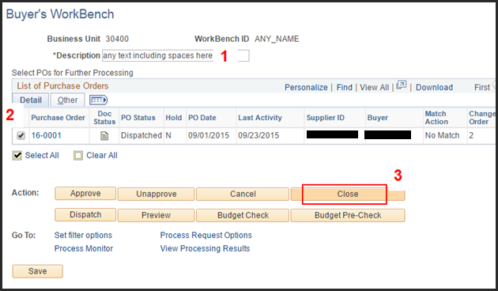
- After clicking 'Close' you see if your PO is qualified to be closed.
Left side = Not Qualified. Right side = Qualified.
This PO is qualified to close, so click Yes to proceed. [If your PO is Not Qualified, see Step 18]
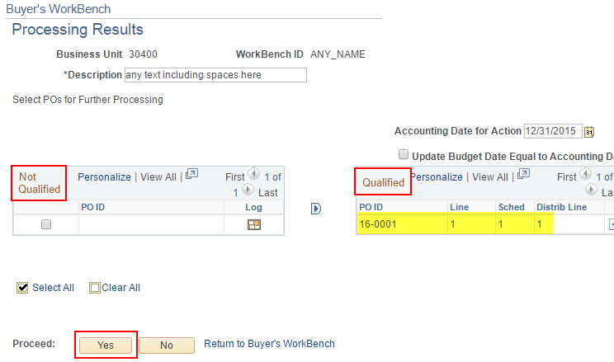
- Click Yes to continue.
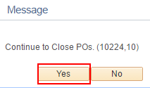
- Notice the PO Status has changed to Complete.
You must Budget Check to release any remaining encumbrance back to the budget.
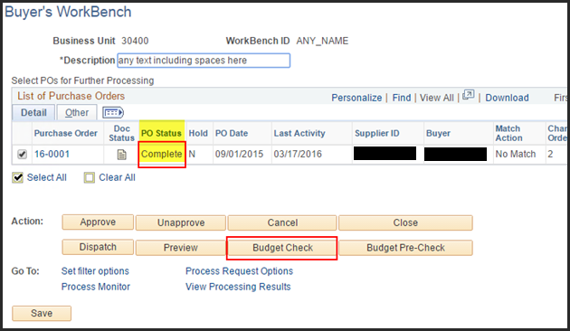
- The PO is qualified to Budget Check, so click Yes to proceed.
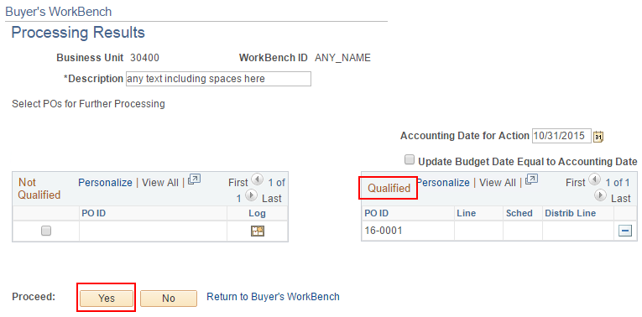
- Click Yes again to proceed.
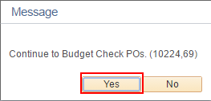
- A closed or cancelled PO cannot be viewed in the Add/Update POs page.
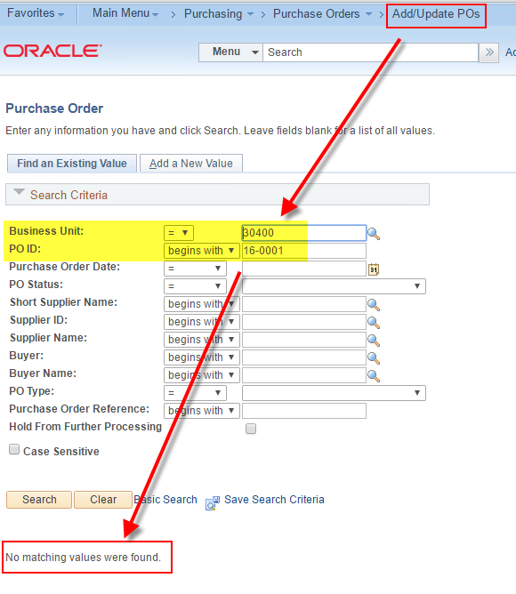

- To view a closed or cancelled PO navigate to the Review PO page.
Notice the PO Status is Compl (Complete/Closed),
the Budget Status is Valid which means it has been successfully budget checked, and
the Encumbrance Balance is 0.00.
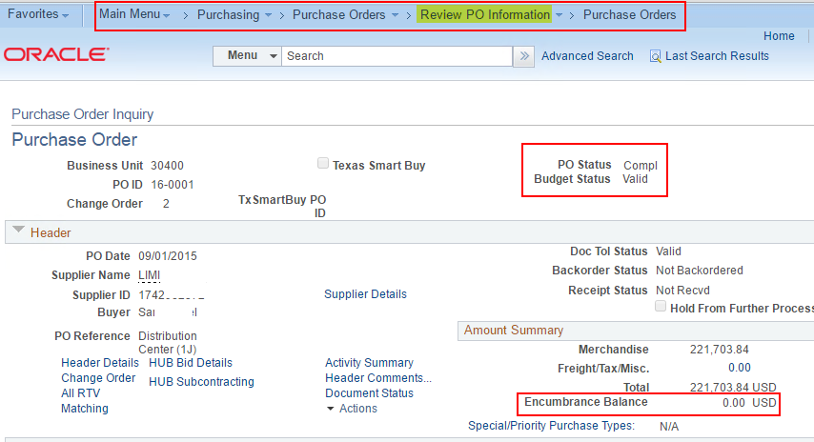
- If another invoice is received for this Purchase Order you can reopen the PO.
The first time you go to the Reopen page you will set up a "Run Control ID" which is your own custom page. You pick the name. No spaces allowed.
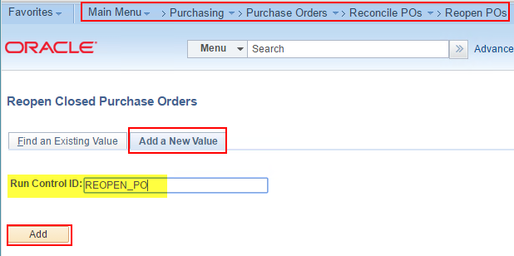
- Enter the specific PO you want to reopen. You will want to reopen the associated requisitions also when the PO was built from one or more requisition.
Then click Run to reopen the PO. Clicking the Run button automatically saves the page. If you're not ready to Run yet but you want to save your changes, click Save.
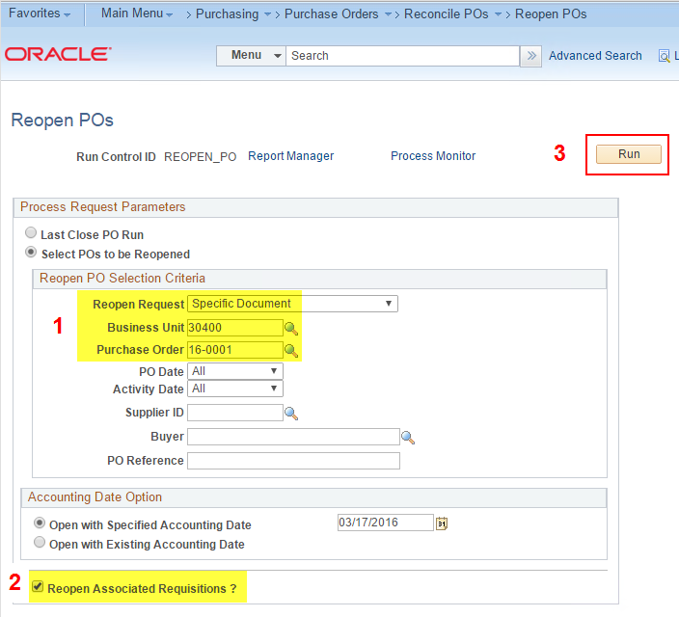
- You can check the progress of the Reopen process by going to the Process Monitor. It should go to a status of 'Success' in less than a minute.
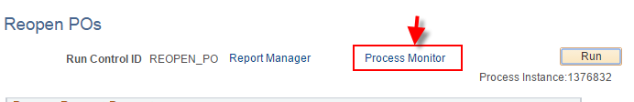 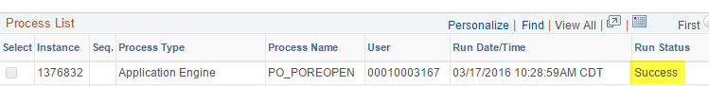
- If Reopen was successful, you should be able to pull the PO up in the Add/Update POs page. The Budget Status will be 'Not Chk'd'. Click the Budget Check button to re-encumber the unused funds that were returned to the budget when the PO was closed. Funds must be available for the PO to budget check successfully. 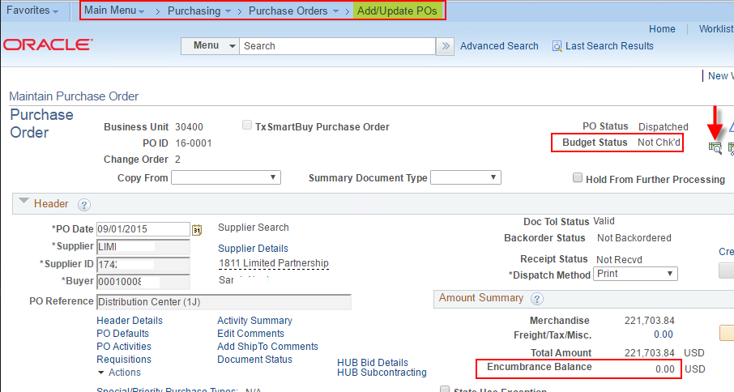
- A successful budget check re-encumbers the unexpended portion of the PO's encumbrance.
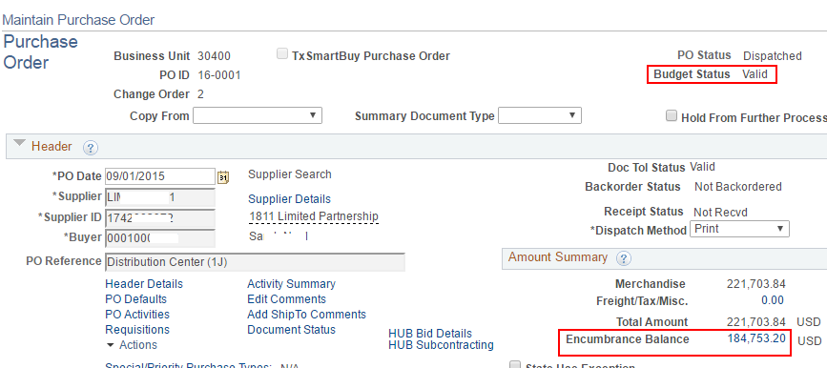
- If you attempt to close a PO from PO Workbench and the PO is 'Not Qualified' to close, click the Log button to see the reason the PO is not qualified to close.
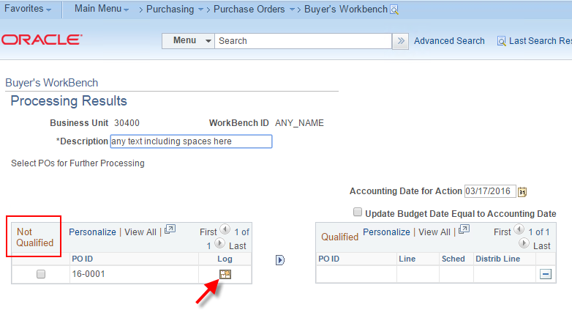
- In this example, the PO is not eligible to close because the PO is marked for 'Receiving Required' but it has not been received.
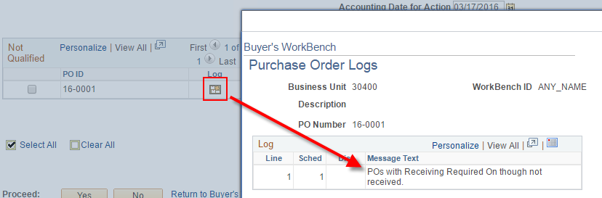
- To solve this problem, open the PO and change receiving to either 'Do Not' or 'Optional'. Either choice will get rid of this error that is blocking your ability to close the PO. 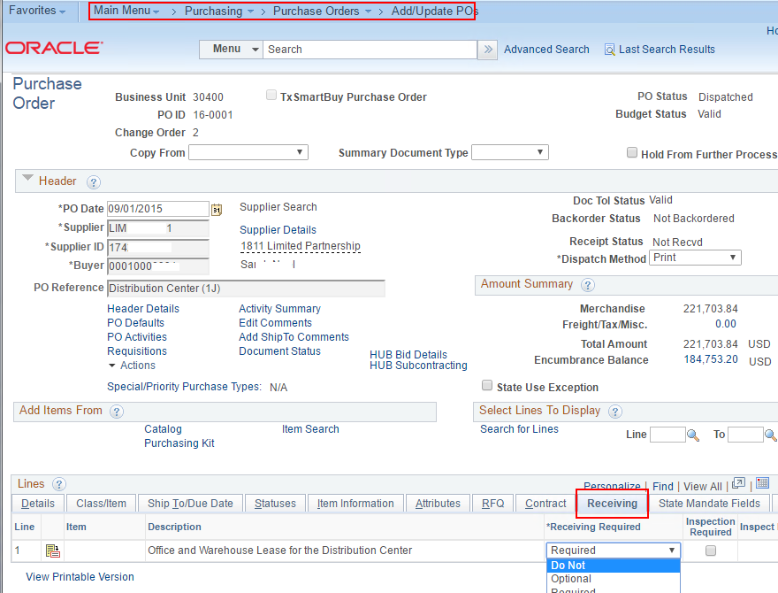

- Another common error that prevents closing a PO is when the PO is marked for Matching Required but has not been Matched. Correct this error by going to the Schedule(s) on the PO and change the Matching to 'Don't Match'.
