PO– Pending Cancel Status
- When you cancel a PO that has ever in its lifetime been Dispatched, the status becomes 'Pending Cancel'.
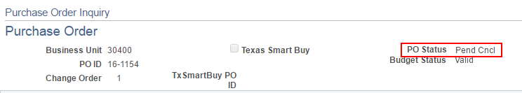
- The status will go from 'Pending Cncl' to 'Canceled' after you run the Dispatch process.
- Why would a PO need to be Dispatched if it has been Canceled?
If the PO has been Dispatched to the Supplier, then notice of cancellation should be Dispatched to the Supplier.
- To find POs that have a status of 'Pending Canceled', go to the Review PO Information > Purchase Orders search page and search by status as shown below.
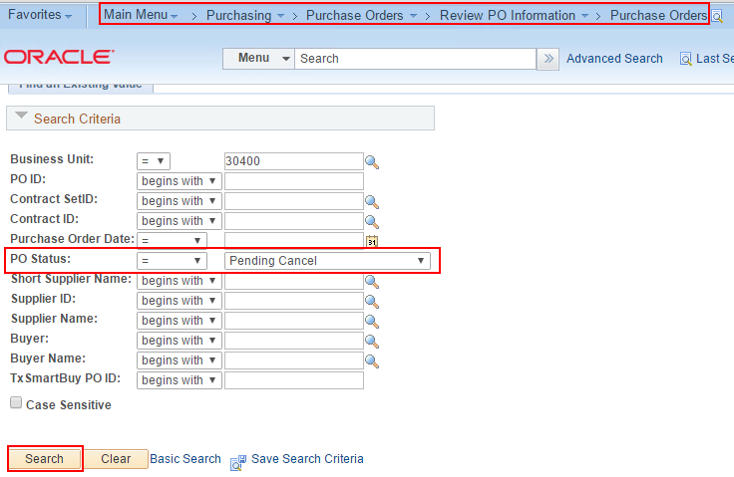
- Because the PO is Canceled and viewable in inquiry mode only, you cannot Dispatch by clicking a button on the PO. There are two other ways to run Dispatch.
- To dispatch via the menu, navigate as shown below. First time, add a Run Control ID. Second and following times, click Search and choose your existing Run Control ID.
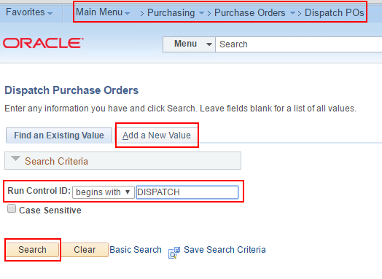
- Enter the PO ID and click Run.
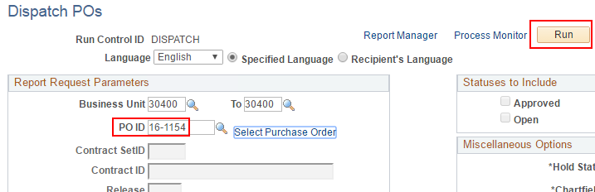
- If the PO ID field turns red and tells you the PO ID is not a valid value, don't worry yet. This is often just a glitch in this page.
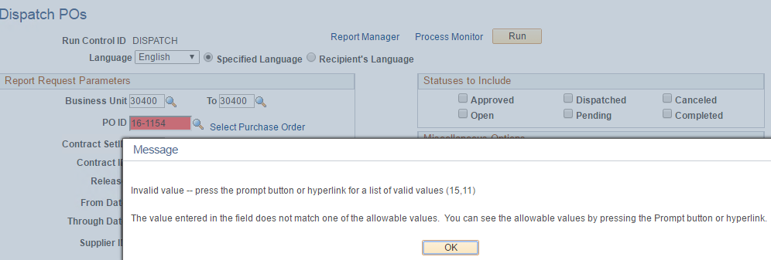
- If the above glitch occurs, click OK to get rid of the message, then click the Select Purchase Order link and search for the PO.
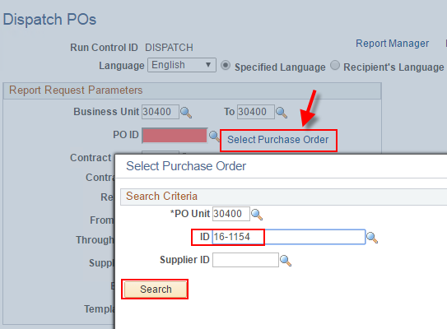
- That should work and you can click Run again.
- Click OK on the Process Scheduler Request page.
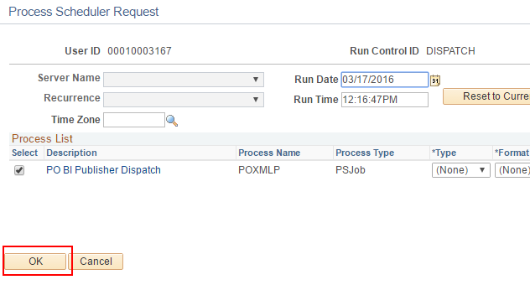
- After you click Run you can make sure the Dispatch process runs successfully by going to the Process Monitor page.
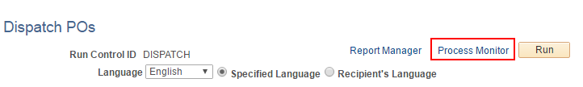

- Scroll to the bottom of the Process Monitor for a link to get back to the Dispatch page.
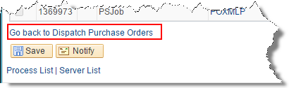
- If you want to see the .pdf of the Canceled/Dispatched PO, or if you want to send a copy to the Supplier, click on Report Manager.
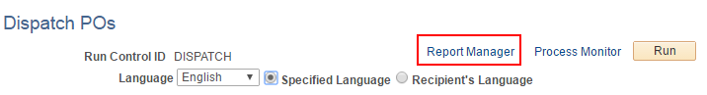
- You'll find a link to the .pdf in the Administration page.
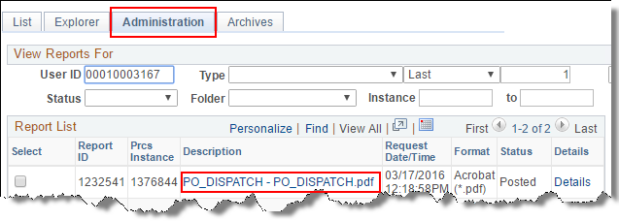
- The "hard copy" (.pdf) shows the lines as Canceled.
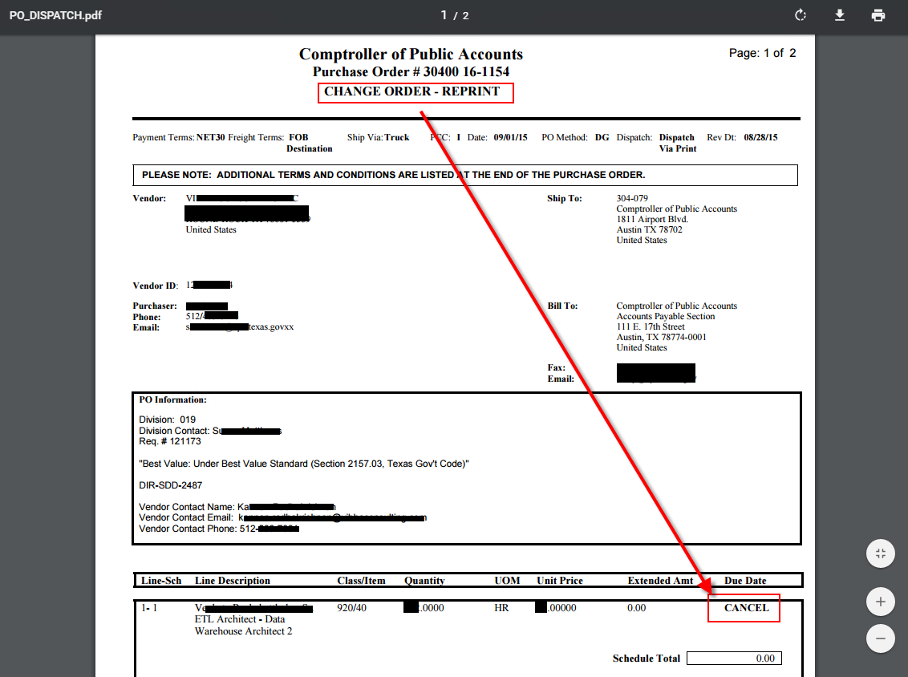
- The second way to Dispatch a PO that is in Pending Cancel status is from Buyer's Workbench.
- Your first time to use Buyer's Workbench, set up your own WorkBench ID here. Use any name you like. No spaces allowed, but you can use underscore(_).
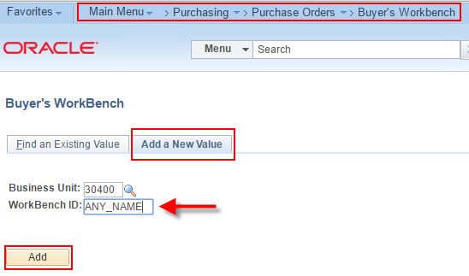
- Your second and following times to use Buyer's Workbench, search for your own Workbench ID. Entering a character or two helps to narrow your search.
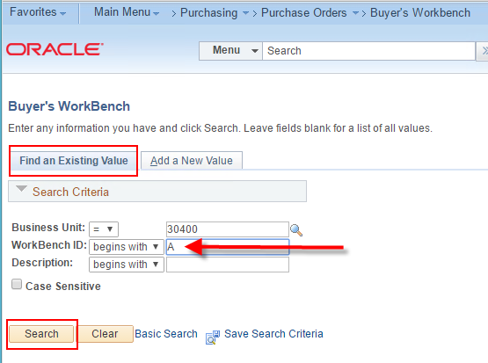
- Click anywhere on your WorkBench ID to load the page.
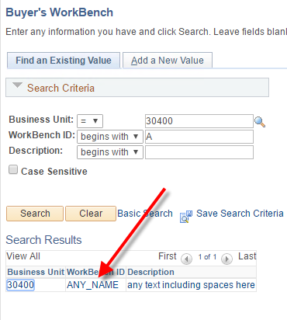

- The first page is a search page. The most common search is for a single purchase order for which you already know the PO ID.
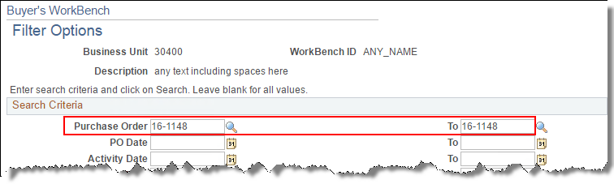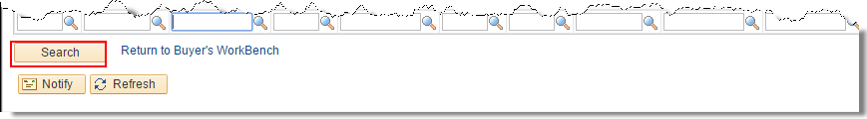
- Your first time on this page you'll need to enter a Description. You can use spaces.
Select the checkbox to the left of the PO ID.
Click the action button. In this example, we are attempting to Dispatch the PO.
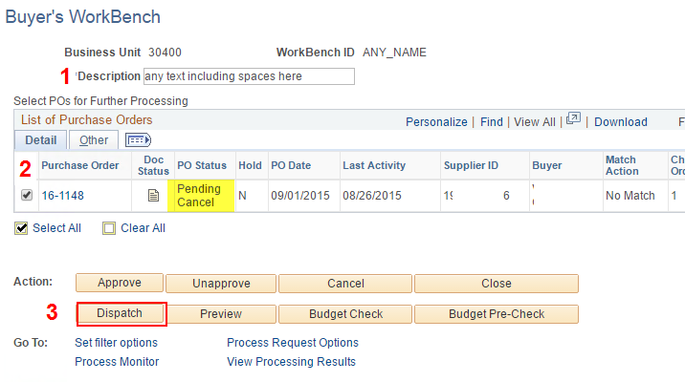

- The first time you attempt to Dispatch from Buyer's Workbench using the Run Control ID you set up in Step 19, you will probably get a pesky message saying you need to select a valid run control id in the Process Request Options Page.
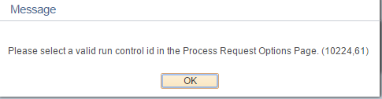
- Click OK to get rid of the message.
- To get a valid Dispatch Run Control ID, open a new page.
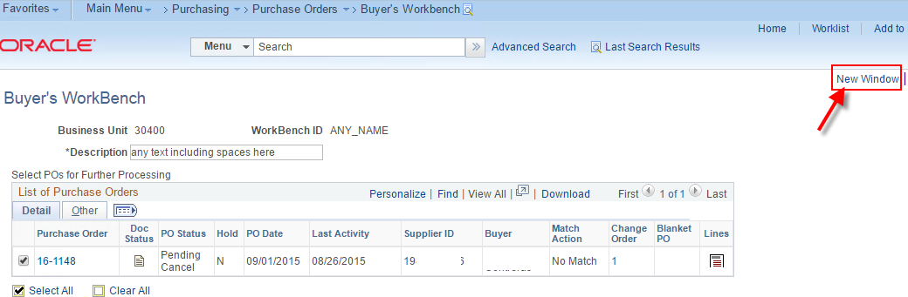
- In the new page, navigate to the Dispatch POs page, go to the Find an Existing Value tab and click Search.
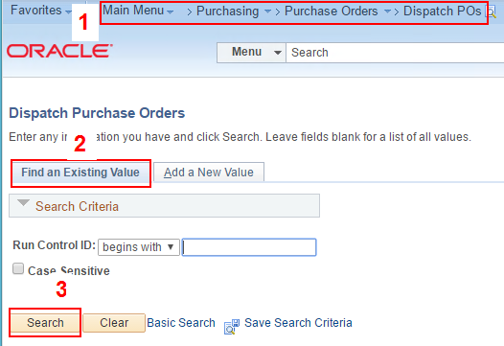
- Memorize a value that has been used to Dispatch POs. Don't click on it. You're finished with this page. You just need the Run Control ID.
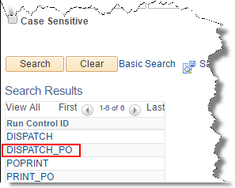
- Go back to Buyer's Workbench.
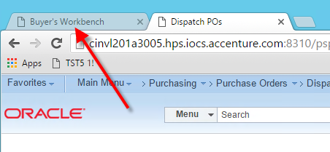
- Click on Process Request Options.
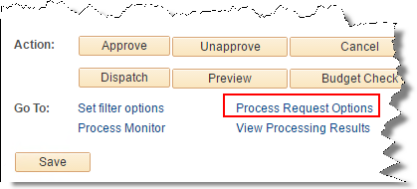

- Remove whatever is in the Run Control ID field and enter the Run Control you memorized in step 28. Enter it exactly. No spaces. Then click OK.
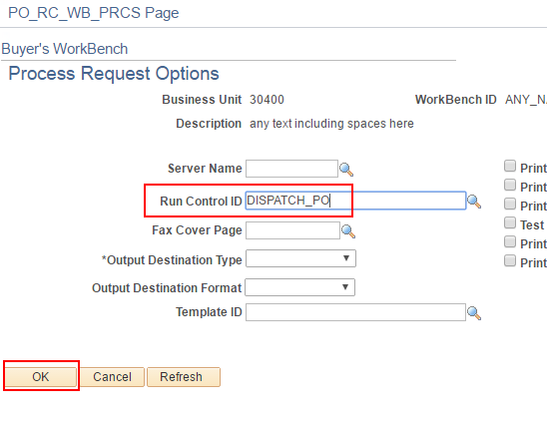
- Now click the Dispatch button again.
- If the PO ID appears on the right under 'Qualified', then click Yes to proceed.
If the PO ID appears on the left under 'Not Qualified', click the Log button to see the reason the PO is not eligible to Dispatch.
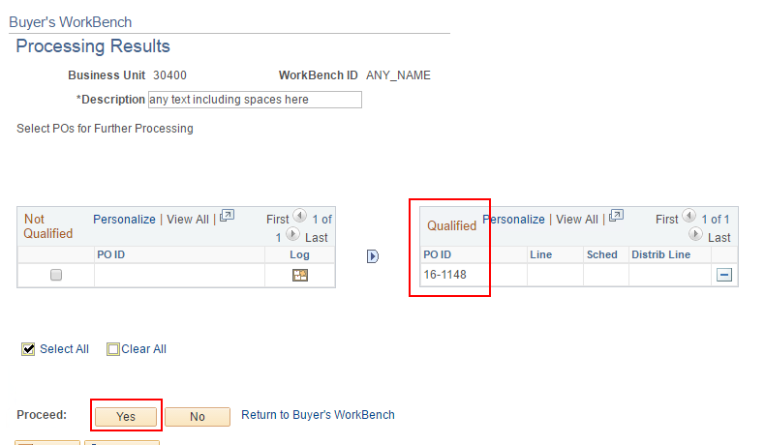
- Click Yes to continue.
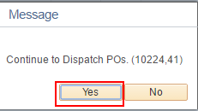
- The PO Status on Buyer's Workbench may still say 'Pending Cancel' because it did not refresh after Dispatch ran successfully. No worries.
- You can verify that the status has changed from Pending Cancel to Canceled by going to the Review PO Information > Purchase Orders page.
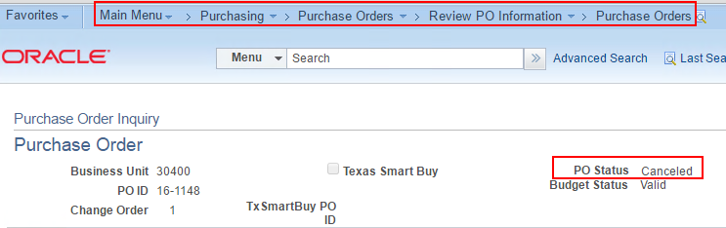
- You can print the hard copy (.pdf) from the Administration tab of Report Monitor.
