Workflow – Approve, Deny, Pushback
- Log in to CAPPS.
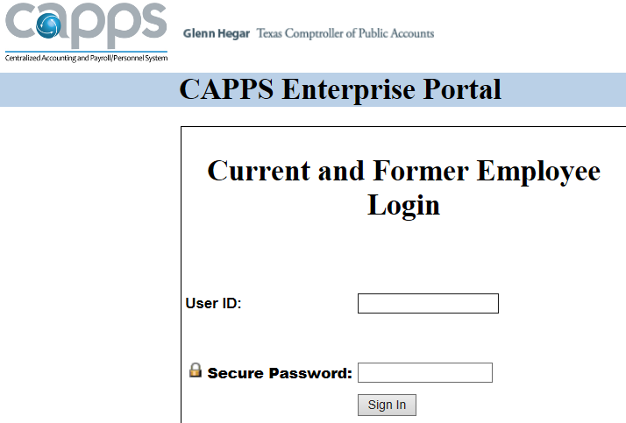
- Go to your Worklist.
- Click the hyperlink for the Requisition or PO you want to approve. The document number (Req ID, PO ID) is sort of buried at the bottom of the hyperlink.
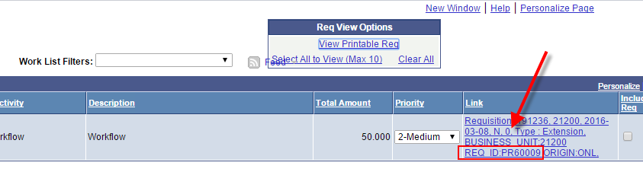
- From this page you can quickly Approve or Deny the Requisition.
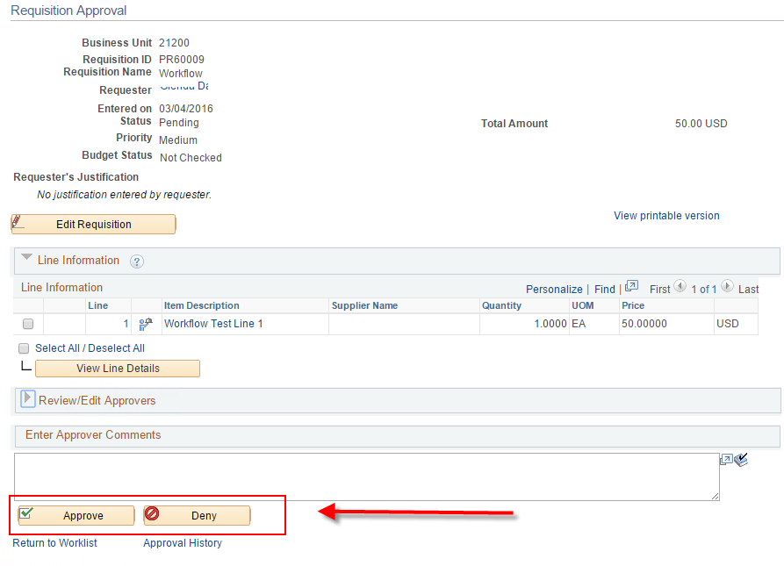
- If you Approve, the requisition will go to the next Approver. If you are the final approval step, the Requisiton will become approved and eligible to budget check.
- If you Deny, you must enter a Comment in the box just above the button.
Denying sends the requisition back to the Requester.
The Requester can make changes and resubmit for approval or cancel the requisition.
- You can view the approval path and even use the green + buttons to insert another approver or reviewer for this particular requisition only.
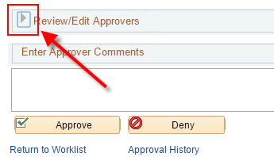 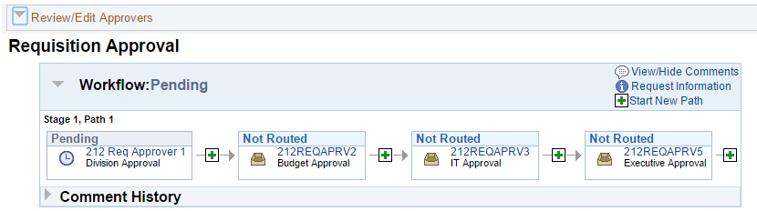
- If you are not the first approver in the workflow path an additional button is available to push the requisition or PO back one step to the previous approver. Comments required.
