PO – ProCard
- ProCard POs are unique only in how you search for the requisitions to pull into the PO. Otherwise, a ProCard PO is just a PO.
- Enter the Supplier, which will be the bank that issued the ProCard, e.g. Citibank. 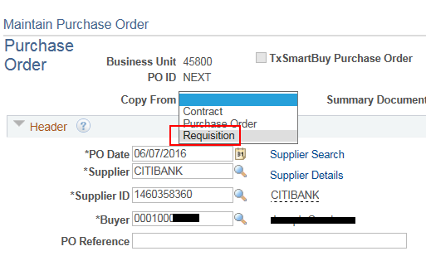
- Choose 'Requisition' in the Copy From dropdown list located just above the Supplier and PO Date field.

- Enter 'PROCARD' in ALL CAPS in the 'Requisition Name' field. This assumes the requesters have been trained to use ALL CAPS when entering Requisition Name on their requisitions. The reason behind training requesters to all use upper case for Requisition Name is because the search field on the PO is case sensitive.
Search Tip: it might be worthwhile to also search for 'PRO' and 'Pro' to make sure you don't miss any requisitions on which the requester failed to use the agreed upon format. For example, if the requester entered the Requisition Name as 'Pro-Card' your search won't find it if you're only searching for PROCARD, but it will find it if you search for 'Pro'. Be cautious in this case not to pick up unwanted requisitions, such as a requisition for Pro Chem, Pro Tech, etc.
