Procurement Contract – Create then Link to Purchasing Documents
Contents
Contract Creation 1
Link Contract to Originating Requisition - eProcurement 9
Associate Contract to Purchase Order 12

Contract Creation
- Navigate to add a Procurement Contract. Main Menu > Procurement Contracts > Add/Update Contracts and either assign a Contract ID by entering a specific contract ID or allow the system to auto-generate the next available contract ID.

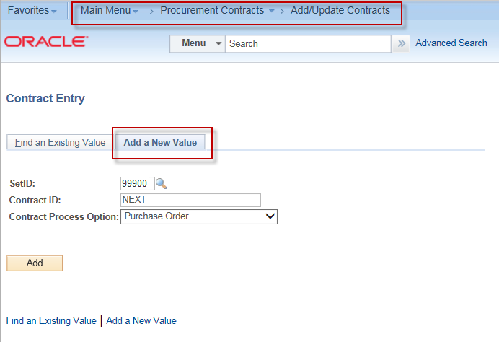
- Enter all required fields highlighted below:
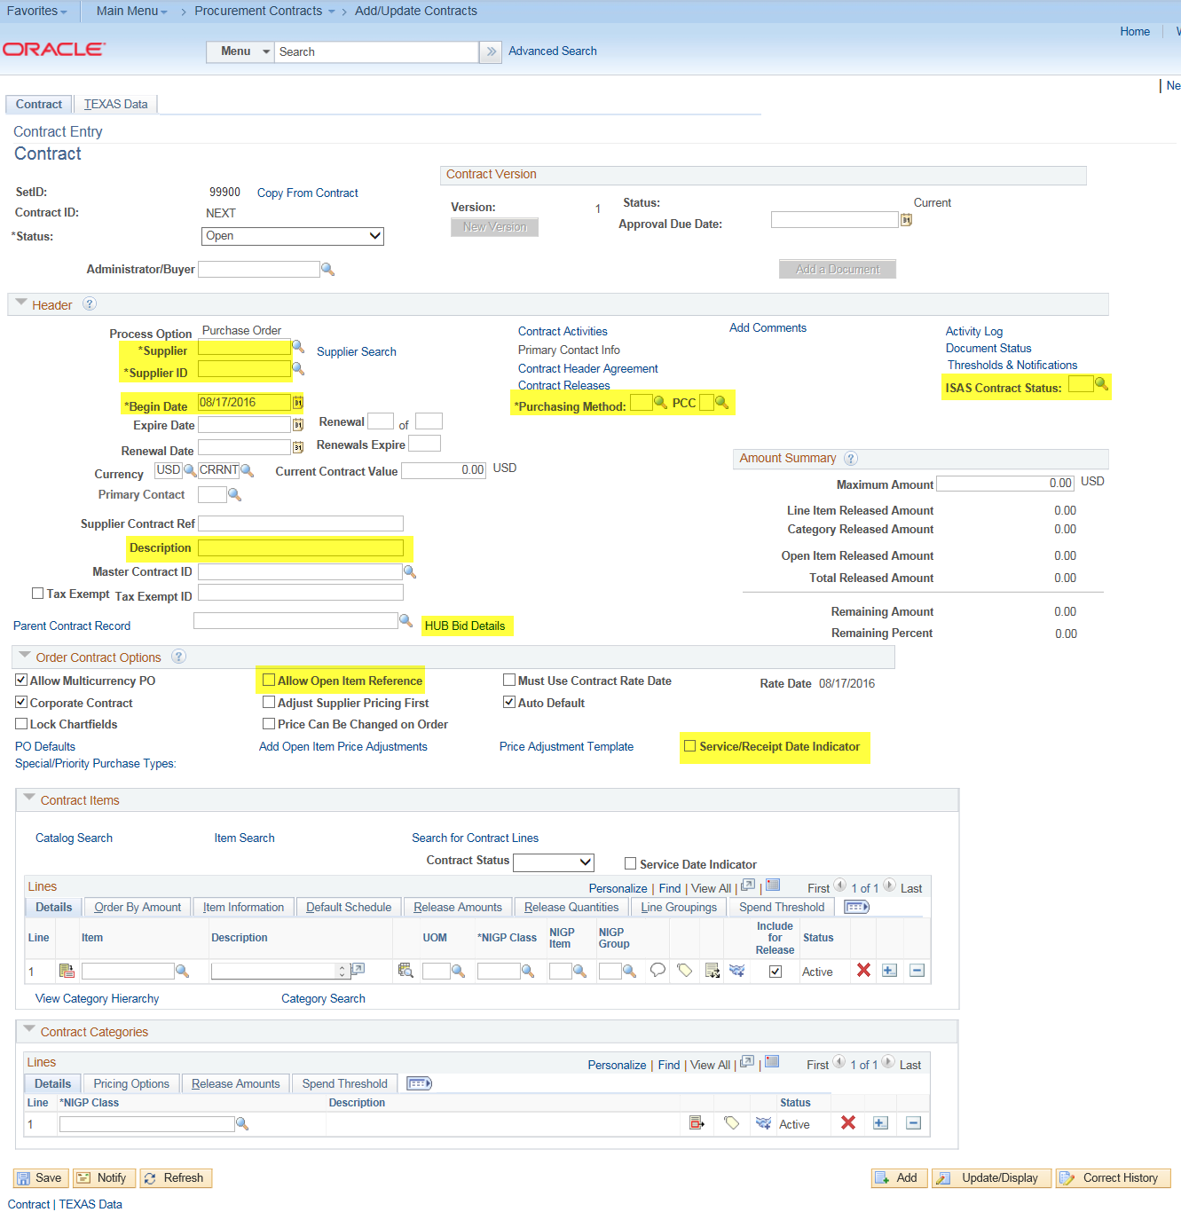

Supplier/Supplier ID: These two fields are linked together and will match. If you know the 10 digit Vendor ID, you may enter the 10 digits in the Supplier ID field. The Supplier field will auto-populate with the name of the supplier based on the standard name associated in the Supplier table.

Begin Date: This date is the date the contract services are to begin.

Purchasing Method/PCC: Enter the appropriate Purchasing Method and PCC for the procurement.

ISAS Contract Status: This field identifies the instance of the contract at the current point in time. New contracts would be entered as “Initial”. Options for this field include:
- A – Amendments
- C – Cancellations
- E – Extension
- I – Initial Execution
- M – Completions
- P – Expirations
- R – Renewals
- R01 – Renewal 1
- R02 – Renewal 2
- R03 – Renewal 3
- R04 – Renewal 4
- R05 – Renewal 5
- R06 – Renewal 6
- R07 – Renewal 7
- R08 – Renewal 8
- R09 – Renewal 9
- R10 – Renewal 10
- S – Suspend
Description: This is a 30 character purpose summary of your procurement.
HUB Bid Details: Competitive bidding information is required for some agencies. The HUB Bid Details link provides users the ability to identify if a purchase is competitive, non-competitive or not applicable. This page enables the users to track the HUB bid summary counts for the type of HUBs sent and received for a procurement. The HUB report is pulled from this page.
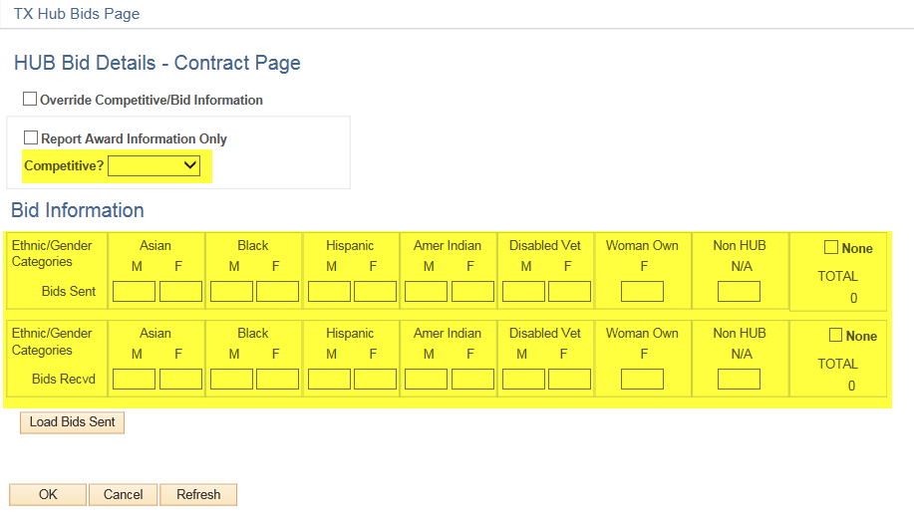
Allow Open Item Reference: This check box will indicate that the contract is a header-only contract. Without this checkbox, contract lines must be entered. If contract lines are used by your agency, the management of the procurement will be driven by the contract. For header contracts, management of the contract is at the Purchase Order.
Service/Receipt Date Indicator: This check box will prohibit any transactions against the contract where the service date falls outside of the terms set within the contract. For Example: If Begin/End dates are 9/1/2016-8/31/2017, all transaction service dates must be between those dates on vouchers and receipts.
Auto Default and Allow Multicurrency PO: Leave these boxes blank.

On the TEXAS Data tab, there are 2 required fields:
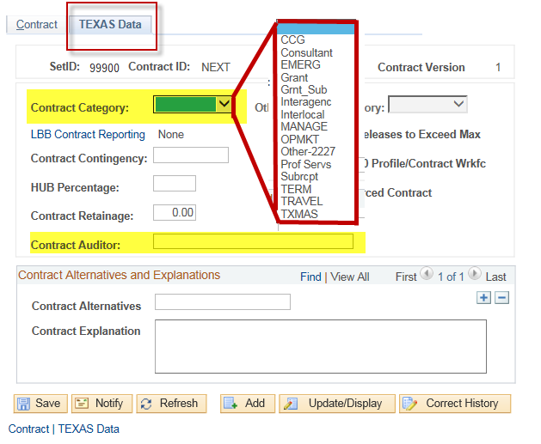

Contract Category identifies category for the contract and can be used for reporting.

Contract Auditor field identifies the individual responsible for the contract. This would be the individual to contact for compliance and intention to renew.

The entries above are required and allows the contract to be saved and a contract ID to be assigned. The contract does not need to be placed in “Approved” status until entry has been completed and contract is ready and available for transactions.

- Complete any remaining fields to complete the entry of the contract:
Expire Date: The date by which a vendor must complete its performance pursuant to the terms of the contract, including amendments, and exercised renewals or extensions. Some contracts do not have a set completion date, but instead rely on other benchmarks. This information is needed to track the overall life of the contract, and the relationship between payments and performance.
Current Contract Value: The Current Contract Value includes the value of the contract, any amendments, and any exercised extensions or renewals; i.e., the total contract amount currently obligated to date. This information specifies how much is currently obligated under the contract.
PO Defaults: To associate a specific vendor mail code (location) to a contract, the correct mail code needs to be associated to the contract. To select a specific mail code, click the PO Defaults link.
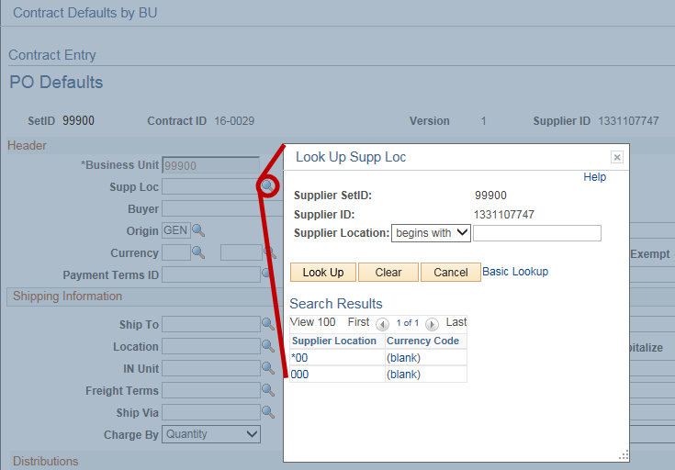
This association will make the full 14 digit supplier ID transmit to LBB for LBB reportable contracts.

TEXAS Data tab – LBB Contract Reporting:
This hyperlink will provide the LBB Contract Reporting categories
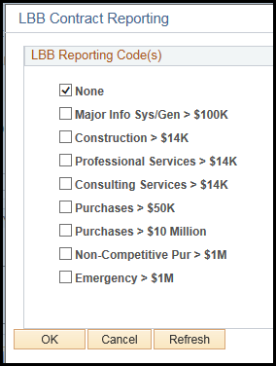

The default value is “None”. If the link is not selected, the contract will default as NOT being LBB reportable.

When any other selection is made, the “None” checkbox is no longer available. Contracts may have a single reporting code associated or several.

- Attach a redacted version of the contract to the contract along with any bid tabulations relative to the contract. Attachments are made at the Comments link:
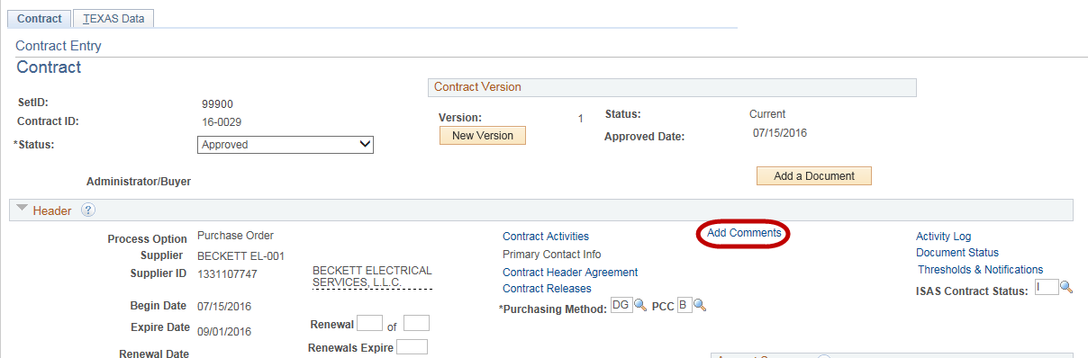

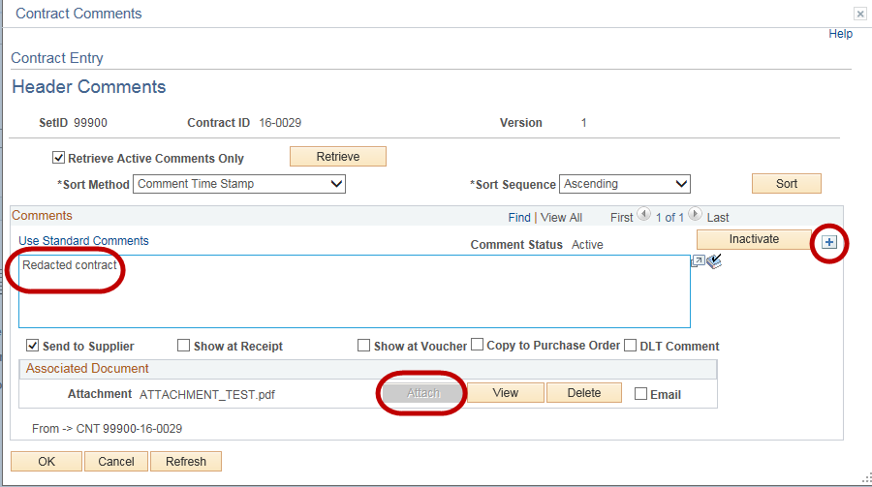
Enter the description for the documentation being attached to provide information on the attachment. Click the Attach button and select the location of the document to be attached and upload the document.

To add additional comments or attachments, select the plus button
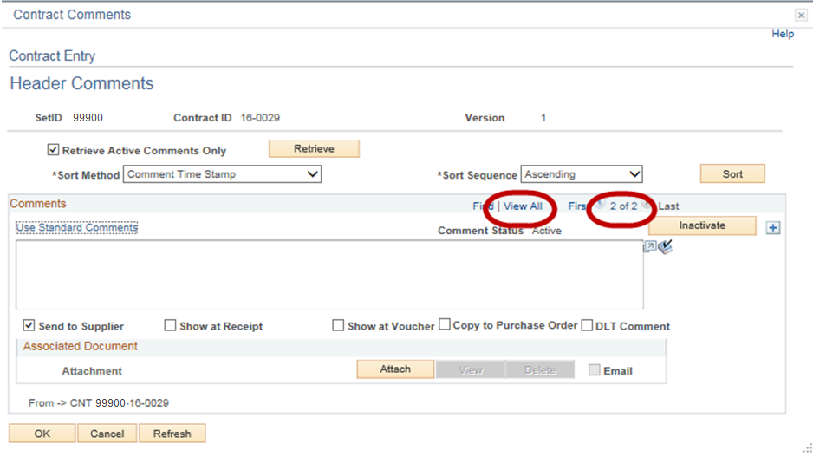
This will add another comment panel. The system tracks the number of comments entered and allows users to “View All”.
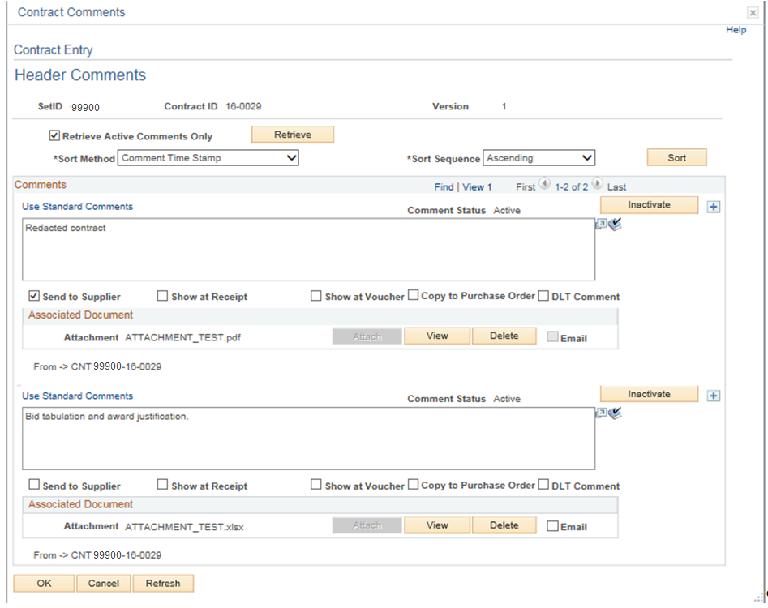

Enter any additional comments & attachments to the contract record and click “OK”.

- Approve contract record.

Link Contract to Originating Requisition - eProcurement
- Navigate to the requisition authorizing the contract:
Main Menu > Manage Requisition
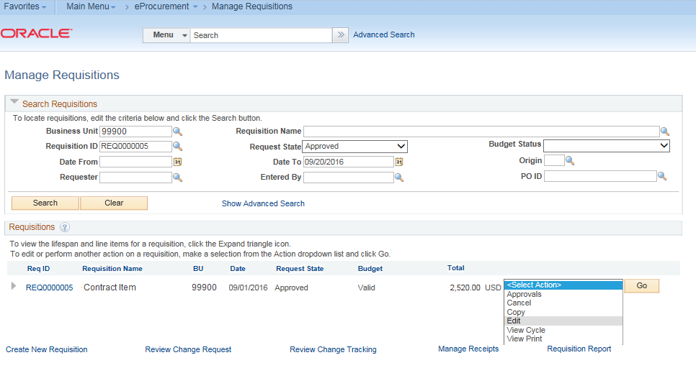

- Identify the requisition to be updated and select Edit
- A system generated message will display stating that editing the requisition may restart the approval process.
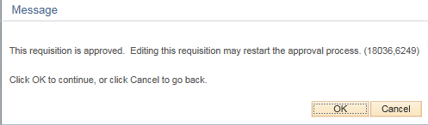
- Click OK
- Click the line details icon,
- In the Contract Information section, search for the appropriate contract ID
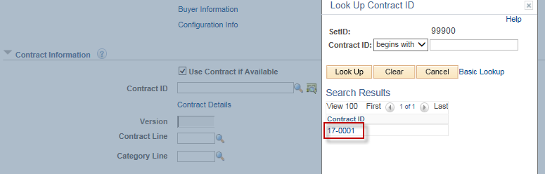
- When you select the contract ID, the associated vendor ID will populate the Supplier ID field.
- Scroll down to the bottom of the window and click OK.
- Save requisition & submit requisition.
- If no other changes are made to the requisition (that might restart the approval process), the requisition status should remain Approved.

Associate Contract to Purchase Order
- Create or navigate to the Purchase Order that you want to link to this Contract.
The Supplier ID on the Contract must match the Supplier ID on the Purchase Order.
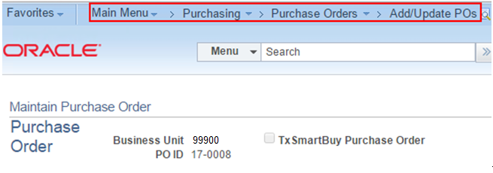
- Go to the Contract tab in the PO Line section and enter the Contract ID.
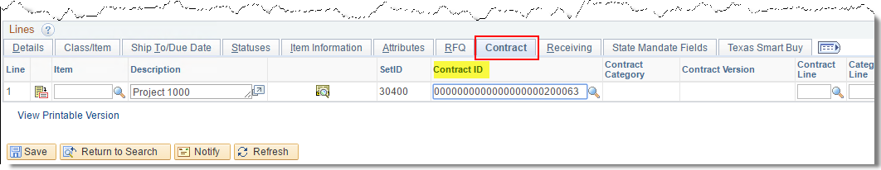
- Save the PO. You will likely receive a message asking if you are sure you want to delete the bid information. Click 'Yes'. The HUB information you entered on the Contract will populate in the HUB information on the PO.
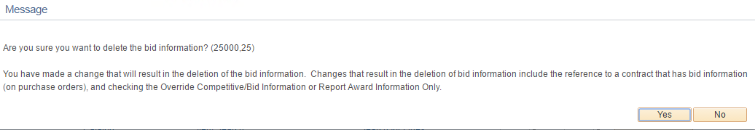

- Navigate to the Contract: Main Menu >Procurement Contracts >Add/Update Contracts
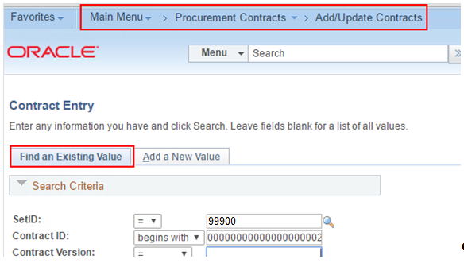

- Note the amount of the Purchase Order shows up in Total Released Amount:
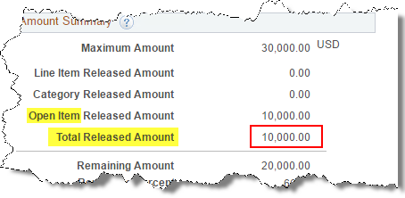
- The "Open Item" Released Amount simply refers to the fact that you are not using an a contract using “Open Items” (header only contract). If you are using contracts at the line level, the Line Item Released Amount section will be displaying. In those instances, you will also need to refer to a contract line for the association at the requisition or Purchase Order assignment (contract + contract line).

