This document shows an example of a Non-PO voucher being routed through one Approval Level

Scenario: Enter a Voucher, Submit for Approval, and the designated approver will approve the voucher.

The AP Entry person will enter a Voucher – it will be put into an Approval Status of “Pending.
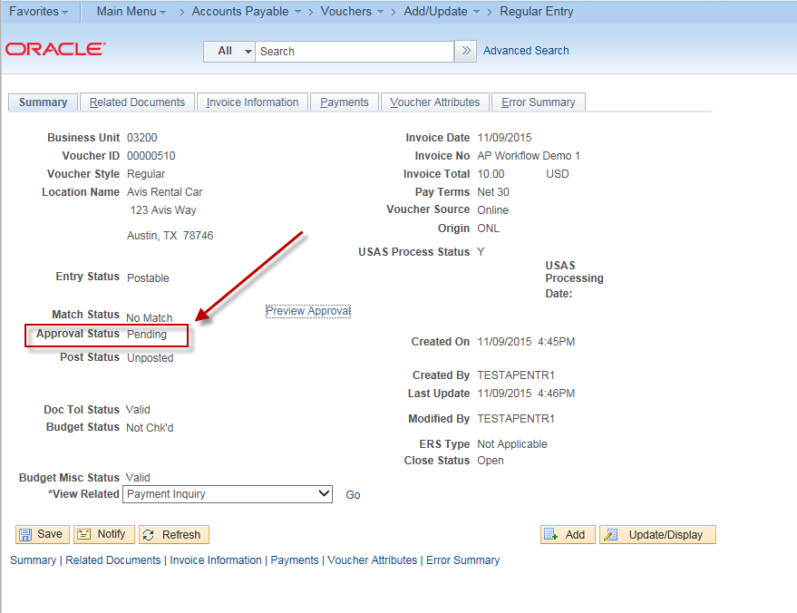

The AP entry person can add attachments to the voucher and choose whether or not the approver will be able to see them:
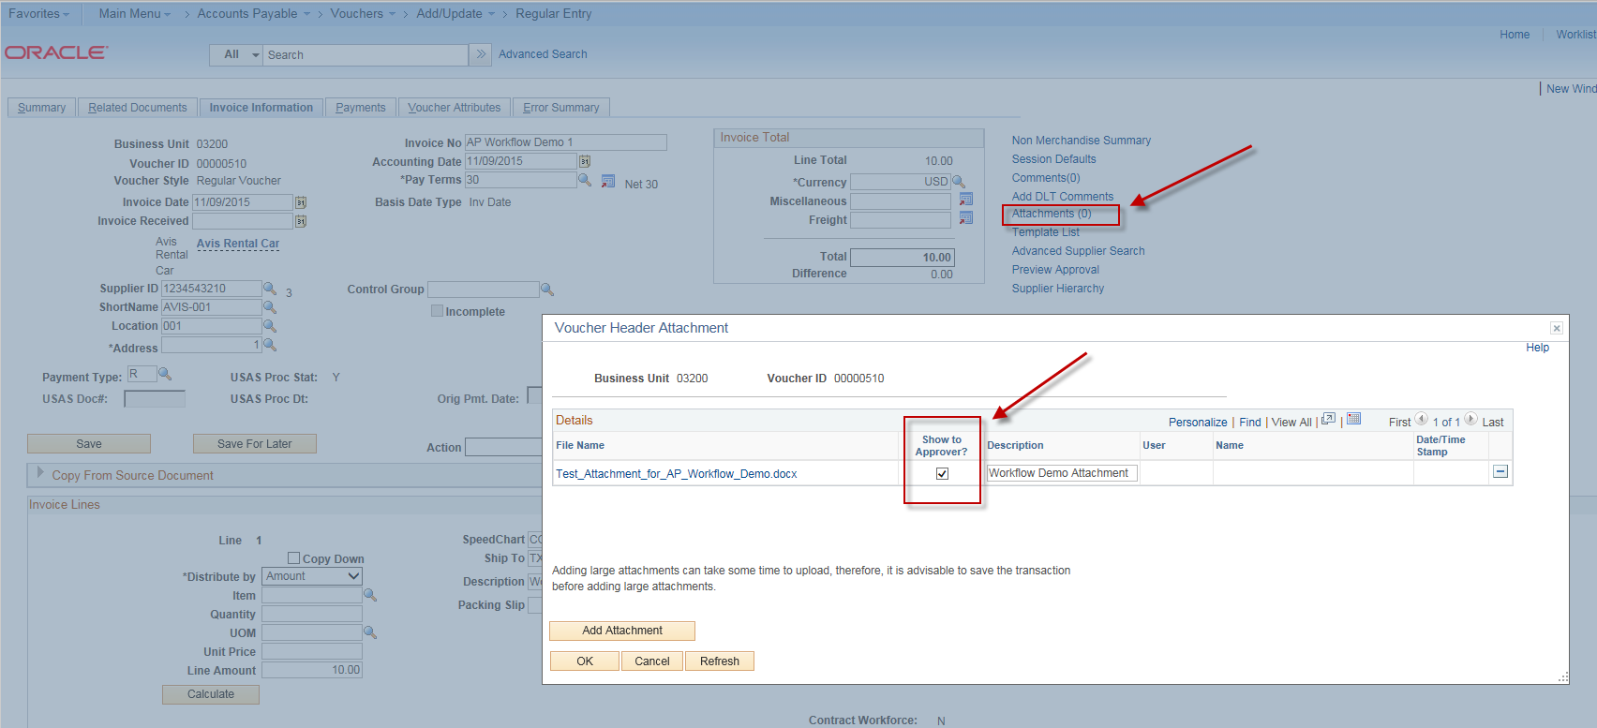

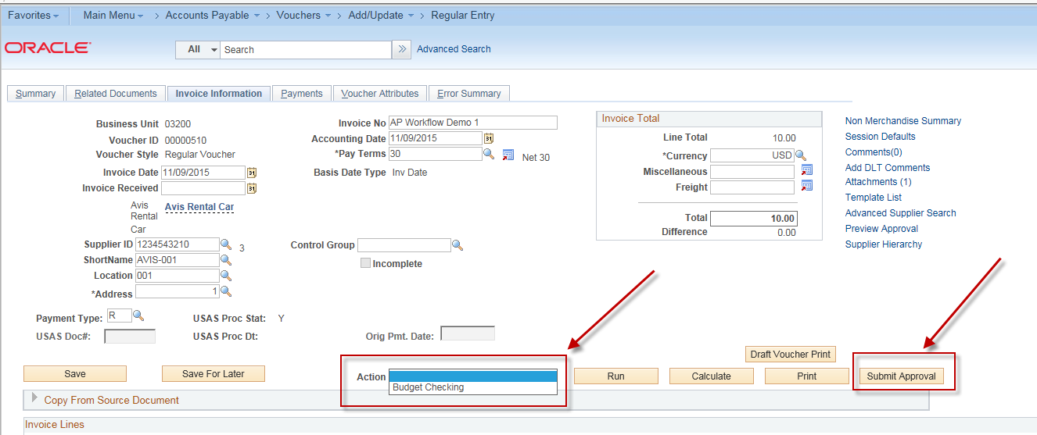
You can specify in the AP Workflow set up that the Budget Checking (for All Vouchers) and Doc Tolerance (for PO vouchers) must be run before submitting the voucher for approval. (“This is a business decision”).

But you CANNOT run Voucher Post before the voucher has been approved.

In this example, after saving the voucher we ran “Budget Checking” and the Budget Status is “Valid”:
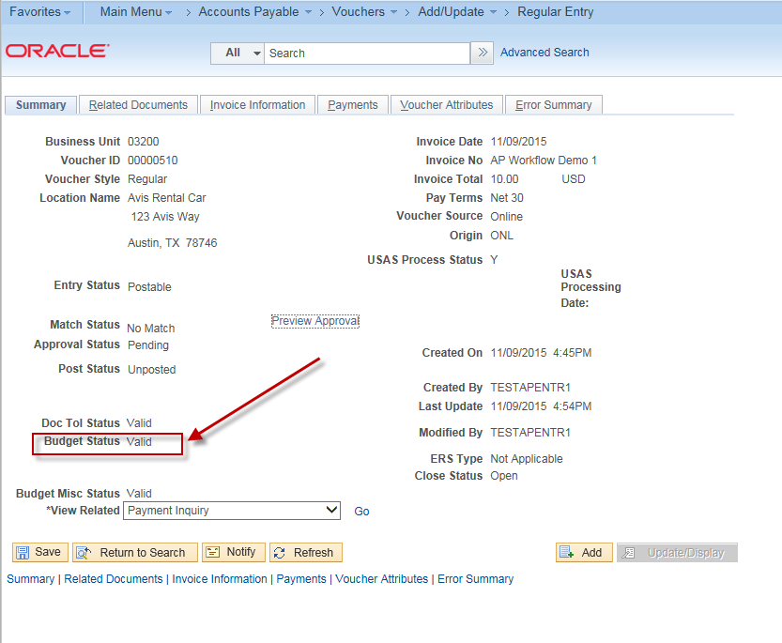
The voucher entry person must click on the “Submit Approval” button in order for this voucher to be routed to the appropriate approver.
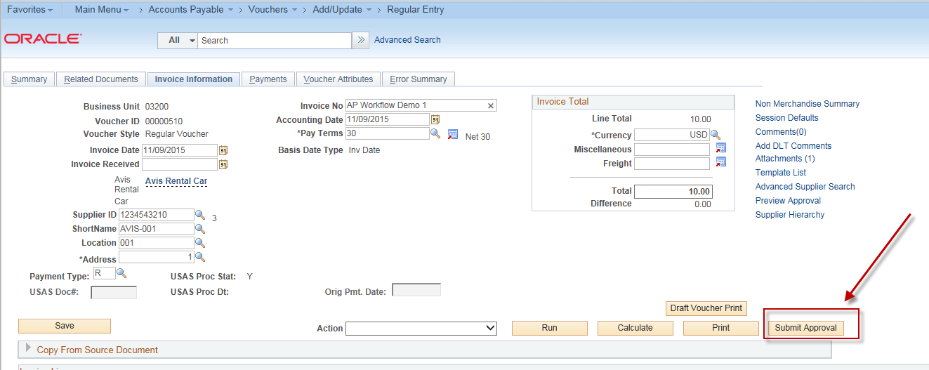

After the voucher entry person clicks on “Submit Approval” button, they can enter a comment
Then click “Ok”. The approver will see this comment on the voucher approval page.
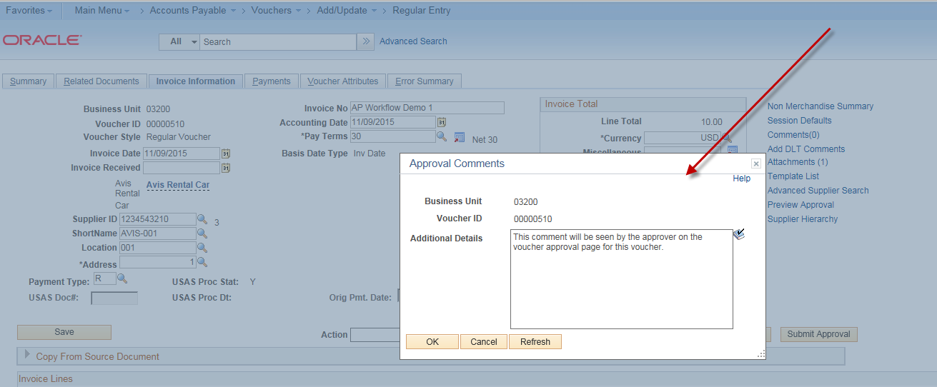

You have the option of turning on email notifications or leaving them turned off. (“This is a key decision”)
Some agencies find that the the approval emails can begin to cause too much clutter in their email inbox.

If email notifications are turned on, an email will be sent to the Level 1 Approver(s).
(Email notifications are not turned on in our current training environment, however, here is an example of the email contents from another demo):
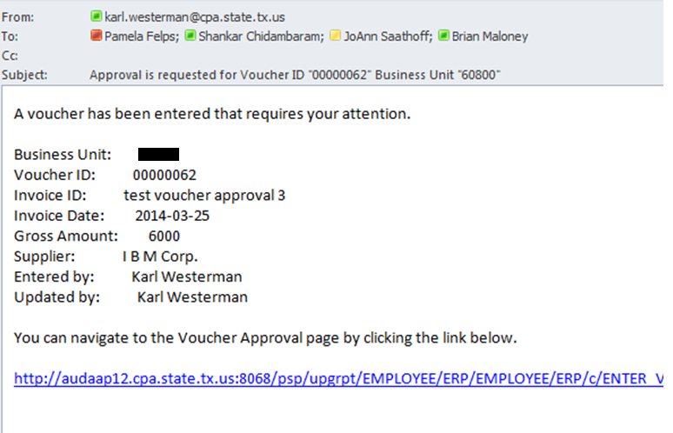

Note: The “from” email address will be from the system email, not the AP voucher entry person, therefore, you should not reply to this email.

The link will take the approver to their CAPPS sign on screen where they will have to enter their CAPPS User Id and Password. When they sign in, they will go to their “Worklist”:
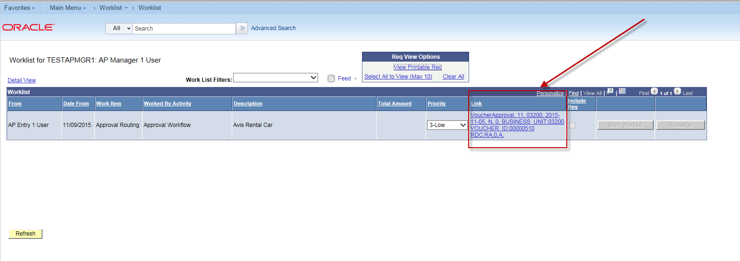
They will need to click on the link that pertains to the voucher that they want to approve.

It will take them to the approval page for that voucher. Here they can view voucher header, line, and GL coding information for the voucher. They can also view comments from the voucher entry person and attachments.
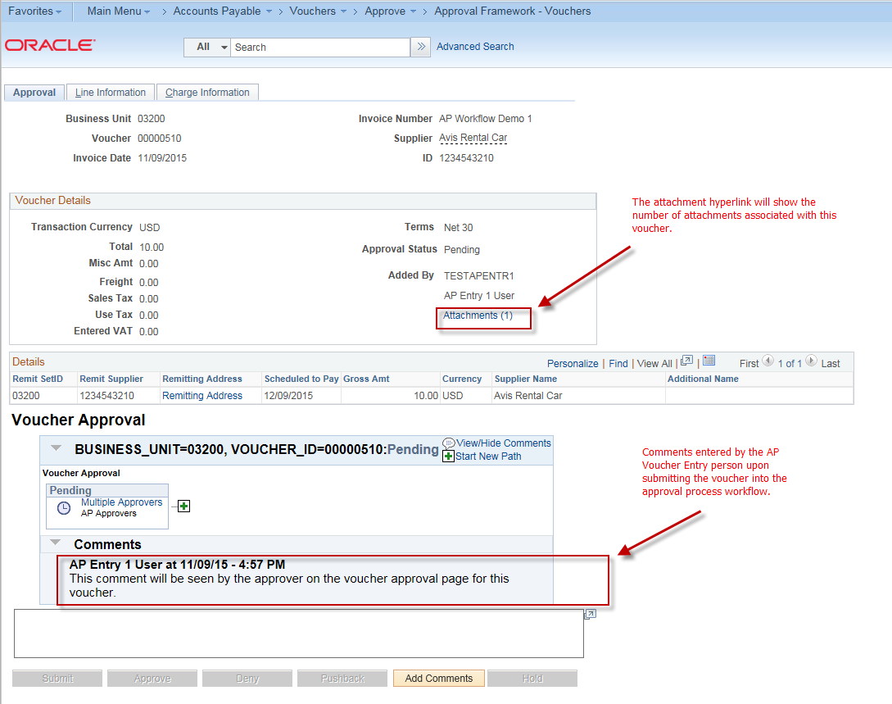

You can click on the “Multiple Approvers” hyperlink under the different approval level boxes and it will show a list of designated approvers for that level for that document.
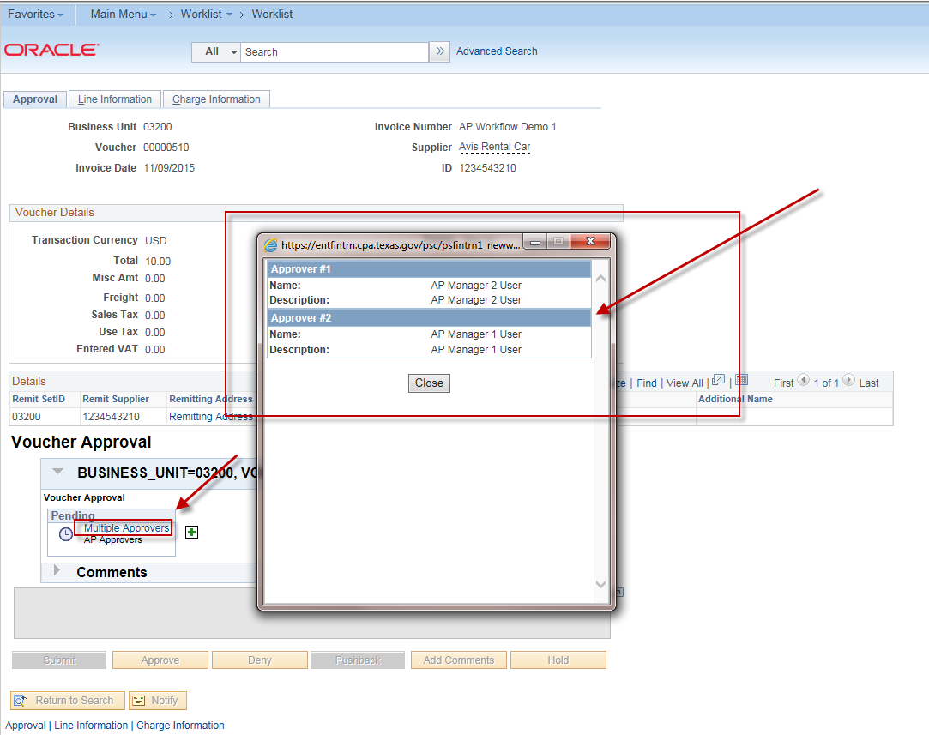

The approver can add a “Reviewer” or an “Additional Approver” for this voucher:
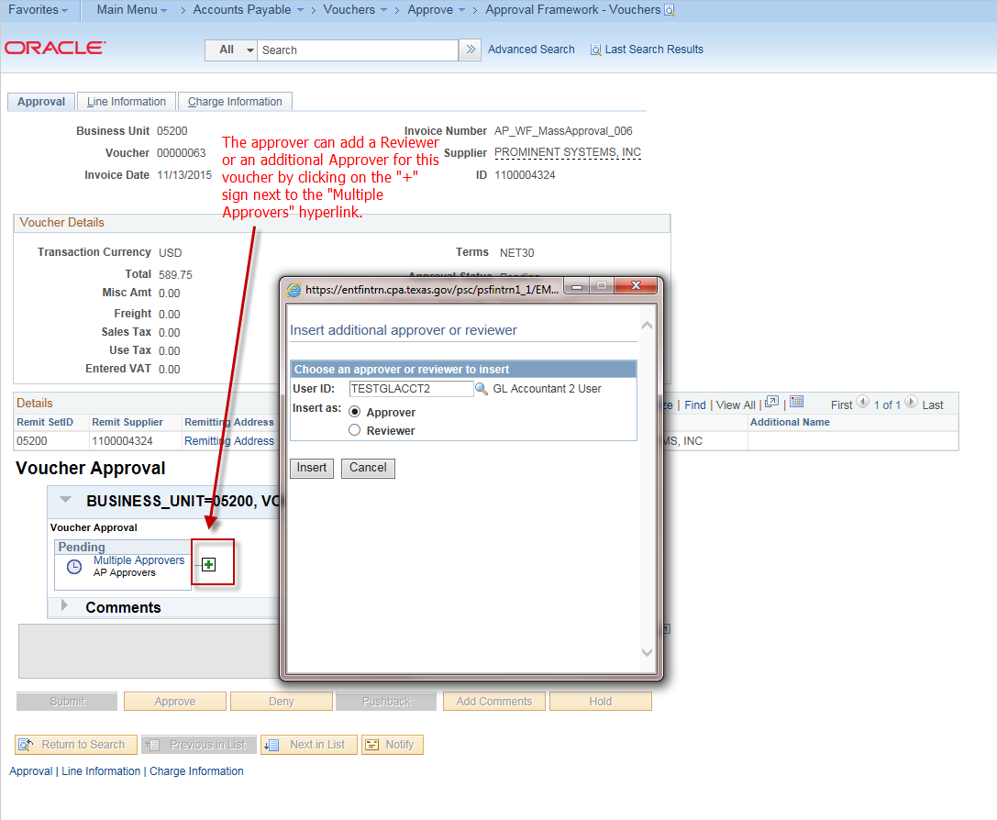

The approver can click on the “Line Information” tab and view information about the voucher line(s):
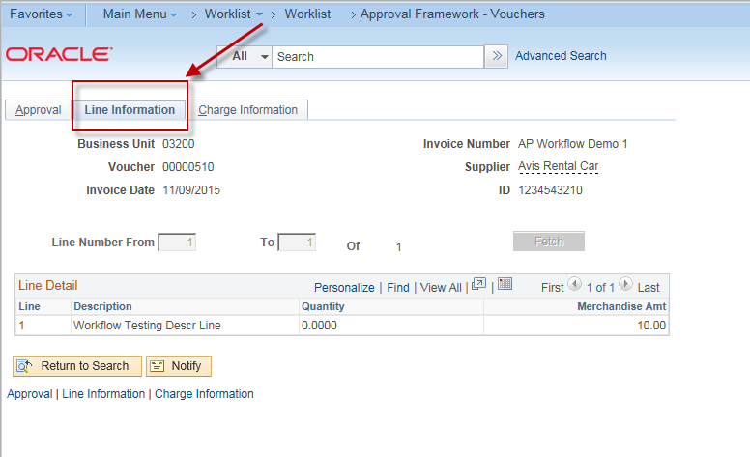
The approver can click on the “Charge Information” tab and view information about the GL Distrib Line(s) of the voucher:
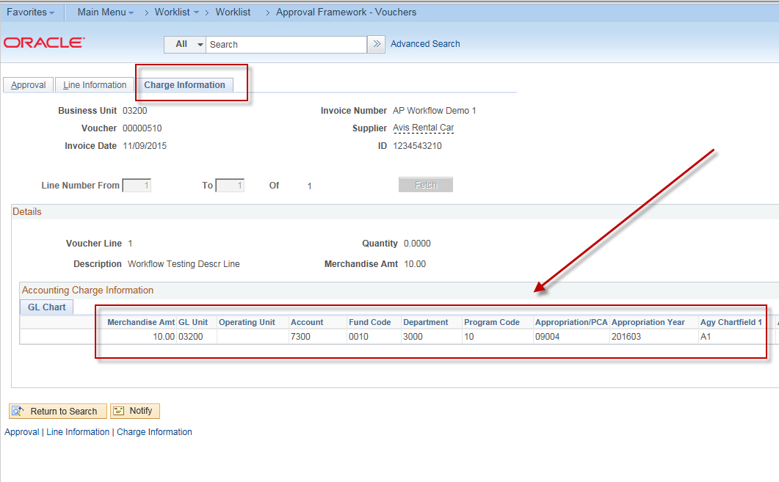

The Approver can add comments:
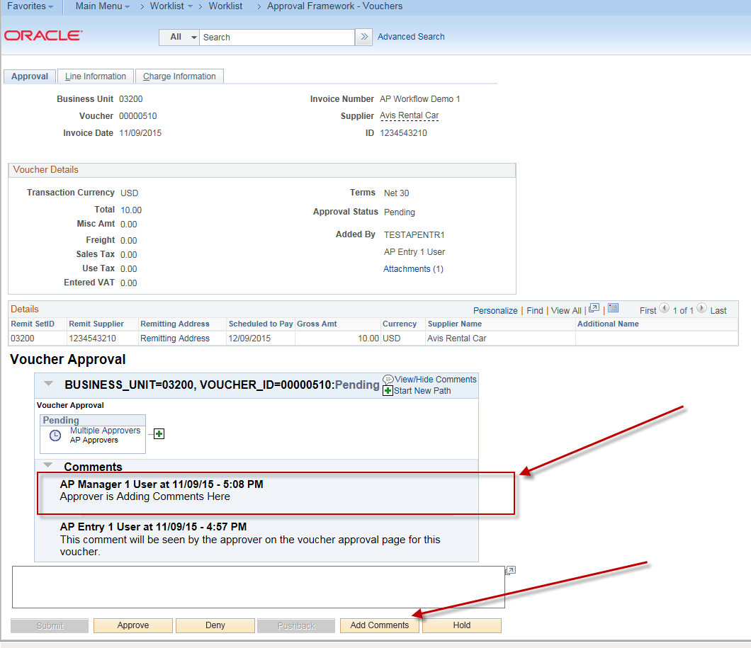

The approver clicks on the “Approve” button and the voucher is “Approved”.
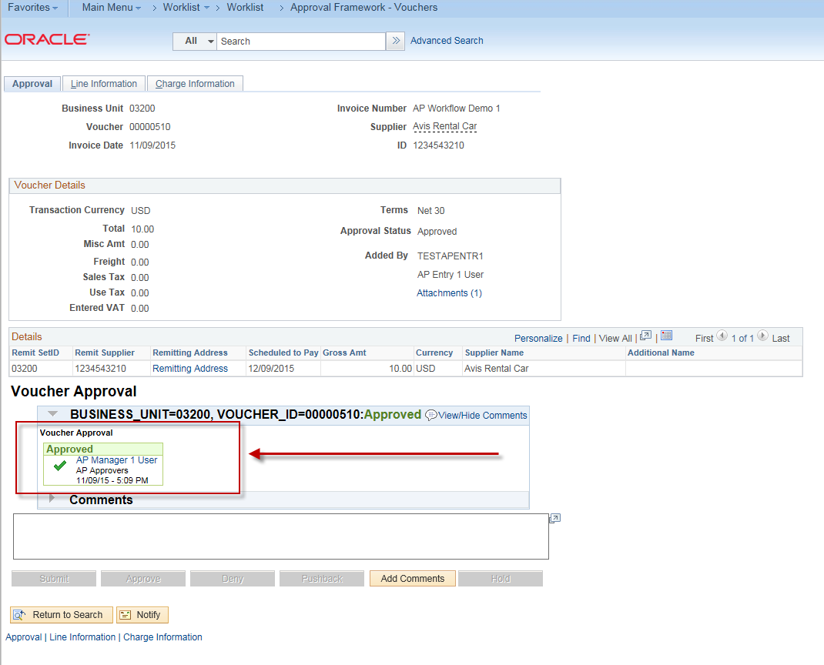

There are different approval actions available to the approver:
- Approve –
They approve the voucher and the voucher is sent to the next level of approvers or marked “Approved”, depending upon the number of approval levels required.
- Deny –
Approval of the voucher is denied and it is sent back to the AP Entry person for re-work
- PushBack -
Send back to the previous level approver and request that they do something additional with the approval.
- Hold – Approver can put voucher on hold until they are ready to Approve, Deny, or Pushback

The voucher drops off of the approver’s worklist after the approver has approved the voucher.
Note: It will also drop off of the approver’s worklist after the approver has denied it or pushed it back.
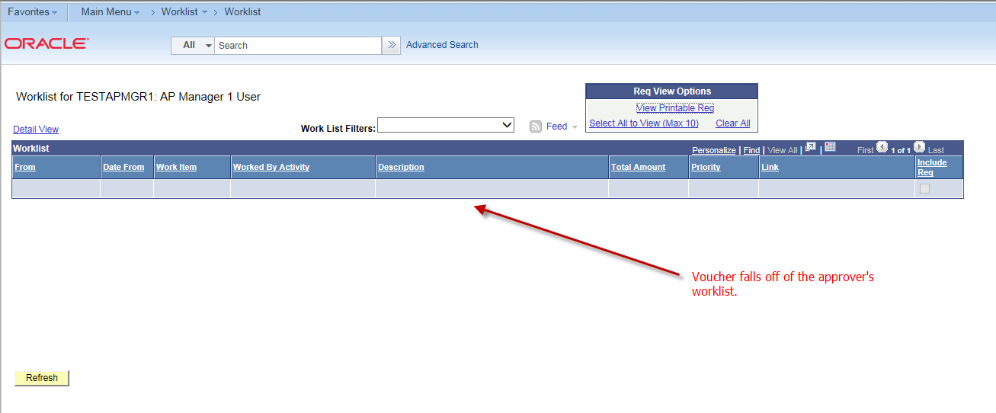

An email is sent to the AP voucher entry person:
(Email is not turned on in our current training environment, however, here is an example of the email contents from another demo):

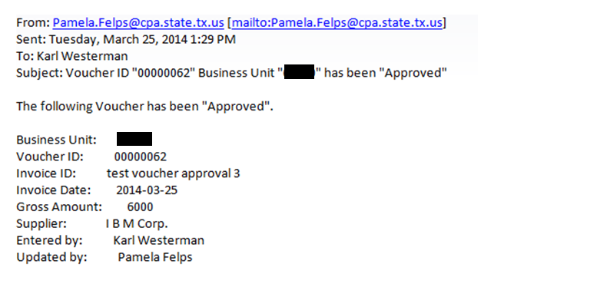

The voucher is in an “Approved” status:
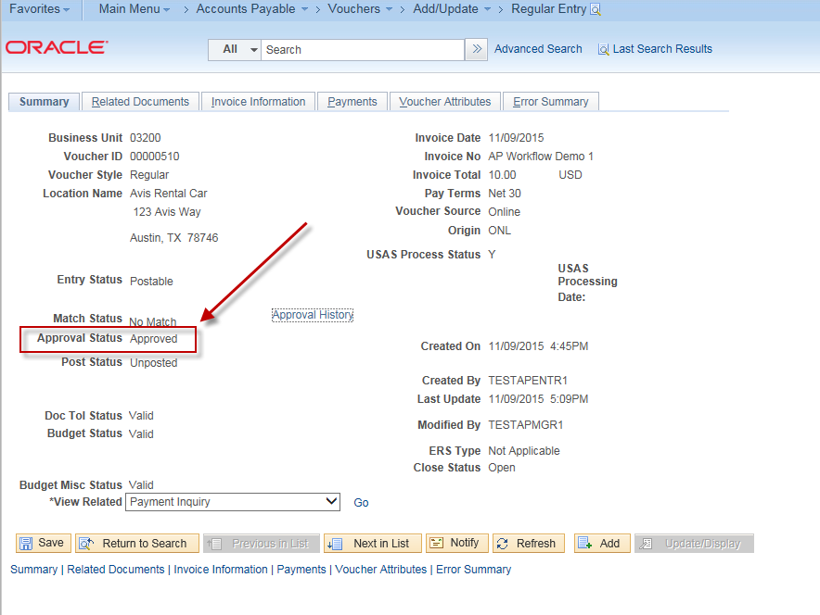
The voucher is available for posting:
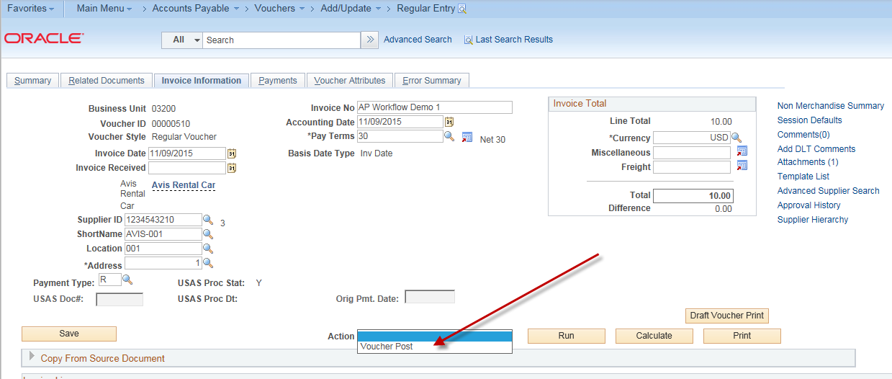

Mass Voucher Approval Page
Approvers can navigate here to perform approval actions on multiple vouchers at once
