Voucher Entry – PO Voucher - Copy and Pay the Whole PO
NOTE: Use this method ONLY if you are paying ALL of the lines on the PO for their FULL amounts.
- Main Menu > Accounts Payable > Vouchers > Add/Update > Regular Entry.
'Add a New Value'
Enter Supplier ID, Invoice Number and Invoice Date
Click “Add”.
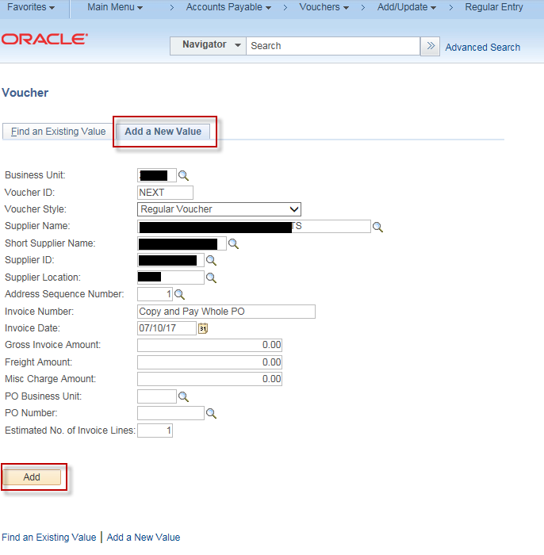

- On the Invoice Information page, click the triangle button to open
Copy From Source Document
Enter your business unit in the “PO Unit” field and select the PO you wish to pay in the “PO Number” drop down field.
Click the “Copy PO” button
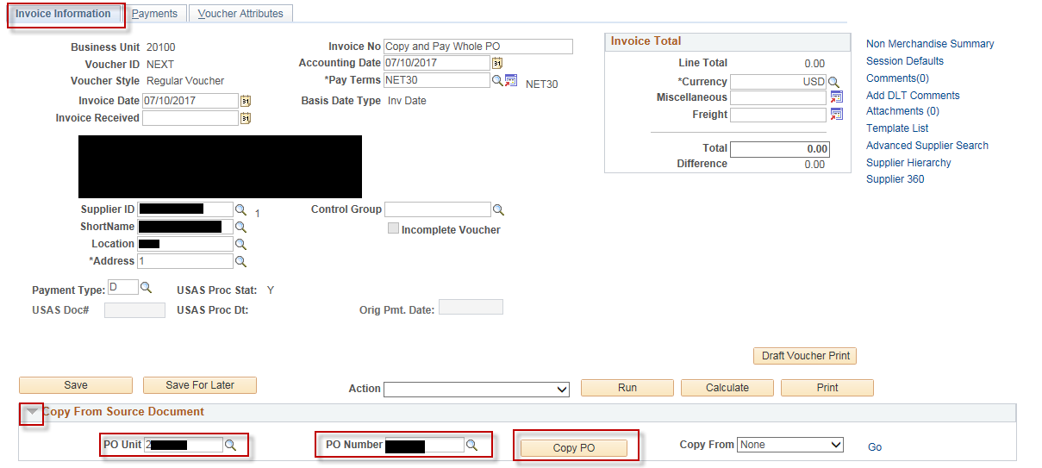

- Enter “Invoice Receipt Date”, “Service Date”, “Invoice Description”
Click “Save”
