Supplier - Add A New ITV State Agency Supplier in CAPPS
- Suppliers > Supplier Information > Add/Update > Supplier
- Tab: Add a New Value
Enter: SetID
Enter: Supplier ID (Must be a valid TINS number)
Enter: Persistence (should always be “Regular”)
Click: Add
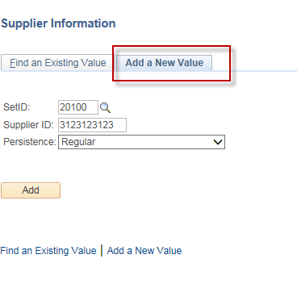
- Tab: Identifying Information
Enter: Supplier Name, Supplier Short Name
Select: “State Agency” in the Classification box
Verify: Persistence is “Regular”
Verify: “Open for Ordering” box is checked on
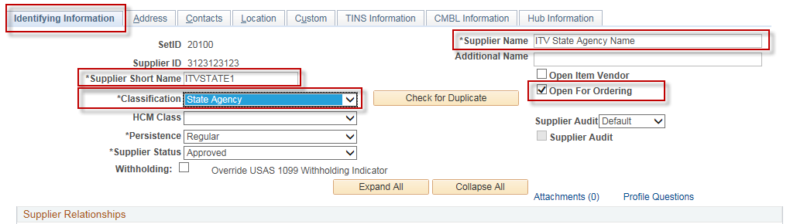
- Tab: Address
Enter: Description (Optional), Address 1, City, Postal (Zip), State
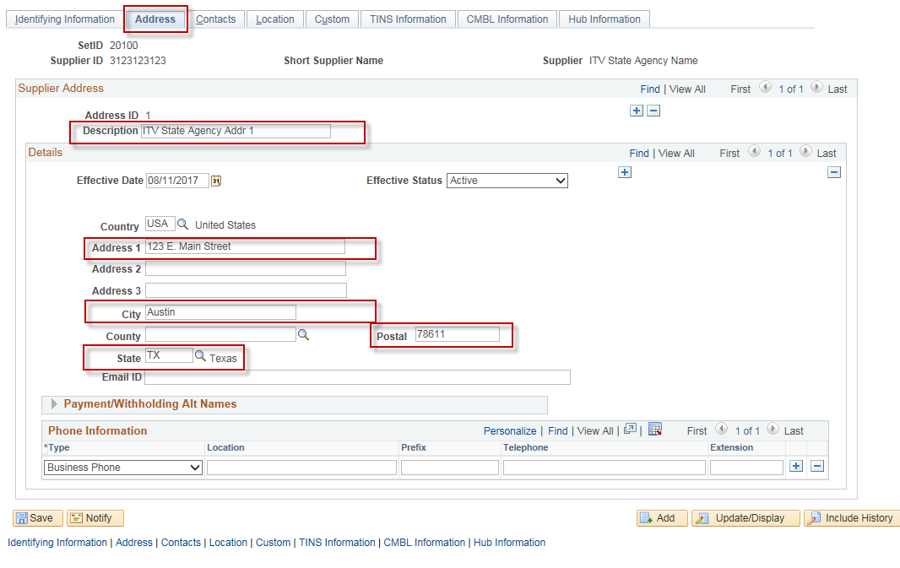
- Tab: Location
Enter: Location (Mailcode)
Enter: Description (name that you will see on the CAPPS voucher entry page)
Verify: Address box is populated with “1”
Verify: Default box is checked on.
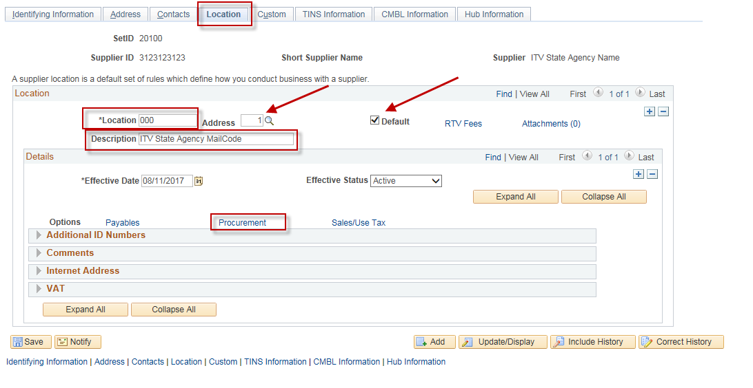
If you want vouchers that are entered for this vendor to automatically default to an accounting entry template of “ITV DOC T”, then click on the “Procurement” hyperlink and do the following:
(NOTE: The “ITV DOC T” accounting entry template will assign a TCode of 225 and a Doc Type of “T” to the voucher. There are additional job aids that describe in more detail how this works. See “CAPPS Configuration - How USAS Document Types are Assigned to Vouchers” and “AET List for Courts” if you are interested in a more detailed explanation)

Click on the arrow next to “Additional Procurement Options” to expand that section.
Select “Specify at this level” in the “Accounting Options” box.
Select the “ITV DOC T” template in the “Accounting Template” box.
Click “OK”.

IMPORTANT: If you have more than one location for this vendor, then you must click on the “Procurement” hyperlink for EACH location and do these steps.
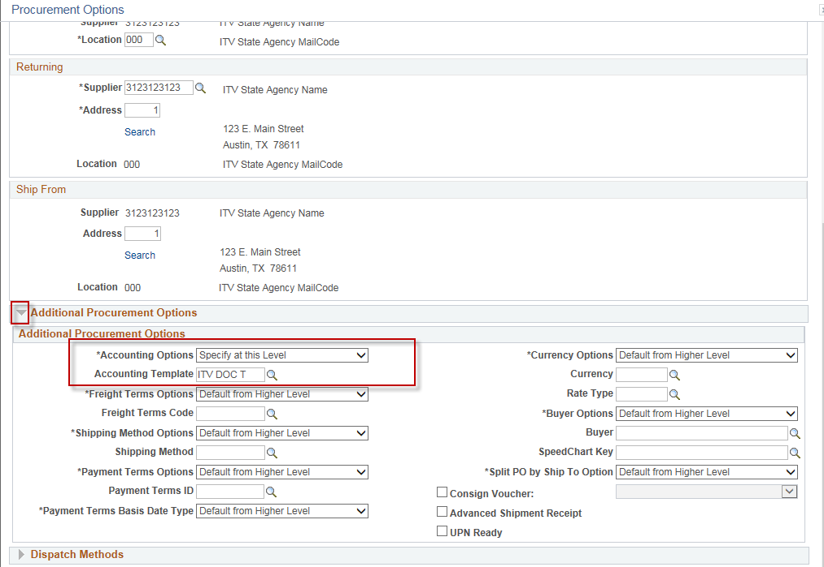
- Tab: TINS Information
In the “Vendor Ownership Information” section:
- Select “U” in the “Ownership Type” box
In the “Vendor Location Information” section:
- Enter the “Location Name” (name that will be displayed on the printed Voucher).
- Select “T” in the “Payment Type” box
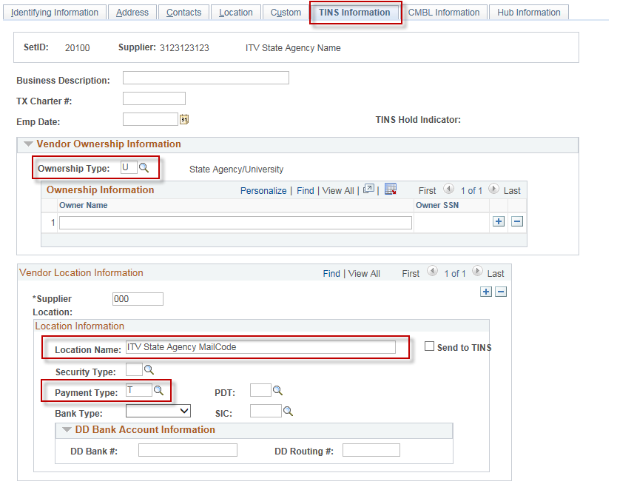
- Click: Save.

