Supplier- Add A Location to an Existing ITV Supplier in CAPPS
- Suppliers > Supplier Information > Add/Update > Supplier
- Tab: Find an Existing Value
Enter: SetID, and one or more Search Parameters such as all or part of Supplier Name or Supplier Id
Click: Search
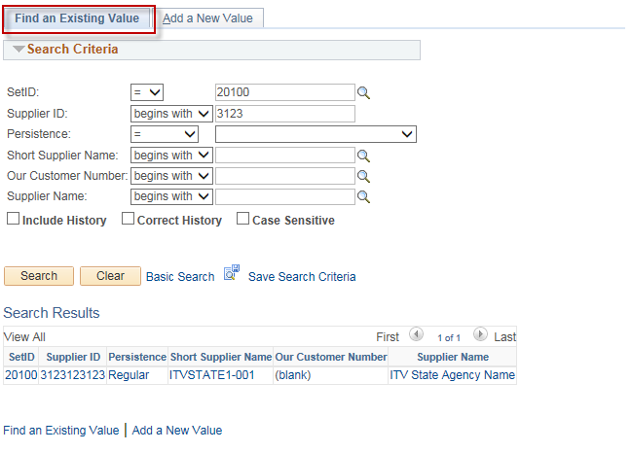
- Select your supplier from the Search Results list by clicking on it:
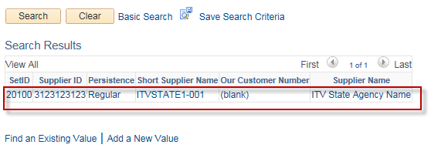
- Tab: Address
Action: Click on the “+” in the “Supplier Address” section
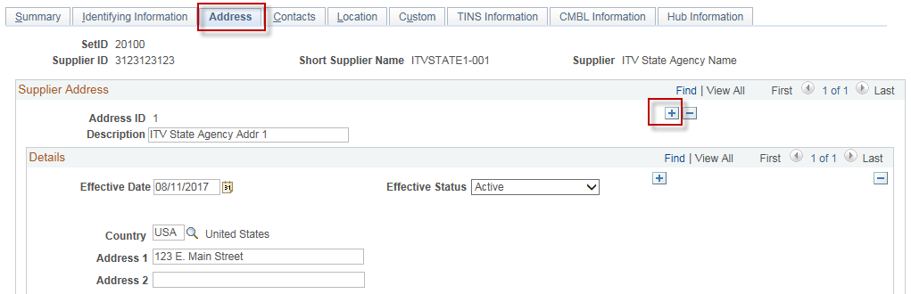

- Enter: Description (optional), Address 1, City, Postal (Zip), State
Click: Save
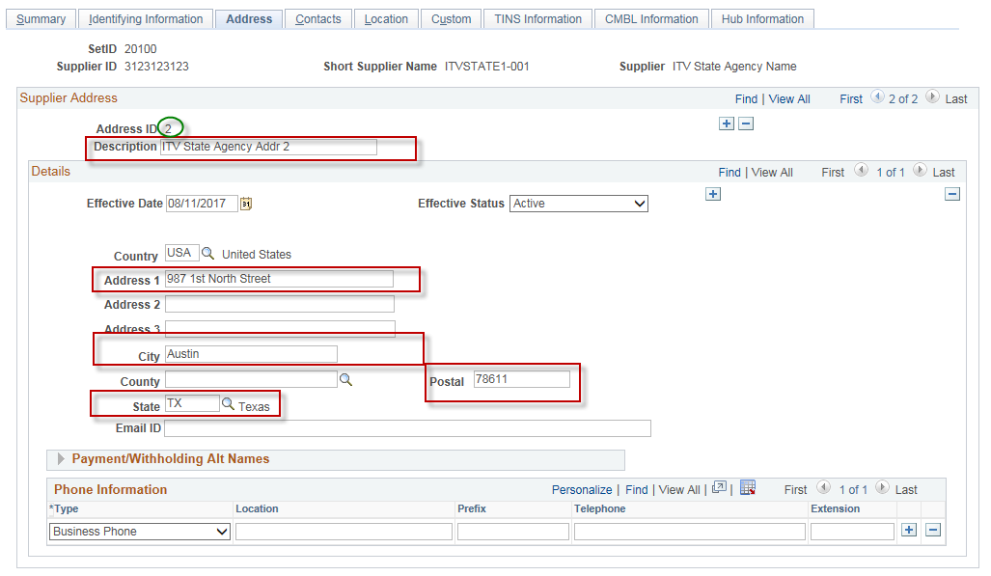Notice that you now have an additional Address ID, in this example it is Address Id #2.
Your next step will be to add a new Location to this vendor that references this new Address Id #2.
- Tab: Location
Action: Click the “+” in the “Location” section
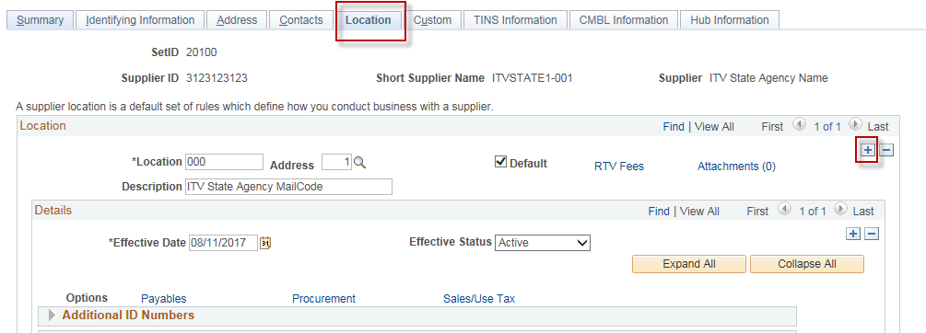

Enter: Location (Mailcode), Description (you see this when entering vouchers in CAPPS)
Select: The new Address in the “Address” drop down. (In this example it is Address Id #2).
Optional: Click on “Default” if this is the new default location for this vendor, otherwise, leave it unchecked.
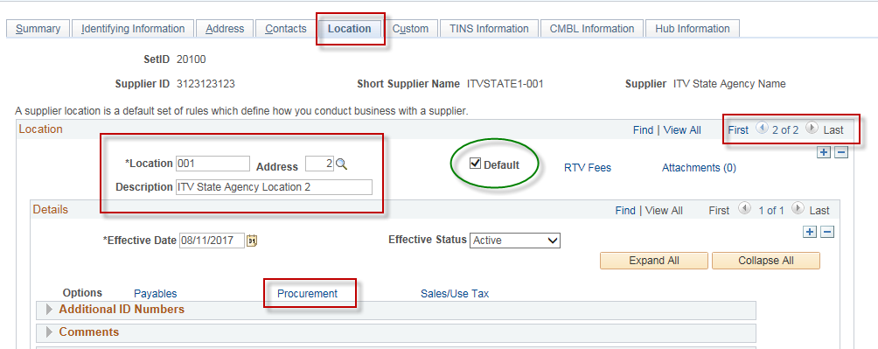
Click on the “Procurement” hyperlink.
Click on the arrow next to “Additional Procurement Options” to expand that section.
Select “Specify at this level” in the “Accounting Options” box.
Select the “ITV DOC T” template in the “Accounting Template” box.
Click “OK”.

IMPORTANT: If you have more than one location for this vendor, then you must click on the “Procurement” hyperlink for EACH location and do these steps.

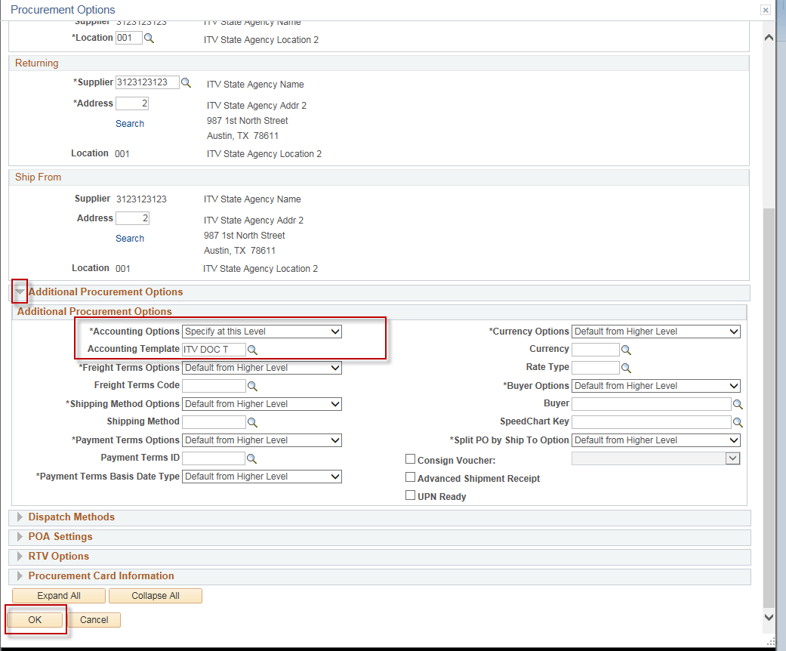

- Tab: TINS Information
In the “Vendor Location Information” section:
- Enter the “Location Name” (name that will be displayed on the printed Voucher).
- Select “T” in the “Payment Type” box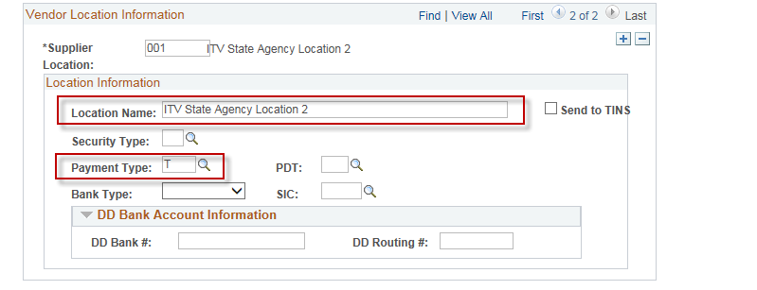
- Click: Save.

