Entering an Asset Profile
Purpose: Use this job aid to add an asset profile to default depreciation methods, estimated life and description for assets. An Asset Profile is only setup for SPA Classes that are used for an agency asset processing.
- Review SPA Class Definition.

https://fmx.cpa.state.tx.us/fmx/pubs/spaproc/appendices/appa/index.php#classcodes

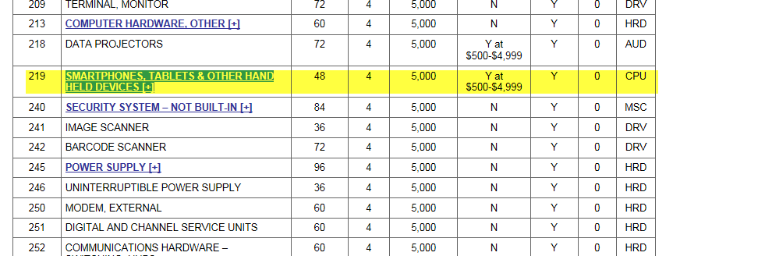

- Add Asset Profile- Definition
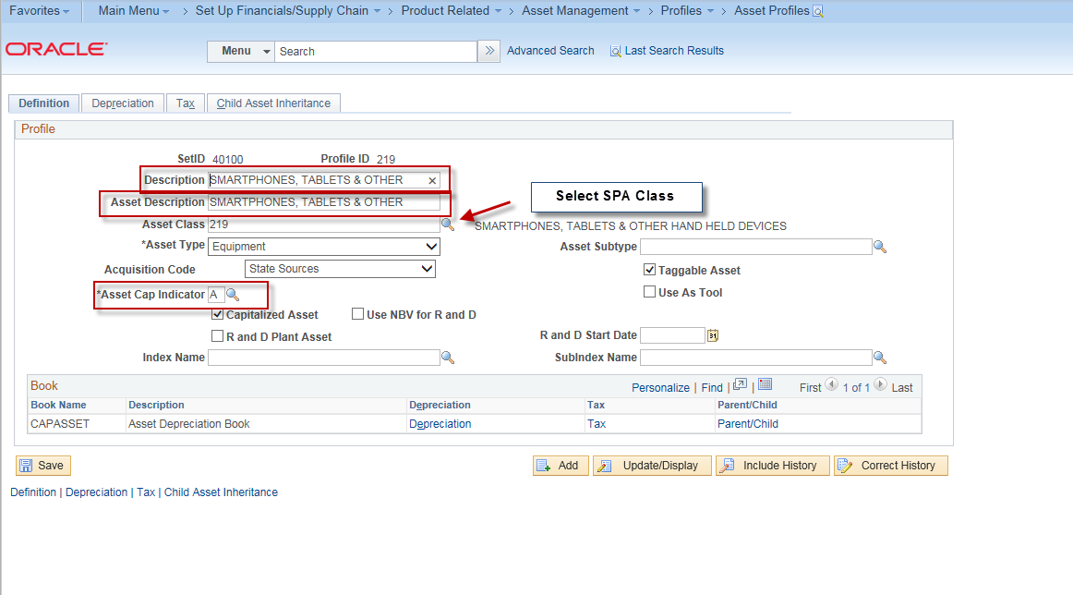
- Enter Description- this is the SPA Class description.
- Enter Asset Description
- Select SPA Class
- Enter the Asset Type
- Enter the Acquisition Code, most of time this is State Source
- Asset CAP indicator = A- Always Capitalized.

- Add Asset Profile- Depreciation

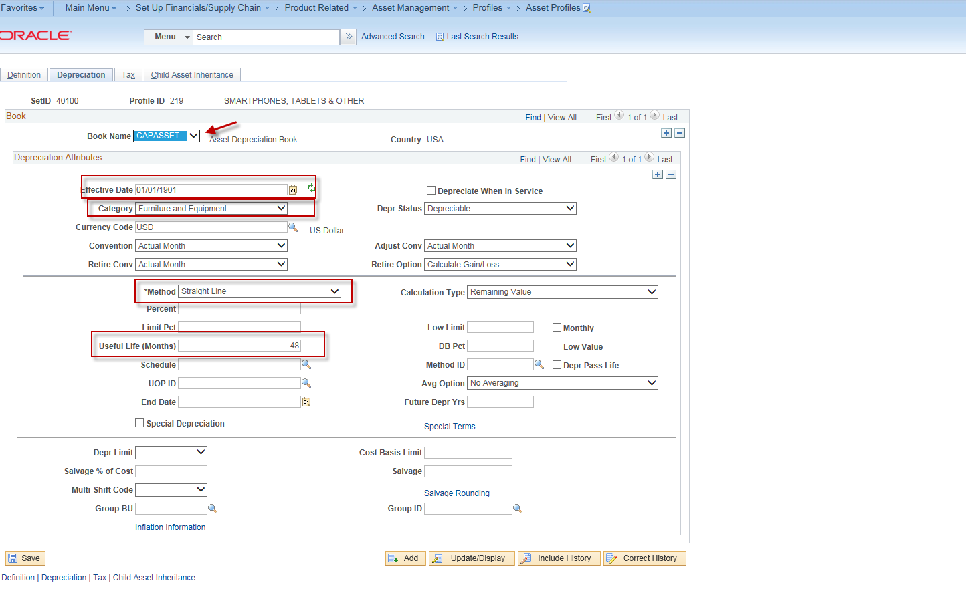

- Enter Effective Date 01/01/1901
- Enter the Category (SPA AFR) = Per SPA Class Definition
- Enter method = Straight Line.
- Enter Useful Life = Per SPA Class Definition
- Click SAVE.

