CAPPS to SPA Reconciliation
Purpose: Use the CAPPS to SPA Reconciliation when comparing CAPPS assets to SPA assets to identify assets missing in CAPPS not in SPA, etc. It is recommended that this process be run after each run of the CAPPS to SPA Integration (SPA002).
The CAPPS to SPA Reconciliation is run in two steps.
Step 1: Run the CAPPS to SPA Reconciliation to compare SPA to CAPPS and build reconciliation table.
Navigate to SPA Reconciliation Report
Main Menu>CAPPS Statewide>Statewide Interfaces>SPA Reconciliation Report
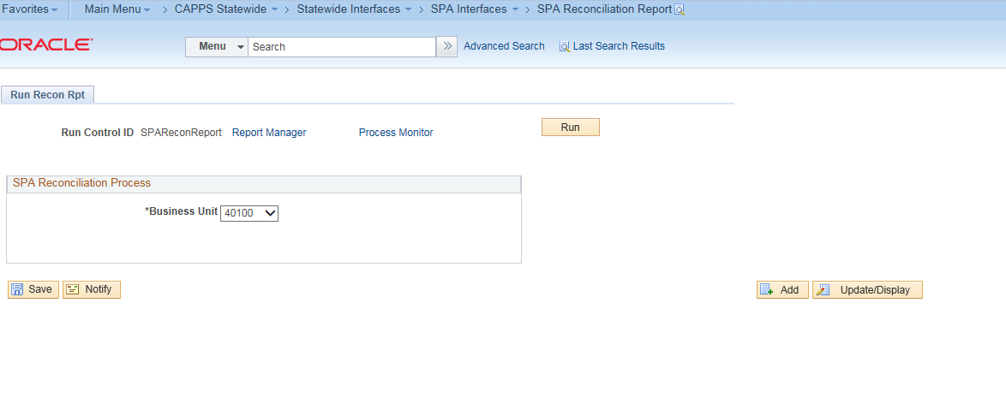
Enter Business Unit
Click Run
Click Process Monitor

Review Process Monitor
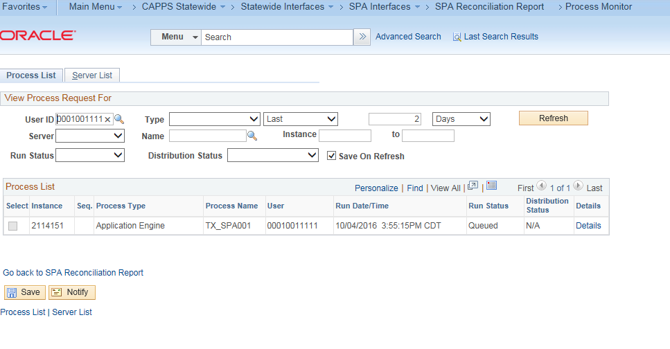

Success, Job is Complete.

Step 2: Run the Business Objects reports SPA Reconciliation Report
Navigate: CAPPS Financials Statement Reports>Asset Management>SPA Reconciliation
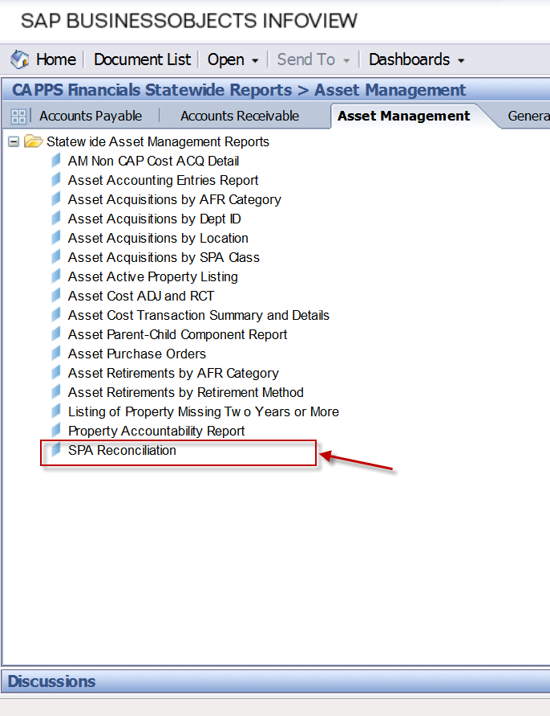
SPA Reconciliation Report is displayed
