Change an Asset Custodian
- Navigation: Main Menu > Asset Management > Asset Transactions > Owned Assets > Basic Add
- Enter: Business Unit, asset ID or any other search criteria, then Search. The asset General Information page is displayed.
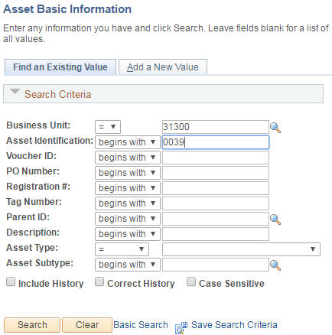
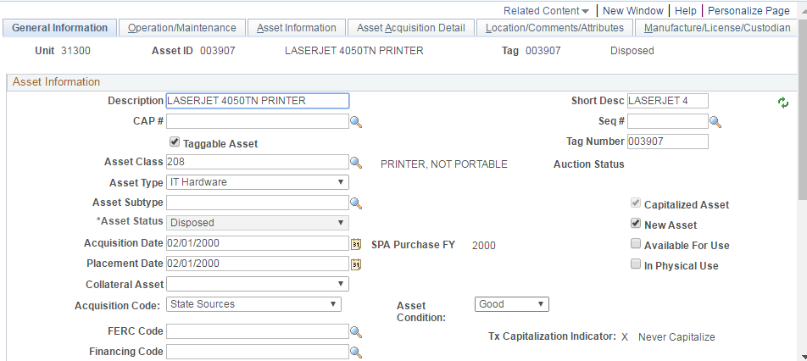

- Navigate to Manufacture/License/Custodian tab to change an asset custodian. Click the “+” icon in the upper right hand corner of the “Custodian” section.
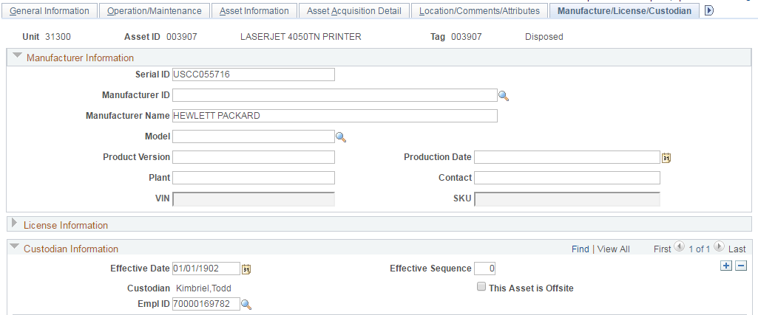

- When a new custodian is added, the count of the custodians is changed from “1 of 1” to “1 of 2”. The Effective Date defaults to today’s date. Select a new custodian using the Custodian field lookup icon. The new custodian Empl ID and the name are displayed. The newer custodian is always at the top of the Custodian Information section.
Click View All to see all the Custodians.
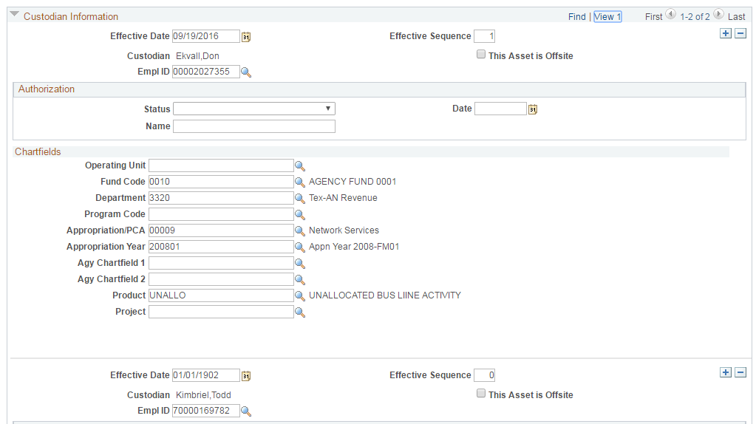
211
1
111
1
- Press the Save button to save the updated custodian.

