Running Business Objects Reports Job Aid

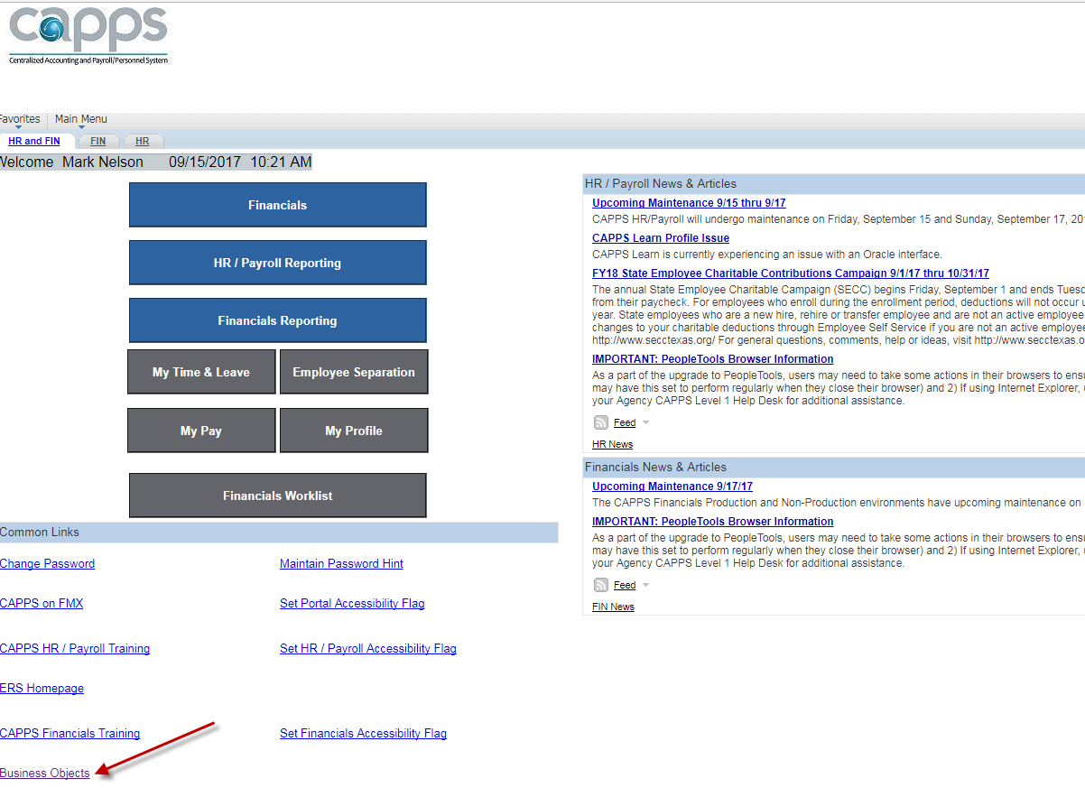

To Access Business Objects for the Statewide CAPPS Reports you will click on the hyperlink on the CAPPS Portal.

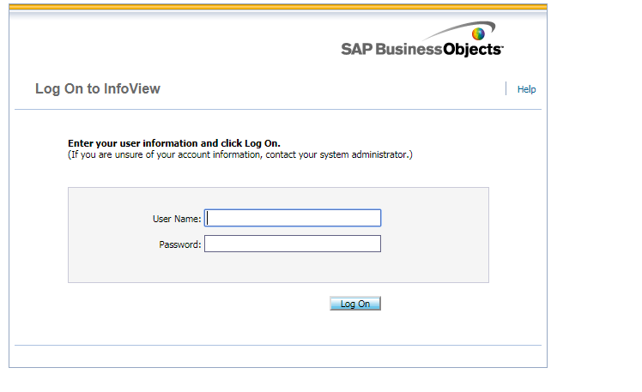
To login to Business Objects, the User Name is the same as your CAPPS User ID and your Business Objects password.
If you require a password reset, please send an email to Project One Security ProjectOne.Security@cpa.texas.gov.

The navigation for CAPPS Statewide Reports is as follows:
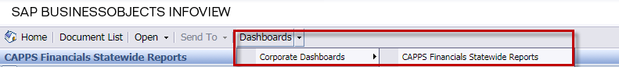

To run a specific report, you select the report name found in the CAPPS module folder General Ledger, Accounts Payable, Purchasing, Asset Management.
For example, to run the Asset Active Property Listing you will select the report here.
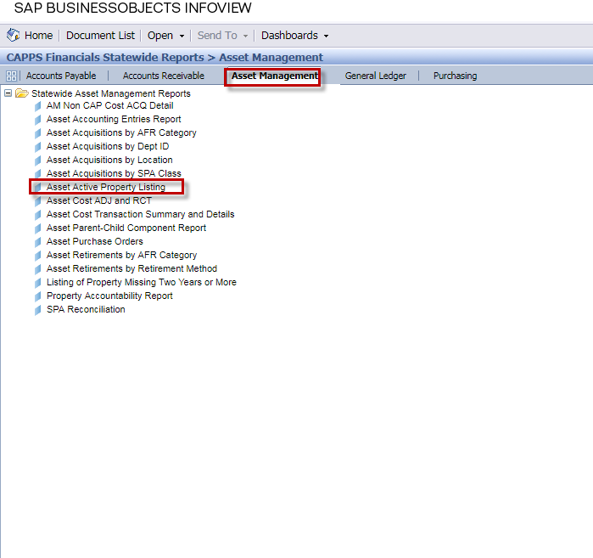
Select Report and the Prompt Values are displayed.
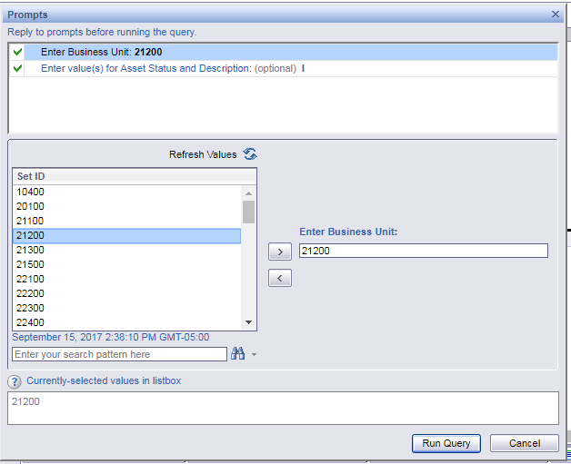
Enter the Report Criteria to run Business Objects report. i.e. Business Unit and then Run Query.

