Common Issues

County and District Monthly Court Activity Reports

Look for numbers that are
  - Too high,
  - Too low, or
  - Otherwise do not make sense

Easily Identifiable Issues
- Critical issues–missing sections and math errors–are identified on your Main page
- If you report Criminal activity, a Hate Crimes report must be submitted each month

- When a report for the previous month has not been submitted, it often leads to docket adjustments in the next month’s report

- A large number of docket adjustments or significant increase in the number of cases reported pending is often the result of numbers being entered incorrectly entered in the Docket Adjustment line

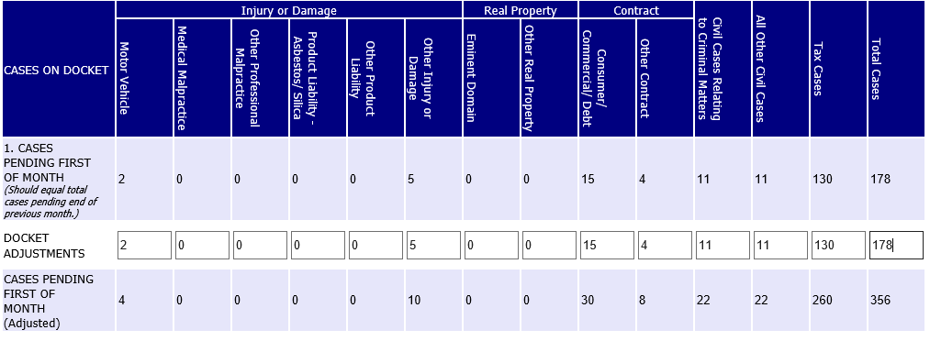

If the large number of cases in the Docket Adjustment line is correct, an explanation should be entered in the Notes field at the bottom of the report.

- Zero in categories where you know there has been activity

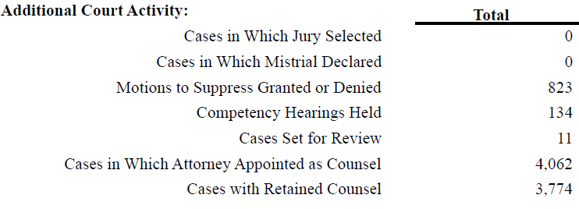

- A large number of cases under All Other Dispositions in any section
The number of cases reported under All Other Dispositions should be very small relative to the other categories, except in the Civil Cases Related to Criminal Matters category.

- A large number of Directed Verdicts in the Civil or Family section
Directed verdict: Rule 301, Texas Rules of Civil Procedure - The court may render judgment non obstante veredicto if a directed verdict would have been proper, and the court may disregard any jury finding on a question that has no support in the evidence.
Directed verdicts are rare, and the number should not be larger than bench and jury trials.

- The number of cases reported in the Criminal Sentencing section should roughly equal the number of cases reported under Convictions. The same rule applies to the Juvenile Disposition section, which should roughly equal the number of cases Adjudicated.
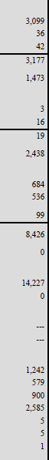
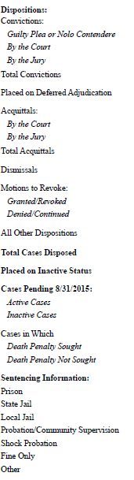
Sentences = 5,317
Total Convictions = 3,177
Sentencing Information should not include cases reported disposed of by
- Deferred adjudication
- Dismissals
- Motions to revoke
- All other dispositions

- A high number of Convictions by the Court compared to Guilty/Nolo Contendere Pleas
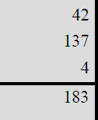
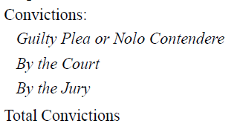
A case should be reported under Conviction by the Court only when the judge presides over a trial and finds the defendant guilty.

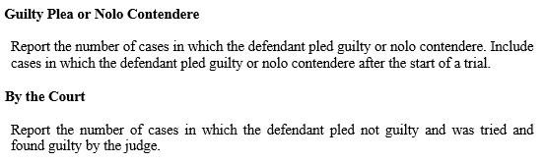

The same rule applies to juvenile cases.
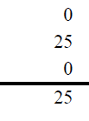
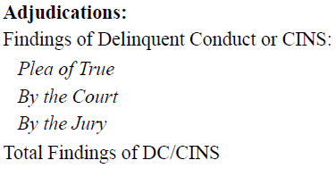

- No or low inventories, guardianship of person reports, annual/final accounts reported

- No active guardianships reported

Potential reasons for errors

Data entry errors
- Typos or numbers entered in wrong line or column
- Information not entered into case management system correctly (wrong codes entered) or at all (no disposition entered, inactive case not reactivated before disposing of the case)

Case management system issues
- Case management system mapping or programming issues
- Reports not programmed correctly
- Updates from new release result in unintended consequences

