Making Changes to the Monthly Court Activity Detail Report

Correcting Reports

Regardless of how the report was originally submitted, either by manually entering it or uploading an XML file, you may correct reports in one of two ways.

Correcting Reports Manually

* You may access the reports for the **current fiscal year** displayed on your Main Page.
* To access the reports for a prior fiscal year back to September 2010, choose **Monthly Report Search and Edit – New Data**. On the next screen you may choose one month or a series of months, then click on Search.

1. Click on the link for the report that you wish to edit.

2. Type in the changes wherever you need to.

3. Go to the bottom of the section and click on **Submit**.

Uploading a Corrected Report or Missing Section

If your case management system is able to generate a **corrected** XML file, you may upload the new information. If your system is not able to generate a corrected file, you may contact OCA to delete the existing report(s) so that you can submit the new information.

1. From the main page, select **View Electronic Submission**.

2. Click on **Browse**, select the corrected file and you will receive the message shown on the screen below. **DO NOT CLICK ON CONTINUE.**

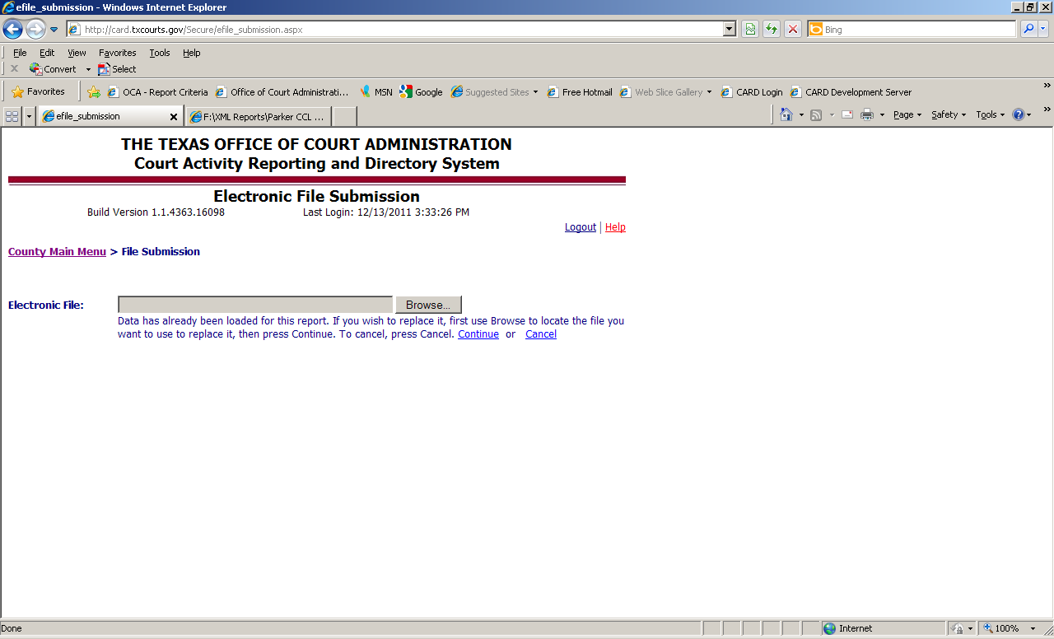

3. Click on **Browse** again, select the file again, then click on **Continue**.

4. Review the submitted report to make sure that nothing is flagged in red as out of balance. Any out of balance reports must be corrected.

Adding a Missing Section

Regardless of how the report was originally submitted, either by manually entering it or uploading an XML file, you may enter missing sections manually.

Making Changes Manually

* You may access the reports for the **current fiscal year** displayed on your Main Page.
* To access the reports for a prior fiscal year back to September 2010, choose **Monthly Report Search and Edit – New Data**. On the next screen you may choose one month or a series of months, then click on Search.

1. Click on the link for any section that has already been submitted for the month that you wish to edit.

2. Once the report is open, click on the tab for section that is missing and fill in the report.

3. Go to the bottom of the section and click on **Submit**.

Things to Keep in Mind

* **Corrections must be made sequentially**, starting with the oldest month first then moving forward to any subsequent months.
* After making corrections, it is strongly suggested that you review any reports that carry pending balances (civil, family, criminal, and juvenile) that were submitted for any month after the corrected report, as **corrections you make can affect the pending balances**.
* **After submitting missing reports, you must review any reports that carry pending balances** (civil, family, criminal, and juvenile) that were submitted for any month after the missing report. Since a report had been missing, there were no pending cases to carry forward from the previous month. As a result, the pending cases get put in the Docket Adjustment line. This must be corrected after the missing report is submitted.

