Running the Reports Received Report

Report Description: This report shows which monthly reports and sections of monthly reports have been received as well as any section of a monthly report that is “Out of Balance.”
- Go to http://card.txcourts.gov.
- Click Submit under the Clerks and Courts Only heading.
- Enter your Login ID and Password and click Login.
- Click Run Report – New Data.
- For Report Type, choose Management Reports. For Report, choose Reports Received and Court Type.
- Click Continue.
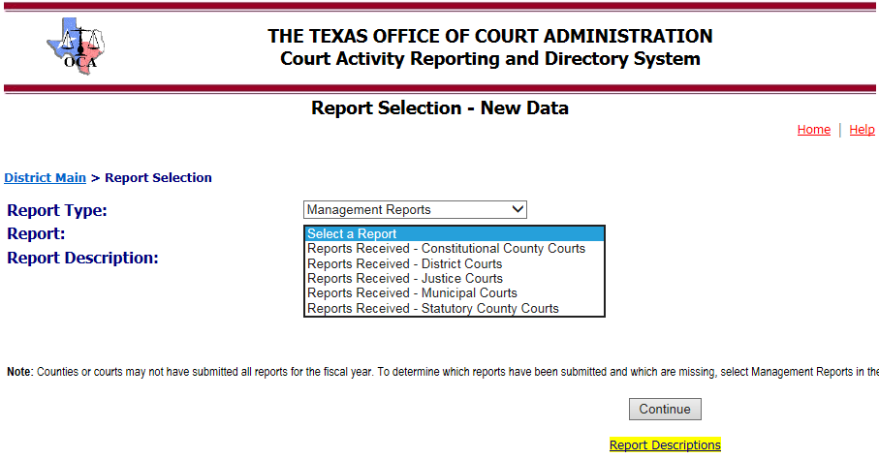
- For district, constitutional county, and statutory county courts, you may run the reports for FY 2011 and forward. You may also run the report for just one county. If you don’t choose a specific county, the resulting report will include all counties.
- For the JP and municipal courts, you may run the reports for FY 2012 and forward. If you don’t choose a specific court, the resulting report will include all courts.
- The format’s available for the report are Acrobat, Excel and Word. Acrobat provides the most printer friendly version. However, the Excel version allows you to make notes, sort, etc. This is the version that is recommended.
- Select Fiscal Year and County. Click Run Report.
-2-
The Reports Received report receive will show:
- * if the reports was received and is in balance
- # if the report has been received and is out of balance. Any report that has an “#” must be corrected. You will also see those reports flagged in red if you log in the database and do a search of reports in the fiscal year. Click Monthly Report Search and Edit – New Data to access reports for previous fiscal years.
- ? if the report (section) has not been received (is missing)
- Y will display after the section if it is required. (Remember that once you submit a section in one month it must be submitted in every month, even if there is no activity to report.)
- N will display after the section if it is not required
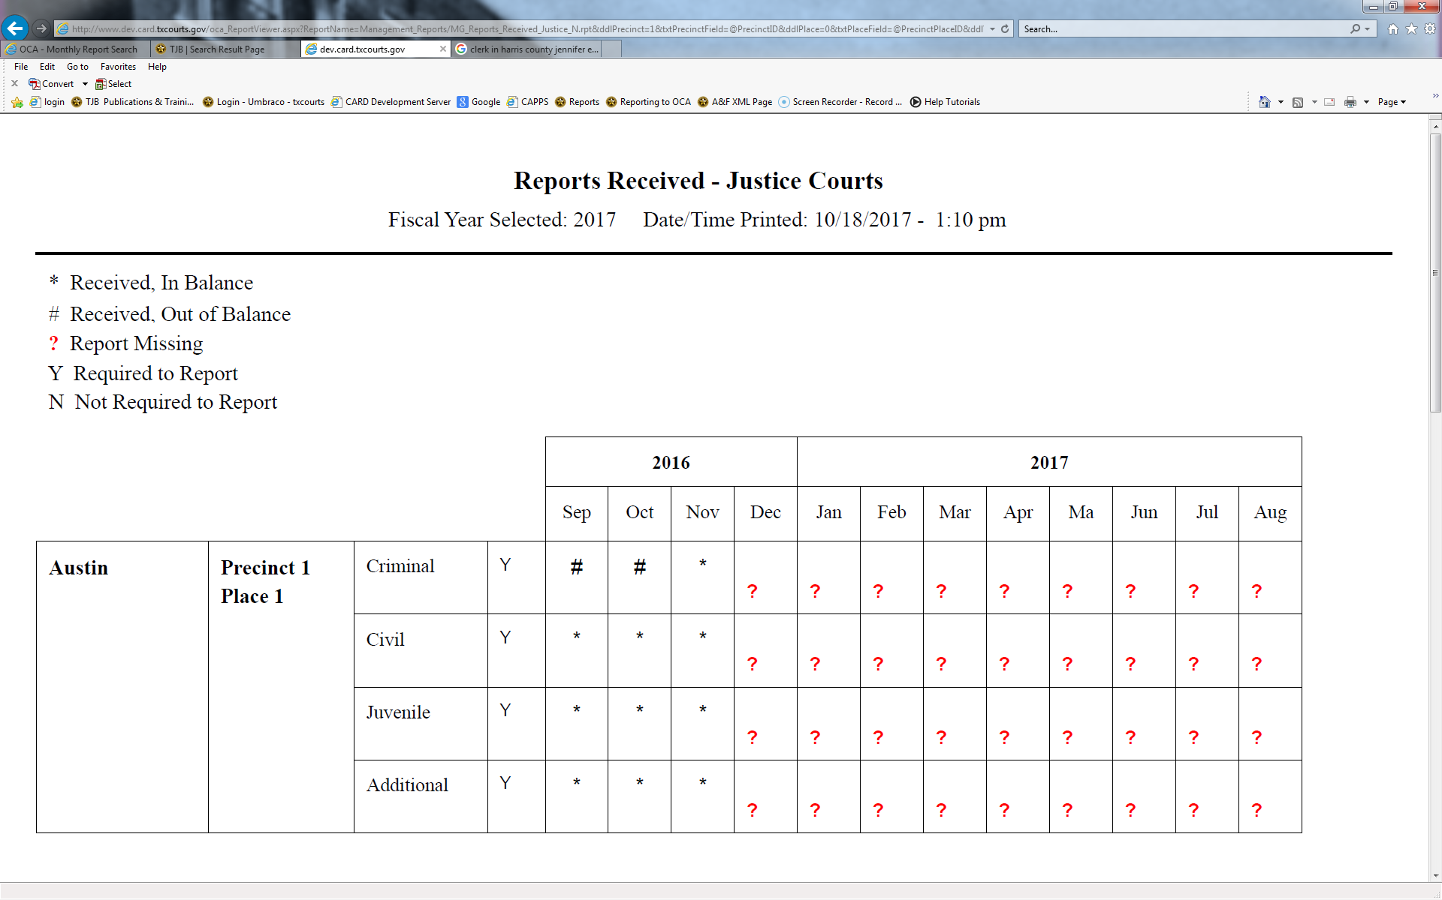

Send questions to judinfo@txcourts.gov.

