CAPPS for Managers

Log into CAPPS
- Enter the URL https://entprtlprd.cpa.texas.gov/ in a browser window.
HINT: You can add this web address to your Favorites for easy access later.
- Click on the Authorized Use Disclaimer page.
HINT: You should have received an email with a temporary password and instructions to reset. If you did not change your password, contact your Security Administrator at _______________.
- Enter your User ID and Password.
- Click

CAPPS Login Screen
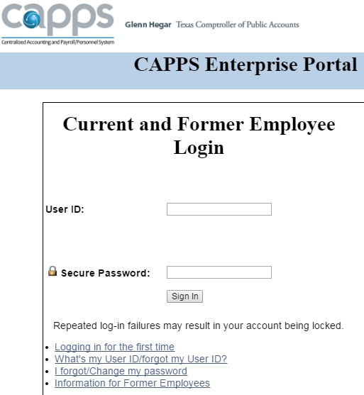

HINT: CAPPS will lock your account after 3 failed login attempts.
HINT: If you set up a Password Hint previously, you can click on I Forgot/Change my password to reset it.

For Help
Contact the following resource if you need additional assistance with logging into CAPPS:
Insert your agency specific instructions here, including your security administrator’s contact information.

Approving Time for Direct Reports
- Click the Manager Self-Service button from the CAPPS main menu.
CAPPS Main Menu: Time & Leave Approval Button
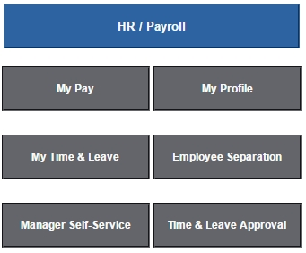
- One of the following messages will display:
You have no time or leave to approve.

OR
You have time to approve.
Click the Manager Summary Approval Page link below or click the Manager Summary Approval Page link in the Manager Self-Service > Time and Leave Management
Manager Summary Approval Page

- Click on the Manager Summary Approval Page link, if you have time to approve.
HINT: Only your direct reports will appear in your Manager Summary Approval Page.
The Manager Summary Approval Page is view only. Clicking the E-Sign & Approve button or the Approve/Deny checkboxes won’t work.

- Click on the Employee Name in the left-hand column to view the employee’s timesheet.
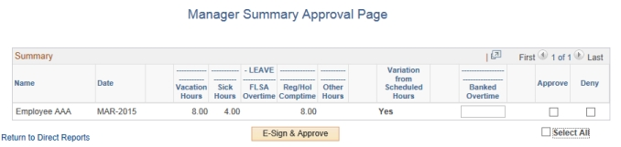

- The Date will default to the 1st day of the month that the employee entered time or leave, but it can be changed if needed. Click

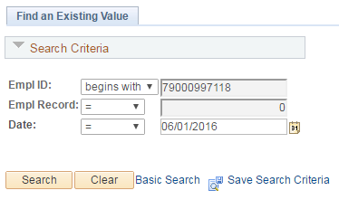

- Review the time and leave entries before approving.
Sample Time Entry Row
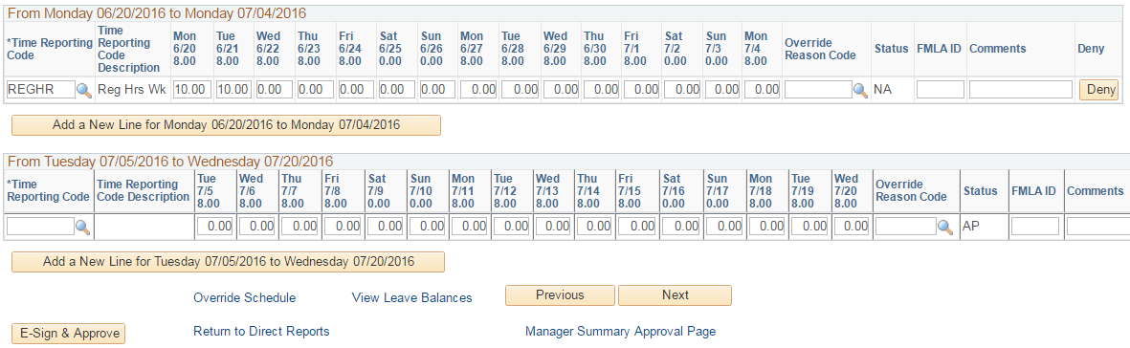

- Commonly used Time Reporting Codes (TRCs) used in CAPPS time and leave:
ADMLT | Administrative Leave Taken | May be awarded for outstanding performance
ANLVT | Annual Leave Taken | Vacation Leave Taken
COMPT | Compensatory Time Taken | Use when you take Regular Comp Time
REGHR | Regular Hours Worked | Use when you work over your scheduled hours
REGHW | Reg Hours Worked on Holiday | Use to record hours worked on a holiday (8 hrs max)
SICKT | Sick Leave Taken | Use when you take Sick Leave
- Click in the bottom left corner of the timesheet to approve all entries. Click OK, and you will be returned to the employee timesheet.
HINT: Click at the end of a row, and an email notification will be sent to the employee. You can also add a comment before clicking Deny. The employee can then make changes and resubmit for approval.
HINT: A status of NA means that the time entry still Needs Approval. A status of AP means that the time entry has been Approved.

