ERS Override for Highly Compensated Employees

- Summary: (required)

For those employees who are highly compensated, their ERS contributions need to be overridden in order to allow for a balanced amount to be deducted every month throughout the year.

- Navigation:

For the employee whom you wish to overridde, navigate to Main Menu Payroll for North America Payroll Processing USA Update Paysheets By Payline

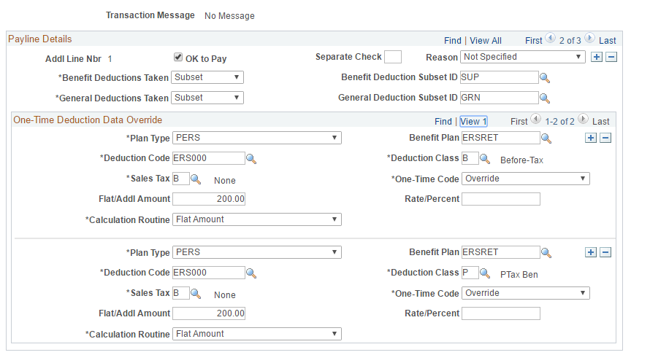

Steps required:
Once on the payline, go to the “One-Time Deduction” tab, scroll over to a payline detail with Ok to Pay turned on and add the override at the “One-Tie Deduction Data Override” level. Make sure to add both an EE and ER amount.

- Navigate to the Payline (navigation above)
- Enter emplid to be modified in the search page
- Navigate to the “One-Time Deduction” tab
- In the “Payline Details” scroll, make sure to scroll over to a line that has “Ok to Pay” checked. The BSY earnings addl pay number is always a good choice
- For the chosen Payline Detail, add a new override amount for both the EE and ER deduction at the “One-Time Deduction Data Override” level. Fill in the following fields:
- For employee deduction:
  - Plan Type –PERS
  - Benefit Plan –ERSRET
  - Sales Tax – B
  - Deduction Class – B (for before tax entry) or P (for Post Tax entry)
  - Flat/Addl Amount – Amount you wish to have deducted
  - One-Time Code – Override
  - Calculation Routine – Flat amount

- For employer deduction:
  - Plan Type –PERS
  - Benefit Plan –ERSRET
  - Sales Tax – B
  - Deduction Class – P (for Employer Tax entry)
  - Flat/Addl Amount – Must be the same as Employee override amount
  - One-Time Code – Override
  - Calculation Routine – Flat amount

- Click Save

After you’ve calculated the check and you wish to view the paycheck navigate to Main Menu Payroll for North America Produce Payroll Review Paycheck

