Workflow – Administrator Approval
- Each agency should have an Administrator Approver and one or two back-up Administrator Approvers, typically management.
- An Administrative Approver has the security to give a requisition full approval, in essence overriding all the regular approval steps.
- When a requisition must be expedited, or a requisition is stuck in an absent approver's worklist, the Administrator Approver can approve for one step or all the way.
- The Administrator Approver navigates to:
- Complete the Search Criteria as shown and click 'Search'
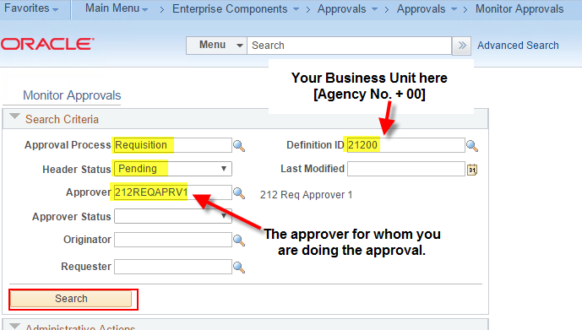
- This should produce a list of one or more requisitions on the above Approver's worklist.
Select the requisition you want to approve.
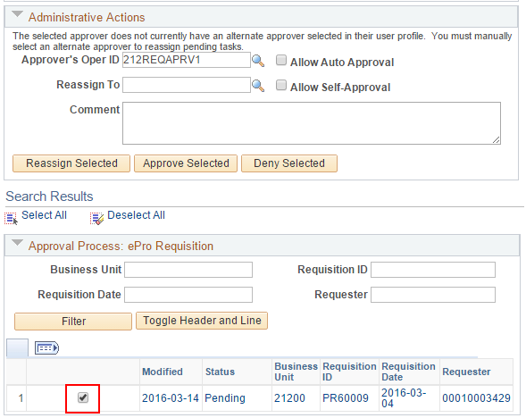
- You can either do the approval (most likely), or you can reassign the requisition to someone else to approve.
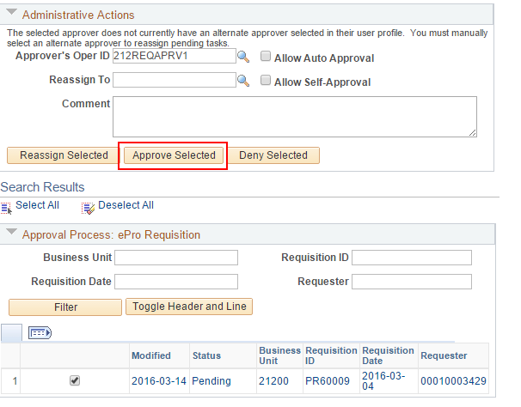
- When a step is approved by the Admin Approver it will display in the workflow path.
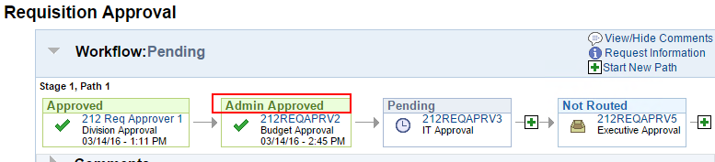
- In order to approve this example requisition all the way through the requisition workflow, repeat the process for the last two approvers.
- To see the workflow path for a requisition, go to Main Menu > eProcurement > Manage Requisitions
- Search for the requisition.
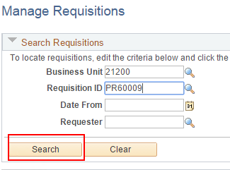
- Open the Request Lifespan and click the Approvals icon.
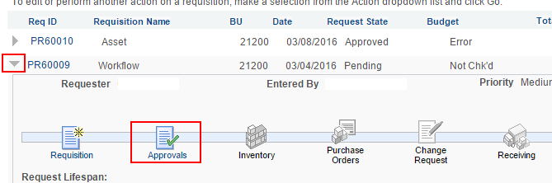
- The approver's user numbers you need to approve will display as shown:
