Receiving – Assets
- Navigate to Add a Receipt.
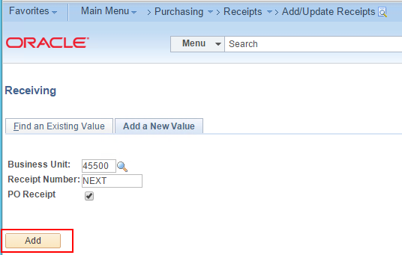
- Fetch in the PO.
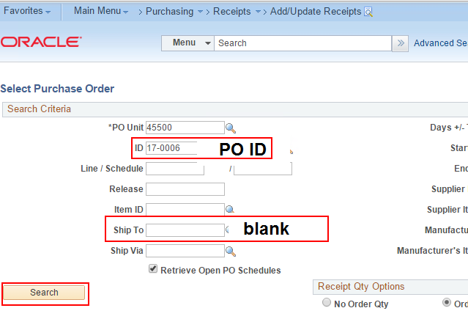
- Select the Asset line you want to receive.
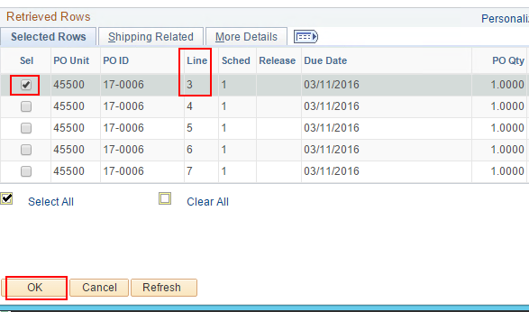
- Enter the quantity of the asset to receive. This will default to the open purchase order amount.
- Click the 'AM Status'link.
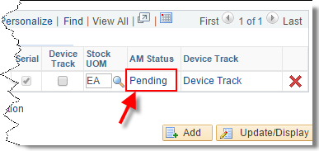
- Populate Tag Number, Serial ID and Asset ID numbers in the following fields. If you do not have an Asset tag #, please contact your Property Manager. 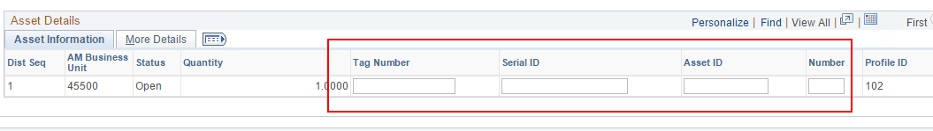
- Go to the 'More Details' tab and select a Custodian from the drop-down list (if you know the custodian – otherwise the Asset Manager can add custodian information later). The custodian must have a 7-number setup in HR to be defined as a custodian.
Click OK.
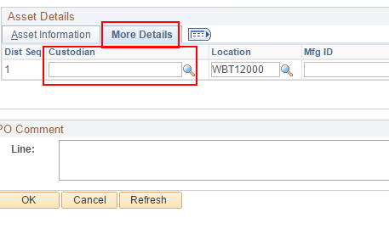
- Update the location of the asset if you know the asset location. Otherwise, the location may be updated at a later time in asset management.
- Save the Receipt.
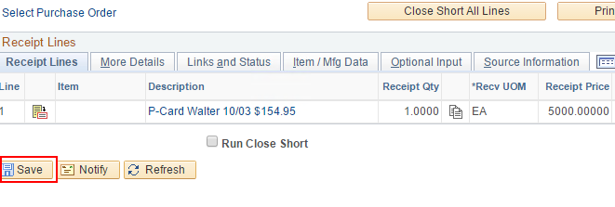
- Click OK to acknowledge the confirmation message.
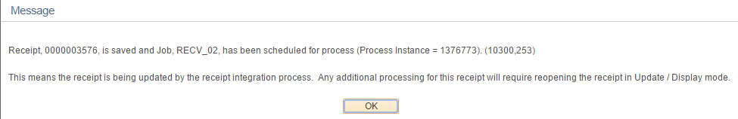
- The asset shell is created in CAPPS AM as ‘Received not in Service’.
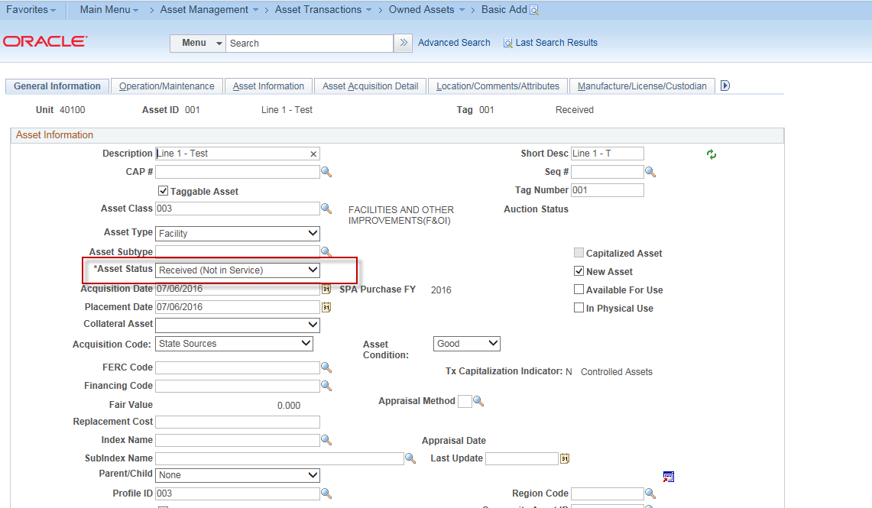
- The Receipt ID is created.
