Receiving – Cancel Receipts
- Navigate to the Receipt you want to cancel.
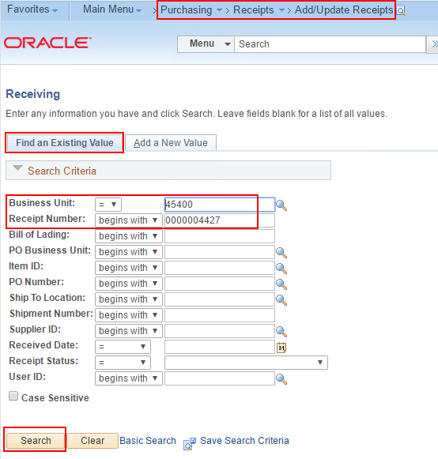
- To cancel a line, click the cancel button (red X) on the line you want to cancel.
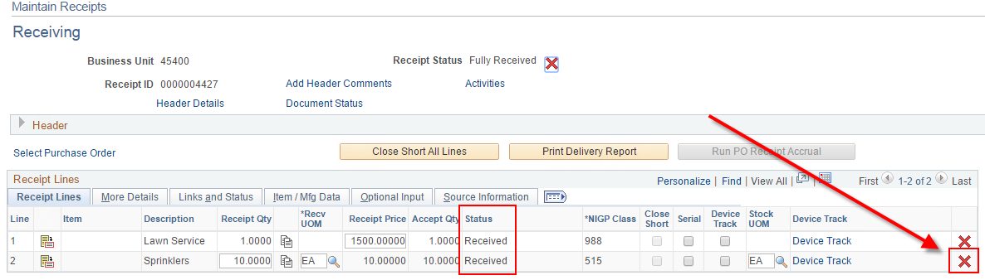
- Confirm.
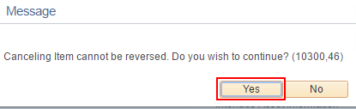
- Save the Receipt.
- Click OK.
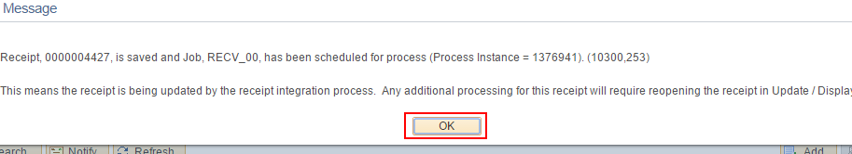
- To cancel the entire Receipt, click the cancel button (red X) at the top of the Receipt.
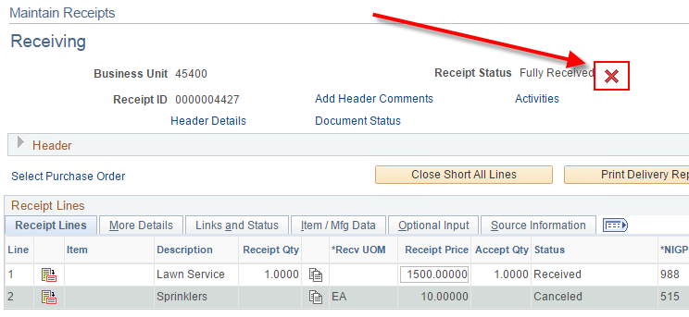
- Confirm
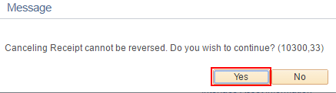
- The receipt saves automatically. Click OK.
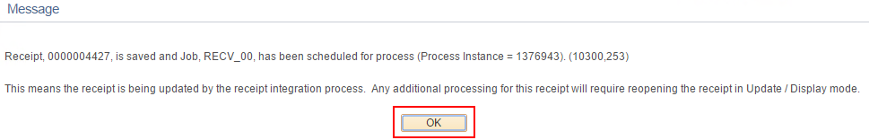
- You can no longer pull the Receipt up in the Add/Update Receipts navigation.
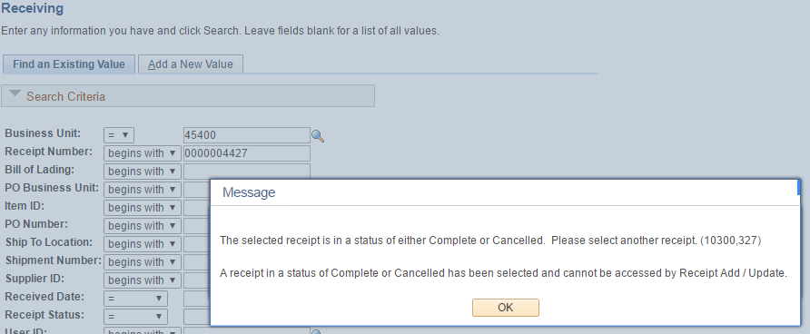
- You can view the canceled Receipt in the inquiry-only page.
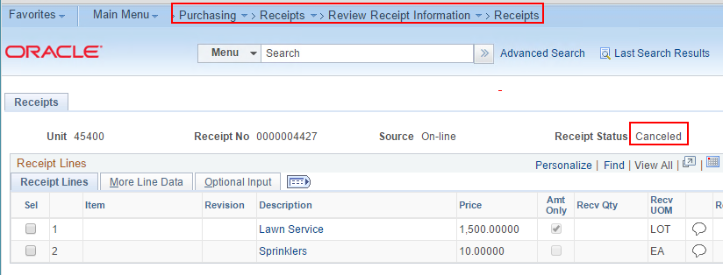
- A Receipt cannot be canceled if it is attached to a Posted Voucher.
