Setting Up Locations and ShipTo Locations
NOTE: ShipTo Locations are always tied to a Location. You must always create a Location before you
create the associated ShipTo Location.
- Add Location
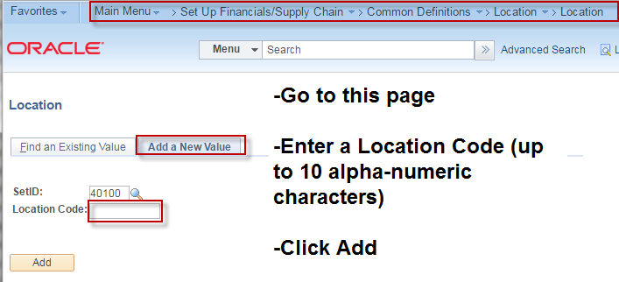
- Enter Description and Address.
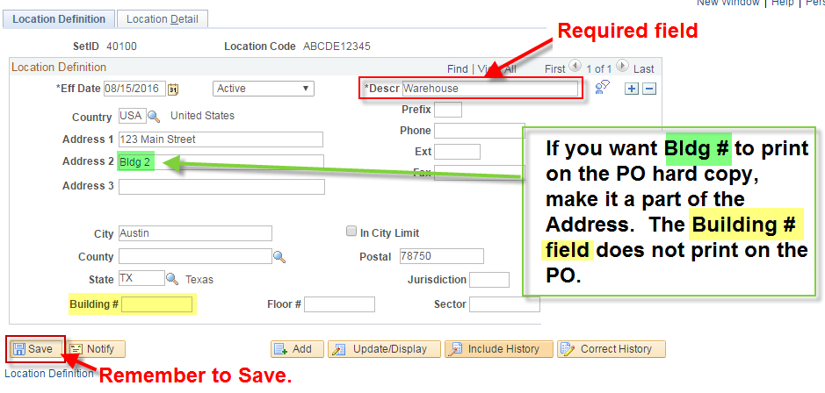

- Make the location a ShipTo Location if you want to use it as a ShipTo on orders.

 