Requisition - Basic Entry
- Navigate to: Main Menu > eProcurment > Requisition
- Select: Special Requests
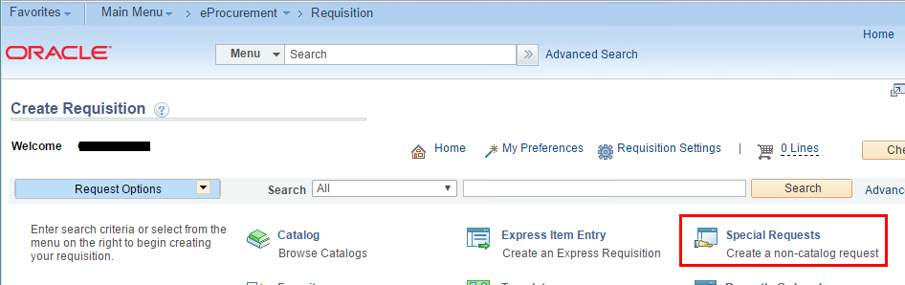
- Enter: Item Description, Price, Quantity, NIGP Class, Unit of Measure, Due Date. Click ‘Add to Cart’.
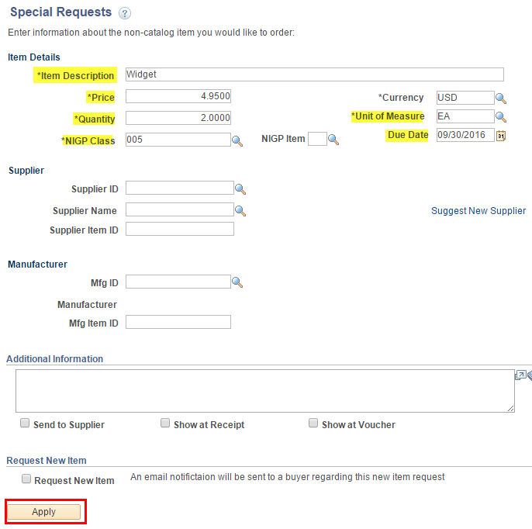
- Click: Checkout
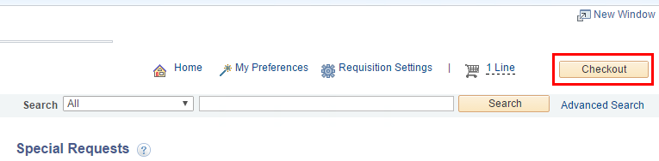
- Enter: Requisition Name
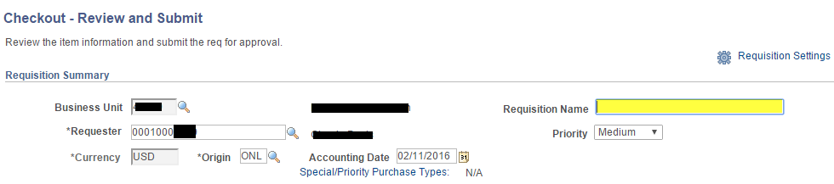
- Click the Line 1 arrow button to reveal Shipping Line 1.
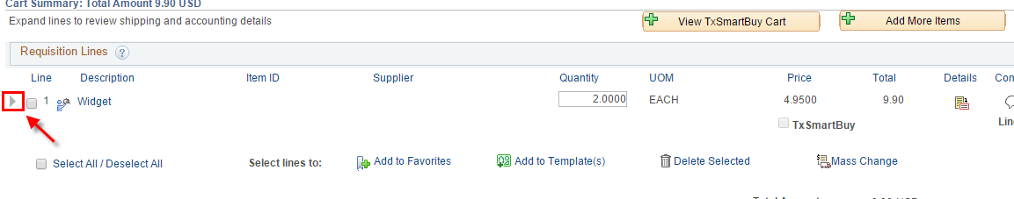
- Click the Accounting Lines arrow to reveal the chartfield entry.
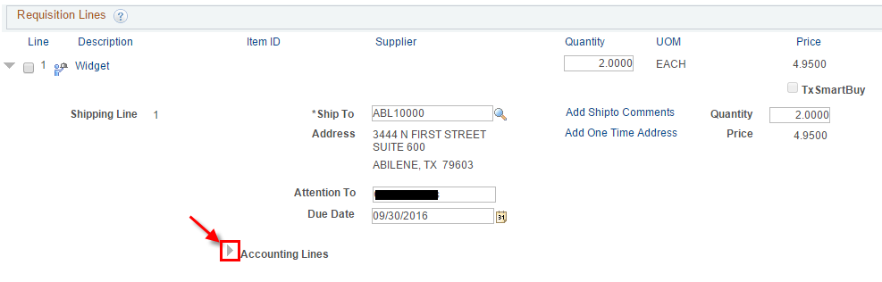
- Select the ‘Chartfields2’ tab and enter the chartfield values required for your agency.
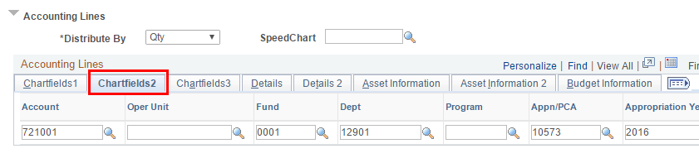
- Scroll to the bottom of the page and click ‘Save and submit’.
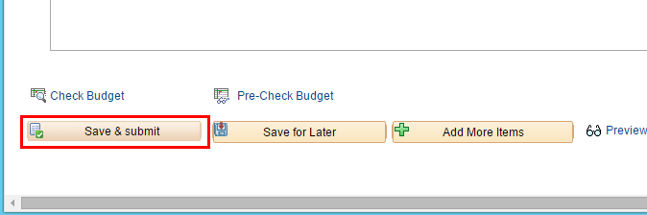
- If the save is successful you will be taken to the Confirmation page.
