Begin a new ePro Req
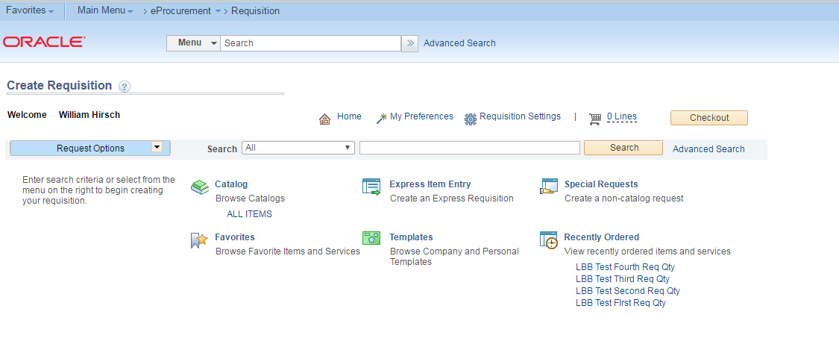
Select Requisition Settings to Add a Supplier for all Req Lines
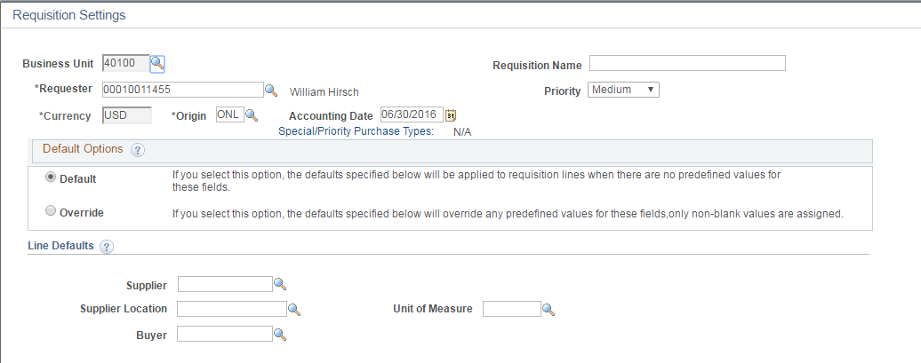
Select the Supplier magnifying glass to search for the desired Supplier and Supplier location
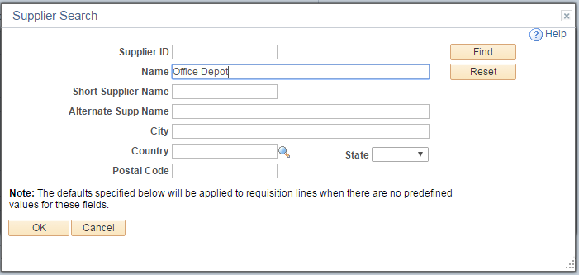
Type a Supplier name into the Name field and select Find
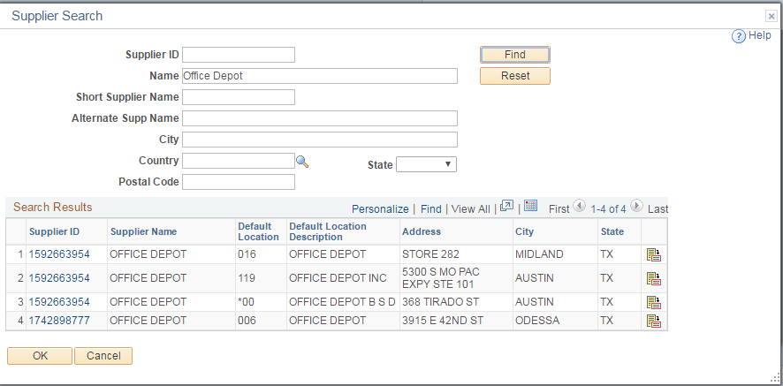
Select the desired Supplier ID / Default Location combination
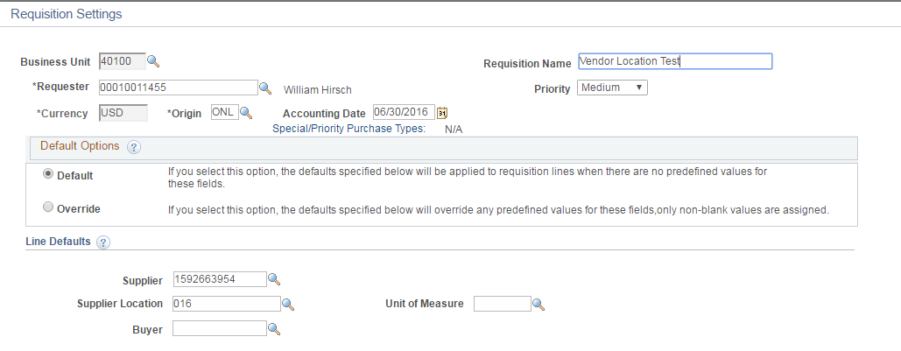
Desired combo populates. Enter Requisition Name and select OK button at page bottom to continue with order
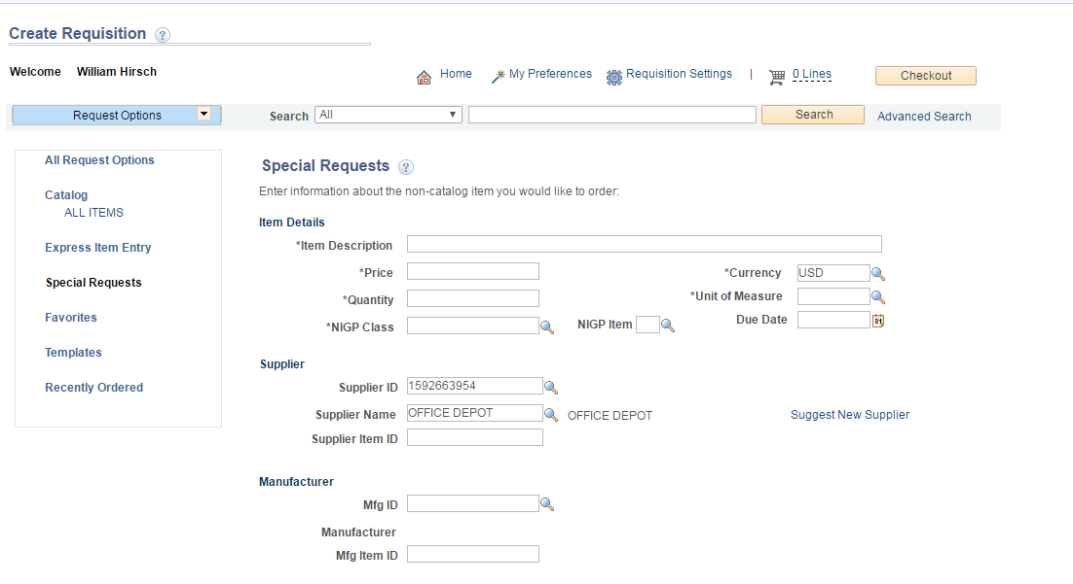
Note that at Special Request page the Supplier is already populated. Continue to enter values as needed
After adding items to shopping cart, select Checkout to proceed to Requisition form
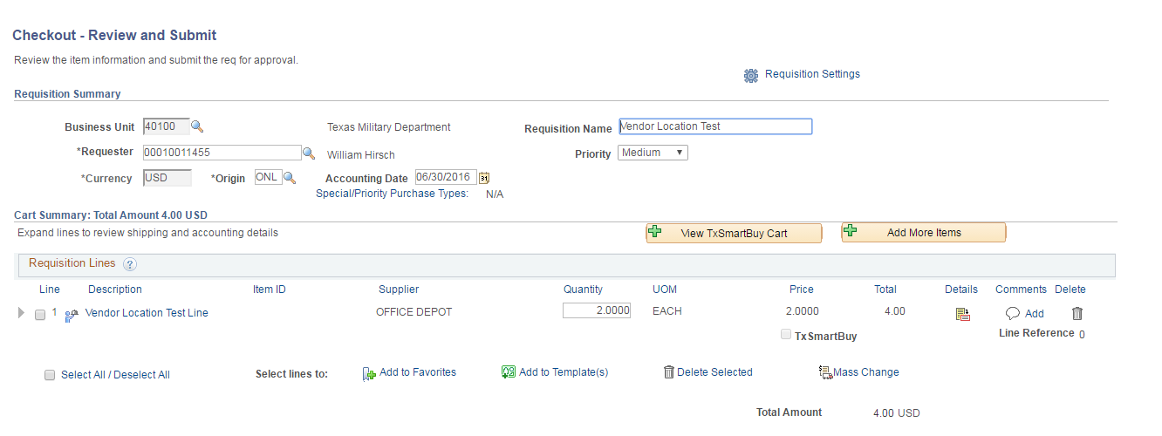
Select the Line Details icon to review Supplier info
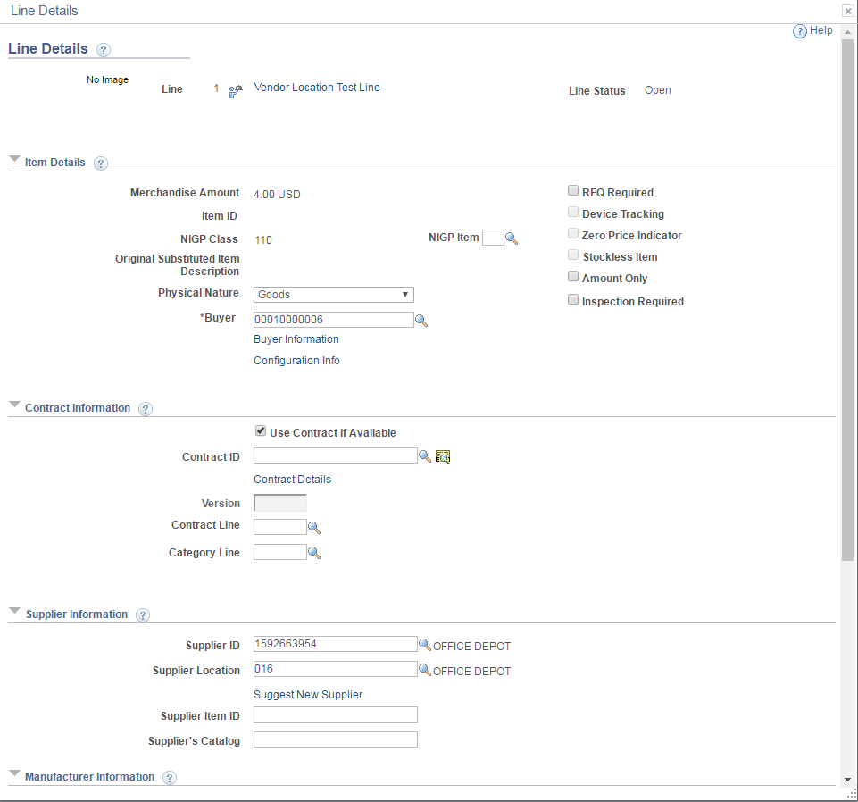
Note the both the Supplier ID and Supplier Location are populated.
Continue entering required information
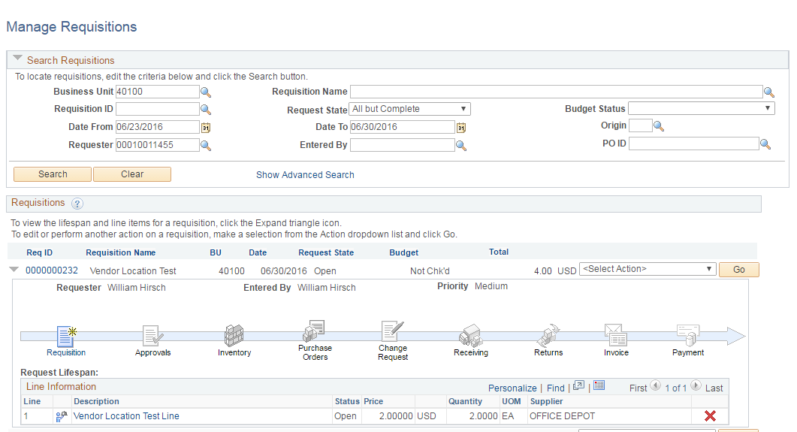
Navigate back to Saved Requisition (with Req ID assigned)
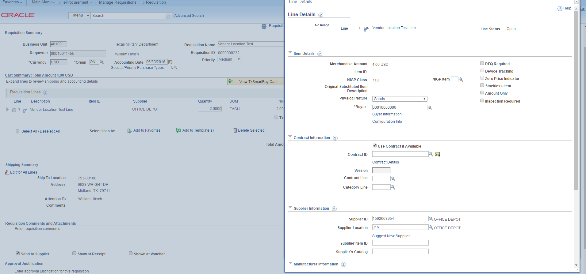
Note the Supplier ID and Supplier Location have been retained.

