Requisition – Update-Change-Edit
- You can add new lines or make changes to an existing requisition.
- The requisition will go back through workflow for approval if you add a new line, increase the amount on an existing line, or change the chartfield.
- If any part of the requisition has already been sourced to a Purchase Order, you may need to coordinate with the Buyer before updating the requisition.
The ‘Request State’ column shows your requisition’s progress in the procurement process.
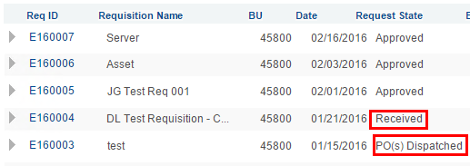
- Whether you want to add a line to an existing requisition or update a line on an existing requistion, start by finding your requisition in the Manage Requisitions page, then choose Edit in the dropdown list and click Go.
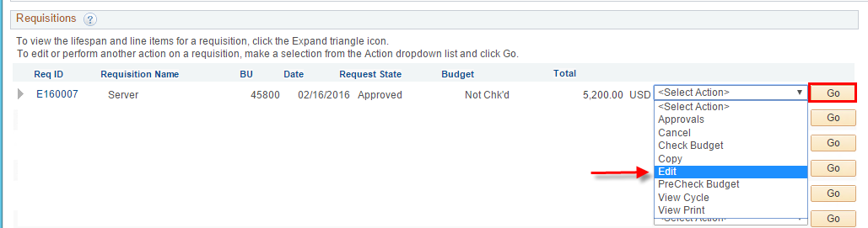
- To add a new line to the requisition click the Add More Items button.
(To update an existing line, go to Step 8.)
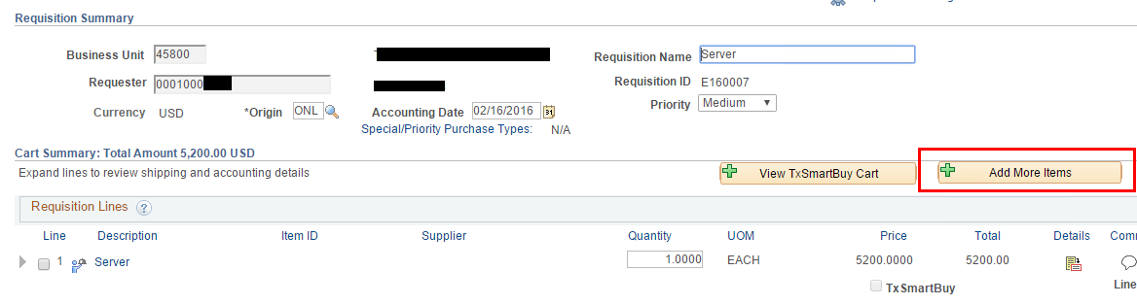
- You will be taken to the Edit Requisition page shown below.
Notice the Cart icon displays the number of lines already in the requisition.
Click ‘Special Requests’.
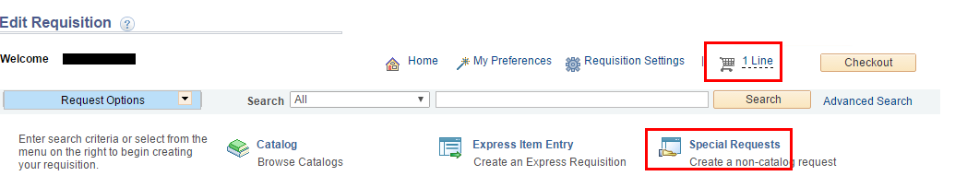
- You are taken to the Special Requests page where you can enter a new line.
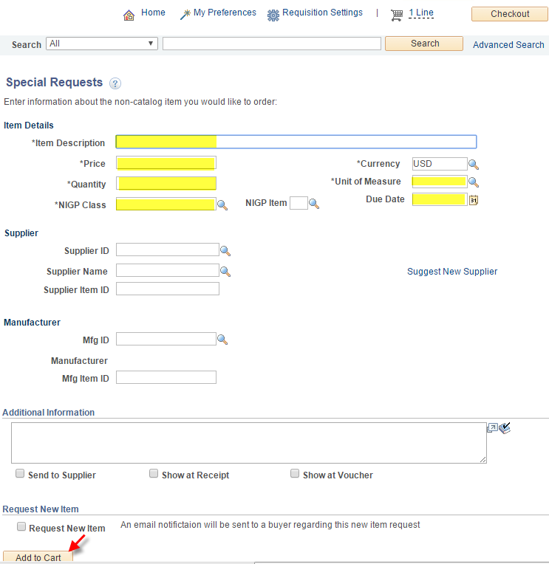
- Click ‘Add to Cart’, then click ‘Checkout’ and complete the new line as usual, adding chartfields, comments, whatever you need before you Save and Submit.
- If you want to save your changes without submitting the requisition back into workflow yet, click the ‘Save for Later’ button rather than the ‘Save and submit’ button.
- If you want to check the current availability of funds, click the ‘Pre-Check Budget’ button. This will not pre-encumber funds. It will only let you know if the requisition would pass budget checking if it were to go through budget checking right now.
Note: just because funds are available right now is no guarantee the funds will still be available when the requisition is approved and goes through the real budget checking.
--continued next page--

- To update an existing line, click on the description of the item you are buying.
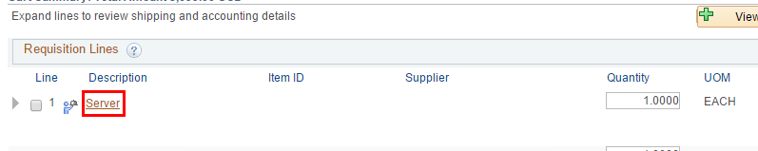
- Make changes and click ‘Apply’.
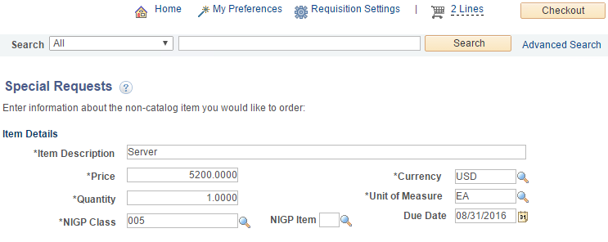
- Click ‘Save and Submit’. Or, if you want to save your changes without submitting the requisition back into workflow yet, click the ‘Save for Later’ button rather than the ‘Save and submit’ button.
- To check the current availability of funds, click the ‘Pre-Check Budget’ button. This will not pre-encumber funds. It will only let you know if the requisition would pass budget checking if it were to go through budget checking right now.

