Requisition – Copy a Requisition
  - Main Menu > eProcurement > Manage Requisitions
  - Find the requisition you want to copy. (see: MANAGE REQUISITIONS - Search Requisitions)
  - Select 'Copy' from the dropdown list and click Go.
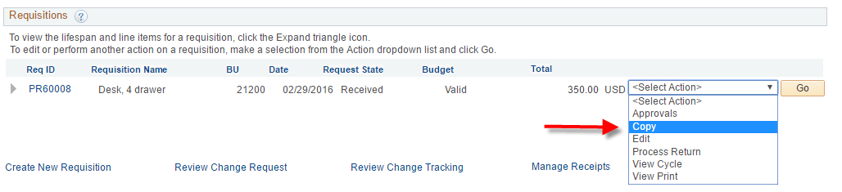
  - Enter a Requisition Name.
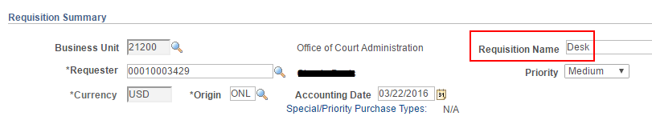
  - Click the Open Ship To and Accounting arrow to the left of the line and update the Due Date.
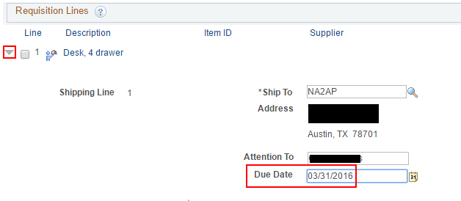
  - Update Comments and Attachments as necessary.
  - Click Save & Submit.
  - Approve and Budget Check.

