MANAGE REQUISITIONS – Edit, Copy, Cancel, Etc.

Editing a Requisition p.1-2
Copying a Requisition p.3
Canceling a Requisition p.4
- To edit a requisition, find the requisition in Manage Requisitions, choose 'Edit' from the dropdown list and click OK.
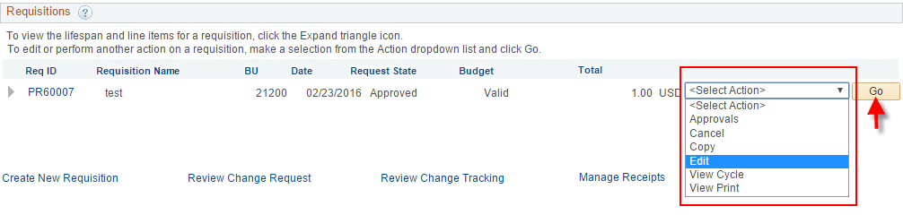
- To edit price, click the line description link.
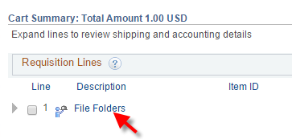
This will take you to the original page where you entered the req line information.
Make your changes. Click Apply. Click Checkout.
Note: if this req line is already on a PO you should communicate with the Puchaser before making changes.
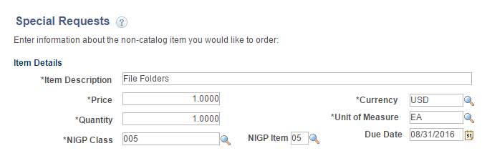
- To add a line, click the Add More Items button.
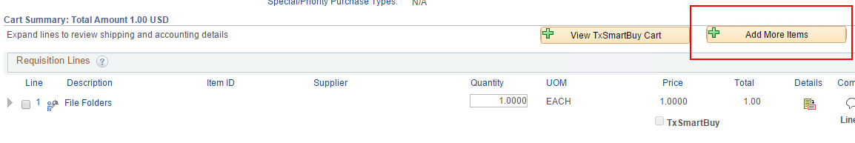
Click 'Special Requests'. Notice the shopping cart displays the number of lines already on your requisition.
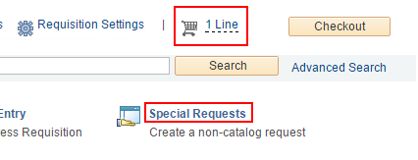
Add the new line information. Click 'Apply'. Click 'Checkout'.
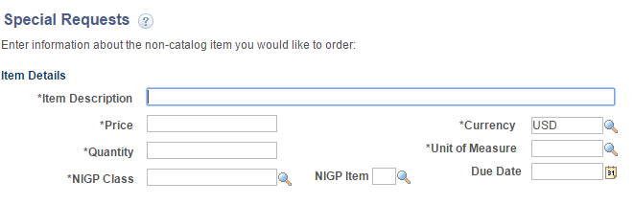
Add the chartfield in the 'Accounting Lines' section.
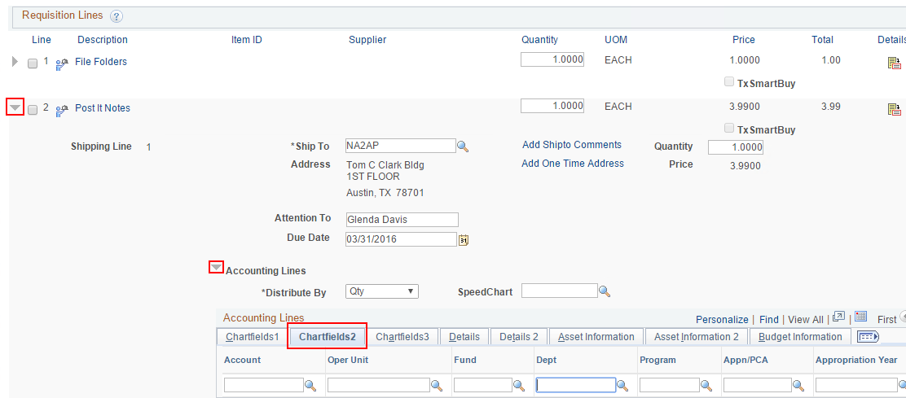
- To copy a requisition, find the requisition in Manage Requisitions, choose 'Copy' from the dropdown list and click OK.
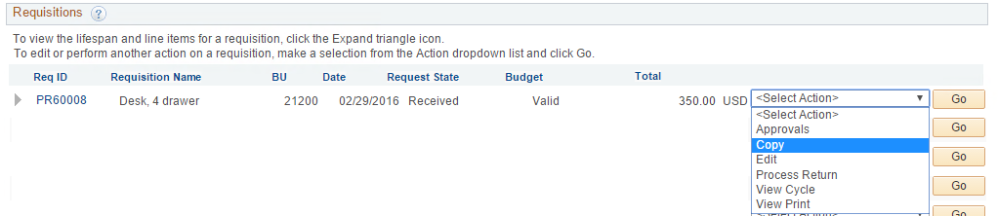

- Enter a Requistion Name. Check other fields such as Origin, chartfield values, comments, attachments, anything that might need to be different from the original requisition.

- When the new/copied requisition is how you need it, Save & Submit.

- To cancel a requisition that is not on a PO yet, you can cancel individual lines with buttons in the Request Lifespan view;
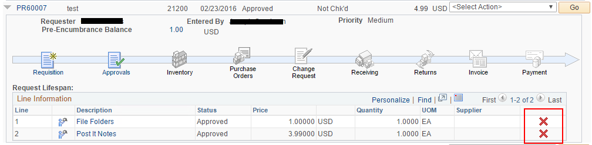
or you can cancel the entire requisition from the dropdown list.
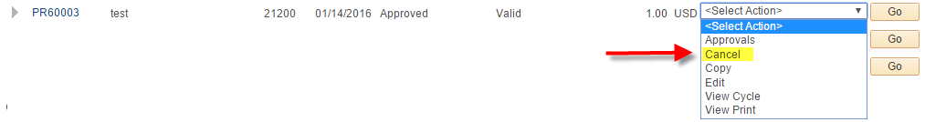
This will take you to a confirmation page.
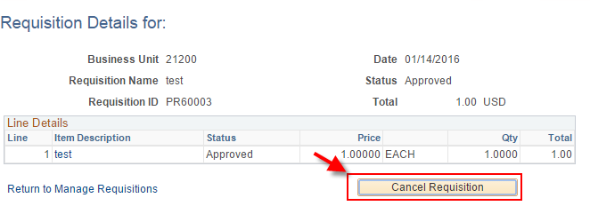
If the requisition had ever been successfully budget checked, you will need to re-budget check to release the pre-encumbrance back to the budget.

