PO – Add A Shipping Line
- Navigate to Main Menu > Purchasing > Purchase Orders > Add/Update Display.
Find An Existing Value.
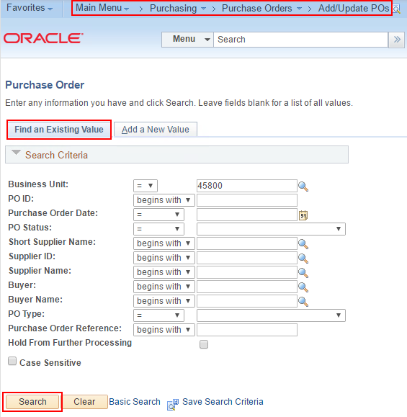
- Select and bring up the PO that needs an additional line for shipping cost.
- Click the Add Row button.
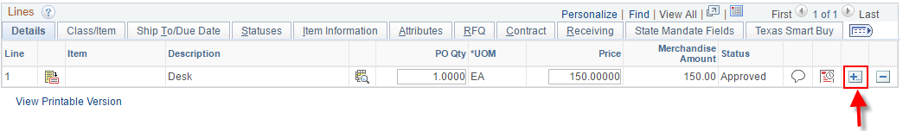
- Click OK.
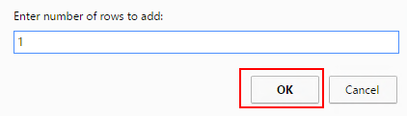
- If the PO was in Dispatched status you will receive a change order message. Click OK.
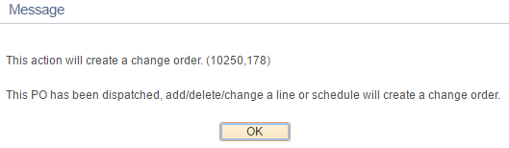
- Enter Description, Qty, UOM, and Price.
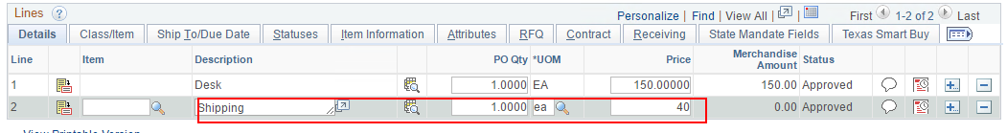
- Go to the Class/Item tab and enter the NIGP Class and NIGP Item.
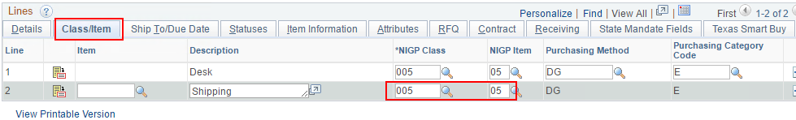
- Go to the Attributes tab and click the Amount Only checkbox. If the actual shipping cost comes in less than expected, the Amount Only designation will allow the price to be adjusted in Receiving.
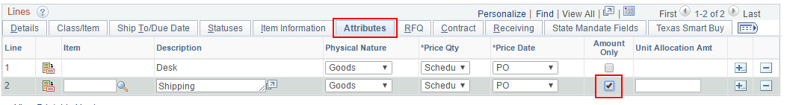
- Click Yes to acknowledge the message reminding you the Qty must be 1 when using Amount Only.
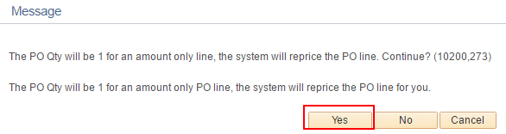
- Go back to the Details tab and click the Schedule button.
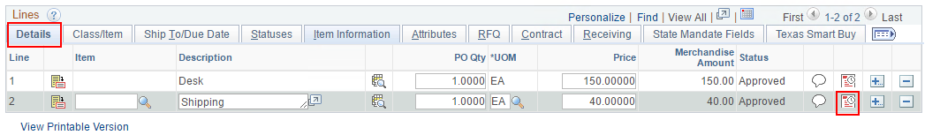
- Click the Distributions/Chartfields button.
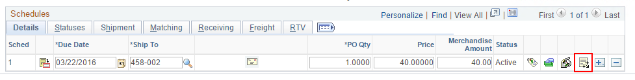
- Click the SpeedChart search button. You can leave the screen blank or enter a few characters to narrow the search. (skip to Step 15 to enter chartfield elements manually)
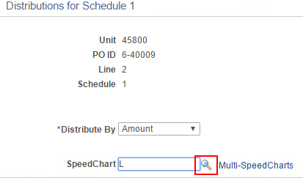
- Select the SpeedChart.
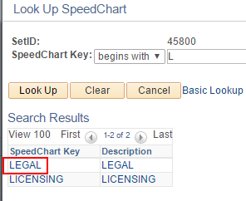
- Add the Account Code and any other required chartfield elements not populated by the SpeedChart. Skip to step 16.
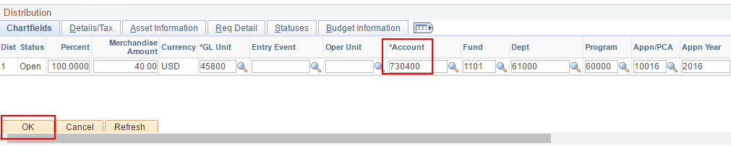
- Enter chartfield elements manually. If you need to know which budget was used for the item being shipped you can navigate to that PO Line's distribution and get the chartfield elements.
- Click OK.
- Return to Main Page.
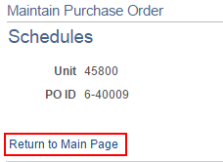
- Save the Purchase Order.
- Approve. Budget Check. Dispatch.

