PO– Comments and Attachments
- PO Header Comments apply to the entire PO.
- PO Line Comments apply to individual lines.
- Attachments are connected via comments pages.
- 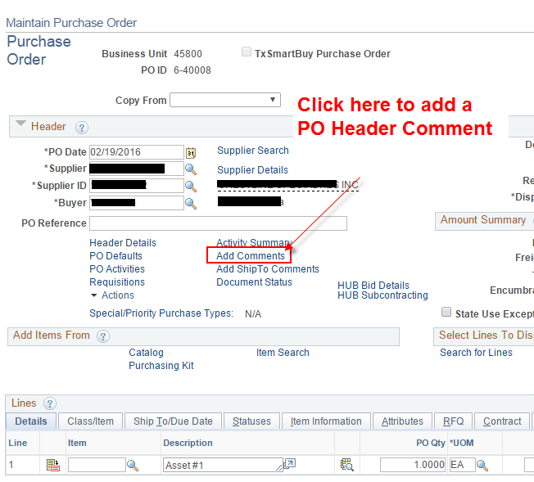
- 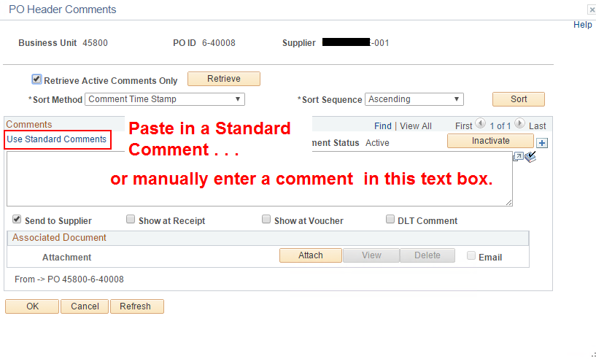
- 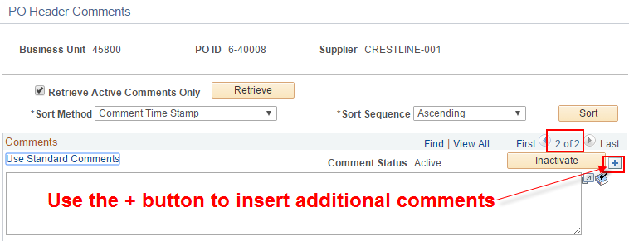
- 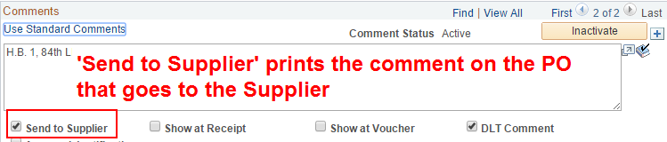
- 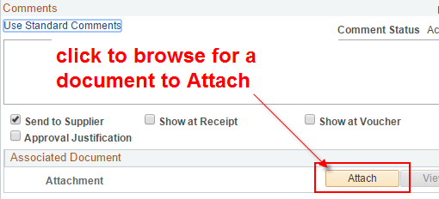
- 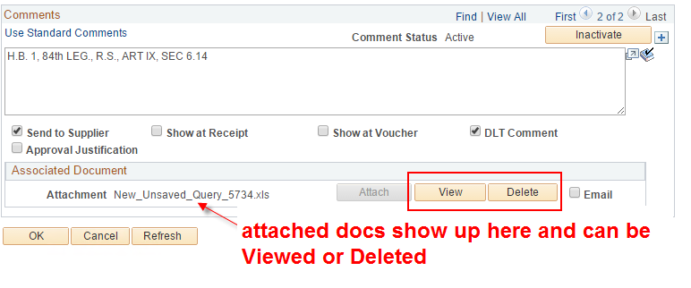
- When a PO Header comment exists, the Add Comments link changes to.
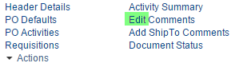
- PO Line comments are entered just like PO Header comments, just in a different place.
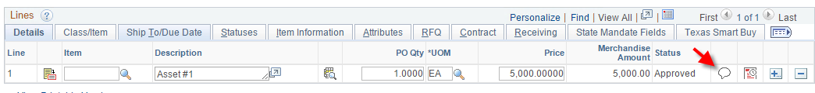
- When a PO Line comment exists, the button indicates so by changing.
From this: To this:
- Documents can be attached to PO Line Comments just like PO Header comments.
- Note: when a Requisition line or lines are pulled into a PO, comments may already exist. The purchaser has full access to make any changes to those comments.

