PO– Finalizing Req Lines from the PO
- When a Purchase Order is budget checked, it moves funds from the Requisition to the Purchase Order.
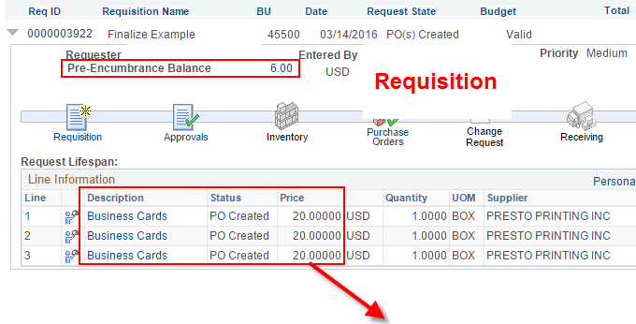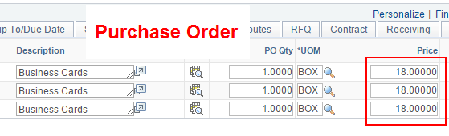
- In this example, the PO only encumbered $54. Therefore the PO only liquidated $54 of the $60 pre-encumbrance on the Requisition. Notice there is still $6 stuck in the pre-encumbrance on the requisition because the PO did not need it.
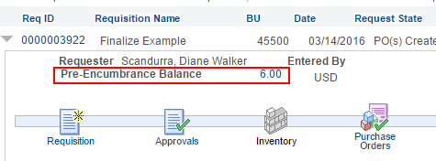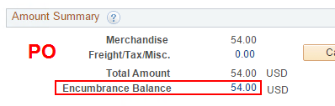
- How do you release the unneeded $6 back to the budget?
'Finalize' the requisition from the Purchase Order.
- On the PO header, click the red 'Finalize' button to the right of the PO Status and Budget Status fields.
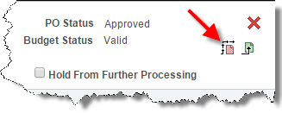
- The 'Finalize' button on the PO tells the Requisition, "I'm finished with you, even though I didn't use all the money, so send any unused funds back to the budget."
- The 'Finalize' button on the PO can be clicked before or after budget checking. If you Finalize after budget checking, another budget check is necessary to release the funds on the requisition back to the budget.
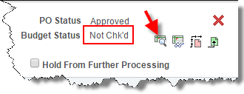
- After you budget check the Finalized PO, the Pre-encumbrance on the associated requisitions should be zero. This view is from the Manage Requisitions page.
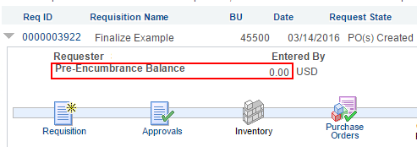
- Once again, you're clicking a button on the PO and budget checking the PO to release funds on the Requisition. This is why we say "finalizing the req from the PO."
- Using the 'Finalize' button on the PO Header liquidates all Requisition lines connected to the Purchase Order.
- You only need to finalize if the PO amount was reduced to less than the amount on the associated req line(s).
- If the original amount on the requisition line(s) is accurate and does not need to be reduced on the purchase order, then there is no need to click Finalize.
- What if the buyer only reduces one line on the PO below the Req amount? Then you only need to finalize that one line, not the entire PO.
- To finalize one line, go to the Line Details page using the button to the left of the line.
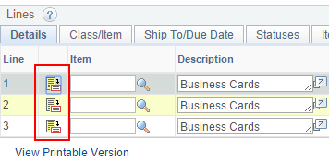
- Finalize button for an individual line.
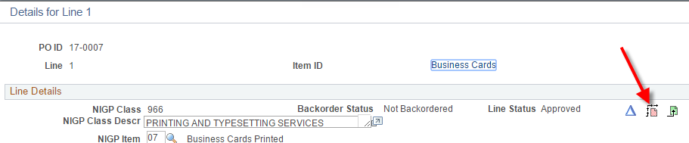
- What if you
-reduce a $20 Req Line to $18 on the PO
-finalize, which sends the unneeded $2 back to the budget
-then later realize you need the full $20 on the PO afterall?
- Answer…click the Unfinalize button on the PO and re-budget check.
This restores the released funds back to the requisition, making them available again to the PO.
