PO– Delete vs Cancel
- Delete and Cancel are not the same thing.
- Delete makes the PO or PO Line disappear as if it never happened.
Cancel only changes the status to 'Canceled'. The PO or PO Line still exist.
- How to delete the entire PO.
If the PO has never passed budget checking you can click the Delete button at the bottom of the PO.
After you click Yes to confirm the message, the PO disappears and the Requisition Lines that were sourced to the PO become available to source again.
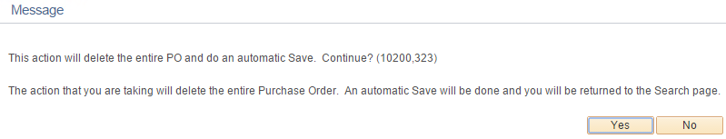
- How to delete a PO Line.
If the PO has never been Dispatched, it's safe to click the Delete button (minus sign) at the right side of the PO Line.
Before you delete the PO Line you must clear (remove) the req line as follows:
- click the Schedule button at the right side of the PO Line
-click the Distribution line at the right side of the Schedule
-go to the Req Detail tab
-click the eraser button
Now you can delete the PO Line and click OK to confirm.
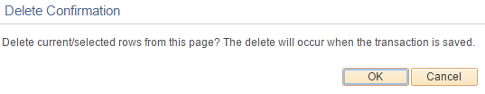
- How To cancel the entire PO.
If the PO has ever in its life passed budget checking and you decide it is not needed, it must be canceled rather than deleted. The reason for this is because budget transactions have occurred which need to be reversed. Therefore you will always run budget checking after canceling a PO to return funds to the budget or to the requisition(s).
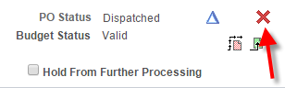
The red X button shown above is the Cancel PO button.
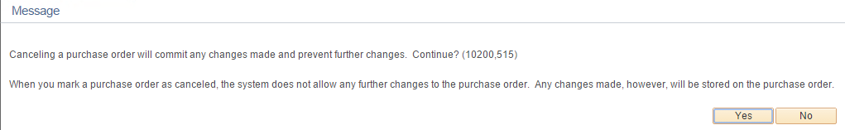
After you click Yes, you should be asked if you will want to re-source the Requisitions that are attached to the Purchase Order.
Answer 'Yes, Re-Source all Reqs' if
-you will need to Re-Source any of the req lines, or
-if any of the Req Lines have not been fully liquidated or finalized.
Answer 'No, Do Not Re-Source Reqs' if
-you know for sure you won't need any of the req lines again and you know for sure that every req line has been fully liquidated or finalized.
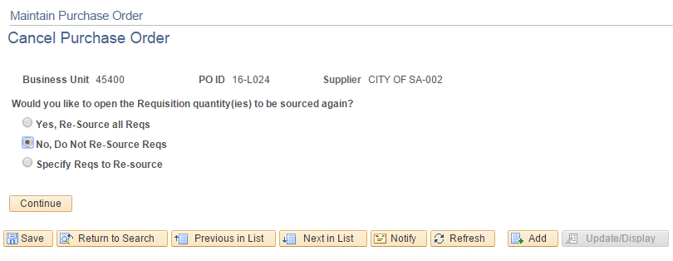
After you click 'Continue', the Budget Check button will appear if any funds are encumbered. Very important that you not miss this button. It's a one shot chance.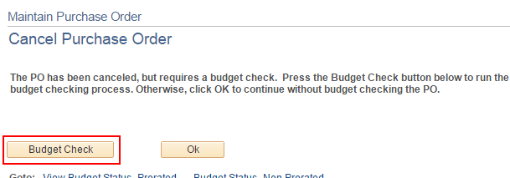
Caution: If you don't click Budget Check, the encumbrance is stuck on the canceled PO. Because the PO is canceled, you cannot pull it up and click the budget check button on the PO. You will be forced to budget check the PO via the page shown below. Much easier just to click the Budget Check button shown above immediately after canceling the PO.
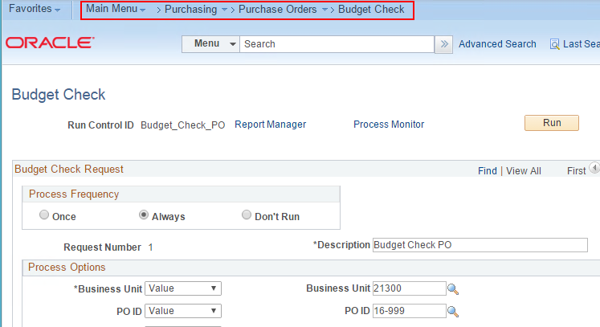

- How to cancel a PO Line.
If the PO has ever in its life been Dispatched and you decide a particular PO Line is not needed, it must be canceled rather than deleted. The reason for this is because theoretically the Supplier has already received the Dispatched PO and needs to be notified if a PO Line is cancelled.
The Cancel Line button is a Red X on the Line Details page.
-Click the Line Details button on the left side of the PO Line.
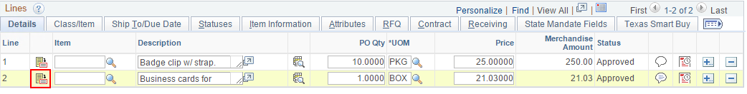
-Click the Cancel Line button.
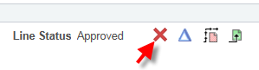
After you cancel the line you will be asked if you want to resource the assoicated requisitions. Finally, you will need to rebudget check the PO to liquidate the encumbrance from the canceled PO Line.
