Voucher Entry- Add an Attachment to a Voucher
- Main Menu > Accounts Payable > Vouchers > Add/Update > Regular Entry.
Click “Find an Existing Value”
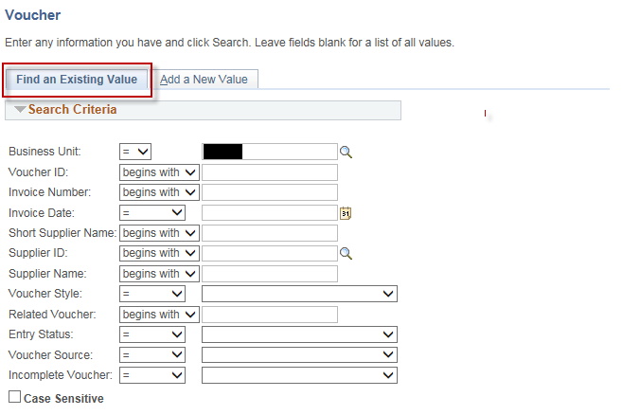

NOTE: You can add an attachment to and Existing voucher or to a new voucher.

- Enter your Search Criteria to find your voucher.
- Click “Search”
Click on your voucher in the Search Results list.
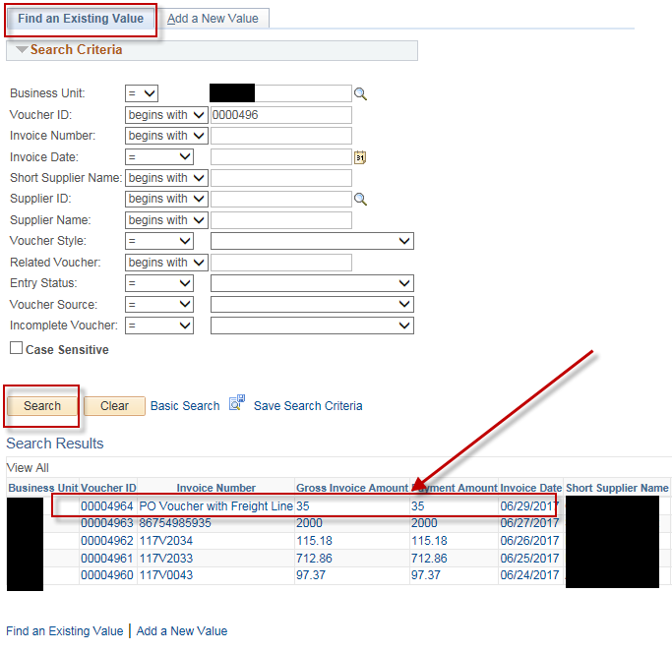
- On the “Invoice Information” tab, Click on the “Attachments” hyperlink.
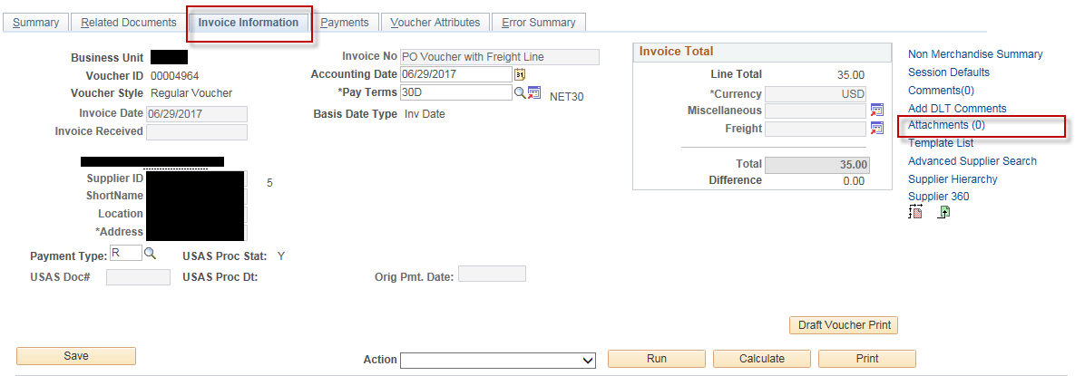
- Click “Add Attachment”, Click “Browse”, find the attachment that you want to upload to this voucher, then click on “Upload”
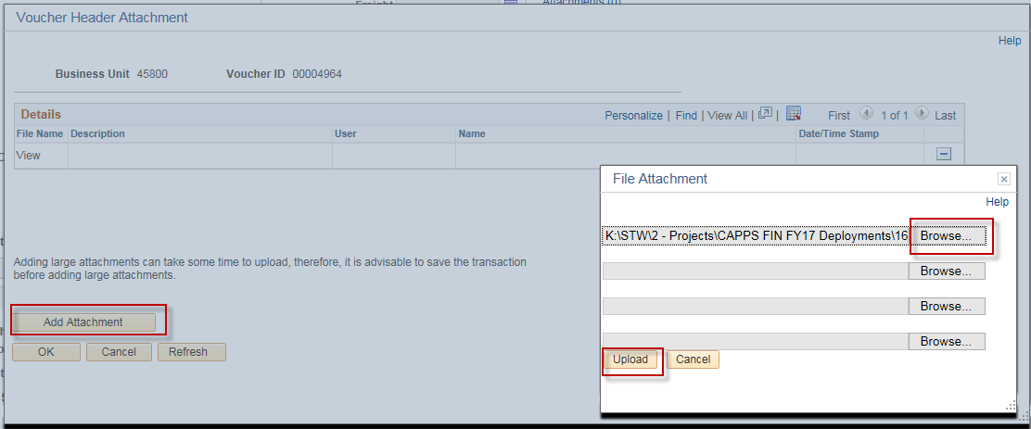

- Enter a Description for the attachment (Optional).
- Click “Ok”
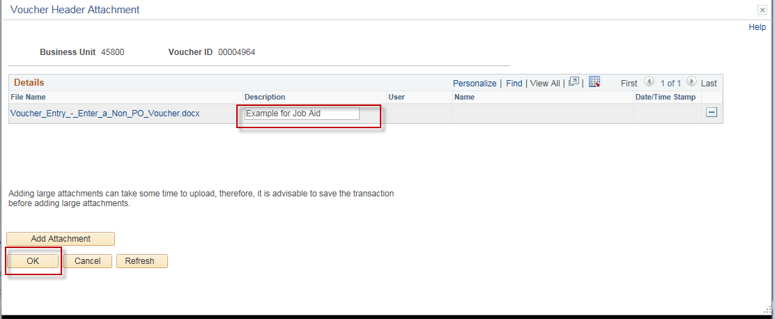
- Click “Save”

