Voucher Entry- Enter a Non PO Voucher to pay a PO from TX Smart Buy
Use this job aid if you are paying a PO from the TX Smart Buy system and you are NOT sourcing a CAPPS PO into this voucher.

- Main Menu > Accounts Payable > Vouchers > Add/Update > Regular Entry.
'Add a New Value'
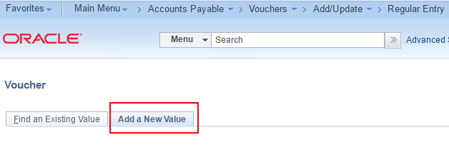
- Enter Supplier ID, Invoice Number, Invoice Date, and Gross Amount
and click Add.
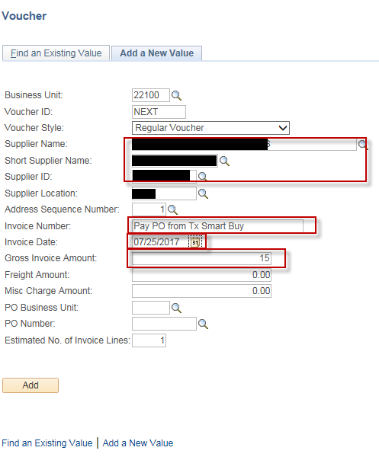

- On the “Invoice Information” tab, scroll down to the “Invoice Lines” section.
Select the appropriate value in the “PCC” field
Enter the TX Smart Buy PO number in the “USAS Requisition” field
Enter the “Inv Receipt Dt”, “Service Date” and “Order Date (Date of TX Smart Buy PO)”.
Enter the “Invoice Description”
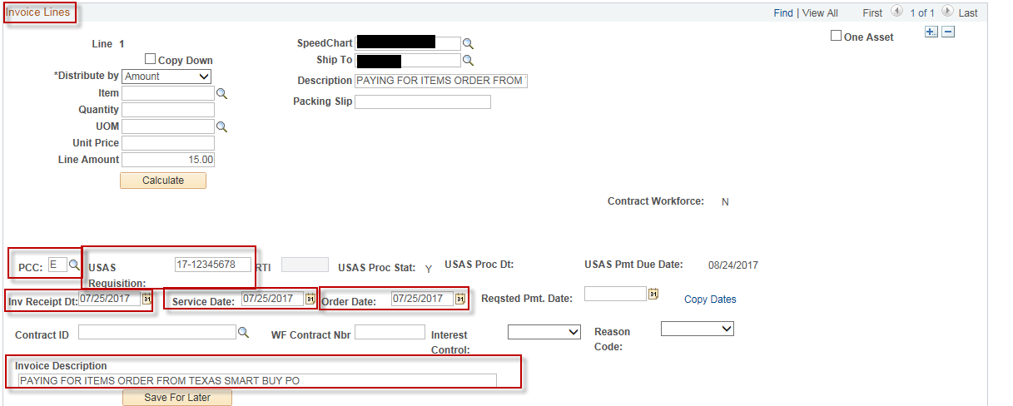
- Scroll down to the “Distribution Lines” section to the “GL Chart” tab and enter the GL Coding (i.e., the GL Chartfield values) information.
** Note: The required GL Chartfield values and combinations vary by agency.
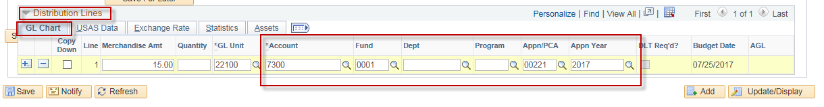

- On the “Voucher Attributes” tab, verify that the value in the “Template” field is the correct value and correct TCode is displayed
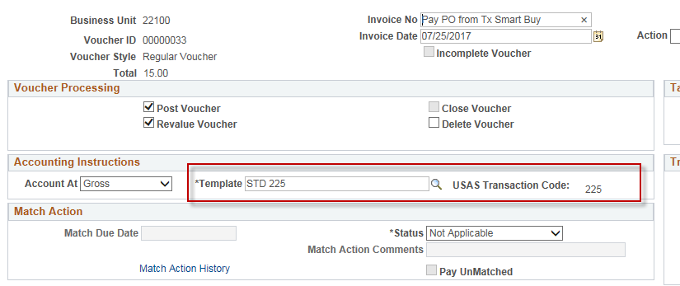

- Attach supporting documentation to the voucher in CAPPS
If you want to attach a soft copy of the PO from TX Smart Buy, on the “Invoice Information” tab click on the “Attachments” hyperlink
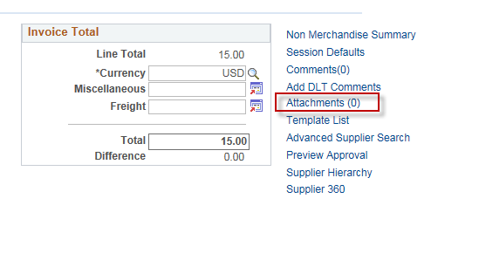

Click “Add Attachment”
Click “Browse” and select your document.
Click “Upload”
Click “Ok”
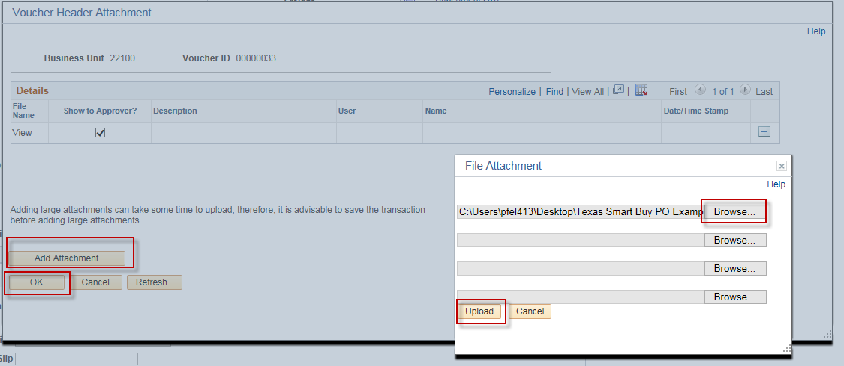

Your “Attachment” hyperlink should show the number of documents that you have attached to the voucher.
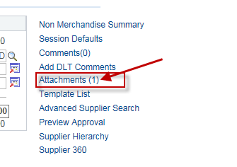

- Click “Save”
- On the “Invoice Information” tab, Select “Budget Checking” in the 'Action' dropdown list and click Run.
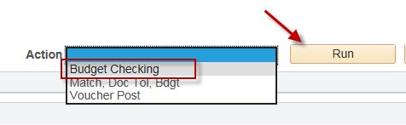
- Click the Refresh button to determine when the process has completed.
- When the “Budget Checking” process has completed, go to the Summary page to verify the voucher's Budget status.
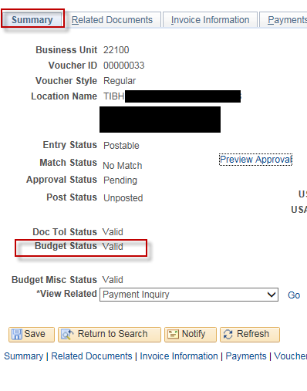
NOTE: If your agency is using the automated AP Workflow, then you must submit this voucher for approval and it must be approved before it can be posted.
The Voucher must be posted before it can be journal generated and sent to USAS.

