Voucher Entry- Freight Line Sourced from PO
Use this job aid if you entered a Freight line on the PO.
- Main Menu > Purchasing > Purchase Orders > Add/Update PO
Enter a separate line for Freight on the PO with the estimated amount.
Budget Check and Dispatch the PO.

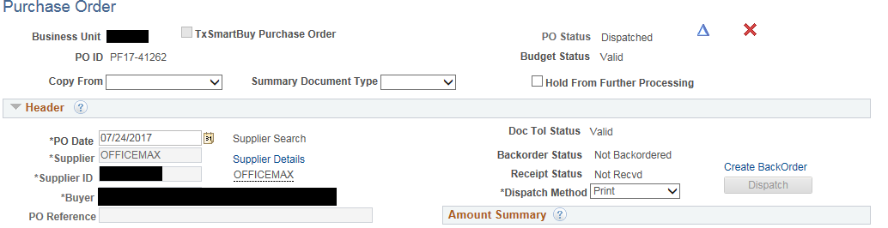
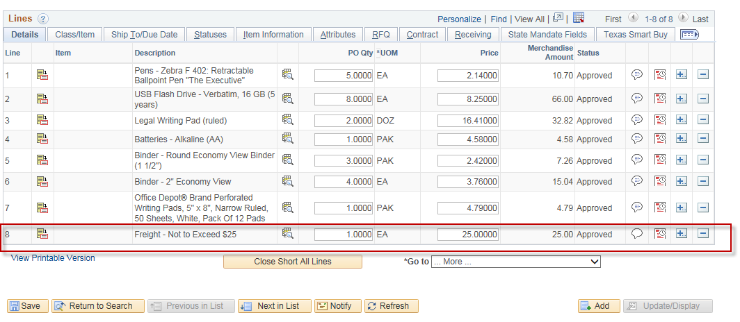

- When you receive the Invoice from the vendor and it is time to Pay the PO:
Main Menu > Accounts Payable > Vouchers > Add/Update > Regular Entry.
'Add a New Value'
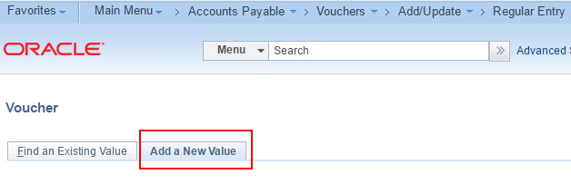
- Enter Supplier ID or Supplier Name, Invoice Number and Invoice Date
and click Add.
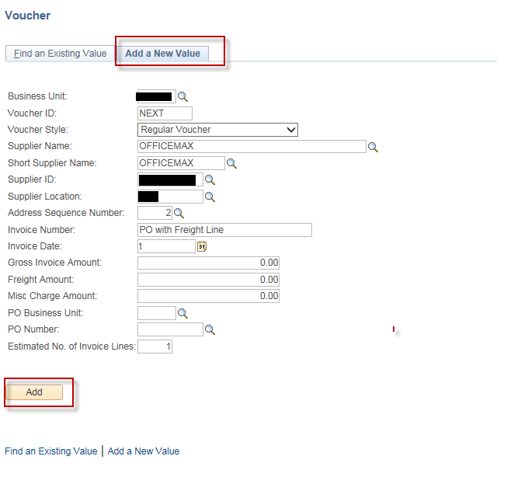
- On the Invoice Information page, click the triangle button to open
Copy From Source Document
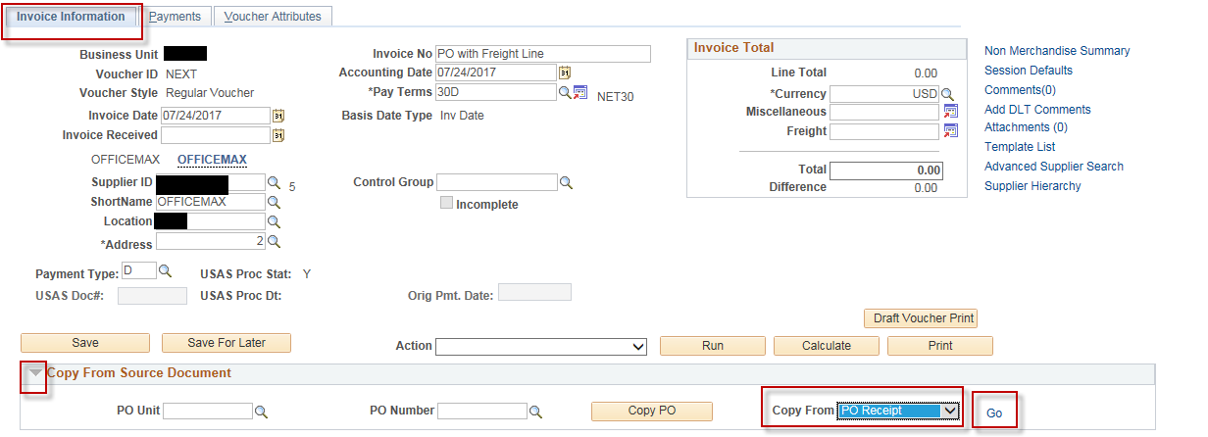
In the 'Copy From' dropdown list, choose ‘PO Receipt’, or “Purchase Order Only” depending upon whether or not you entered a Receipt into CAPPS for this PO, and then click Go.
- In the Copy Worksheet page, enter PO Business Unit and PO Number From and click Search.
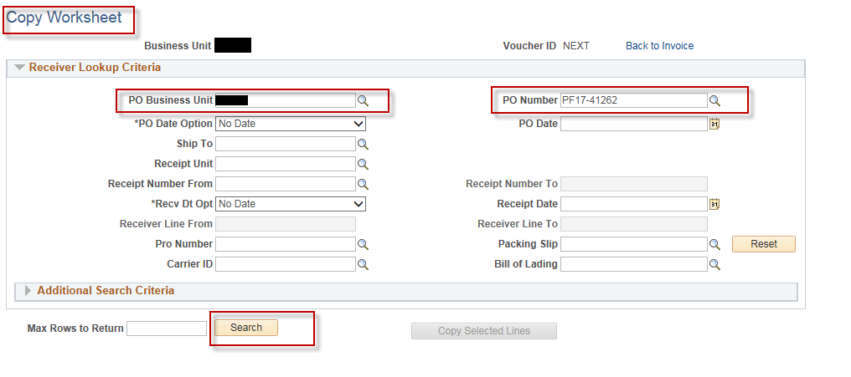

- Select the line or lines you are paying and click “Copy Selected Lines” button
Navigate to the lines as needed and click on the checkbox in the “Select” column.
Instead of clicking each individual line, you can click on the “Select All” hyperlink if you want to pay all of the PO lines.
Click the “Copy Selected Lines” button.
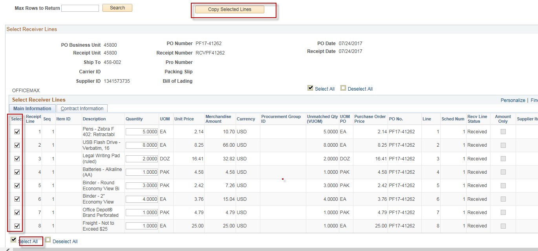
- On voucher Line 1, Click on the “Copy Dates” hyperlink and enter the “Invoice Receipt Date” or you can enter the date directly into the “Invoice Receipt Dt” field manually on each voucher line.
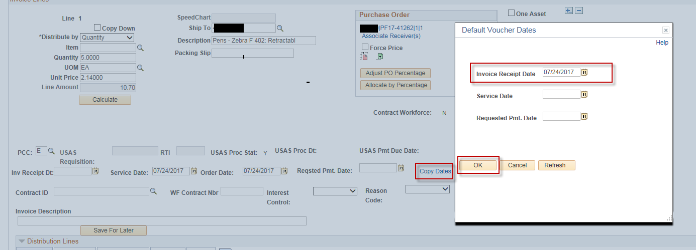

- Navigate to the voucher line that is for the “Freight” Charges either using the “View All” hyperlink or the arrow, to get to the “Freight” charges line
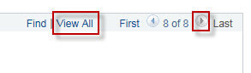

- Enter the correct Freight amount on the voucher line in the “Unit Price” field.
Click the “Calculate” button on the voucher line.
Notice that doing this also updates the “Merchandise Amt” on the GL Distributions line to the updated amount
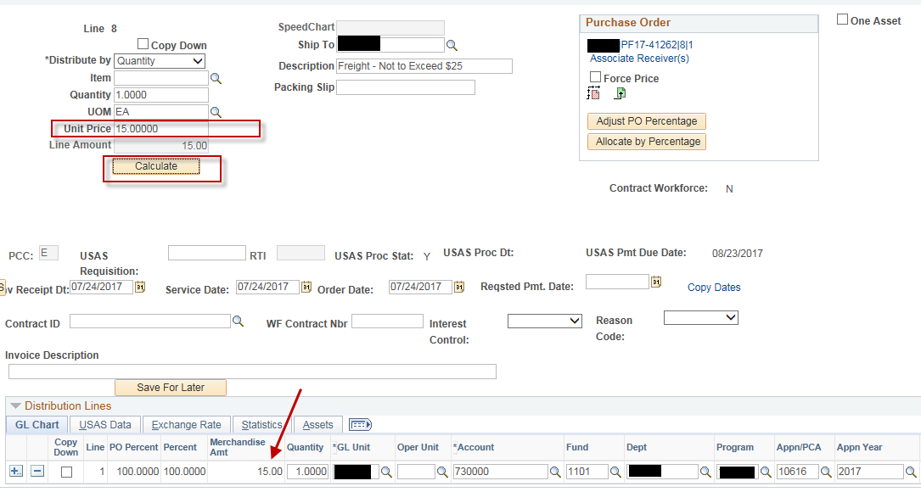
- Click on the “Finalize” icon on the Freight voucher line.
This will liquidate the unused amount that was entered on the freight line on the PO.
It is IMPORTANT to make sure that you click the finalize button on the correct voucher line, i.e., make sure you are clicking the icon on the freight line.
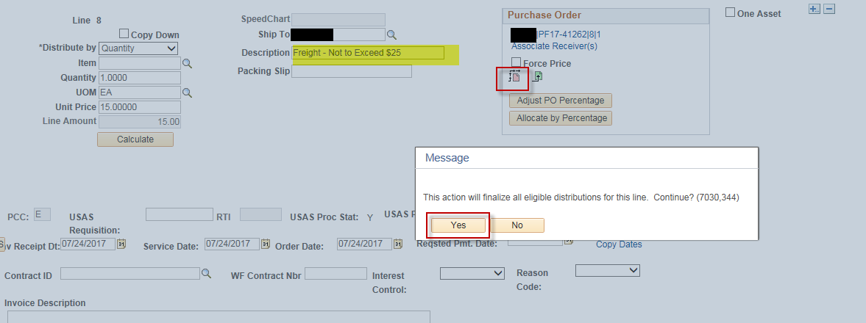
- Update the voucher “Total” amount on the voucher header to include the adjusted amount on the Freight line and then click the “Calculate” button
Click “Save”
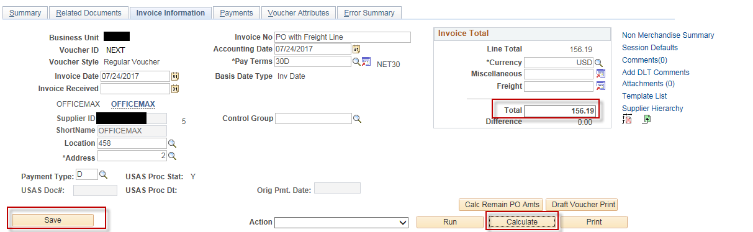

- Click “OK” if you get a message saying “Difference between voucher and total payment amounts is ……”
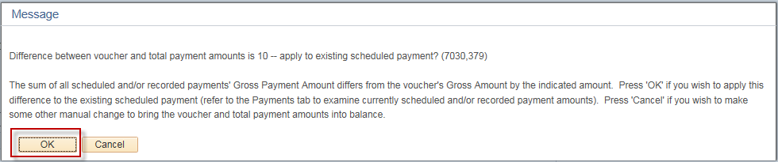
- Select Match, Doc Tol, Bdgt in the 'Action' dropdown list and click Run.
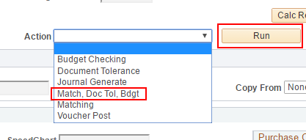
- Click the Refresh button to determine when the process has completed.
- When the processes have completed, go to the Summary page to verify the voucher's Match, Doc Tol and Budget statuses.
