Voucher Entry- KDoc or ETV or Adjustment
This job aid shows how to create an adjustment for a voucher that was originally coded to the wrong GL Chartfield value(s).

- Create a new voucher using the applicable Adjustment Voucher Style:
- If the original voucher that you need to adjust was a “Regular Voucher” style, then use the “Adjustments” voucher style
- If the original voucher that you need to adjust was a “Multi-Vendor Voucher” or “ProCard Voucher” style, then use the “Multi-Vendor Adjustment” voucher style

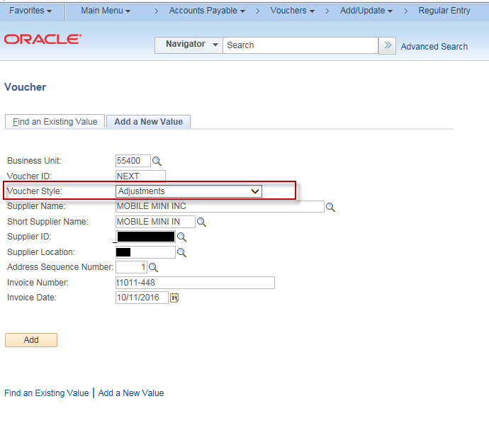

- Use the Copy from Worksheet Functionality
Expand the “Copy from Source Document” section and click on the “Copy from Worksheet” hyperlink
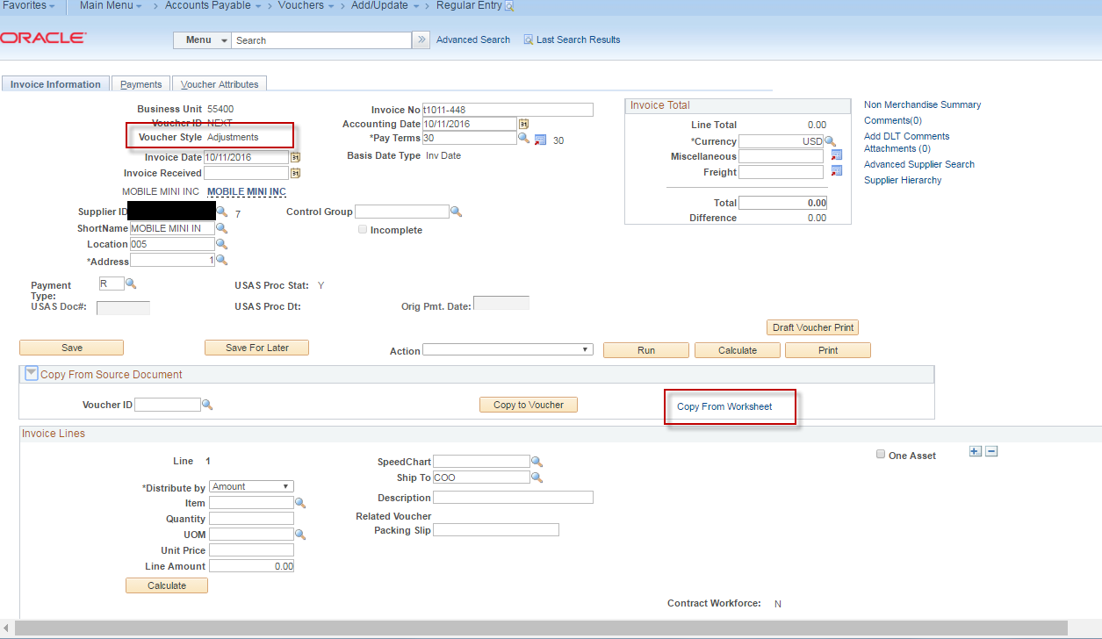

- Select the Voucher that was incorrect and click Search

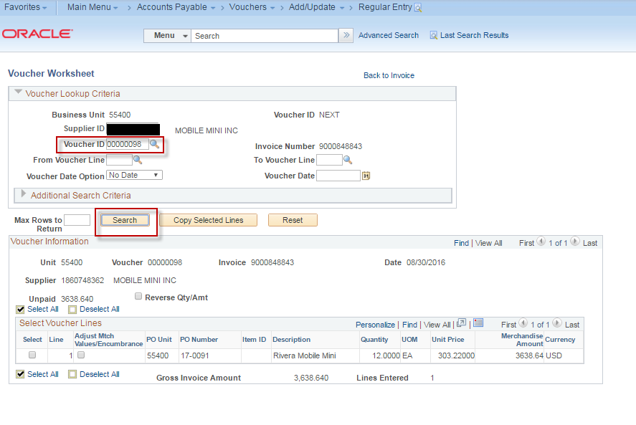

- Select the Line and mark the ‘Reverse Qty/Amt. This will bring in the line from the original voucher as a negative.

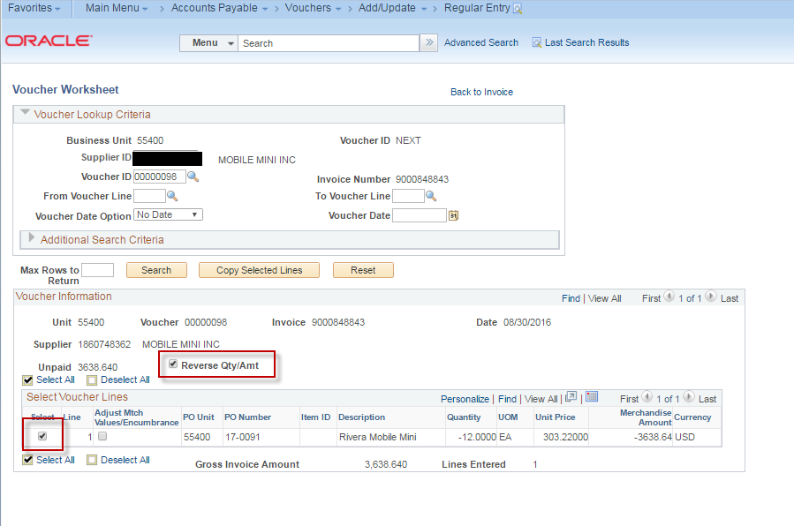

- Click the ‘Copy Selected Lines’.
- Click the ‘Copy From Worksheet’ link again.

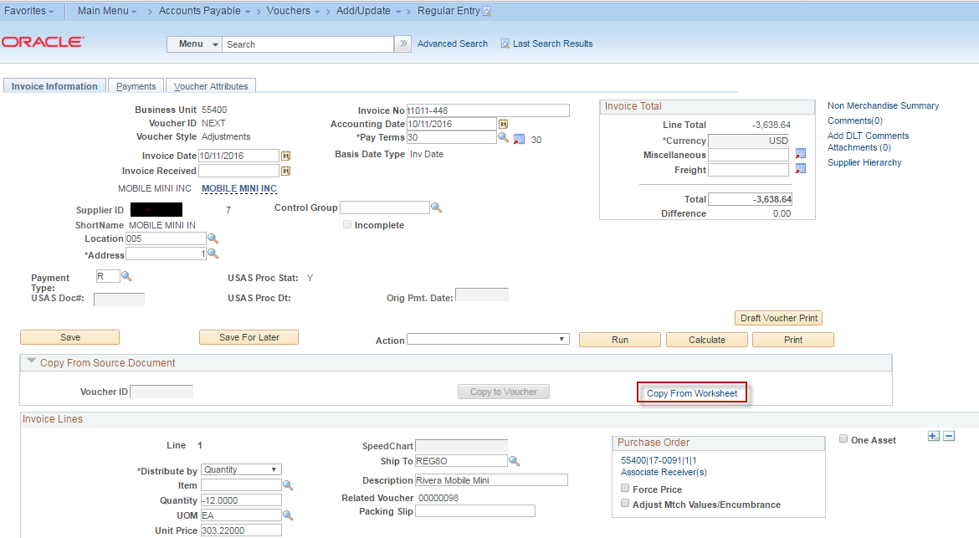

- Select the voucher again and click search.

- Select the line but leave the ‘Reverse Qty/Amt’ box unchecked. (This will bring in the line again with the amount as a positive.

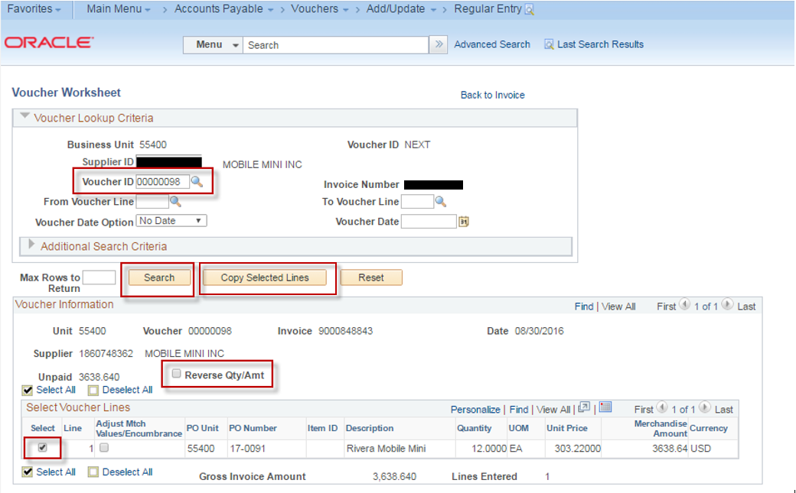
- Click the ‘Copy Selected Lines’ to create the second voucher line.

- Click the ‘View All’ so that you can see both Voucher lines.

If this is a PO voucher, there will be a “Purchase Order” box on each voucher line. If this box appears, make sure to check ON the “Adjust Mtch Values/Encumbrance” checkbox for BOTH voucher lines.

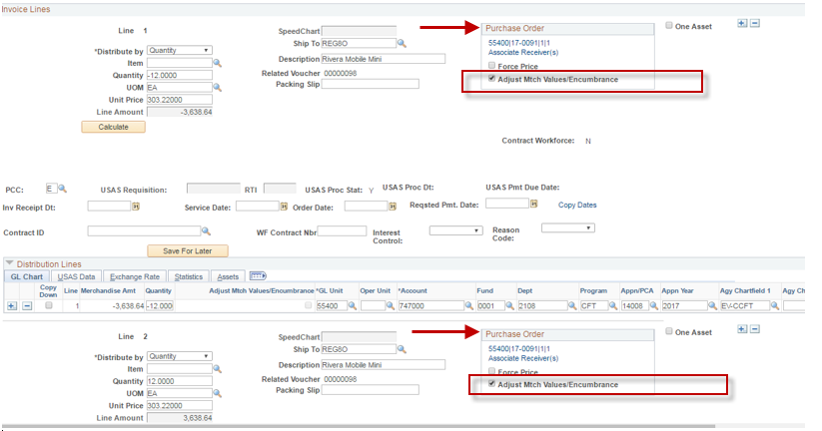

- Scroll down to Line 2 (the positive line) and change the Account and/or the applicable GL Chartfield value.

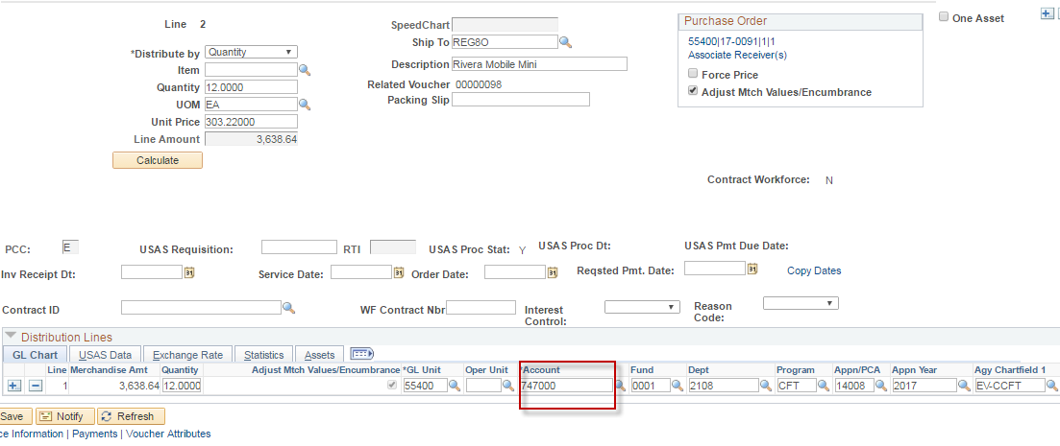

- Scroll to the top of the voucher and change the total amount to 0. Click the ‘Calculate’ Button.

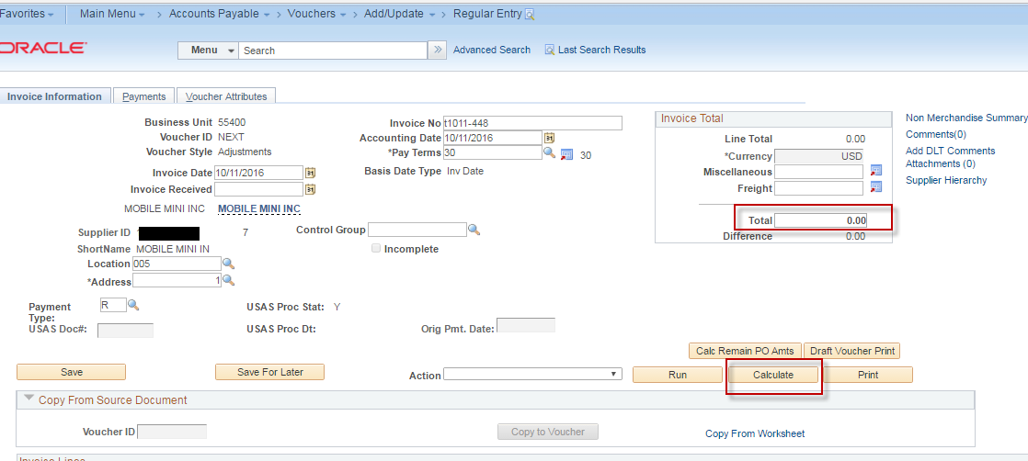

- Click the “Voucher Attributes” tab and change the Template to the “ETV 408”.

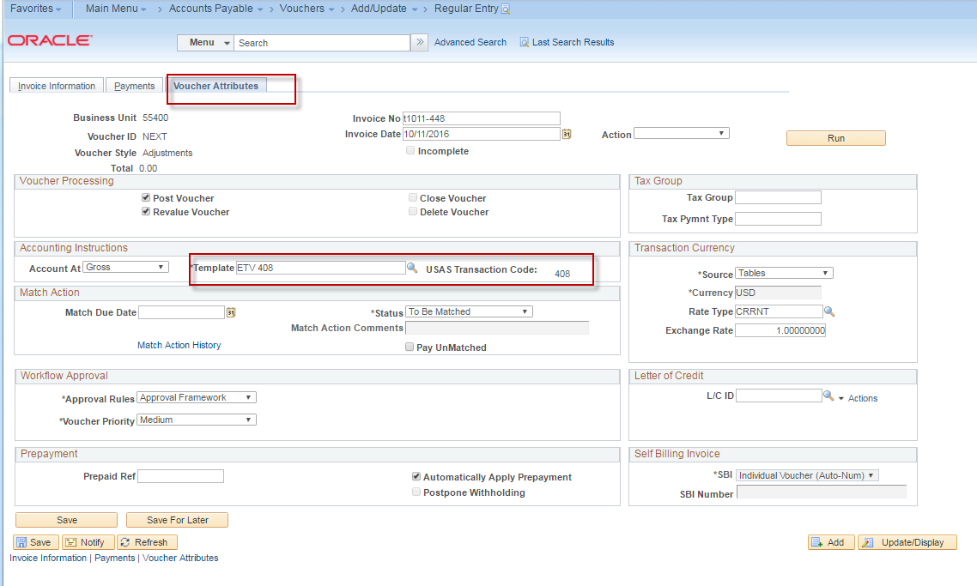

- Click “Save”

- On the “Invoice Information” tab, Select Match, Doc Tol, Bdgt in the 'Action' dropdown list and click Run.
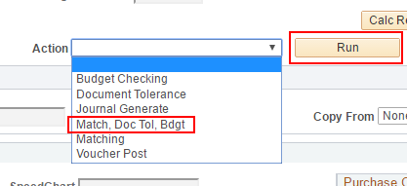
- Click the Refresh button to determine when the process has completed.
- When the processes have completed, go to the Summary page to verify the voucher's Match, Doc Tol and Budget status.

- If your agency is using the automated AP Workflow, submit your voucher for approval.
- Once your voucher is approved, it should be ready for Voucher Posting.
- If your agency is not using the automated AP Workflow, your voucher should be ready for Voucher Posting.

