Voucher Entry- PO Receiver Worksheet
- Main Menu > Accounts Payable > Vouchers > Add/Update > Regular Entry.
'Add a New Value'
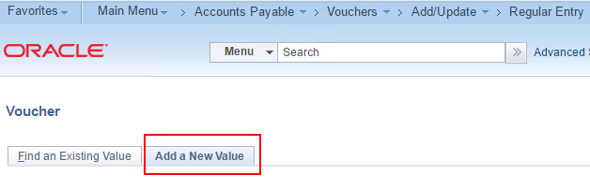
- Enter Supplier ID, Invoice Number and Invoice Date
and click Add.
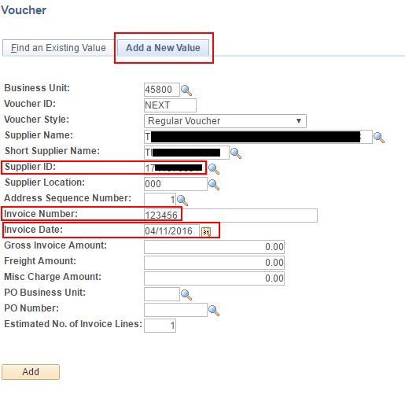
- On the Invoice Information page, click the triangle button to open
Copy From Source Document
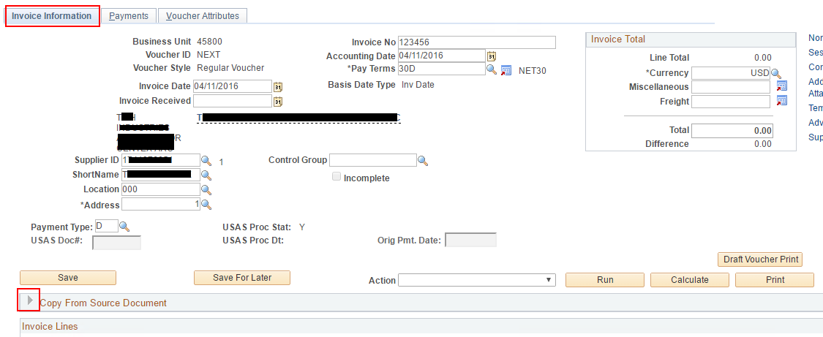
- In the 'Copy From' dropdown list, choose 'PO Receipt' and click Go.
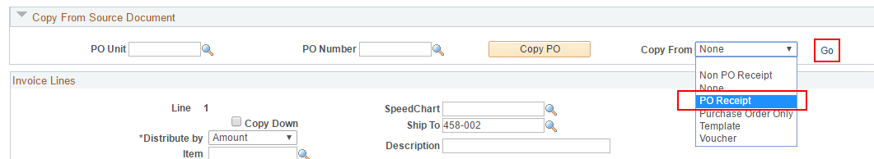
- In the Copy Worksheet page, enter PO Business Unit and PO Number From and click Search.
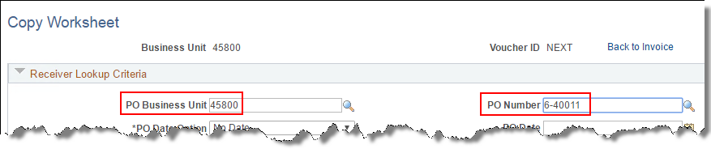
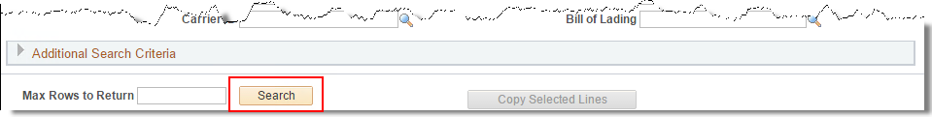
- Select the line or lines needed and click Copy Selected Lines
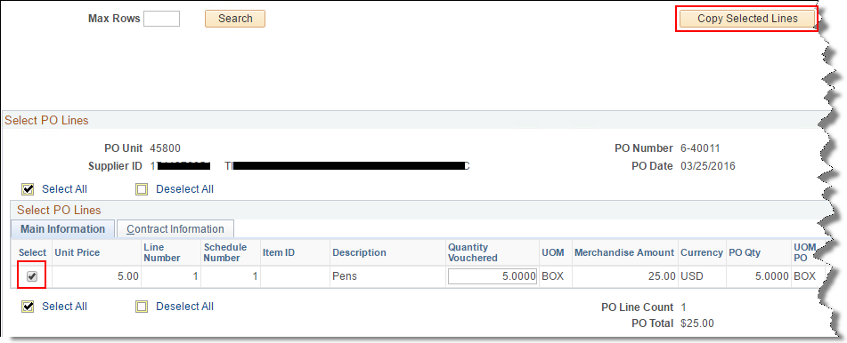
- Navigate the lines as needed to select the lines needed for payment before clicking
Copy Selected Lines.
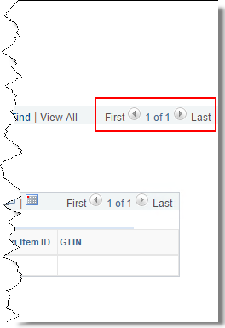
- Enter the Inv Receipt Dt and Invoice Description.
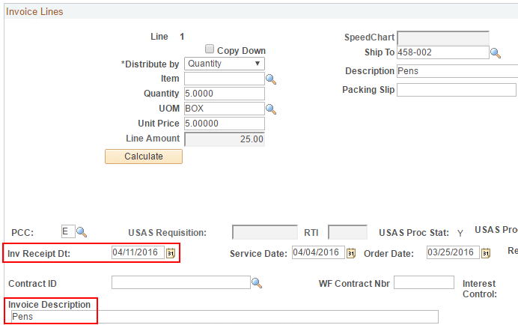
- Save the voucher.
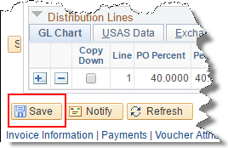
- Select Match, Doc Tol, Bdgt in the 'Action' dropdown list and click Run.
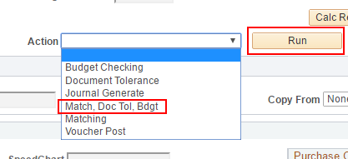
- Click the Refresh button to determine when the process has completed.
- When the processes have completed, go to the Summary page to verify the voucher's Match, Doc Tol and Budget status.
