Config – Create New DLT Comments
Use this job aid if you need new DLT comments (for instance, you want to combine 3 DLT comments into 1 to pull into a voucher.)
- Main Menu > Setup Financials/Supply Chain > Product Related > Procurement Options > Purchasing > Standard Comments
'Add a New Value'
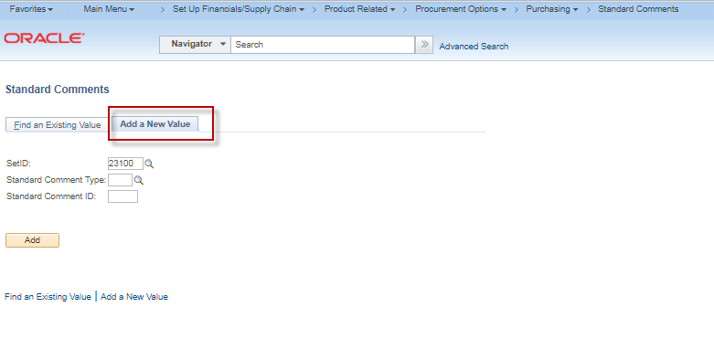

- Select the Standard Comment Type and enter the Standard Comment Id.
(The ‘DLT’ standard comment type is used when you want the DLT to be sent to USAS. The Standard Comment ID is the value that you will see when you are selecting the comment on your voucher or purchase order.)

Click the ‘Add’ button.
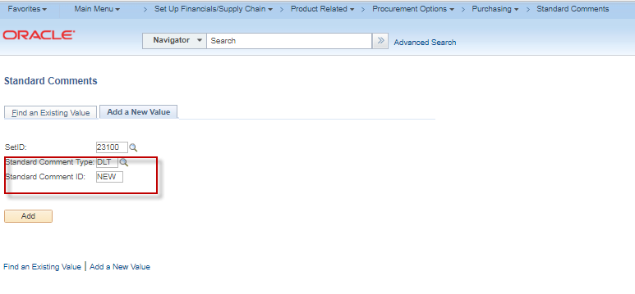

- Enter the Effective Date, Description, and Comments. Click the ‘SAVE’ button.
