The USAS Outbound Interface is a batch process that runs every day at 4:00 PM to send vouchers to USAS for processing. This interface looks for vouchers that have successfully run through all of the processes (matching, document tolerance, and budget checking), have been posted (Voucher Post) in Accounts Payable, and have been journal generated. During this process, the USAS Document Number is assigned and the USAS Process Status is updated.

The Accounts Payable Batch Schedule follows. The right side are the scheduled processes. The left side depicts processes that must be run manually (either on the voucher page or through a batch process) in order to go to USAS.

Below are instructions for running all necessary processes from the batch run control page in order to meet the 4:00 PM deadline. When using the batch run control page, you can run these processes for multiple vouchers at once.
The processes are:
- Matching
- Doc Tolerance
- Budget Checking
- Voucher Post
- Journal Generation

For each process, a new run control should be setup. The run control will be used for any subsequent processing.

Matching

SCENARIO NAME AP-070-030-002_RUN_MATCHING_BATCH
DESCRIPTION: Run matching using the batch run control page
SCENARIO STEPS:
STEP 1
Navigate to Accounts Payable -> Batch Processes-> Vouchers> Matching

STEP 2
If you have a run control already setup for Matching, click 'Find an Existing Value' tab.
Click "Search" and select your run control ID. Skip to step 5

STEP 3
If you do not have a run control ID for Matching, click on the 'Add a New Value' tab and type in a
run control name that you can remember. No spaces are allowed in the name, however, you can
use an underscore.('_')

STEP 4
Click 'Add'. This should take you to the 'Matching' run control page.

STEP 5
On the "Match Request" run control page, enter a Description
Click on the "Process Frequency" drop down and select "Always Process"
Click on the "Match Action" drop down and select "Matching"
Click on the "Options" drop down and select "Business Unit"
Leave the "As Of Date" field Blank
Make sure the "Run Document Association Only" checkbox is not checked
Make sure the "Autopilot Run Control" checkbox is not checked

In the "Business Unit" section click the dropdown for the "Business Unit" column and select your business
unit
Click "Save"

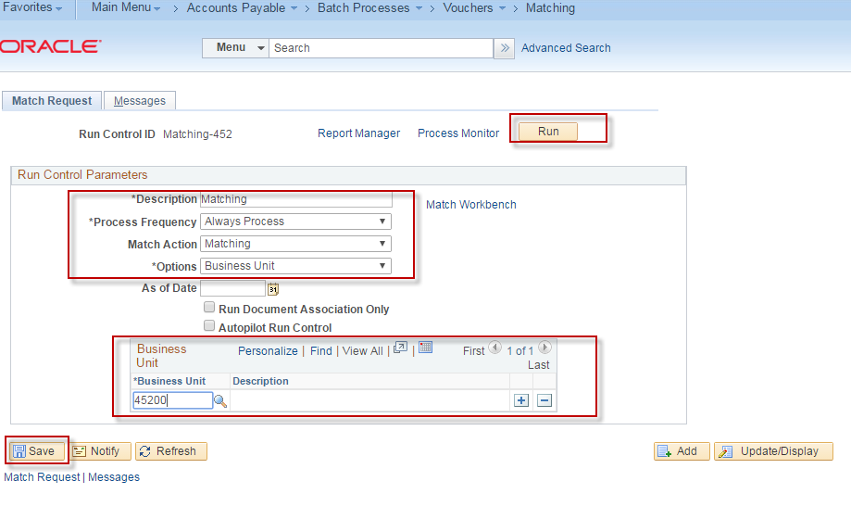

STEP 6
Click "Run"

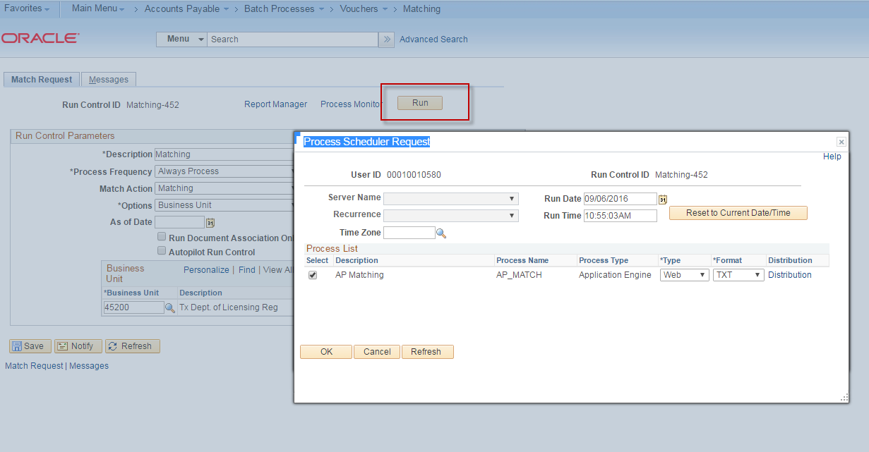

STEP 7
On the "Process Scheduler Request" Page in the "Process List" section, make sure the check the
box for "AP Matching" (AP_MATCH ) is checked on.

Click ‘OK’

STEP 8
The Process Instance will be displayed at the top of the "Match Request" page. Make note of
the Process Instance number.
Click the "Process Monitor" link
This should take you to the "Process Monitor" page

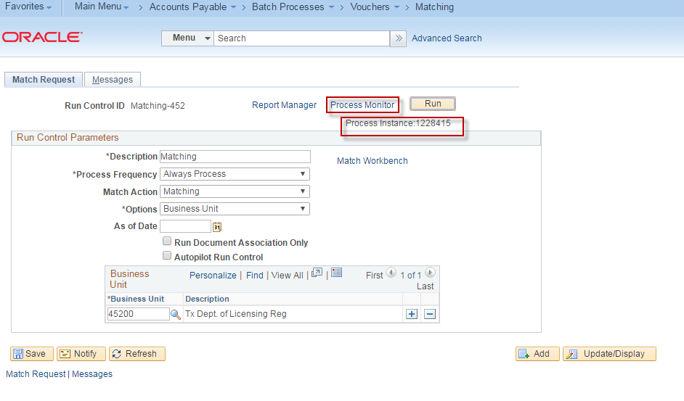
STEP 9
You should see your Process Instance number in the "Process List" section.
Click "Refresh"
Process Name "AP_MATCH" run status will be refreshed. Upon successful completion of the
Matching job, the RUN STATUS will be "Success" and the Distribution Status will be “Posted”.

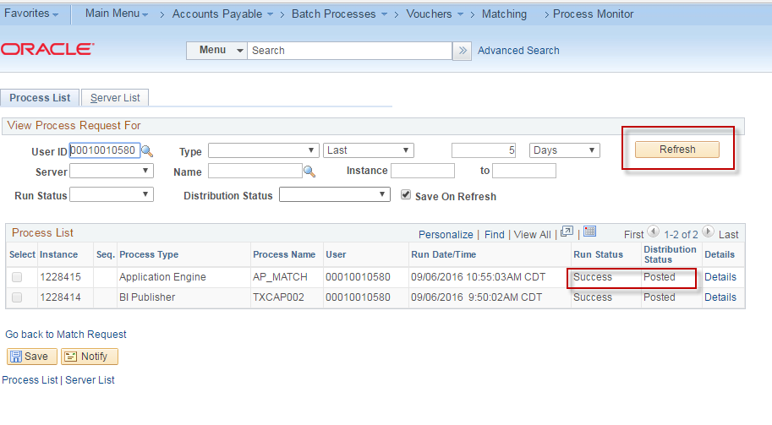

STEP 10
Click the "Go back to Match Request" link at the bottom of the "Process Monitor" page to go back to the "Match Request" page.

STEP 11 – (Optional Step)
To determine if there are any vouchers with Matching Errors, click on the ‘Match Workbench’ link.

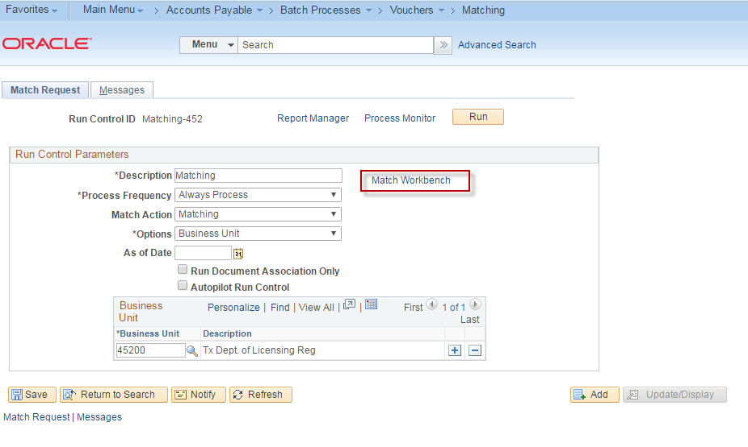

STEP 12
Enter:
Business Unit
Match Status
(Choose ‘Match Exceptions Exist’ to see if there are errors or ‘To Be Matched’ to see if there is anything that hasn’t been matched.)

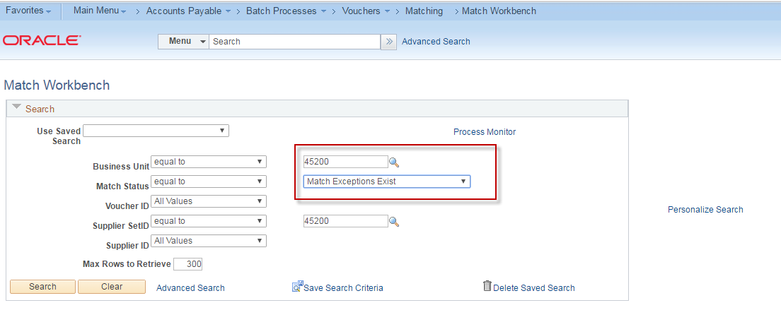

STEP 12
Click ‘Search’
(A list of vouchers that meet the criteria will display.)
Document Tolerance
SCENARIO NAME AP-070-020-002_RUN_DOC_TOLERANCE_BATCH
DESCRIPTION: Run Doc Tolerance from the batch run control page
SCENARIO STEPS:
STEP 1
Navigate to Accounts Payable -> Batch Processes-> Vouchers> Document Tolerance

STEP 2
If you have a run control already setup for Doc Tolerance Checking, click 'Find an Existing Value'
tab.
Click "Search" and select your run control ID. Skip to step 5

STEP 3
If you do not have a run control ID for Doc Tolerance Checking, click on the 'Add a New Value' tab and type in a run control name that you can remember. No spaces are allowed in the name,
however, you can use an underscore.('_')

STEP 4
Click 'Add'. This should take you to the 'Doc Tolerance' run control page.

STEP 5
On the Doc Tolerance run control page, enter:
Description (enter a meaningful description)
In the 'Process Frequency' drop down, select 'Always Process'
In the 'Document Type' drop down select 'Voucher'
In the 'Run Option' drop down select 'Voucher'
This will enable the 'Business Unit' and 'Voucher Id' fields in the 'Voucher' section below

STEP 6
In the 'Voucher' section, click on the 'Business Unit' lookup enter your business unit.
Click on the 'Voucher ID' lookup box and select your voucher id.
Click 'Save'

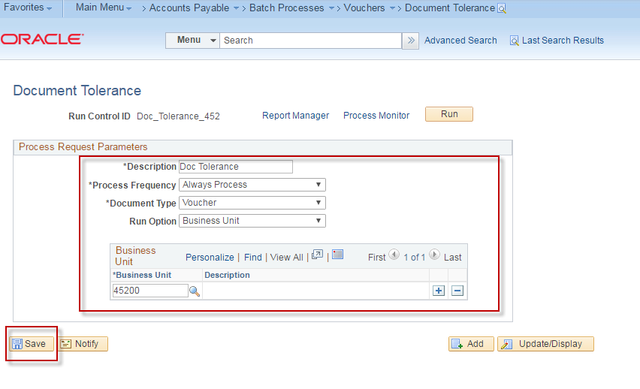

STEP 7
Click 'Run'
The 'Process Scheduler Request' page will be displayed

STEP 8
On the 'Process Scheduler Request' page make sure that the box next to 'Document Tolerance
Checking' (FS_DOC_TOL ) is checked on
Make sure that under the 'Type' column the value of 'Web' is entered
Make sure that under the 'Format' column the value of 'TXT' is entered
Click 'OK'
The 'Document Tolerance' page will be displayed again

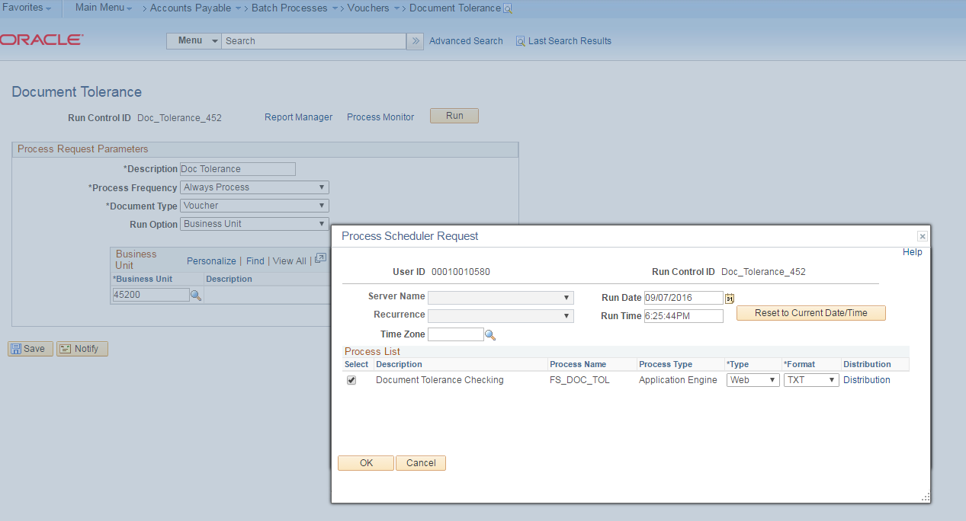

STEP 9
You should see a Process Instance number displayed showing the Document Tolerance batch
process running.

STEP 10
Click on the Process Monitor hyperlink and find the process instance just initiated. It should be the
same Process Instance number displayed in the previous step.

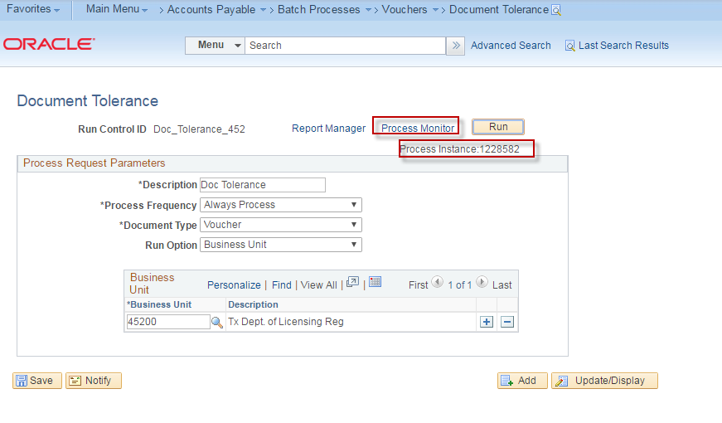

STEP 11
Use the ‘Refresh’ button until the Run Status displays ‘Success’ and the Distribution displays ‘Posted’. Click the ’Go back to Document Tolerance Requests’ link.

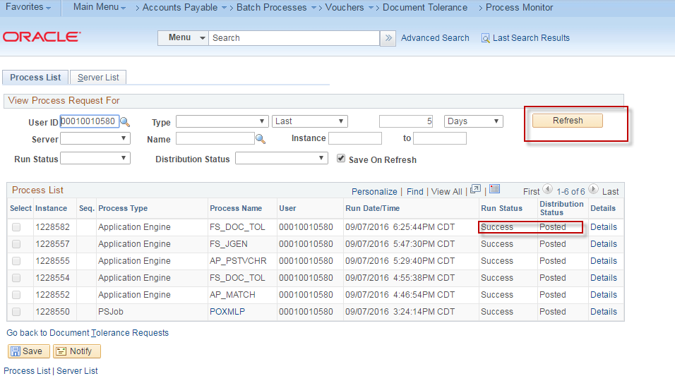

Budget Check
SCENARIO NAME AP-RUN_BUDGET_CHECK_BATCH
BUS PROCESS: AP-070-010-002_RUN_BUDGET_CHECK_BATCH
DESCRIPTION: Run budget checking for the voucher using the batch run control page
SCENARIO STEPS:
STEP 1
Navigate to Accounts Payable > Batch Processes > Vouchers > Budget Check

STEP 2
If you have a run control already setup for Budget Checking, click 'Find an Existing Value' tab.
Click "Search" and select your run control ID. Skip to step 5

STEP 3
If you do not have a run control ID for Budget Checking, click on the 'Add a New Value' tab and
type in a run control name that you can remember. No spaces are allowed in the name, however,
you can use an underscore.('_')

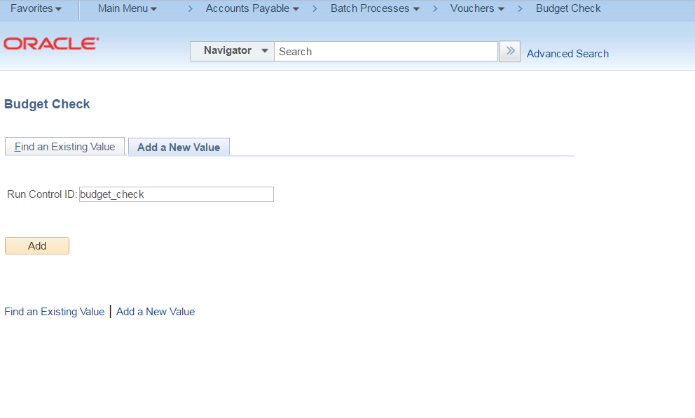
STEP 4
Click 'Add'. This should take you to the 'Budget Check' page.

STEP 5
On the "Budget Check" run control page, click on the "Process Frequency" drop down box and
select 'Always Process'

STEP 6
Enter a Description that you can remember
STEP 7
Click on the 'Transaction Type' lookup box select 'AP_VOUCHER'

STEP 8
Leave the 'Budget Pre-Check' check box blank.

STEP 9
In the 'Selection Parameters' section, click on the drop down box for 'Field Name' and select
'Business Unit'. Under the 'Value Type' column select 'Value'. Under the 'From/To' column select
your business unit. Click the '+' sign at the end of this row so that it will add another row under

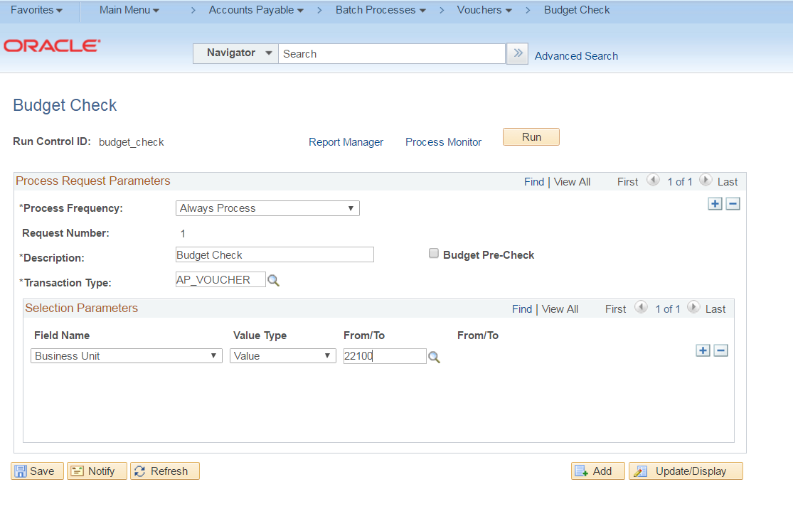

STEP 10 -- Optional
In the 'Field Name' drop down box select 'Voucher ID'. In the 'Value Type' drop down box select
'Value'. In the 'From/To' drop down box select the voucher id that you want to budget check. Click
the 'Save' button at the bottom of the page.

STEP 11
Click the 'Run' button. The 'Process Scheduler Request' window should pop up. Underneath the
'Process List' section, make sure that the check box next to the budget checking process (Comm.
Cntrl. Budget Processor) is checked on. Also make sure that under the 'Type' column the value of
'Web' is entered. Under the 'Format' column, make sure that the value of 'TXT' is entered.

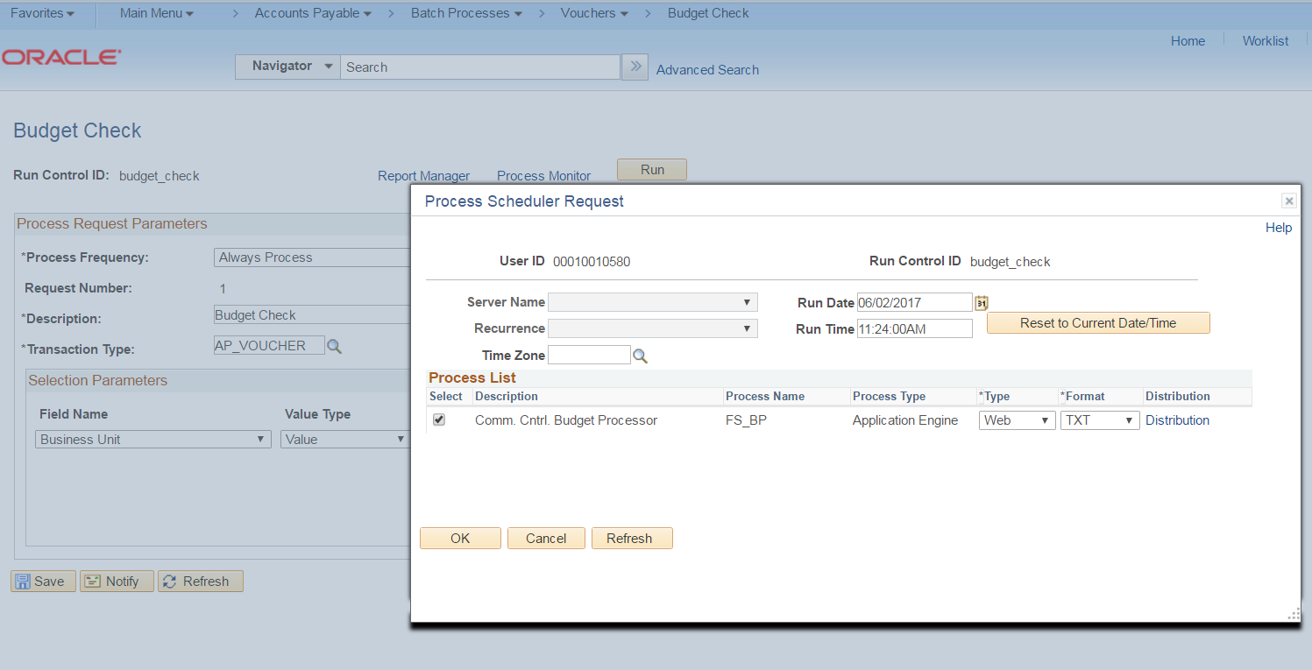
STEP 12
Click on 'OK'. The 'Process Scheduler Request' window should disappear and you will see a
'Process Instance' number displayed underneath the "Run" button on the "Budget Check" page.
Make note of your process instance number.

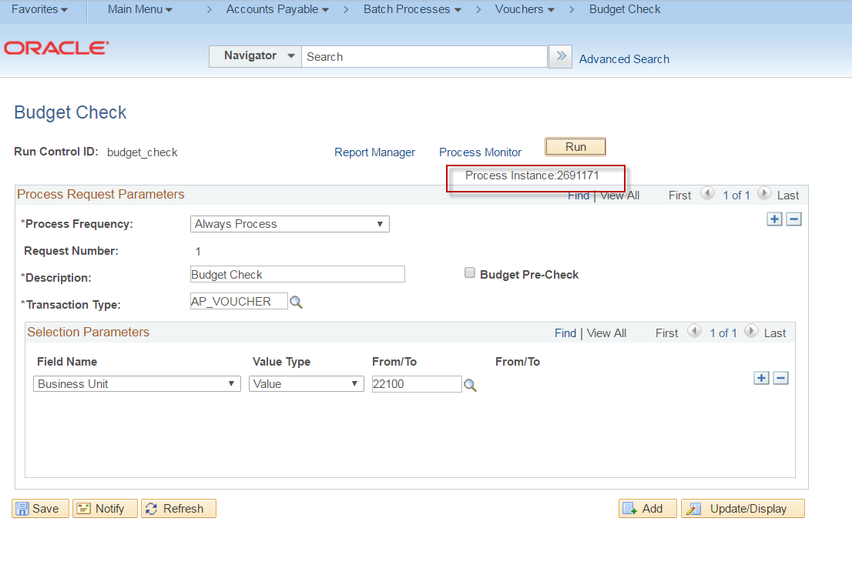

STEP 13
Click on the 'Process Monitor' hyperlink. This will take you to the Process Monitor page. Look for
the process instance number on this page. This is your batch job for the Budget Checking process
that you just submitted.

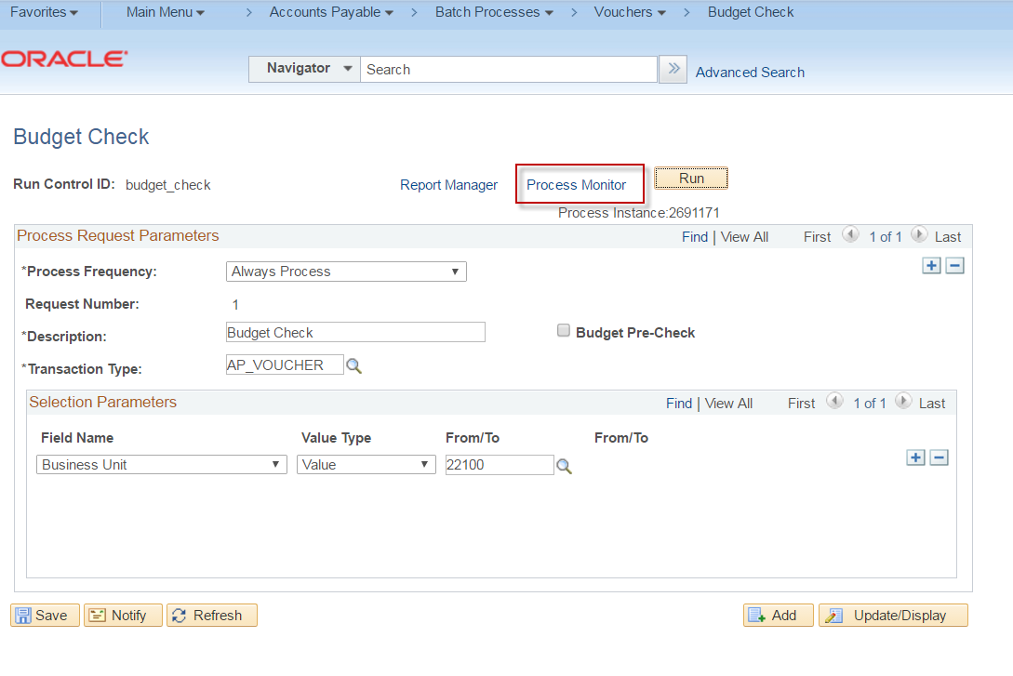

STEP 14
Click the 'Refresh' button at the top of the Process Monitor page.

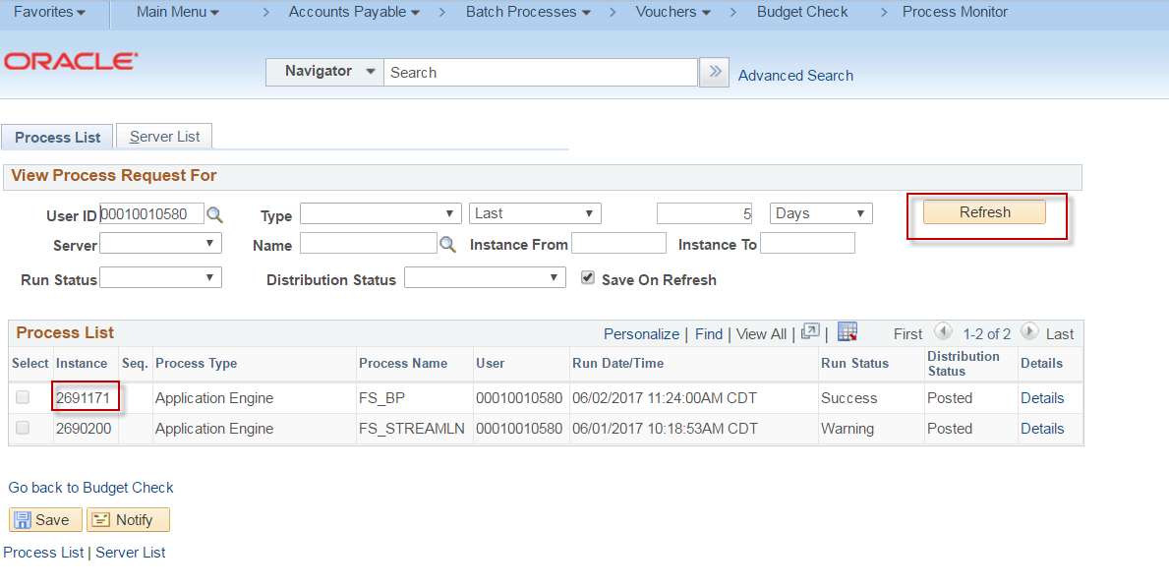

STEP 15
When Run Status for your process instance says 'Success', the budget checking job is completed.
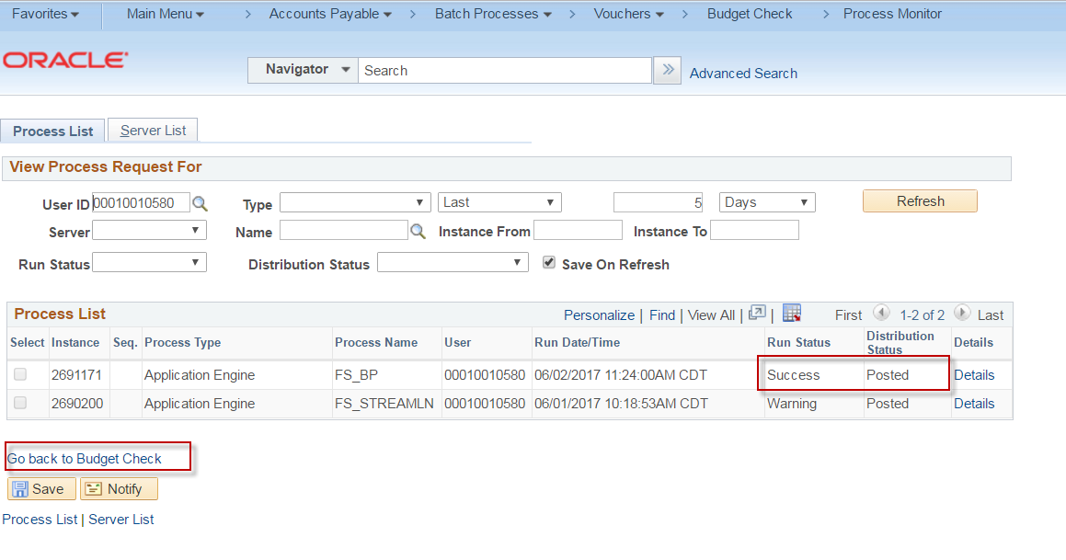

STEP 16
Test Complete

Voucher Post

SCENARIO NAME AP-070-040-002_POST_VOUCHER_BATCH
DESCRIPTION: Run the voucher post process using the batch run control page
SCENARIO STEPS:
STEP 1
Navigate to Accounts Payable > Batch Processes > Vouchers > Voucher Posting

STEP 2
If you have a run control already setup for Voucher Posting, click 'Find an Existing Value' tab.
Click "Search" and select your run control ID. Skip to step 5

STEP 3
If you do not have a run control ID for Voucher Posting click on the 'Add a New Value' tab and type
in a run control name that you can remember. No spaces are allowed in the name, however, you
can use an underscore.('_')

STEP 4
Click 'Add'. This should take you to the 'Voucher Posting' run control page.

STEP 5
On the Voucher Posting run control page, enter a Short Description into the "Request Id" field
Enter a Long Description into the "Description" field
Select "Always Process" in the "Process Frequency" drop down
Select "Post Voucher" in the "Post Voucher Option" drop down
Leave the default value as "Invoicing Supplier" in the "Prepayment Application Method" box

STEP 6
In the "Post Voucher List" section, click on the "Business Unit" dropdown and select your Business
Unit
In the "Voucher ID" drop down select your voucher id that you wish to post.
Leave the "Autopilot Run Control" check box blank
Click "Save"
Click "Run"

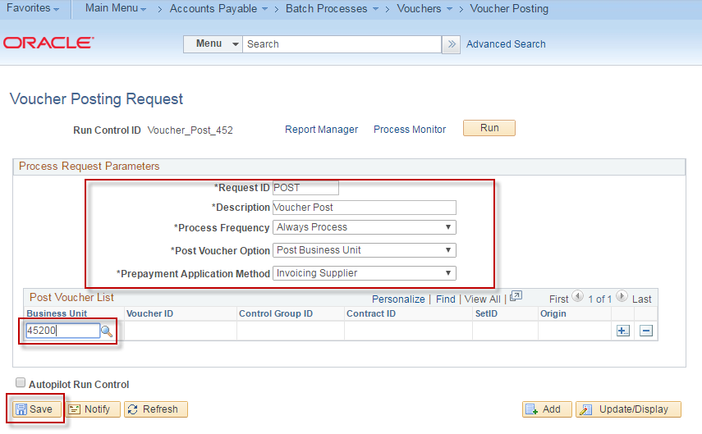

STEP 7
The "Process Scheduler Request" window should appear
Verify that the box is checked next to the "PS/AP Voucher Posting" checkbox.
Verify that the value under the "Type" column is "Web".
Verify that the value under the "Format" column is "TXT"
Click ‘OK’

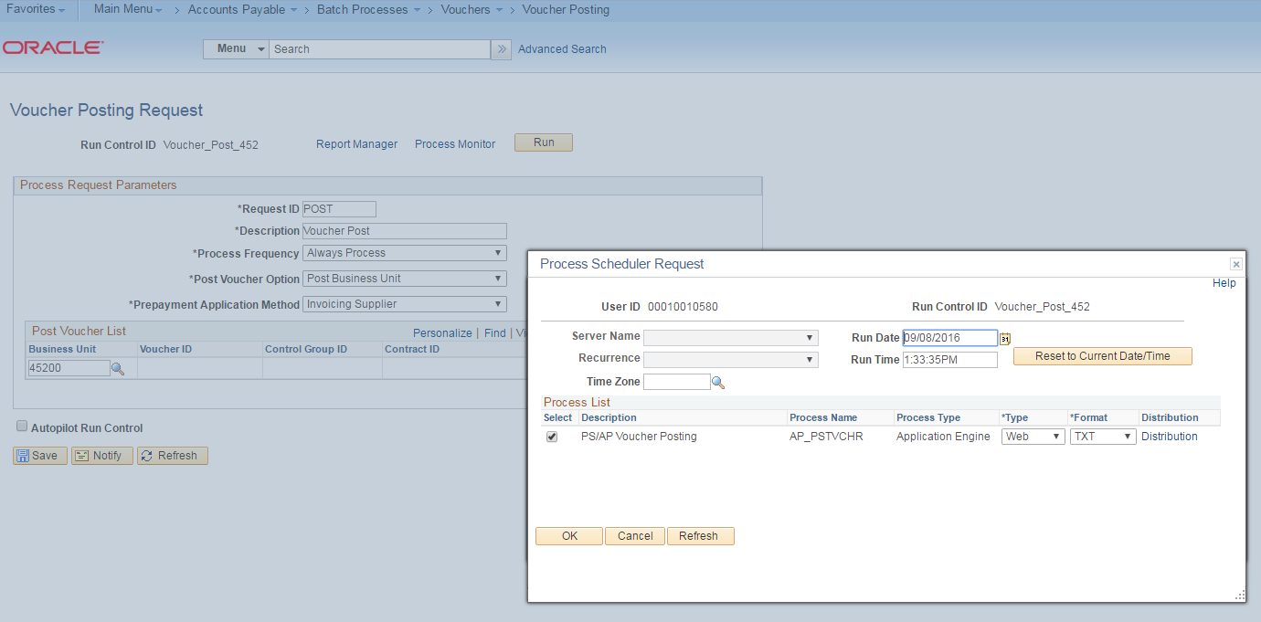

STEP 8
You will be taken back to the "Voucher Posting Request" page.
A "Process Instance" number will be displayed at the top of the "Voucher Posting Page"
Make note of the Process Instance Number

Click on the "Process Monitor" hyperlink.

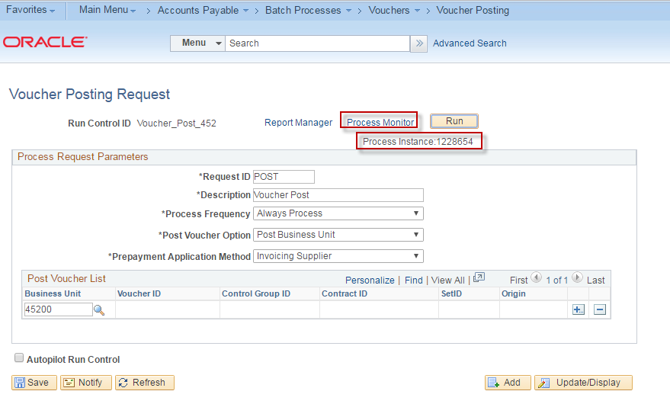
STEP 9
Click the ‘Reset’ button until the Run Status displays ‘Success’ and the Distribution displays ‘Posted’.

Click the ‘Go back to Voucher Posting Request’ link

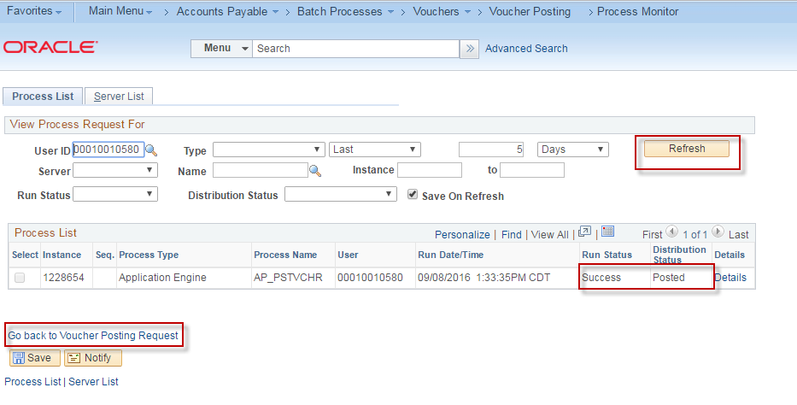

Journal Generate for AP

DESCRIPTION: Run the journal generation process for AP Transactions to post them to the general ledger.
SCENARIO STEPS:
STEP 1
Navigate to General Ledger > Journals > Subsystem Journals > Generate Journals

STEP 2
If you have a run control already setup for Journal Generate, click 'Find an Existing Value' tab.
Click "Search" and select your run control ID. Skip to step 5

STEP 3
If you do not have a run control ID for Journal Generate click on the 'Add a New Value' tab and type
in a run control name that you can remember. No spaces are allowed in the name, however, you
can use an underscore.('_')

STEP 4
Enter the following:
- Edit (Select)
- Budget Check (Select)
- Post (Select)
- Process Frequency – Always
- Ledger Group – Actuals
- Template – Accrual
- Accounting Definition Name -- APDEFN

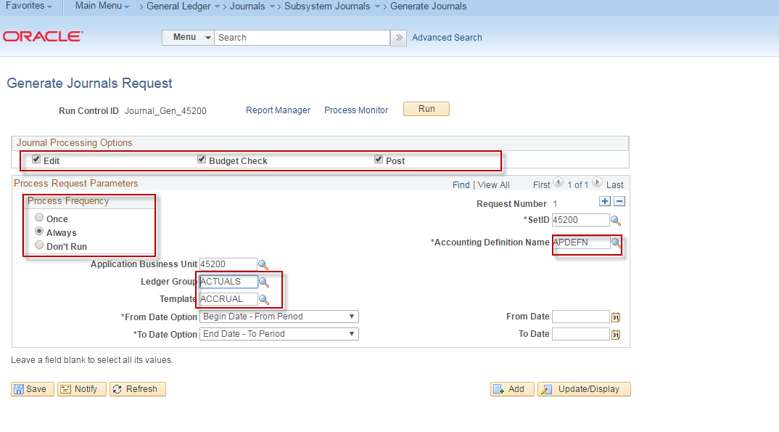
STEP 5
Click the ‘+’ to add another value

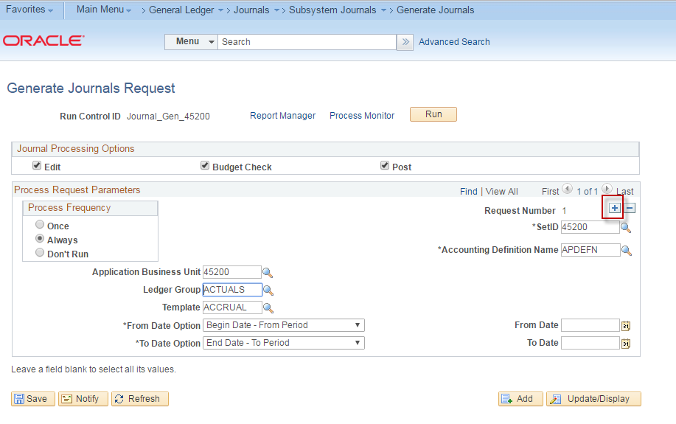

STEP 6
Enter:
- Process Frequency – Always
- Ledger Group – Actuals
- Template – AP_REVALUE
- Accounting Definition Name – APDEFN
Click ‘Save’

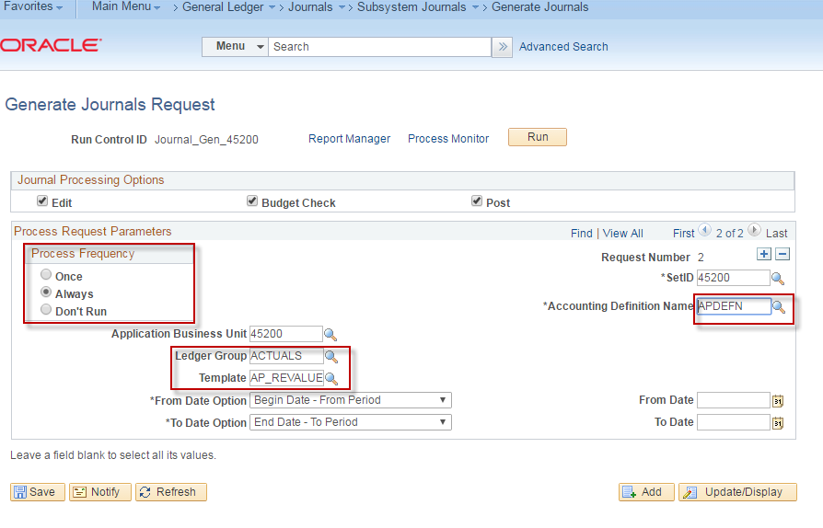

STEP 7
Click ‘Run’

STEP 8
Select ‘FS_JGEN’. Verify that the Type is ‘Web’ and the Format ‘TXT’.

Click ‘OK’

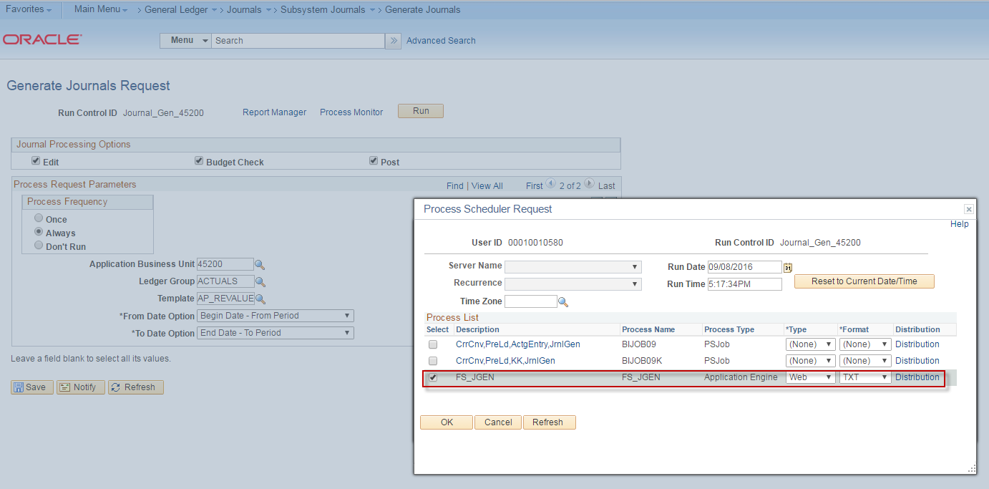

STEP 9
Verify that a Process Instance Number is Displayed and click on the ‘Process Monitor’ link.

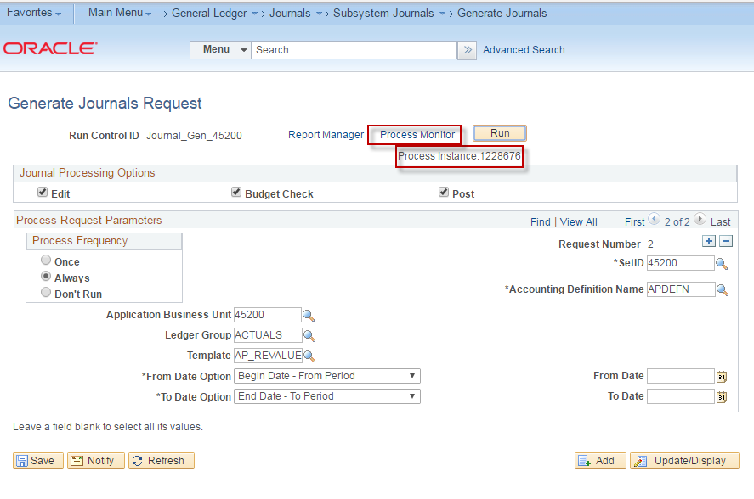

STEP 10
Click the ‘Refresh’ button until the Run Status displays ‘Success’ and the Distribution Status displays ‘Posted’.

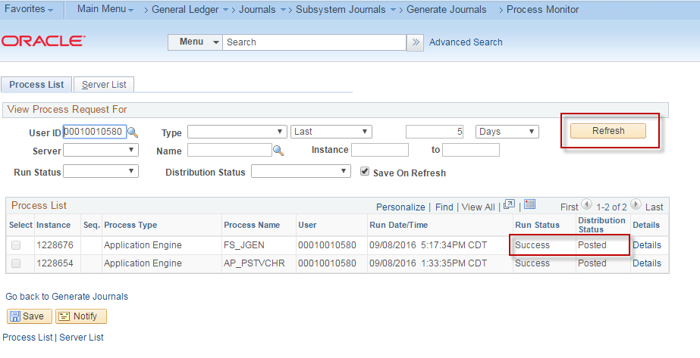

STEP 11
Click the ‘Go back to Generate Journals’ link.

